大物实验数据 古宜民 2018/12/09

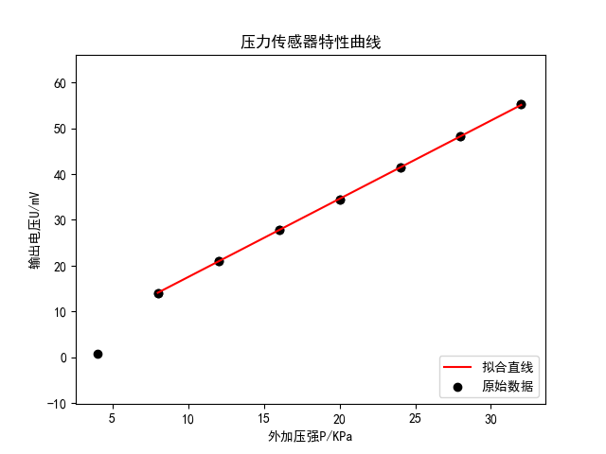

linear regression:   
 slope: 1.70804   
 intercept: 0.439286   
 r-value: 0.999988   
 p-value: 9.35578e-13   
 std-err: 0.0037244   
 r-squared: 0.999976   
 斜率标准差: 0.0037244   
 截距标准差: 0.0802261

