大物实验数据 古宜民 2020/09/21

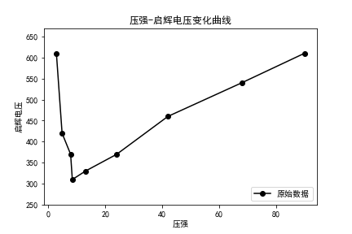

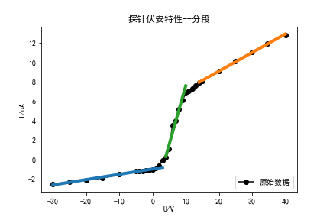

Ii01, Ii02, dV/dI, Te, Ne:3.92826261008807123.660075721722674-0.25500910746812399965.8793361001142.562784462535401e+18



Ii01, Ii02, dV/dI, Te, Ne:0.96092874299439565.271899059024807-0.82742316784869987801.3480123120112.896576938452897e+18