中国科学技术大学计算机学院

计算机网络实验报告

实验三
利用Wireshark观察TCP报文

学 号：PB15111604
姓 名：金泽文
专 业：计算机科学与技术
指导老师：张信明

中国科学技术大学计算机学院
2017 年 12 月 8 日

一、 实验目的
1、 通过捕获观察并分析TCP报文，理解TCP的细节，包括：为了reliable传输的SEQ、ACK序号使用；TCP的拥塞控制算法-慢启动和拥塞避免；TCP的流控制机制；TCP连接的建立。
二、 实验原理
Wireshark是一个packet分析工具，可以抓取packet，并分析出详细信息。Wireshark使用wincap作为接口，直接与网卡进行packet交换，监听共享网络上传送的packet。

三、 实验条件
1、 硬件条件： 联想Y700：
i5-6300HQ 2.30GHz
16G 内存
Intel(R) Dual Band Wireless-AC 3165
2、 软件条件： Win10 Professional 1703
Wireshark2.4.2

四、 实验过程
1、 向远程服务器发送一个txt文件，并捕获TCP报文。
·首先下载alice.txt
·到指定页面选中要上传的文件。
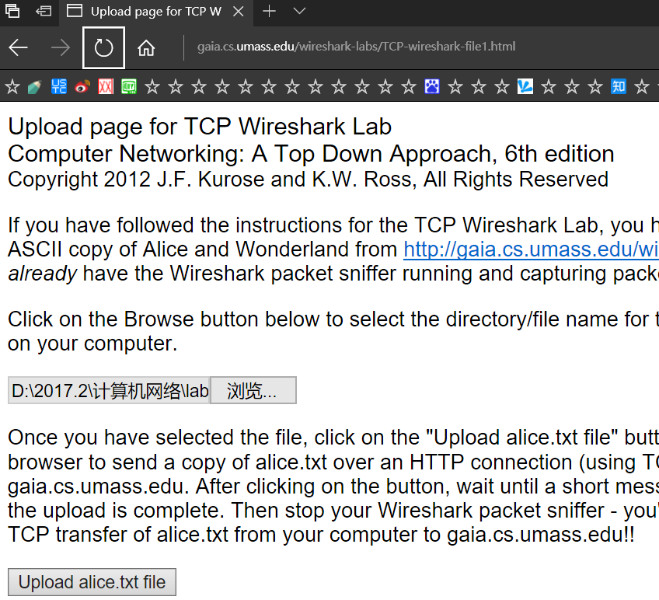
·打开wireshark开始捕获。
·开始上传文件。
·成功上传之后，终止捕获。
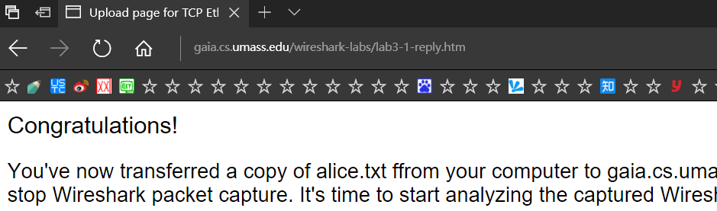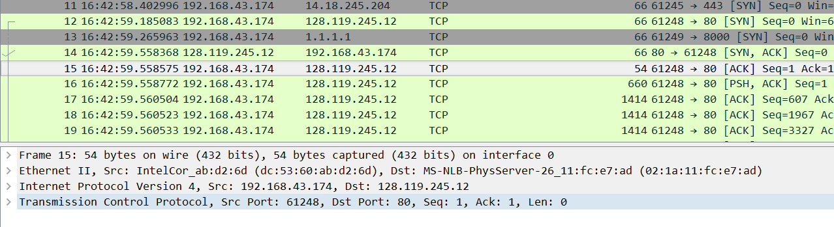
2、 开始回答问题。

- 结果分析

以下是pdf中14个问题对应的回答
（除3、14题，都是用的提供的trace文件。）
1. What is the IP address and TCP port number used by the client computer (source)
that is transferring the file to gaia.cs.umass.edu? To answer this question, it’s
probably easiest to select an HTTP message and explore the details of the TCP
packet used to carry this HTTP message, using the “details of the selected packet
header window” (refer to Figure 2 in the “Getting Started with Wireshark” Lab if
you’re uncertain about the Wireshark windows).
答：客户端电脑的ip地址：192.168.1.102；TCP端口：1161。如下图：
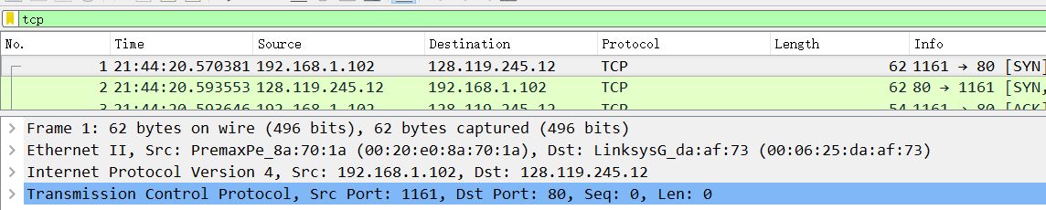
2. What is the IP address of gaia.cs.umass.edu? On what port number is it sending
and receiving TCP segments for this connection?
答：如题1的图，IP地址为：128.119.245.12；端口号：80。
3. What is the IP address and TCP port number used by your client computer
(source) to transfer the file to gaia.cs.umass.edu?
答：自己捕获一遍之后，得到下图。我自己电脑的IP地址为：192.168.43.174，端口号：61248

4. What is the sequence number of the TCP SYN segment that is used to initiate the
TCP connection between the client computer and gaia.cs.umass.edu? What is it
in the segment that identifies the segment as a SYN segment?
答：如下图，SYN的Seq序号为0。
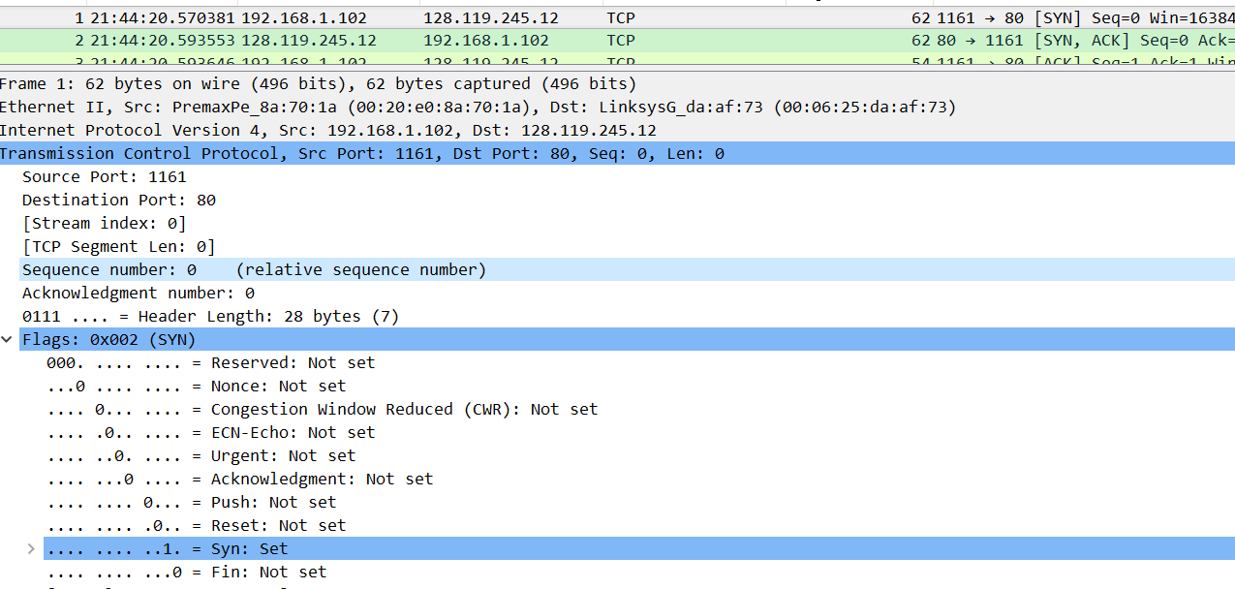
确认报文为SYN报文的标志是报文的TCP HEADER中的flag field中被置为1的SYN标志。
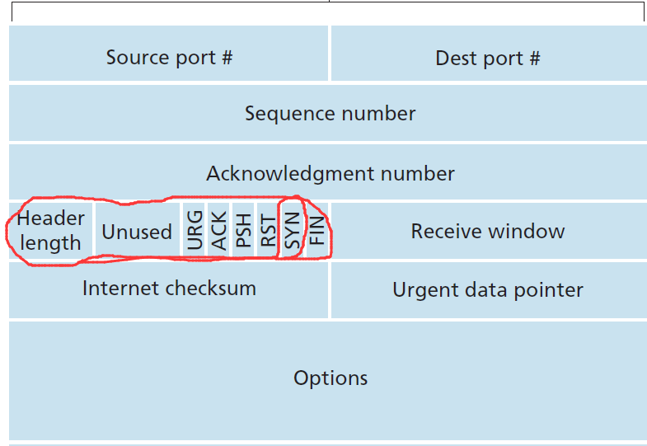

5. What is the sequence number of the SYNACK segment sent by gaia.cs.umass.edu
to the client computer in reply to the SYN? What is the value of the
ACKnowledgement field in the SYNACK segment? How did gaia.cs.umass.edu
determine that value? What is it in the segment that identifies the segment as a
SYNACK segment?
答：如下图。
序号为0。
Acknowledgement field为1。
gaia.cs.umass.edu将该值设置为所期望的下一个来自客户端的报文的Sequence Number。
Flag field中被置为1的ACK位和SYN位。
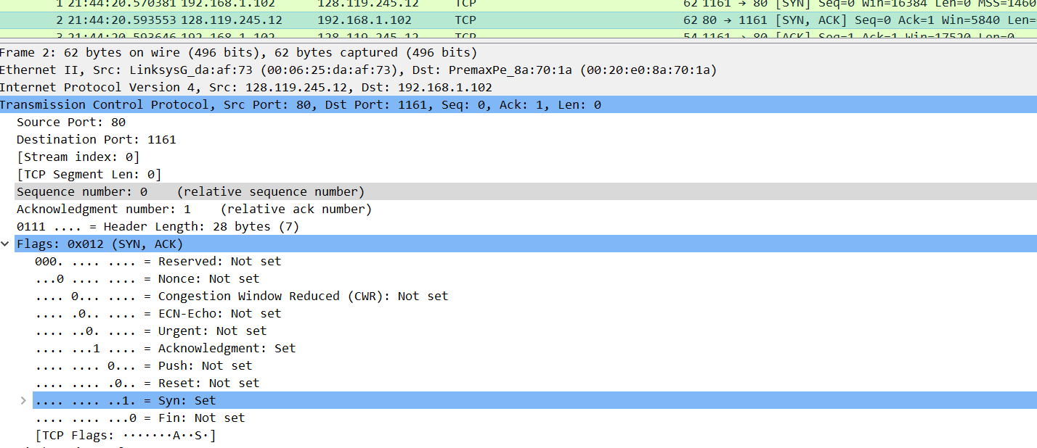
6. What is the sequence number of the TCP segment containing the HTTP POST
command? Note that in order to find the POST command, you’ll need to dig into
the packet content field at the bottom of the Wireshark window, looking for a
segment with a “POST” within its DATA field.
答：如下图，1。
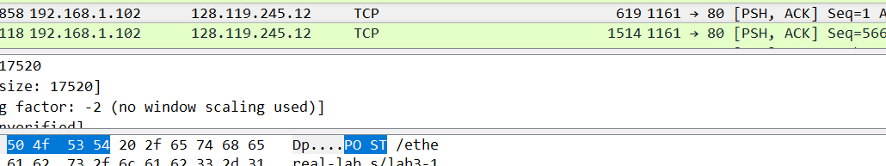

7. Consider the TCP segment containing the HTTP POST as the first segment in the
TCP connection. What are the sequence numbers of the first six segments in the
TCP connection (including the segment containing the HTTP POST)? At what
time was each segment sent? When was the ACK for each segment received?
Given the difference between when each TCP segment was sent, and when its
acknowledgement was received, what is the RTT value for each of the six
segments? What is the EstimatedRTT value (see page 249 in text) after the
receipt of each ACK? Assume that the value of the EstimatedRTT is equal to
the measured RTT for the first segment, and then is computed using the
EstimatedRTT equation on page 249 for all subsequent segments.
答：根据下图，再根据等式：
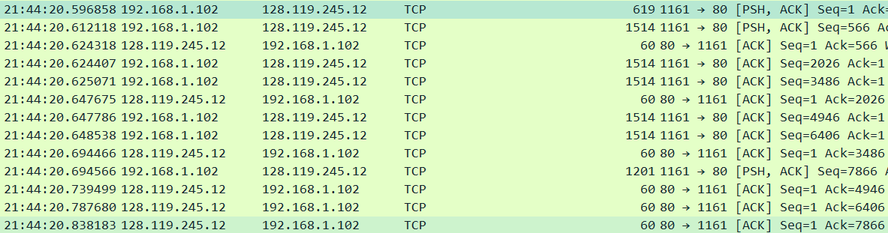
（令为0.125,）得到下表：
i | Seq | 发送时间 | 收到ACK时间 | RTT(ms) | EstimatedRTT(ms)
1 | 1 | 21:44:20.596858 | 21:44:20.624318 | 27.5 | 27.5
2 | 566 | 21:44:20.612118 | 21:44:20.647675 | 35.6 | 28.5125
3 | 2026 | 21:44:20.624407 | 21:44:20.694466 | 70.1 | 33.7109375
4 | 3486 | 21:44:20.625071 | 21:44:20.737499 | 114.4 | 43.79707031
5 | 4946 | 21:44:20.647786 | 21:44:20.787680 | 139.9 | 55.80993652
6 | 6406 | 21:44:20.648538 | 21:44:20.838183 | 189.7 | 72.54619446

8. What is the length of each of the first six TCP segments?
答：分别是565,1460,1460,1460,1460,1460。如下图：
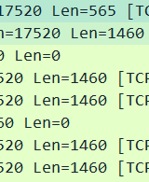
9. What is the minimum amount of available buffer space advertised at the received
for the entire trace? Does the lack of receiver buffer space ever throttle the sender?
答：服务器最小的缓冲空间（Win）为5840字节。全程服务器端的Win在慢慢变大，最后变到62780字节，没有throttle发送端。
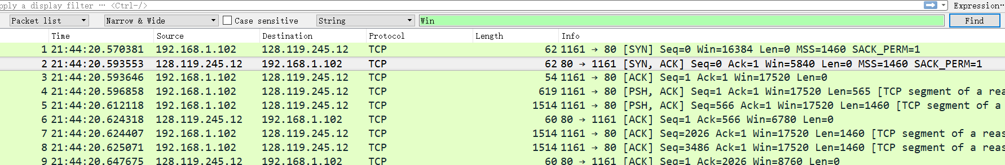
10. Are there any retransmitted segments in the trace file? What did you check for (in
the trace) in order to answer this question?
答：没有重传的报文。检查发送端是否发送过两个具有相同Seq序号的报文，Seq序号是否严格单调递增。
11. How much data does the receiver typically acknowledge in an ACK? Can you
identify cases where the receiver is ACKing every other received segment (see
Table 3.2 on page 257 in the text).
答：典型的是1460和2920字节。此外还有566，1147，892，2352（892+1460）等。一次ACK所acknowledge的字节数根据相邻Ack的差值算出。一次确认两个报文的有确认2920和2352字节的。比如trace文件中第52个报文，就是确认了2352字节；比如第60个报文，就是确认了2920字节。
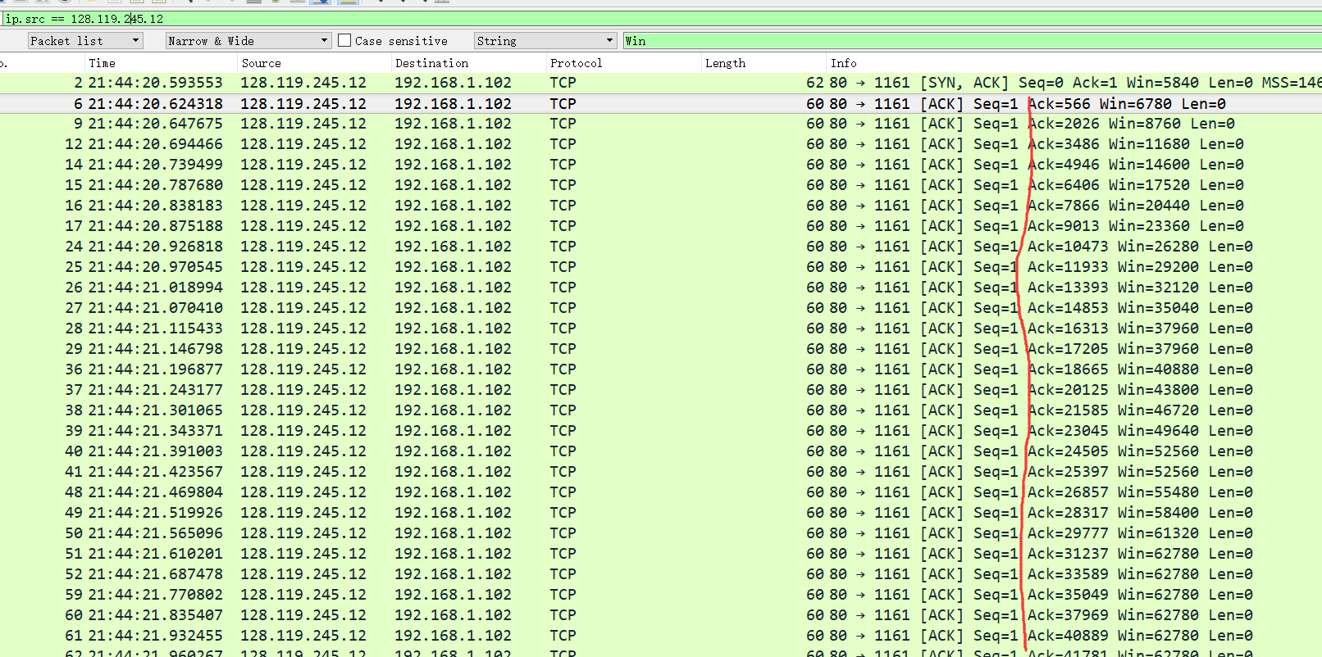
12. What is the throughput (bytes transferred per unit time) for the TCP connection?
Explain how you calculated this value.
答：考虑第一次发送post到发送端收到最后一条Ack这一过程。
总的时长t = 21:44:26.026211-21:44:20.596858= 5.429353（s）。
所传递的字节数w = 164091-1=164090（Bytes）。
吞吐量为 w/t = 30222 Bps=30.222 KBps
13. Use the Time-Sequence-Graph(Stevens) plotting tool to view the sequence
number versus time plot of segments being sent from the client to the
gaia.cs.umass.edu server. Can you identify where TCP’s slowstart phase begins
and ends, and where congestion avoidance takes over? Comment on ways in
which the measured data differs from the idealized behavior of TCP that we’ve
studied in the text.
答： 慢启动在post发送开始时开始，但是看不出何时结束，也看不出拥塞避免何时开始。因为从这个trace可以看出没有出现3次冗余ACK或者超时，也就没有丢包，没有拥塞发生。
不同点：
不同于课本上所说的先第一次慢启动，等到拥塞时再第二次进入慢启动同时调整ssthresh，cwnd值，等到cwnd大于等于ssthresh时进入拥塞避免这样的策略，我们的trace文件中没有冗余ACK，没有丢包，没有拥塞，没有以上的状态转换。而是：数据发送的速率被严格限制在了第一次慢启动结束前，并且到了后面一直重复这一过程：连续发送1460*5+892*1字节=8192字节的包就会暂停发送，直到这8192字节被全部ACK。这一数据传输过程，应该是被应用程序所严格的控制着，而不仅仅依赖于TCP自身的拥塞控制机制。
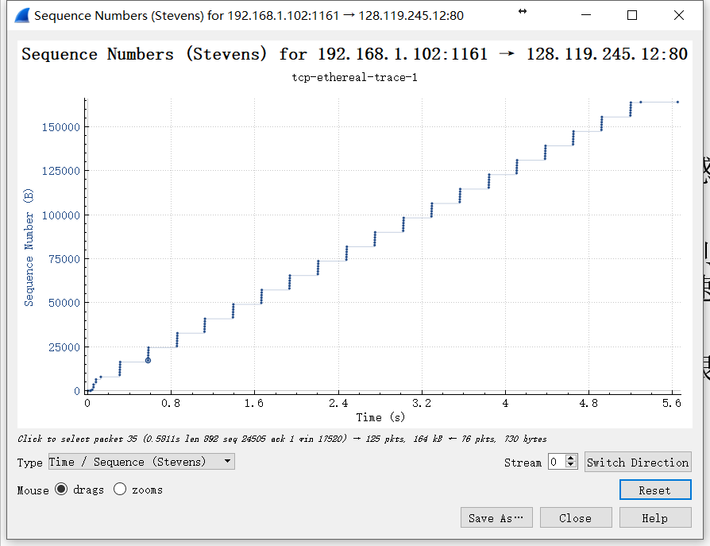
14. Answer each of two questions above for the trace that you have gathered when
you transferred a file from your computer to gaia.cs.umass.edu
答：同样，慢启动在post发送开始时开始，但是看不出何时结束，因为从我下面的截图可以看出cwnd一直再指数增长；同时，我的trace文件中可以看出，除了两个一次的冗余ACK之外，没有三次冗余ACK，也就没有丢包，没有拥塞，所以慢启动没有结束，所以拥塞避免也没有开始。
不同点：我这里实际的情况是：在慢启动的开始，cwnd不是从1个MSS开始，而是以大约9个MSS（MSS=1360Bytes）开始，之后再指数递增。并且我这里还没有慢启动结束，就已发送完所有的数据。
