中国科学技术大学计算机学院

计算机网络实验报告

实验二
利用Wireshark观察http报文

学 号：PB15111604
姓 名：金泽文
专 业：计算机科学与技术
指导老师：张信明

中国科学技术大学计算机学院
2017 年 11 月 6 日

一、 实验目的
1、 熟悉并掌握wireshark；
2、 通过捕获观察并分析http报文，理解http；
二、 实验原理
Wireshark是一个packet分析工具，可以抓取packet，并分析出详细信息。Wireshark使用wincap作为接口，直接与网卡进行packet交换，监听共享网络上传送的packet。

三、 实验条件
1、 硬件条件： 联想Y700：
i5-6300HQ 2.30GHz
16G 内存
Intel(R) Dual Band Wireless-AC 3165
2、 软件条件： Win10 Professional 1703
Wireshark2.4.0

四、 实验过程
1、Wireshark的安装
由于之前有分析报文的需要，所以早已装好。
2、 利用Wireshark观察http报文并回答问题
· The Basic HTTP GET/response interaction
打开edge，打开wireshark，稍等片刻，开始捕获同时设置过滤为“http”，打开
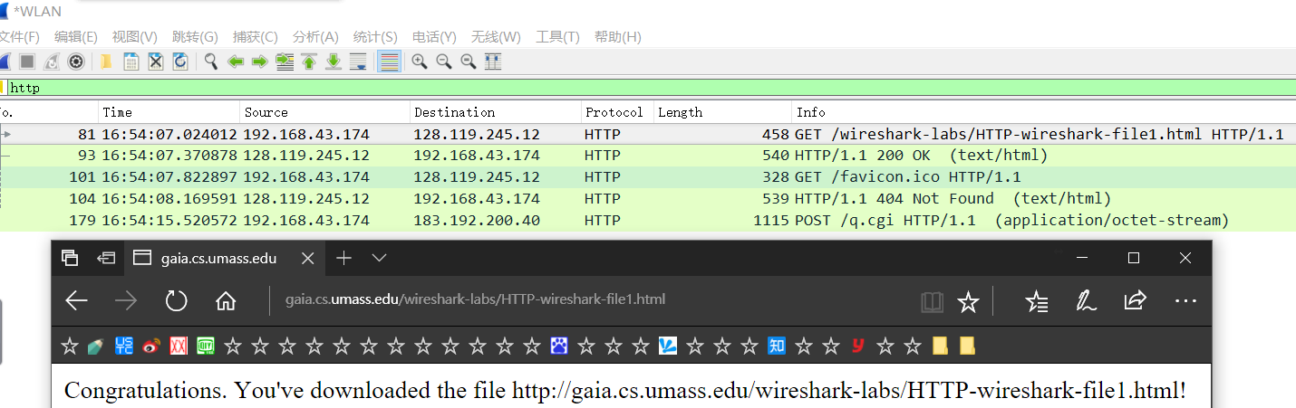
停止捕获。得到下图：

·The HTTP CONDITIONAL GET/response interaction
清除浏览器缓存，重新打开wireshark开始捕获，重新打开浏览器，打开网页，并快速刷新一次，停止捕获。观察wireshark中http报文。得到下图：
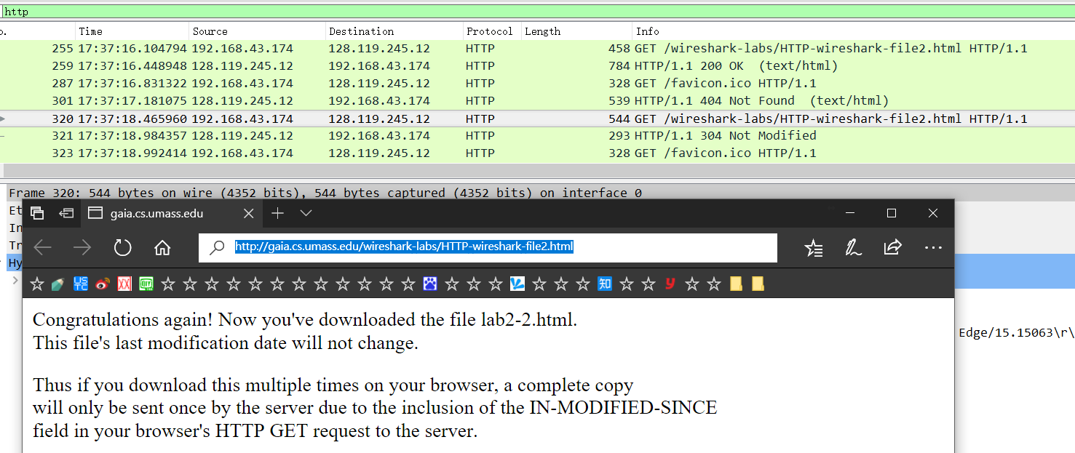
·Retrieving Long Documents
清除浏览器缓存，打开wireshark开始捕获，打开网页
，停止捕获，得到：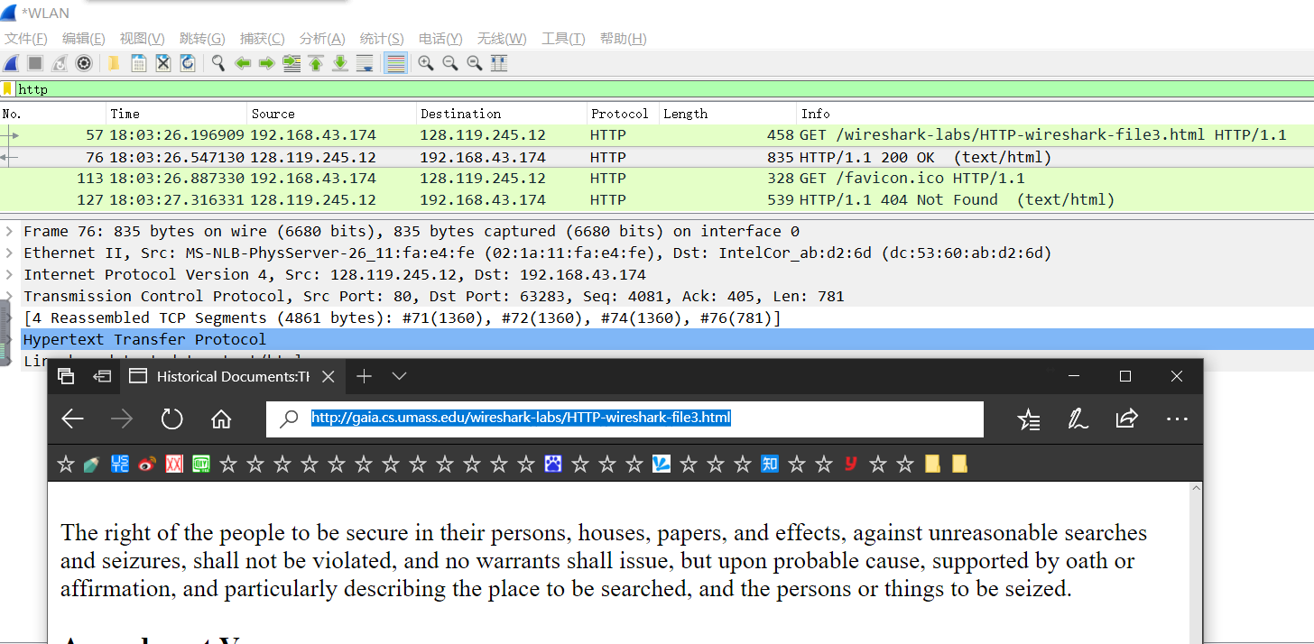
· HTML Documents with Embedded Objects
清除浏览器缓存，打开wireshark开始捕获，打开网页
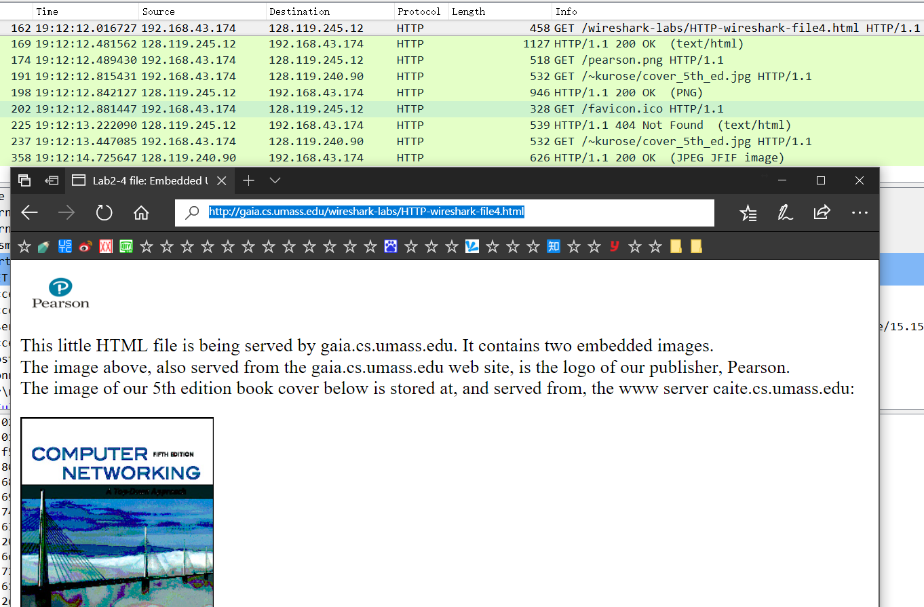
等到两张图片加载完毕，停止捕获。得到下图：
· HTTP Authentication
清除浏览器缓存，开始捕获，打开
并输入用户名密码，加载完毕之后停止捕获。得到下图：
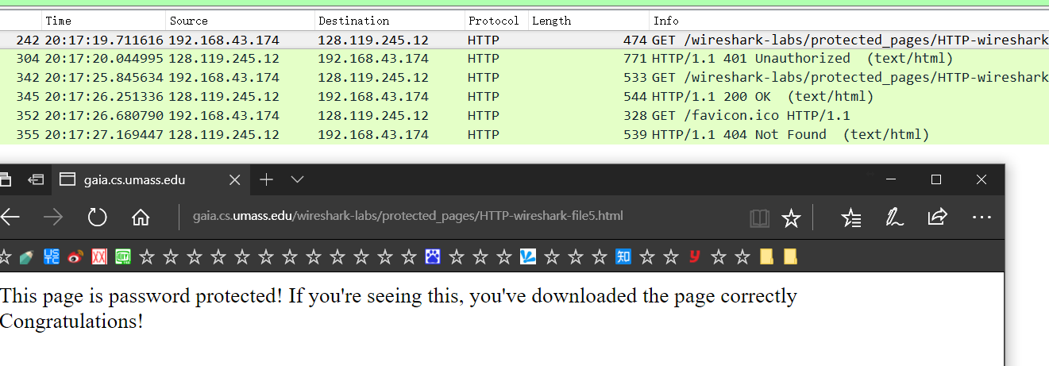
- 结果分析

以下是《http报文抓取及分析》对应的回答
1. Is your browser running HTTP version 1.0 or 1.1? What version of HTTP is the
server running?
答：都是HTTP 1.1，如下图:
2. What languages (if any) does your browser indicate that it can accept to the
server?
答：简体中文（大陆使用）、简体中文、英文（美）、英文。如下图：
3. What is the IP address of your computer? Of the gaia.cs.umass.edu server?
答：我的是192.168.43.174，服务器的是128.119.245.12
4. What is the status code returned from the server to your browser?
答：200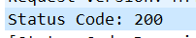
5. When was the HTML file that you are retrieving last modified at the server?
答：
6. How many bytes of content are being returned to your browser?
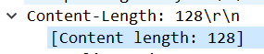
答：128字节，如下图

7. By inspecting the raw data in the packet content window, do you see any headers
within the data that are not displayed in the packet-listing window? If so, name
one.
答：Server，Last-Modified等
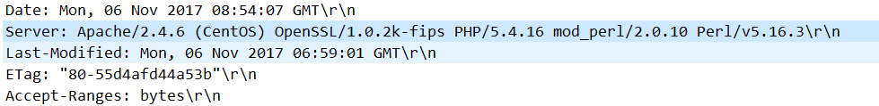
8. Inspect the contents of the first HTTP GET request from your browser to the
server. Do you see an “IF-MODIFIED-SINCE” line in the HTTP GET?
答：没有
9. Inspect the contents of the server response. Did the server explicitly return the
contents of the file? How can you tell?
答：第一次的回应确实返回了文件内容，因为这次的报文里包含了Content-Type:text/html和Content-Length。
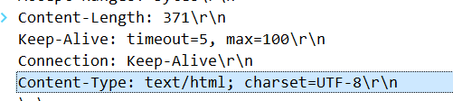
10. Now inspect the contents of the second HTTP GET request from your browser to
the server. Do you see an “IF-MODIFIED-SINCE:” line in the HTTP GET? If
so, what information follows the “IF-MODIFIED-SINCE:” header?
答：有。
它后面是上一次response时发送的文件Last-Modified对应的时间。
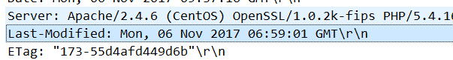

11. What is the HTTP status code and phrase returned from the server in response to
this second HTTP GET? Did the server explicitly return the contents of the file?
Explain.
答：304 Not Modified。没有实际发送文件内容。因为这次的response没有Content-Type，Content-Length，说明没有文件内容发过来

12. How many HTTP GET request messages were sent by your browser?
答：1个
13. How many data-containing TCP segments were needed to carry the single HTTP
response?
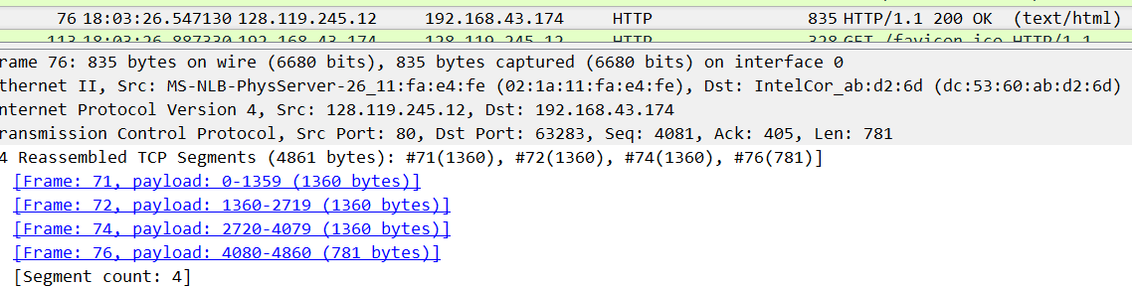
答：4个。
14. What is the status code and phrase associated with the response to the HTTP GET
request?
答：200 OK
15. Are there any HTTP status lines in the transmitted data associated with a TCP induced
“Continuation”?
答：没有。正如lab的pdf里面提到的
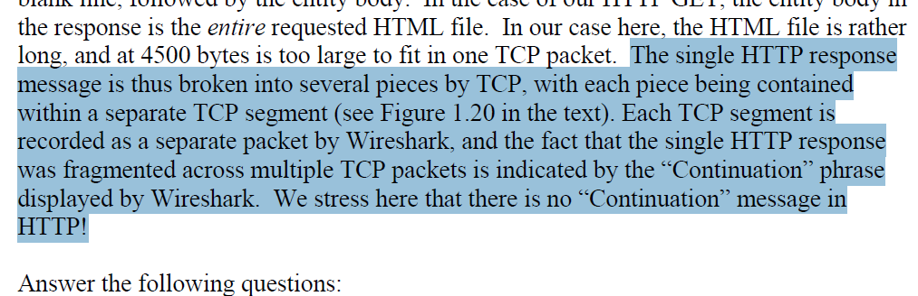
16. How many HTTP GET request messages were sent by your browser? To which
Internet addresses were these GET requests sent?
答：一共5个。3个发往gaia.cs.umass.edu（128.119.245.12）,2个发往caite.cs.umass.edu（128.119.240.90）。
17. Can you tell whether your browser downloaded the two images serially, or
whether they were downloaded from the two web sites in parallel? Explain.
答：parallel，因为person.png发出后没等到person.png的response回来，就已经发送了cover_5th_ed.jpg的get请求了，如下图：
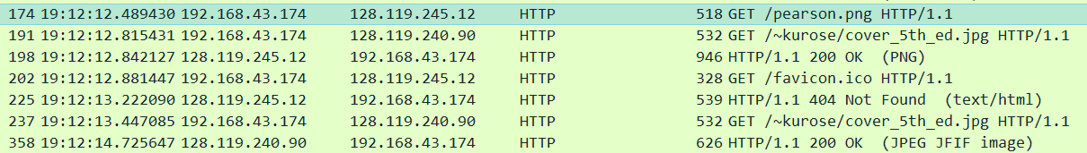
虽然get person.png的请求发送过了0.33s左右才有cover_5th_ed.jpg的get请求发送。
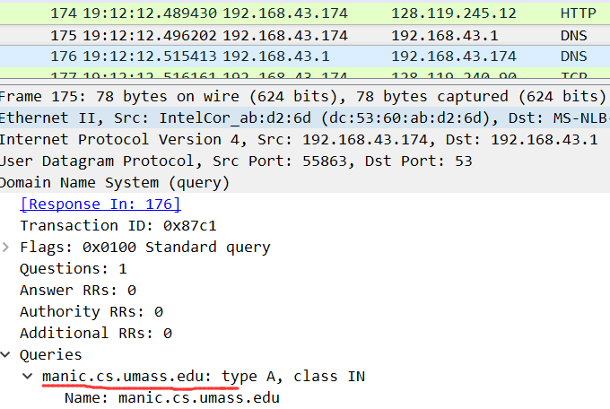
但是仔细一看（如下图），发送GET pearson.jpg请求之后过了0.007s左右发送了dns查询请求，正是另一张图片地址的dns查询。这么看来，get前后相差的0.33s根本不多。
18. What is the server’s response (status code and phrase) in response to the initial
HTTP GET message from your browser?
答：401 Unauthorized
19. When your browser’s sends the HTTP GET message for the second time, what
new field is included in the HTTP GET message?
答：Authorizations： Basic
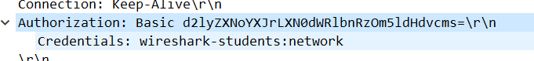
以下是《Wireshark简介》对应的回答
1. List up to 10 different protocols that appear in the protocol column in the
unfiltered packet-listing window in step 7 above.
答：TCP UDP HTTP TLSv1.2 OICQ ARP DNS RTPproxy NBNS MDNS
2. How long did it take from when the HTTP GET message was sent until the HTTP
OK reply was received? (By default, the value of the Time column in the packetlisting
window is the amount of time, in seconds, since Wireshark tracing began.
To display the Time field in time-of-day format, select the Wireshark View pull
down menu, then select Time Display Format, then select Time-of-day.)
答：约0.47s
3. What is the Internet address of the gaia.cs.umass.edu (also known as wwwnet.
cs.umass.edu)? What is the Internet address of your computer?
答：128.119.245.12 192.168.43.174（本地）
4. Print the two HTTP messages displayed in step 9 above. To do so, select Print
from the Wireshark File command menu, and select “Selected Packet Only” and
“Print as displayed” and then click OK.
答：助教说不用答啦啦啦

以下是《ppt》对应的回答
1.分析HTTP中get和post请求方式的区别。
答：
·通常意义上的区别：
GET一般用于查询信息，
POST一般用于改变信息。
·原理上的区别：
根据HTTP规范，GET用于信息的获取，应该是安全并且幂等的。
根据HTTP规范，POST表示可能修改服务器上的资源的请求，是非幂等的。
·实际中的区别：
- GET请求将请求的数据附在URL之后，
POST将请求的数据放在HTTP包的包体中。而实际中浏览器或者操作系统可能对url长度进行限制，所以GET，POST此时所能传输的信息有区别。
- POST的安全性别GET高。
对于密码等隐私数据，GET会放在url上，而POST不会。ur

