中国科学技术大学计算机学院

计算机网络实验报告

实验四
利用Wireshark观察IP报文

学 号：PB15111604
姓 名：金泽文
专 业：计算机科学与技术
指导老师：张信明

中国科学技术大学计算机学院
2017 年 12 月 27 日

一、 实验目的
1、 通过捕获观察并分析IP报文，理解IP的细节，掌握traceroute的使用。
二、 实验原理
Wireshark是一个packet分析工具，可以抓取packet，并分析出详细信息。Wireshark使用wincap作为接口，直接与网卡进行packet交换，监听共享网络上传送的packet。
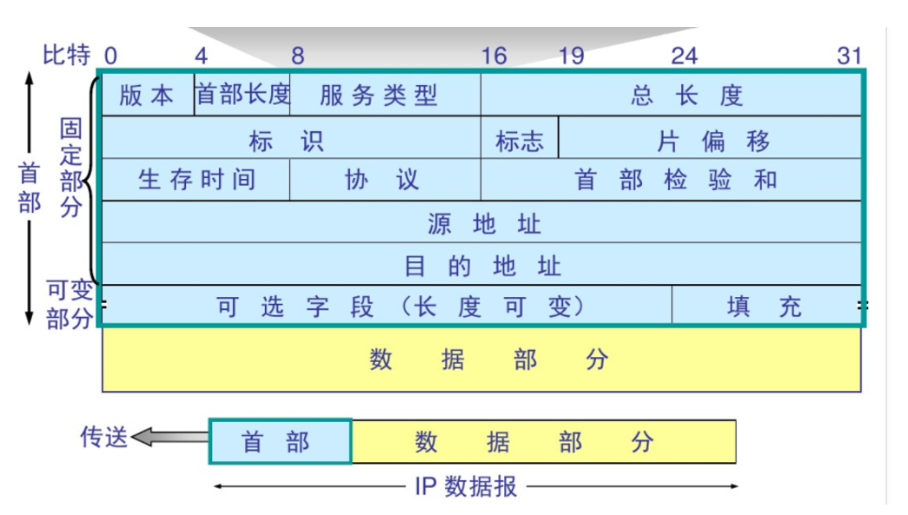
IP数据报首部的TTL(Time to live)表示数据报的生存时间,每经过路由器转发一次,就至少减少1,当减少到0的时候,会被路由器丢弃,并返回ICMP消息.
Traceroute通过巧妙的设置ttl,通过一次次的重传,与ttl+1来得到到目的地址的路径上的路由器的信息.
三、 实验条件
1、 硬件条件： 联想Y700：
i5-6300HQ 2.30GHz
16G 内存
Intel(R) Dual Band Wireless-AC 3165
2、 软件条件： Win10 Professional 1703
Wireshark2.4.2
以及WSL(Windows Subsystem for Linux)(如下)
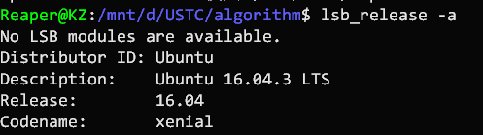
traceroute for Linux, 2.0.21
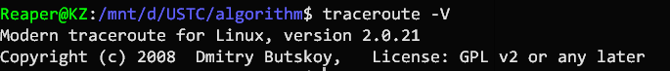
四、 实验过程
1、 安装traceroute
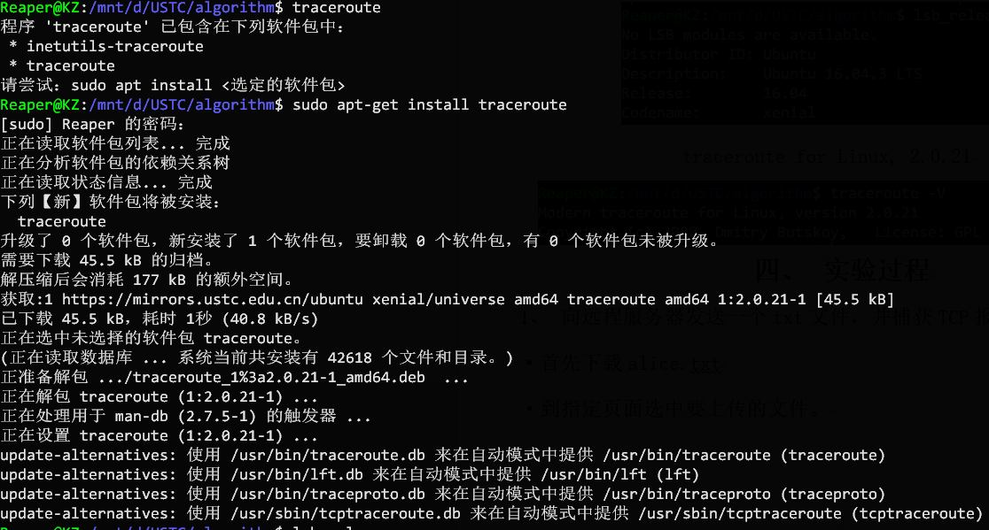

2、 利用traceroute发包并用wireshark查看.
用wireshark开始捕获,用traceroute发送3个56字节,2000字节,3500字节的包.
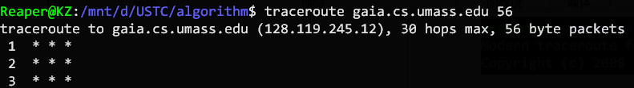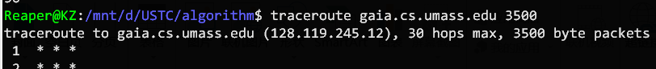
- 结果分析

以下是pdf中15个问题对应的回答
(到第4题使用我自己抓的包,之后由于我的电脑没有发icmp包出去,所以用的是官网下载的包.)
1. Select the first ICMP Echo Request message sent by your computer, and expand
the Internet Protocol part of the packet in the packet details window. What is the IP address of your computer?
答：192.168.43.174
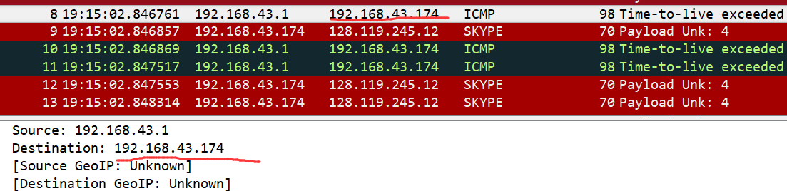
2. Within the IP packet header, what is the value in the upper layer protocol field?
答： 1(表示ICMP)
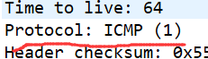
3. How many bytes are in the IP header? How many bytes are in the payload of the
IP datagram? Explain how you determined the number of payload bytes.
答： 20字节,84-20=64字节.payload字节数就是总字节数减去header字节数.
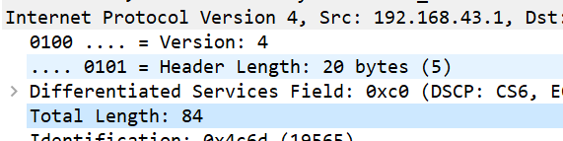
4. Has this IP datagram been fragmented? Explain how you determined whether or
not the datagram has been fragmented.
答： 没有被fragmented.因为more fragments位没有被置为1.如下:
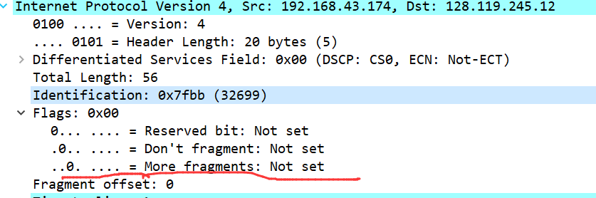

5. Which fields in the IP datagram always change from one datagram to the next
within this series of ICMP messages sent by your computer?
答： 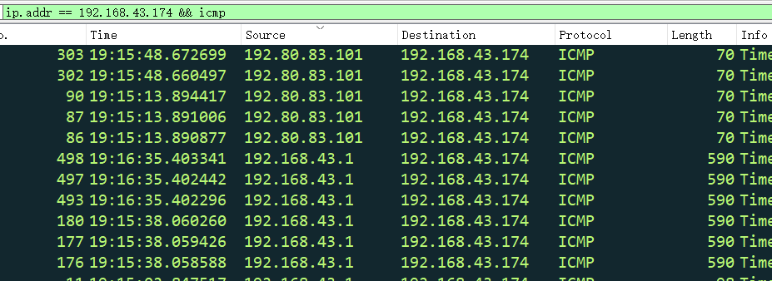
↑由于我电脑没有抓到自己电脑发的icmp,所以这部分题用官网下载好的trace文件.
从下面可以看出:
Header中的TTL,checksum,Identification总改变
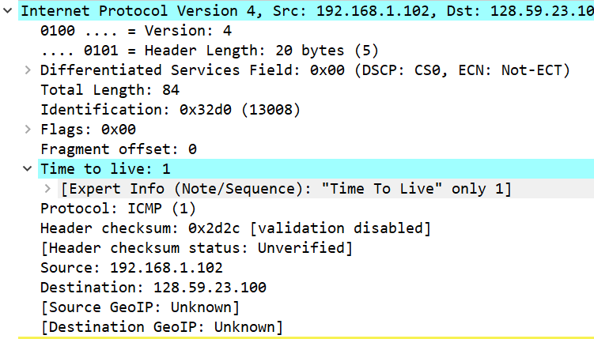
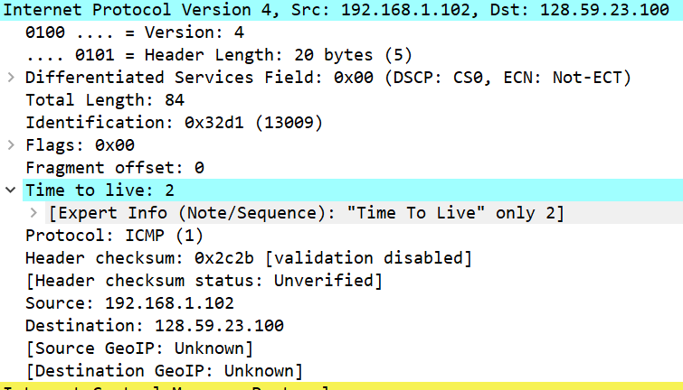

6. Which fields stay constant? Which of the fields must stay constant? Which fields must change? Why?
答：stay constant:
Version, header length, Differentiated Services Field, flags, fragment offset, protocol, source ip address, destination ip address.
必须不变的是
Version:因为都是ipV4.
Protocol:都是ICMP
Header length: 因为protocol不变,是icmp,所以header不变
Differentiated Services:理由同上,都是icmp类型
source ip address,destination ip address:源,目的地址在这一过程不变
必须变的是:
TTL:因为traceroute会改变ttl
Identification:IP数据报之间要有不一样的id
Header checksum:因为header每次都会不一样

7. Describe the pattern you see in the values in the Identification field of the IP
datagram.
答： 每个id会比前一个增加1
8. What is the value in the Identification field and the TTL field?
答： 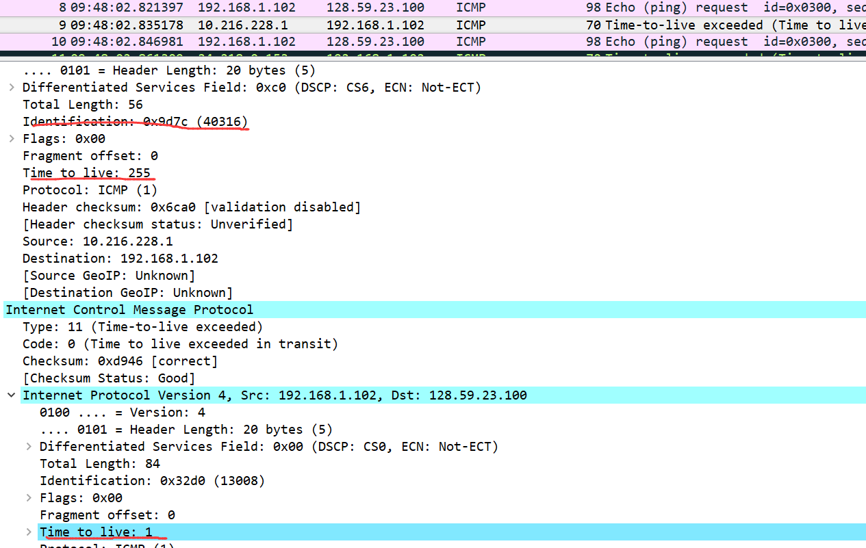
第一跳的id为0x9d7c(40316),ttl为255
9. Do these values remain unchanged for all of the ICMP TTL-exceeded replies sent
to your computer by the nearest (first hop) router? Why?
答： id变化,因为id相同表示ip包是同一个大包的fragment,这里的id需要独立.ttl不变.因为在一段时间内(排除电脑转移或者网络环境彻底变化),电脑的第一跳路由是不变的,其ttl的初始值已经是255了,默认不会改变.

10. Find the first ICMP Echo Request message that was sent by your computer after
you changed the Packet Size in pingplotter to be 2000. Has that message been
fragmented across more than one IP datagram? [Note: if you find your packet has
not been fragmented, you should download the zip file
http://gaia.cs.umass.edu/wireshark-labs/wireshark-traces.zip and extract the ipethereal-
trace-1packet trace. If your computer has an Ethernet interface, a packet
size of 2000 should cause fragmentation.3]

答： 是的,被分成了2份fragments.
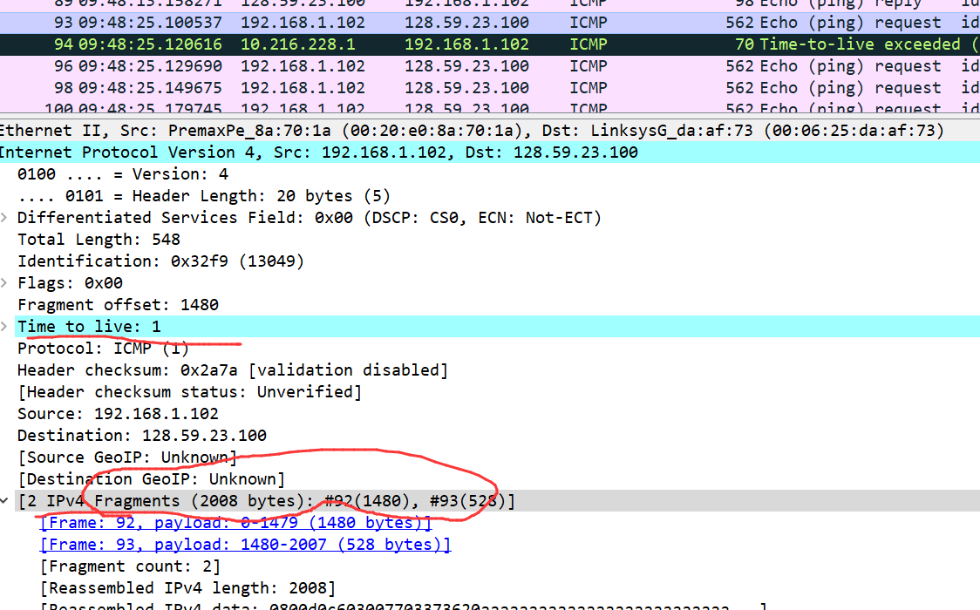

11. Print out the first fragment of the fragmented IP datagram. What information in
the IP header indicates that the datagram been fragmented? What information in the IP header indicates whether this is the first fragment versus a latter fragment?How long is this IP datagram?
答： 有上一题的图找到No.92 frame,得到:
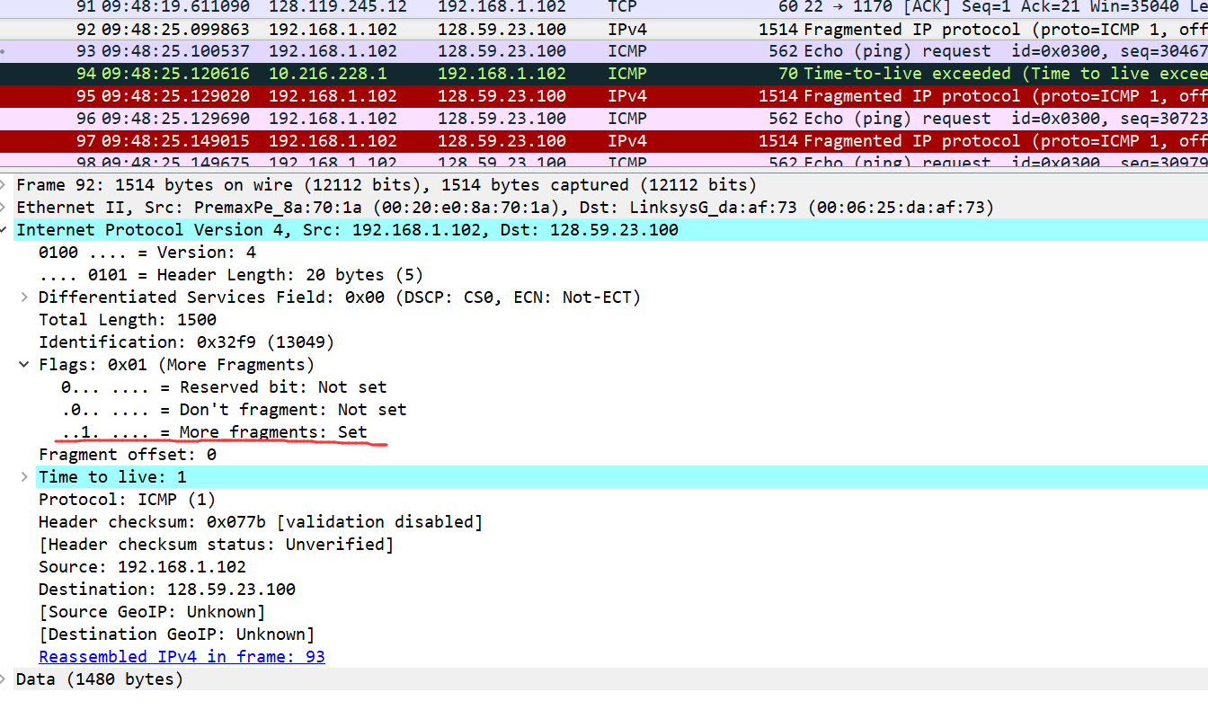
其中flags中的 More fragments位被置为1.
这里的fragment offset为0,
整个ip包的长度为1500字节.
12. Print out the second fragment of the fragmented IP datagram. What information in
the IP header indicates that this is not the first datagram fragment? Are the more
fragments? How can you tell?
答：如下图所示.与No.92 frame相同id的No.93 frame,其fragment offset为1480,非0,表示不是第一个.
不能根据more fragments位判断是不是第一个,因为最后一个fragment的more fragments位也是0.
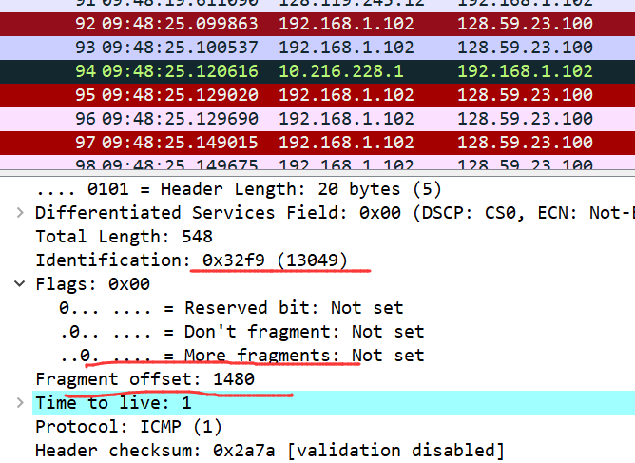
13. What fields change in the IP header between the first and second fragment?
答：就这两个fragment来说的话,变的有:
Total length, flags, fragment offset, header checksum
对于所有的第一个fragment与第二个fragment来说的话,一般肯定变的有:
Fragment offset和header checksum

14. How many fragments were created from the original datagram?
答： 3个
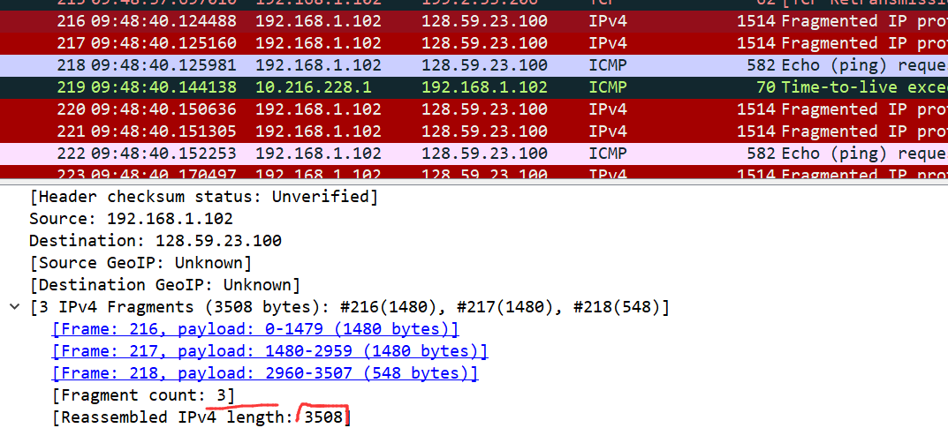
15. What fields change in the IP header among the fragments?
答： header checksum, fragment offset.
第一个第二个的more fragments位是1,第三个是0
第一个第二个的length是1500,第三个是568
第一个第二个的

