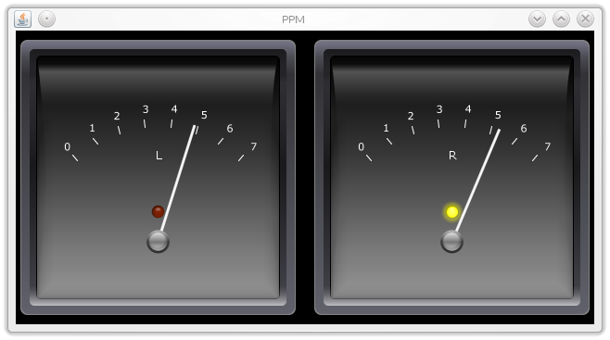

PPM-java
Technical documentation
PH, 2017-01-13

Introduction
According to an Article on Wikipedia, "a peak programme meter (PPM) is an instrument used in professional audio for indicating the level of an audio signal." It is different from a normal VU meter in that it has a very short rise time (integration time) and a long return time. This allows audio producers to continouusly monitor the peaks of a programme signal. ppm_java implements a PPM type II which has a rise time of 23 dB in 10 ms and a fall time of -24dB in 2800ms.
The audio level maps to the meter scale as:
Input level [dB] |  | Meter mark
min | max | min | max
-130 | -24 | 0 | 1
-24 | -20 | 1 | 2
-20 | -16 | 2 | 3
-16 | -12 | 3 | 4
-12 | -8 | 4 | 5
-8 | -4 | 5 | 6
-4 | 0 | 6 | 7
0 | ... | 7 | 7

System requirements
ppm-java requires
- Java (Tested with Java 1.8.)
- JackD audio server (Tested with version 1.9.10)
Test setup was a Linux machine (Kubuntu 14); program hasn't been tested on other platforms.

Running
ppm-java runs as a Jack client which means that there must be a running instance of JackD before starting ppm-java. Once both of them are running, ppm-java will find the running JackD server and register as a client. The ppm-java client can then connect to outputs of any other clients registered with JackD and watch the audio levels.

Example session
If JackD isn't running, start it:
/usr/bin/jackd -r -dalsa -dhw:0 -r44100 -p1024 -n3 -Xraw
Start ppm-java from the commandline. We'll run it with the graphical linear gauge:
java -jar /path/to/ppm.jar -u guiLinear \
-l /var/log/ppm.log
After a while this will bring up a horizontal linear gauge. If the meter is receiving audio data the gauge will show the current audio levels:
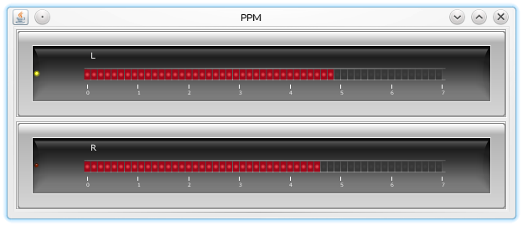

Architecture
For the user this program has a very simple purpose: It just displays the level of a stereo signal using PPM II ballistics. The program should scale easily to implement new features. For example, the user might be interested in a history view to see the last minute of level measurements. Or, the meter could be used as a silence detector, sending an alarm event somewhere if the audio level falls below a threshold for a prolonged time. To aid scalability the program follows a modular design
Developing ppm-java posed several challenges:

- Good balance between scalability and fitness for the purpose. The challenge is to create a framework which is well suited for the task whilst being generic enough to accomodate further development.
- Making two parallel activities with different priorities work together. On one side we have got a high priority activity (the JackD process), on the other side we've got a low priority activity (user interface updates). Both sides run independently of each other, i.e. in separate threads. We have to avoid priority inversion where the low priority thread (user interface updates) blocks the high priority thread (JackD).
- Minimizing data loss. The high priority JackD thread needs to work need for a protection against priority inversion brings up the possibility of data loss. For example we get data loss if the user interface thread blocks, whilst the JackD thread keeps pushing audio data. The challenge is to build in some mechanism that minimizes data loss.
- Keeping performance up. We need a framework which is able to process the audio data without much latency, so that updates on the meter happen almost immediately after the corresponding audio has come into the meter. There's always some latency with any audio application, but for a a metering solution the latency should be less than 25ms.

Implementation
On the input side, ppm-java is a jack client, i.e. it has to work with the JackD audio server. The input side is time critical as the jack server has multiple clients connected and cannot affort to 'hang' due to one slow client. Therefore the input side of ppm-java must run as smoothly as possible. At the same time ppm-java is a GUI application, i.e. has to update a graphical frontend. The GUI side not time critical - if it hangs for a few moments it's user annoying but at least it doesn't pull the entire system down with it! The challenge is to avoid tight coupling between both sides whilst minimizing data loss due to the coupling being too loose.
The central piece to the solution is the atomic buffer, implemented as class (ppm_java.util.storage.TAtomicBuffer). This class stores the audio samples coming from the input side and releases them to the GUI side when requested. The buffer is atomic in the sense that one thread at a time can read/write data to/from the buffer.

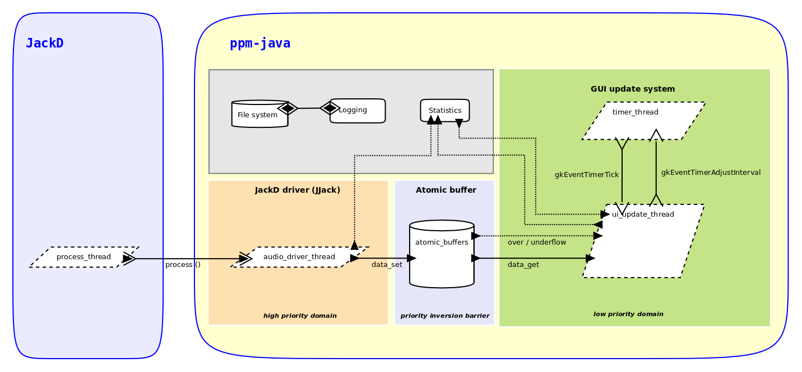
JackD
ppm-java relies on the Jack audio server as audio backend which runs in it's own process, jackd. All communication with Jack is encapsulated in the class ppm_java.backend.module.jackd.TAudioContext_JackD. This class relies on a library (JJack) for the actual connection with Jack.
Thanks to JJack, communicating with Jack can be as easy as writing a short class.

Here is a class that receives audio from a mono port on the Jack server and prints the sample values on the console (excerpt):
- @Override
- public void process (JJackAudioEvent e)
- {
- int nInPorts;
- FloatBuffer inBuf;
- int nSamples;
- int i;
- float s;
- float sRect;
- float peak;

- fIFrame++;
- System.out.print ("Frame: " + fIFrame + "; ");

- nInPorts = e.countInputPorts ();
- if (nInPorts >= 1)
- {
- inBuf = e.getInput (0);
- nSamples = inBuf.limit ();
- peak = 0;
- if (nSamples >= 1)
- {
- for (i = 0; i < nSamples; i++)
- {
- /* Get next sample. */
- s = inBuf.get (i);

- /* Rectify (i.e. mirror a negative sample to it's positive opposite). */
- sRect = (s < 0) ? -s : s;

- /* Determine peak value. */
- peak = (sRect > peak) ? sRect : peak;
- }

- System.out.println ("Peak value (abs): " + peak + ".");
- }
- else
- {
- System.out.println ("Empty frame (no samples). Peak value unavailable.");
- }
- }
- else
- {
- System.out.println ("No ports registered. Peak value unavailable.");
- }
- }

- System.out.println ("-------------------------------------------------------------------------------------------------");
- System.out.println (details);
- System.out.println ("-------------------------------------------------------------------------------------------------");

- /* Activate connection to JackD. This will begin to call the ::process() method */
- JJackSystem.setProcessor (this);
- }

- private void _Terminate ()
- {
- try
- {
- JJackSystem.shutdown ();
- }
- catch (JJackException e)
- {
- e.printStackTrace();
- }
- }
- }
This program produces the peak value of all absolute sample values (excerpt):
Frame: 41; Peak value (abs): 0.44421417.
Frame: 42; Peak value (abs): 0.36387947.
Frame: 43; Peak value (abs): 0.3119365.
-------------------------------------------------------------------------------------------------
Terminating...
-------------------------------------------------------------------------------------------------

High priority domain
This is the domain in which the JackD server and our audio driver operate.

Low priority domain
Most of the program runs here.

Class hierarchy

https://en.wikipedia.org/wiki/Peak_programme_meter
This is a hard balancing act - it's tempting to totally overengineer and create micromodules or to go the shortcut route and hack some contorted monolithic construction. Half a year later even the author won't have a clue what this thing does!
http://www.jackaudio.org
https://sourceforge.net/projects/jjack

