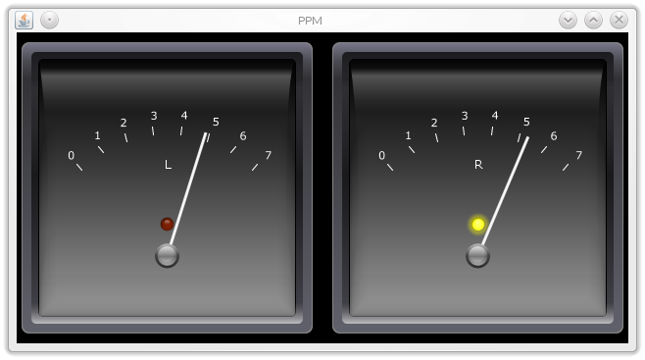

PPM-java
Technical documentation
PH, 2017-01-13

Introduction
According to an Article on Wikipedia, "a peak programme meter (PPM) is an instrument used in professional audio for indicating the level of an audio signal." It is different from a normal VU meter in that it has a very short rise time (integration time) and a long return time. This allows audio producers to continouusly monitor the peaks of a programme signal. ppm_java implements a PPM type II which has a rise time of 23 dB in 10 ms and a fall time of -24dB in 2800ms.
The audio level maps to the meter scale as follows:
Input level [dB] |  | Meter mark
min | max | min | max
-130 | -24 | 0 | 1
-24 | -20 | 1 | 2
-20 | -16 | 2 | 3
-16 | -12 | 3 | 4
-12 | -8 | 4 | 5
-8 | -4 | 5 | 6
-4 | 0 | 6 | 7
0 | ... | 7 | 7

Running

System requirements
ppm-java requires
- Java (Tested with Java 1.8.)
- JackD audio server (Tested with version 1.9.10)
Test setup was a Linux machine (Kubuntu 14); program hasn't been tested on other platforms.

Example session
If JackD isn't running, start it:
user@local:~$ /usr/bin/jackd -r -dalsa -dhw:0 -r44100 -p1024 -n3 -Xraw
Start ppm-java from the commandline. We'll run it with the graphical linear gauge frontend:
user@local:~$ java -jar /path/to/ppm.jar -u guiLinear -l /var/log/ppm.log
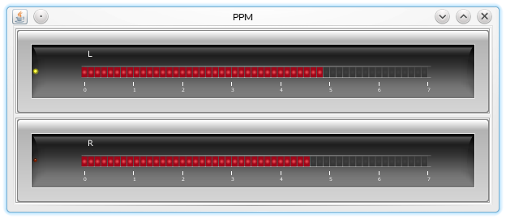
This will bring up a horizontal linear gauge. If the meter is receiving audio data the gauge will show the current audio levels:

Implementation

Design overview
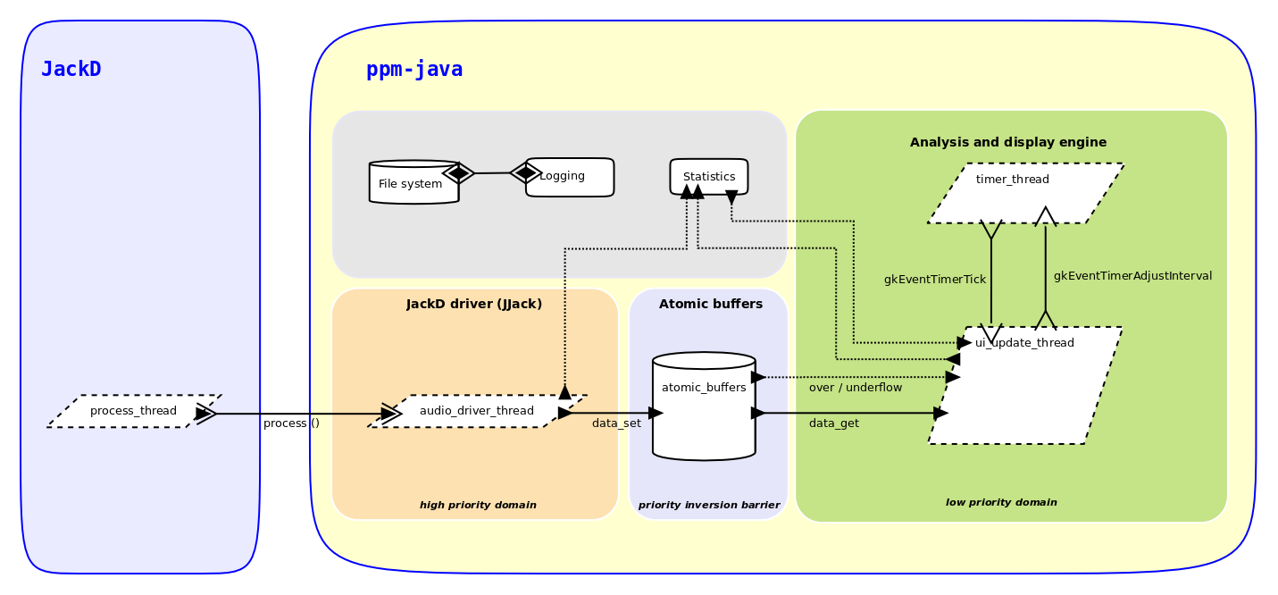
ppm-java continouusly receives chunks of audio samples from the Jack server, and, for each chunk,
- computes the absolute peak value,
- converts it from raw sample values to decibels,
- applies a stepping integrator (PPM ballistics),
- and displays the result on a frontend.
Two activites are happening here: On the one hand, Jack delivers sample chunks, and, on the other hand, the program updates a display. These are two distinct activities, and both run in separate threads. The Jack side of things is handled by the audio driver thread, and everything else runs within the analysis and display engine thread.
The audio driver thread is time critical as it integrates with the Jack server. This means we cannot afford to have the audio driver run slow on us, as this would affect the Jack server and potentially the whole ecosystem of clients connected with the Jack server. The analysis and display engine (GUI side) not time critical - if it hangs for a few moments it's user annoying but at least it doesn't pull the entire Jack system down with it! For the program to run well we need to prevent priority inversion where the low priority thread (display engine) blocks the high priority thread (audio driver). We need to decouple the display engine from the audio driver in such a way that the audio driver won't get stuck (even if the display engine is frozen) and the display engine receives the audio data with minimal data loss.
Because of the need for decoupling we cannot send data directly from the audio driver to the display engine. Instead we use a bank of special buffers (one per channel) which receives data from the audio driver and holds it ready for the display engine when it fetches the data. The buffers are designed such that setting and fetching are atomic, i.e. only one thread a time can read/write data to the buffer (That's why we call them 'atomic buffers'). The bank of buffers acts as a priority inversion barrier between the display engine and the audio driver.

Challenges
- Good balance between scalability and fitness for the purpose. The challenge is to create a framework which is well suited for the task whilst being generic enough to accomodate further development.
- Making two parallel activities with different priorities work together. On one side we have got a high priority activity (the jackd process), on the other side we've got a low priority activity (user interface updates). Both sides run independently of each other, i.e. in separate threads. We have to avoid priority inversion where the low priority thread (user interface updates) blocks the high priority thread (jackd).
- Minimizing data loss. The high priority jackd thread needs to work need for a protection against priority inversion brings up the possibility of data loss. For example we get data loss if the user interface thread blocks, whilst the JackD thread keeps pushing audio data. The challenge is to build in some mechanism that minimizes data loss.
- Keeping performance up. We need a framework which is able to process the audio data without much latency, so that updates on the meter happen almost immediately after the corresponding audio has come into the meter. There's always some latency with any audio application, but for a a metering solution the latency should be less than 25ms.

Atomic buffer
The atomic buffer is implemented as class TAtomicBuffer. This class stores the audio samples coming from the input side and releases them to the GUI side when requested. Setting data and fetching data is done by two differnt threads, at the same time. One thread constantly pushes data to the buffer, whilst the other thread constantly fetches it from the buffer. This is a classic producer/consumer scenario.
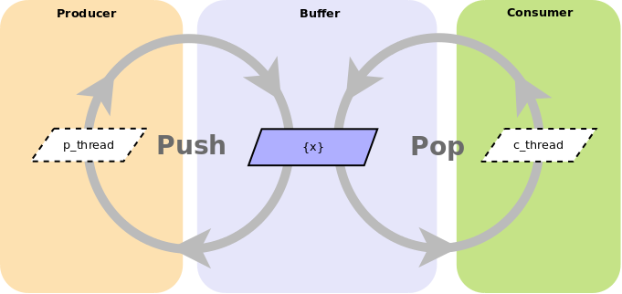
Without precautions, if multiple threads use the same object we can get surprising results. The following program has two theads simultaneously access a shared buffer. One thread pushes data, the other thread pops it. No precautions are taken to make this program “multithread-proof”.
Main program:
package ppm_java._dev.concept.example.multithread.unsafe;
public class TDev_Example_multithread_unsafe
{
public static void main (String[] args)
{
TDev_Example_multithread_unsafe unsafeClient;

unsafeClient = new TDev_Example_multithread_unsafe ();
unsafeClient.start ();
}

private TThreadConsumer fConsumer;
private TThreadProducer fProducer;
private int fValue;

/**
*
*/
public TDev_Example_multithread_unsafe ()
{
fConsumer = new TThreadConsumer (this);
fProducer = new TThreadProducer (this);
fValue = 0;
}

public void start ()
{
fConsumer.start ();
fProducer.start ();
}

public void Pop ()
{
System.out.println ("Entering Pop (). Number: " + fValue);
if (fValue > 0)
{
fValue--;
try {Thread.sleep (500);} catch (InterruptedException e) {}
}
System.out.println ("Exiting Pop (). Number: " + fValue);
}

public void Push ()
{
System.out.println ("Entering Push (). Number: " + fValue);
if (fValue < 1)
{
fValue++;
try {Thread.sleep (500);} catch (InterruptedException e) {}
}
System.out.println ("Exiting Push (). Number: " + fValue);
}
}

Producer:
package ppm_java._dev.concept.example.multithread.unsafe;

class TThreadProducer extends Thread
{
private TDev_Example_multithread_unsafe fHost;

public TThreadProducer (TDev_Example_multithread_unsafe host)
{
fHost = host;
}

@Override
public void run ()
{
int i;
int delay;

delay = 0;
for (i = 1; i <= 10; i++)
{
fHost.Push ();
delay += 10;
try {Thread.sleep (delay);} catch (InterruptedException e) {}
}
}
}
Consumer:
package ppm_java._dev.concept.example.multithread.unsafe;

class TThreadConsumer extends Thread
{
private TDev_Example_multithread_unsafe fHost;

public TThreadConsumer (TDev_Example_multithread_unsafe host)
{
fHost = host;
}

@Override
public void run ()
{
int i;
int delay;

delay = 200;
for (i = 1; i <= 10; i++)
{
fHost.Pop ();
delay -= 10;
try {Thread.sleep (delay);} catch (InterruptedException e) {}
}
}
}
The output of the program shows that Push() and Pop() are executed at arbitrary times. The producer and consumer just tread on each other's toes. The result is messed up data.
Entering Push (). Number: 0
Entering Pop (). Number: 0 <--- Pop() should not be executed here.
Exiting Push (). Number: 0 <--- Number should be 1.
Exiting Pop (). Number: 0
Entering Push (). Number: 0
Entering Pop (). Number: 1
Exiting Push (). Number: 0
Entering Push (). Number: 0

Thread coordination primitives.
Since version 1.0 Java has support for multithreaded applications, through synchronized methods and blocks. The synchronized keyword creates a protected section of code that can only be entered by one thread a time. Such a section is called a critical section.
To make our program multithread proof we need to declare the main program's Push() and Pop() methods as synchronized.

public synchronized void Pop ()
{
System.out.println ("Entering Pop (). Number: " + fValue);
if (fValue > 0)
{
fValue--;
try {Thread.sleep (500);} catch (InterruptedException e) {}
}
System.out.println ("Exiting Pop (). Number: " + fValue);
}

public synchronized void Push ()
{
System.out.println ("Entering Push (). Number: " + fValue);
if (fValue < 1)
{
fValue++;
try {Thread.sleep (500);} catch (InterruptedException e) {}
}
System.out.println ("Exiting Push (). Number: " + fValue);
}

This creates order, as both threads politely wait for each other! Now, our data is correct:
Entering Pop (). Number: 0
Exiting Pop (). Number: 0
Entering Push (). Number: 0
Exiting Push (). Number: 1
Entering Pop (). Number: 1
Exiting Pop (). Number: 0
Entering Push (). Number: 0
Exiting Push (). Number: 1
Entering Pop (). Number: 1
Exiting Pop (). Number: 0
The synchronized keyword turns a method into a critical section. When a thread executes such a method then any other threads trying to execute the same method is made to wait until the first thread has finished. This is the reason why the synchronization in our example program works. If the producer thread has entered the Push() method, and the consumer tries to enter the Pop() method before the producer has finished, then the consumer must wait until the producer has left the Push() method. Both, Push() and Pop() are synchronized on the same object. The object is the lock; once it's acquired by a thread, no other thread can acquire it until the first thread has released the lock. This forces the producer and the consumer to wait for each other, ensuring data integrity. In a picture - the object is a room, and the threads are two storytellers in the room. Synchronization means only one of them can speak at a time.
Locking is object wide: If an object has multiple synchronized parts and one thread enters one of these, then no other thread can enter any synchronized parts of that object, until the first thread has finished. In other words, if one synchronized part in an object is locked, then all of the other synchronized parts are locked as well.

Wait problem

Synchronization means waiting. If one thread enters a synchronized section, all other threads have to wait. This can block a thread for an uneccessarily long time. Here is an example which demonstrates the problem of the long wait:
Main program:

package ppm_java._dev.concept.example.multithread.wait;

public class THouse
{
public static void main (String[] args)
{
THouse house;

house = new THouse ();
house.GetMeSomeVisitors ();
}

private TVisitor[] fVisitors;

public THouse ()
{
int i;

fVisitors = new TVisitor [10];
for (i = 0; i < 9; i++)
{
fVisitors[i] = new TVisitor (this, i);
}
}

public void GetMeSomeVisitors ()
{
int i;

for (i = 0; i < 9; i++)
{
fVisitors[i].start ();
}
}

public synchronized void Visit (int id)
{
System.out.println ("Got visitor: " + id);
try {Thread.sleep (1000);} catch (InterruptedException e) {}
}
}

Visitor:
package ppm_java._dev.concept.example.multithread.wait;

class TVisitor extends Thread
{
private THouse fHouse;
private int fID;

public TVisitor (THouse house, int id)
{
fHouse = house;
fID = id;
}

@Override
public void run ()
{
long t0;
long t1;
long dT;

System.out.println ("Visitor #" + fID + ": Trying to make a visit to the house.");

t0 = System.currentTimeMillis ();
fHouse.Visit (fID);
t1 = System.currentTimeMillis ();
dT = t1 - t0;

System.out.println ("Visitor #" + fID + ": Done my visit. Took me: " + dT + "ms.");
}
}
A group of visitors would like to visit a house. Each visit in the house is restricted to exactly one second. Only one visitor can visit a time. All others have to wait. Unfortunately, the output shows excessive waiting times for most visitors:
Visitor #0: Trying to make a visit to the house.
Visitor #1: Trying to make a visit to the house.
Visitor #2: Trying to make a visit to the house.
Got visitor: 0
Visitor #4: Trying to make a visit to the house.
Visitor #5: Trying to make a visit to the house.
Visitor #3: Trying to make a visit to the house.
Visitor #6: Trying to make a visit to the house.
Visitor #7: Trying to make a visit to the house.
Visitor #8: Trying to make a visit to the house.
Got visitor: 8
Visitor #0: Done my visit. Took me: 1001ms.
Visitor #8: Done my visit. Took me: 1998ms.
Got visitor: 7
Visitor #7: Done my visit. Took me: 2998ms.
Got visitor: 6
Visitor #6: Done my visit. Took me: 3999ms.
Got visitor: 3
Visitor #3: Done my visit. Took me: 5002ms.
Got visitor: 5
Visitor #5: Done my visit. Took me: 6002ms.
Got visitor: 4
Visitor #4: Done my visit. Took me: 7003ms.
Got visitor: 2
Got visitor: 1
Visitor #2: Done my visit. Took me: 8004ms.
Visitor #1: Done my visit. Took me: 9004ms.
Only visitor #0 has a speedy reception. Visitor #1 has the worst deal - nine seconds!
The problem is the synchronization mechanism: When one thread acquires a lock, all other threads trying to acquire the same lock will be suspended until the lock is released. And that can be a long time. For a realtime thread such as the audio driver in ppm-java, any wait is prohibitive.

Wait free access
Since version 1.5 Java offers atomic variables in the package java.util.concurrent.atomic. Atomic variables are variables that can be manipulated with one single processor instruction. As a side effect, this makes them inheritly thread-safe.
java.util.concurrent.atomic offers several types of atomic variables, but of special interest is the type java.util.concurrent.atomic.AtomicInteger, and especially it's method compareAndSet()). The proper signature of this method is
public final boolean compareAndSet(int expect, int update)
compareAndSet atomically sets the value to update if the current value equals expect. The method returns true if the value was successully changed. If the value change failed, the method returns false. This method makes it useful to coordinate multiple threads without locking them up. Here is the visitor program again, this time using an AtomicInteger as coordination primitive:

It is possible to use atomic var

Modules
Behind the simple purpose of this program is a modular machinery implementing it. Various modules work together, each one performing a small sub task. The various modules can be connected; once done they work together as a complete whole.
The modular design increases complexity initially, but makes the design much more flexible. For example, all frontends except the consoleText frontend include PPM ballistics, and due to the modular nature this special case was easy to accommodate. Also, a modular design aids development of new features. For example, the user might be interested in a history view to see the last minute of level measurements. Or, the meter could be used as a silence detector, sending an alarm event somewhere if the audio level falls below a threshold for a prolonged time.
At the moment, ppm-java comprises the following modules:
TAudioContext_JackD | The audio driver (backend).
TNodePump | Data pump. Fetches audio data from the attached atomic buffer and passes it on to the next module. Data is fetched and passed on each time a gkEventTimerTick is received.
TNodePeakEstimator | Calculates the absolute peak value of a sample chunk. Being absolute, the value is always positive.
TNodeConverterDb | Converts a sample (peak) value from raw level to dB. Conversion according to  y = 20 log₁₀ (x)  where x: normalized absolute sample value [Vnorm],  0 <= x <= 1  y: sample value [dB]
TNodeIntegrator_PPMBallistics | A stepping approximator to emulate PPM ballistics.
Derivatives of VFrontend | The frontend used for the current session.

Backend
ppm-java runs as a Jack client. The Jack server connects audio programs and hardware so they can communicate with each other. Jack runs in it's own process, jackd. This means that there must be a running instance of jackd before starting ppm-java. Once both of them are running, ppm-java will find the running jackd server and register as a client. The user can then connect ppm-java to outputs of any other clients registered with JackD and display the audio levels on a frontend.
Through the Jack audio server, ppm-java can receive audio data from attached hardware or from other Jack compatible programs. All communication with Jack is encapsulated in the module TAudioContext_JackD which relies on the JJack library for the actual connection with Jack.
JJack makes it easy to write Jack clients. Here's a client that receives audio from a port on the Jack server and prints peak sample values on the console (full program, see appendix 1, listing 1):

package ppm_java._dev.concept.trial.JJack;

import... /* Various imports */

/**
* Loads the JJack driver, connects to a running instance of JackD and prints
* the peak of every incoming frame to stdout.
*
* @author peter
*/
public class TDev_Trial_JJack_process_01 implements JJackAudioProcessor
{
public static void main (String[] arge) {/* Setup stuff... */}

private int fIFrame = 0;
public TDev_Trial_JJack_process_01 ()
{
fIFrame = 0;
}

public void process (JJackAudioEvent e)
{
FloatBuffer inBuf;
int nSamples;
int i;
float s;
float sRect;
float peak;

fIFrame++;
inBuf = e.getInput (0);
nSamples = inBuf.limit ();
peak = 0;
for (i = 0; i < nSamples; i++)
{
/* Get next sample. */
s = inBuf.get (i);

/* Rectify (i.e. mirror a negative sample to it's positive opposite). */
sRect = (s < 0) ? -s : s;

/* Determine peak value. */
peak = (sRect > peak) ? sRect : peak;
}
System.out.println ("Frame: " + fIFrame + "; Peak value (abs): " + peak + ".");
}
}

The central piece of this code is the method process(JJackAudioEvent e). The method receives one parameter of type JJackAudioEvent (provided by JJack) which contains everything needed to extract and push audio data from/to the Jack server. All the client's sample processing is done in the process(...) method. The Jack server (via the JJack bridge) calls this method in an endless cycle (several times per second) until the program ends.
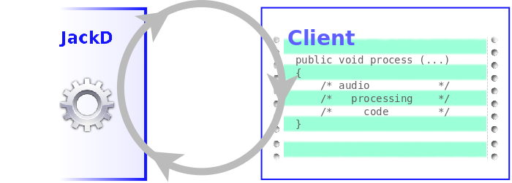
The audio driver thread is time critical, i.e. a call to process(...) method must be guaranteed to complete in a fixed time shorter than the cycle time of the jackd instance. Here's the program output:
native jjack library loaded using system library path
natively registering jack client "JJack"
jack_client_new: deprecated
using 2 input ports, 2 output ports
Frame: 1; Peak value (abs): 0.0.
Frame: 2; Peak value (abs): 0.0.
Frame: 3; Peak value (abs): 0.0.
Frame: 4; Peak value (abs): 0.042320143.
Frame: 5; Peak value (abs): 0.036235876.
Frame: 6; Peak value (abs): 0.038238987.
Frame: 7; Peak value (abs): 0.038017016.
Frame: 8; Peak value (abs): 0.04076365.
Frame: 9; Peak value (abs): 0.022242684.
Frame: 10; Peak value (abs): 0.022647541.
In ppm-java we cannot push the data directly to the display engine. If the engine blocks whilst it receives data it would result in the audio driver being stuck in the process(...) method (priority inversion), with unknown side effects for the running jackd instance. To prevent this from happening we push the audio data to a bank of atomic buffers (one per audio channel) from where the display engine will fetch it. The atomic buffers are designed to stream data from a high priority thread to a low priority thread without ever blocking the high priority thread. This way we decouple the time critical audio driver thread from the low priority display engine thread. The display engine might still get stuck - but now the only consequence would be lost data. The audio driver (i.e. the jack server) will continue to work, even if the display engine freezes up.

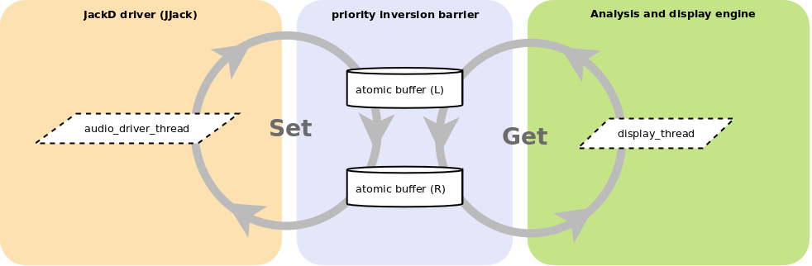
Analysis and display engine
The main work of ppm-java is done inside the analysis and display engine. This device takes the raw audio data and converts it to a stream of decibel values to display them on a front end. The engine comprises multiple modules.

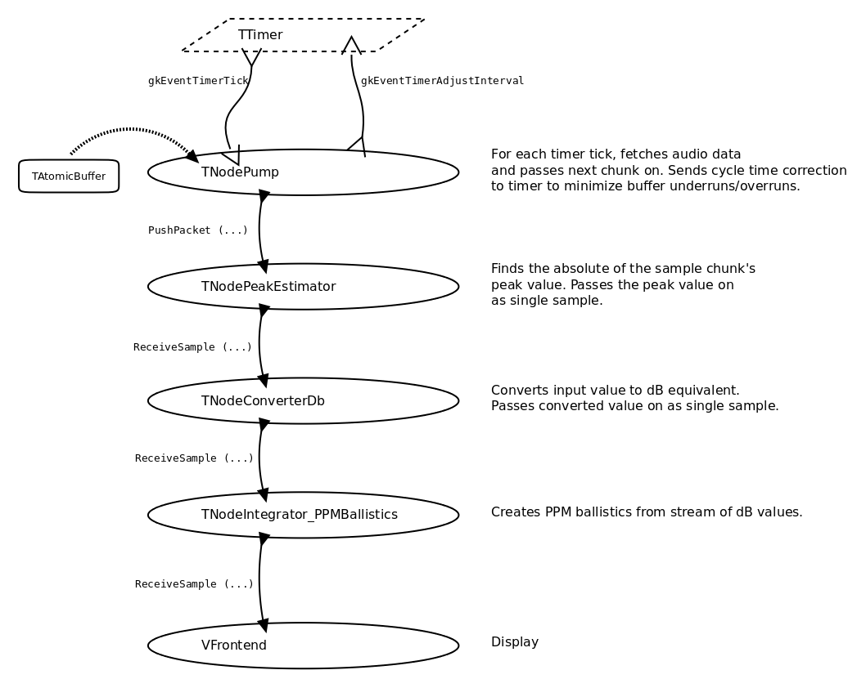
The analysis and display engine runs inside a low priority thread. It is connected to the audio driver backend by a bank of atomic buffers which ensure that the analysis and display engine won't slow down the audio driver thread. This comes at the price of data integrity. If the analysis and display engine does slow down (e.g. graphics takes longer than usual to do a refresh) then it will miss some of the data values coming from the audio driver. There isn't really any other way to resolve freeze-ups of the display engine than to simply drop the past data and carry on with the current data.

Frontends
Various frontends are available. Some offer graphical user interface, others work in text-only mode, i.e. in the console from which ppm-java has been started. Most of them include PPM ballistics in the display.
guiRadial | A PPM lookalike.
guiLinear | Horizontal linear bargraph.
consoleLinear | Horizontal linear bargraph on the console (text mode). | 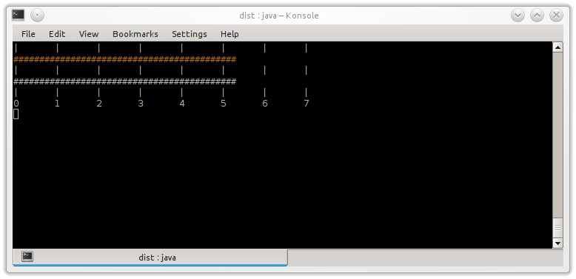
consoleText | Text stream to stdout. Data is presented in JSON format. This frontend is designed to stream audio level data to another application - e.g. via a pipe.  When ppm-java runs with this frontend, there will be no PPM ballistics, i.e. the peak values will be displayed directly, without integration. | 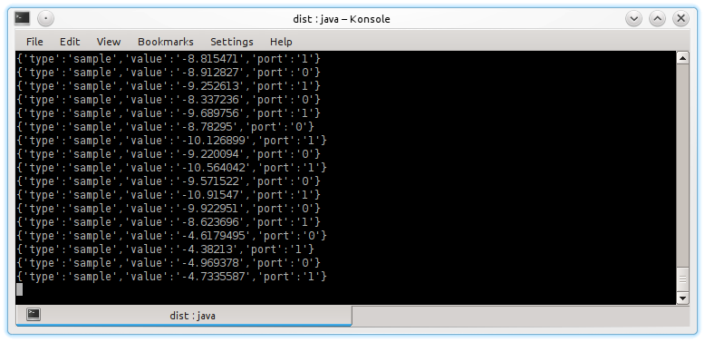

Session setup

Events

Statistics interface

Class hierarchy

Roadmap
- Finish documentation (est. one week).
- True peak capabilities. So far, we just take the highest absolute sample value per GUI cycle and use that for the display. However, in reality most peaks fall between peaks on the actual waveform. This means our meter does not display the waveform peaks but only the sample peaks, resulting in an underread of typically 3dB. A truepeak module is needed to reduce the underread. We would design the truepeak module according to the recommended algorithm in BS.1770-4 (est one week).
- Port to C++/QT. The ppm-java program is a proof of concept. And it was simply easier to do the design in Java (e.g. we don't have to keep track of header files). Once the design has matured, it should be fairly straight forward to port the program to C++, using the QT toolkit and other support libraries (est. four weeks).

Appendices

App. 1: Example listings

Listing 1:

package ppm_java._dev.concept.trial.JJack;

import java.nio.FloatBuffer;
import de.gulden.framework.jjack.JJackAudioEvent;
import de.gulden.framework.jjack.JJackAudioProcessor;
import de.gulden.framework.jjack.JJackException;
import de.gulden.framework.jjack.JJackSystem;
import ppm_java.util.logging.TLogger;

/**
* Loads the JJack driver, connects to a running instance of JackD and prints
* the peak of every incoming frame to stdout.
*
* @author peter
*/
public class TDev_Trial_JJack_process_01 implements JJackAudioProcessor
{
public static void main (String[] args)
{
TDev_Trial_JJack_process_01 processor;

/* Setting up Jack client and terminator thread. */
processor = new TDev_Trial_JJack_process_01 ();

/* Connecting with the running instance of Jack */
JJackSystem.setProcessor (processor);

/* Terminator timer - must run in separate thread */
new Thread ()
{
public void run ()
{
try
{
Thread.sleep (500);
JJackSystem.shutdown ();
}
catch (JJackException | InterruptedException e)
{
e.printStackTrace();
}
System.exit (1);
}
}.start ();
}

private int fIFrame;

public TDev_Trial_JJack_process_01 ()
{
fIFrame = 0;
}

/**
* The process callback. Called by the Jack server via the JJack bridge. Time critical!
*/
@Override
public void process (JJackAudioEvent e)
{
FloatBuffer inBuf;
int nSamples;
int i;
float s;
float sRect;
float peak;

fIFrame++;
inBuf = e.getInput (0);
nSamples = inBuf.limit ();
peak = 0;
for (i = 0; i < nSamples; i++)
{
/* Get next sample. */
s = inBuf.get (i);

/* Rectify (i.e. mirror a negative sample to it's positive opposite). */
sRect = (s < 0) ? -s : s;

/* Determine peak value. */
peak = (sRect > peak) ? sRect : peak;
}
System.out.println ("Frame: " + fIFrame + "; Peak value (abs): " + peak + ".");
}
}

Glossary
Priority inversion
In computer science, priority inversion is a problematic scenario in scheduling in which a high priority task is indirectly preempted by a lower priority task effectively "inverting" the relative priorities of the two tasks.
This violates the priority model that high priority tasks can only be prevented from running by higher priority tasks and briefly by low priority tasks which will quickly complete their use of a resource shared by the high and low priority tasks.
https://en.wikipedia.org/wiki/Priority_inversion

License
A program to display audio levels using PPM ballistics.
Copyright (C) 2017 Peter Hoppe
This program is free software: you can redistribute it and/or modify it under the terms of the GNU General Public License as published by the Free Software Foundation, either version 3 of the License, or (at your option) any later version.
This program is distributed in the hope that it will be useful, but WITHOUT ANY WARRANTY; without even the implied warranty of MERCHANTABILITY or FITNESS FOR A PARTICULAR PURPOSE. See the GNU General Public License for more details.
You should have received a copy of the GNU General Public License along with this program. If not, see <http://www.gnu.org/licenses/>.

https://en.wikipedia.org/wiki/Peak_programme_meter
This is a hard balancing act - it's tempting to totally overengineer and create micromodules or to go the shortcut route and hack some contorted monolithic construction. In both cases, half a year later even the author won't have a clue what this thing does!
Note that, in this program push and pop just increment/decrement a counter. The point of the demo still holds.
With plain variables, thread safety is not guaranteed. For example, with a plain variable a simple assignment may need multiple processor instructions to complete which opens it up to data corruptions if manipulated by multiple threads simultaneously.
http://www.jackaudio.org
https://sourceforge.net/projects/jjack
BS.1770-4, Annex 2. https://www.itu.int/dms_pubrec/itu-r/rec/bs/R-REC-BS.1770-4-201510-I!!PDF-E.pdf

