Python course II
(c) 2019, Peter Hoppe
This work is licensed under the Creative Commons Attribution 4.0 International License. To view a copy of this license, visit http://creativecommons.org/licenses/by/4.0/ or send a letter to Creative Commons, PO Box 1866, Mountain View, CA 94042, USA.
A copy of this license has been included in this repository.

Objective
This course provides an introduction into advanced features of Python such as classes and objects, installing and using third party libraries (python-Qt, python-vlc, ...) and some advanced programming constructs such as state engines and how to coordinate asynchronous program flows.
The course is highly practical - we show the concepts by designing a simple media player application which implements all the concepts we teach. To make things more interesting we implement two different UI types, a local GUI and a web GUI.
I'm not the best imaginative namegiver, but for reference, let's call our wonderful product MyPlayer. Any ideas for a better name?

Prerequisites
Windows/Linux (advanced user)
Python (basic programming skills: Variables & statements, control structures, functions).
Basic Git usage (Setting up repo, commit, branch)
A lot of persevearance, googling and pushing through! Explanations are sometimes sparse on purpose!

Requirements
Average Laptop / Desktop machine plus peripherals.
OS: Windows (10) or (K)Ubuntu Linux 18
Python 3
Python IDE (PyClipse)
Programmer friendly editor (Windows: Notepad++, Linux: Kate or GEdit)
TortoiseGit (Windows) + deps, Just Git (Linux)

Agenda
- Installation
  - Python 3
  - PyClipse
  - python-qt
  - python-vlc
  - Git + friends
- Program structure
  - Components and their purpose
- The GUI
  - Visual design
  - Architecture: Delegate pattern
  - Logic, GUI-Only
- The controller
  - State machine
  - Integrating the GUI
- The backend
  - The audiosystem (vlc) - Introduction
    - Instantiating
    - Functions
    - Events
  - Integrating vlc into backend
  - Playlist
- The controller II
  - Integrating the backend into controller
  - Integrating volume slider
  - Passing runtime info to GUI (Track position/info)
- Web GUI, visual design
- Web service
  - Web GUI delegate
  - Comms channel to web client (web sockets)
- Integrating WEB GUI
  - The Javascript library
  - Trying it out

Lesson 1: Installation (2019-08)
Objective: Set up the Development environment: Python+libs, git, IDE

Linux
We use KUbuntu, 64 bit, and assume a working system. For the installation you need an open Terminal (emulator). KUbuntu offers you a program for that (aptly named Konsole). There you will type everything.

VLC player
That's for your media player backend to play your muzac.
sudo apt install vlc

Qt
This is the framework which puts your local GUI on your screen.
sudo apt install qt4-designer

git
A source code management system. You need it to keep track of your project.
sudo apt install git
sudo apt install git-gui
sudo apt install git-man

Python + libs
You also need python plus some libs to bind qt and vlc into it.
sudo apt install python3
sudo apt install pyside-tool
sudo apt install python-qt4
sudo apt install python3-pip
sudo pip3 install python-vlc

Java
Needed for LiClipse. We'll be using the openJDK which ships with KUbuntu. Unfortunately the official Oracle Java8 can't be installed via repository, and it seems OpenJDK is enough. Check whether you have Java installed. On my laptop I get:

java -version
java version "1.8.0_201"
Java(TM) SE Runtime Environment (build 1.8.0_201-b09)
Java HotSpot(TM) 64-Bit Server VM (build 25.201-b09, mixed mode)
If it tells you it doesn't have java, you need to install it:
sudo apt install default-jdk
Your system will download and install the standard Kubuntu JDK

Python IDE (LiClipse)
We'll be using LiClipse. It comes as a trial version with full functionality. After 14 days you will get a tender reminder (popup box) that you really should buy a license (software will continue to work though). It will cost $80, and I'd recommend buying it as it supports the developer (devs do need to eat, too - even if they say that their food is code).
Head over to https://www.liclipse.com/download.html. You'll probably have a 64 bit version of KUbuntu, so download the 64 bit version. You will get a file with the ending .tar.gz (e.g. liclipse_5.2.4_linux.gtk.x86_64.tar.gz). For your info - that's a compressed tar archive.
Once the file has downloaded, make yourself a directory /home/your-user-name/bin/liclipse and copy the file into that one. Then
- open the folder in Dolphin
- right click it
- choose Extract -> Extract archive here, autodetect subfolder
This will create another sub folder. To start LiClipse cd into that sub folder and execute LiClipse. (Hint) - you can make that a menu item in your KDE startup menu.
- LiClipse comes with git support inbuilt so you can use git from inside your dev environment. Outside of LiClipse you can use the TortoiseGit features directly inside the Windows explorer, via right click on a (repository) folder.

Windows (10)
Whilst we could install everything directly into Windows there's a better way by setting up a virtual machine with a Kubuntu guest and then to use that as development machine. For the VM environment you can use VMWare (expensive, but if you have it, why not) or Virtualbox. With respect to setting up a VM and installing Linux, this would exceed the scope of this guide. Suffice to say that you should give the VM a harddisk with at least 30 GB and at least 4GB of memory. Also, the VM guest (i.e. VM thing you set up) needs a working connection to the internet and a working audio output. When you have the base system working, follow the Linux part of this chapter (above) to get your dev environment ready.
Task: Using QtDesigner and pyuic, make python put a helloworld window onto your screen! Your window should look something like this:
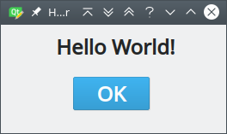

Lesson 2: Program structure
Objective: Show the general structure of the player program.
fig 1: Program overview
This chapter is a first get-to-know-me in broad strokes. We present the overall design of our player application. Subsequent chapters will go into much more detail, but this one wants to present the "big picture".
A good program design is hard to get to and needs experience! In today's interconnected world everything is super complicated! Design flaws are hard to beat once the project grows, so it's very important to get things right early! Several principles guide the development of MyPlayer.
- Separation of concerns. Example from the real world: A well designed company structure will result in employees who are competent in what they do and communicate well. Software design is similar! We take take a big problem, split it up into sub problems then write components that tackle those sub problems independently and work well together. Result: Program works well and can be maintained by dummies!
MyPlayer realizes this principle by splitting up the whole application into smaller independent components. Furthermore, we isolate the components in separate layers. We have a system layer which operates the system parts (Local GUI, web GUI, VLC player), a control layer which represents the player's view of everything (controller, frontend and backend facades) and a translation layer (delegates) which translates what the control components want to a "language" which the system components understand (and vice versa).
- Talking about "language" - API, API, and again, API ! Did I say API? Good separation of concerns is only half the story. What good is the independence if the stuff doesn't talk to each other? We need a well defined interaction between the different components. In programmer's mumbo jumbo such interaction way is called API (Application programming interface). API thinking is all over the application.
  - Each component provides a clean interface - a bunch of methods to set getters and setters (methods that get and set stuff inside the component) and event handlers - which respond to other components wanting something. All methods follow a consistent naming scheme. For example, getters always start with get.
  - The components in the system layer all have very different requirements and thus very different methods. To present a more consistent API of the system components we use a layer of delegates that "translate" between the resp. system components and the control components. As a result the control components have a consistent view onto the system components. For example, the two frontends (Local GUI and web GUI) are very different in what they do and how they, but thanks to their respective delegates they look the same to the Frontend facade. This approach reduces complexity so we can pretty much plug any frontend into the running application and access them all same way.
For the media player component (VLC) we also use a delegate; technically this isn't necessary, but we still use it in case we want to use a different media framework. Plus, it's just more consistent - now any system component talks to our application via a delegate. This means one less special case and one thing less to consider!
Getting a design right is the hardest part of software design. This setup is just an attempt to make the application easier to understand and maintain. We meet the design challenge by splitting the whole setup into separate components and providing a clearly defined interaction between those components.

Some code to layout
Pardon the weird language, but layout is jargonese for the way our source code is organized! In our longish introduction we talked about layers and modules. This reflects directly in how we set up the packages and modules - or in everyday speech - the folder structure and what source files we put there. I'm sure there are more interesting ways of laying out code, but I sugggest we organize it somewhat along the layers and modules we presented above. Fig. 2 shows what it looks like.

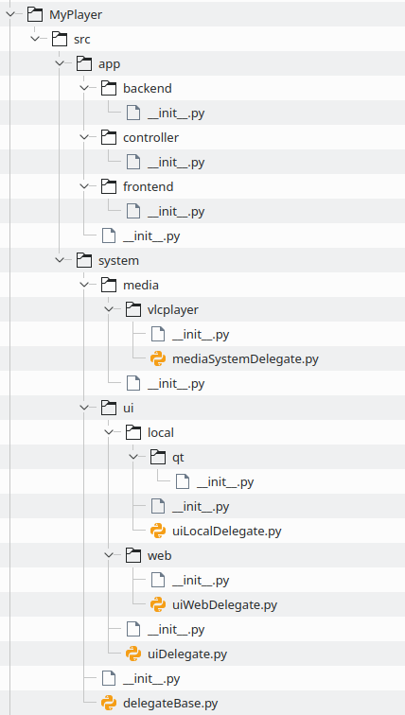
fig 2: Source layout

Noticed something? Blimey, where are those delegates???? If you look closely you will see them lumped with the respective system components! The local GUI has got a UILocalDelegate, the web UI has got a UIWebDelegate and the VLC driver has got a MediaSystemDelegate. The app layer components will use the delegates, and only the delegates to use the various system components. We'll see the details of all this later, but for now we note that the app layer talks in appanese with the delegates who translate that stuff into systemese for the system layer (and vice versa). If we pull this off correctly then it will be a breeze to integrate the system components into the app components!
The astute reader will have observed that there's no test code! That's right - but this guide is already demanding enough! Throwing in unit testing would be like adding rocks to your full grain muesli!
Task: In LiClipse, set up the project and create a structure of python modules implementing the program structure we explained.
As a plus, maybe make a GUI and let python execute it.
Using Konsole, put the project under git control.

Lesson 3: The GUI
Objective: Design the GUI (visually), build integration into player application and show a simplistic approach to the GUI logic
Let's start with the simple stuff up front. There's always time to complicate, so let's complicate later! We want to design the user interface first.
On your dev system (that virtual machine we set up in part 1) start QtDesigner (Start menu -> Development) and use it to create a user interface like this:
Some of the controls need specific names, so that the GUI works with the code we develop later. You can see those on my designer (fig. 4).
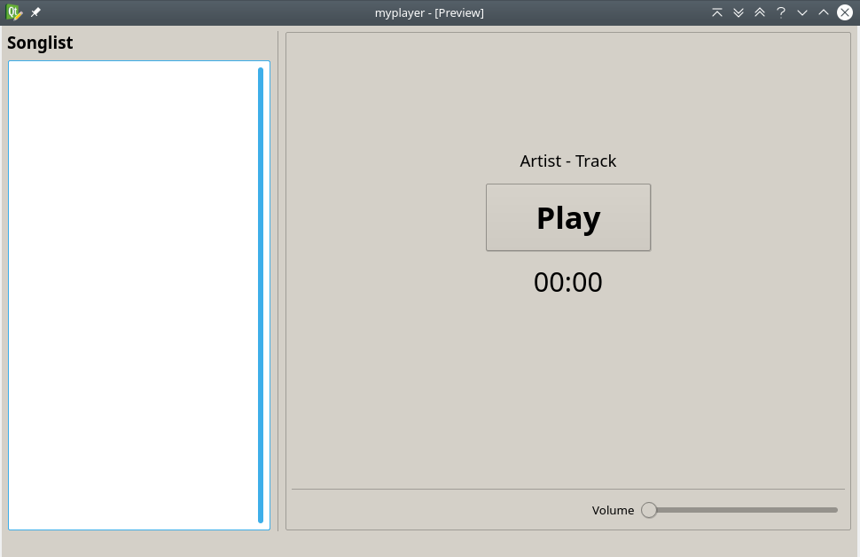fig 3: GUI (local)
fig 4: Developing UI in QtDesigner
Once you are done with the design you can save the final .ui file into your project (I stuffed it into a new directory MyPlayer/src/app/frontend/_assets, so let's use that one).
With that done we need to translate the .ui file into python code. Open konsole, cd into that _assets directory and do:
pyuic4 -x -o ./gui.py ./gui.ui
You can look at the result by listing that directory's contents:
ls -la
total 32
drwxrwxr-x 2 peter peter 4096 Aug 20 18:00 .
drwxrwxr-x 3 peter peter 4096 Aug 20 17:53 ..
-rw-rw-r-- 1 peter peter 9062 Aug 20 18:00 gui.py <---- python file
-rw-rw-r-- 1 peter peter 9792 Aug 20 17:56 gui.ui
The new python file is your local GUI. When you run this script you will see MyPlayer's main window. Run it and try out the various controls on it (button, slider, ....).

There's been an event in China...
As you operated the GUI you noticed ... nothing interesting! Button gets pressed, Slider moves... but nothing much else! What's wrong? GUI's gone on strike? Not really, but in order for stuff to happen you need to write some event handlers and connect them with the GUI elements we want to use. Once connected an event handler will do whatever we program into it when the corresponding GUI element experiences the event. Let's illustrate my skimpy explanation with an example and revisit that homework after lesson 1 (HelloWorld). Like our GUI here the HelloWorld thingy was dead as a Dodo! You could hit that OK button and nothing happens! Let's declare war on lazy GUIs and have it show "How are you?" when we click that OK button!
For starters, let's see the source code generated by my pyuic compiler:
- # -*- coding: utf-8 -*-

- # Form implementation generated from reading ui file './helloworld.ui'
- #
- # Created by: PyQt4 UI code generator 4.12.1
- #
- # WARNING! All changes made in this file will be lost!

- from PyQt4 import QtCore, QtGui

- try:
- _fromUtf8 = QtCore.QString.fromUtf8
- except AttributeError:
- def _fromUtf8(s):
- return s

- try:
- _encoding = QtGui.QApplication.UnicodeUTF8
- def _translate(context, text, disambig):
- return QtGui.QApplication.translate(context, text, disambig, _encoding)
- except AttributeError:
- def _translate(context, text, disambig):
- return QtGui.QApplication.translate(context, text, disambig)

- class Ui_MainWindow(object):
- def setupUi(self, MainWindow):
- MainWindow.setObjectName(_fromUtf8("MainWindow"))
- MainWindow.resize(325, 223)
- self.centralwidget = QtGui.QWidget(MainWindow)
- self.centralwidget.setObjectName(_fromUtf8("centralwidget"))
- self.btnOK = QtGui.QPushButton(self.centralwidget)
- self.btnOK.setGeometry(QtCore.QRect(110, 130, 90, 35))
- font = QtGui.QFont()
- font.setPointSize(16)
- self.btnOK.setFont(font)
- self.btnOK.setObjectName(_fromUtf8("btnOK"))
- self.lblMsg = QtGui.QLabel(self.centralwidget)
- self.lblMsg.setGeometry(QtCore.QRect(20, 30, 261, 51))
- font = QtGui.QFont()
- font.setPointSize(28)
- font.setBold(True)
- font.setWeight(75)
- self.lblMsg.setFont(font)
- self.lblMsg.setAlignment(QtCore.Qt.AlignCenter)
- self.lblMsg.setObjectName(_fromUtf8("lblMsg"))
- MainWindow.setCentralWidget(self.centralwidget)

- self.retranslateUi(MainWindow)
- QtCore.QMetaObject.connectSlotsByName(MainWindow)

- def retranslateUi(self, MainWindow):
- MainWindow.setWindowTitle(_translate("MainWindow", "MainWindow", None))
- self.btnOK.setText(_translate("MainWindow", "OK", None))
- self.lblMsg.setText(_translate("MainWindow", "Hello World", None))

- if __name__ == "__main__":
- import sys
- app = QtGui.QApplication(sys.argv)
- MainWindow = QtGui.QMainWindow()
- ui = Ui_MainWindow()
- ui.setupUi(MainWindow)
- MainWindow.show()
- sys.exit(app.exec_())

This code doesn't do anything interesting, apart from showing a pretty window when running it in python. Let's do that:

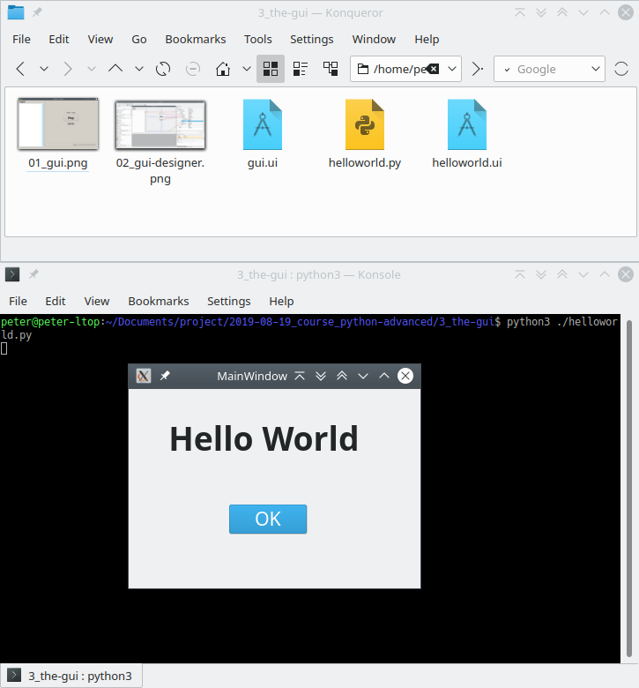
Apart from a few basics this GUI doesn't do anything when you click on it - The button turns blue when you click on it and the application quits when you click that little cross thingy on the top right corner. But we want the thing to do something interesting when we click that button! Let's say that "something" is: Changing "Hello World" to "How are you?". We need a few things to accomplish that.
Firstly, we need to create an event handler. For that we need to edit the python file which pyuic generated (helloworld.py). You could do that in LiClipse, but let's keep things simple and use Kate instead (Start button -> Utilities -> Kate). So - open helloworld.py in Kate. You may want to delete that offputting warning at the top ("all changes will be lost"). This is relevant when you recreate helloworld.py by running pyuic again. No worries, we won't do that, so you might as well get rid of that confusing warning.
Then in Kate edit your code so it looks like this:

- # -*- coding: utf-8 -*-

- # Form implementation generated from reading ui file './helloworld.ui'
- #
- # Created by: PyQt4 UI code generator 4.12.1
- #

- from PyQt4 import QtCore, QtGui

- try:
- _fromUtf8 = QtCore.QString.fromUtf8
- except AttributeError:
- def _fromUtf8(s):
- return s

- try:
- _encoding = QtGui.QApplication.UnicodeUTF8
- def _translate(context, text, disambig):
- return QtGui.QApplication.translate(context, text, disambig, _encoding)
- except AttributeError:
- def _translate(context, text, disambig):
- return QtGui.QApplication.translate(context, text, disambig)

- class Ui_MainWindow(object):

- def Handle_OK_Click():
- print ("Ouch you clicked me!")

- def setupUi(self, MainWindow):
- MainWindow.setObjectName(_fromUtf8("MainWindow"))
- MainWindow.resize(325, 223)
- self.centralwidget = QtGui.QWidget(MainWindow)
- self.centralwidget.setObjectName(_fromUtf8("centralwidget"))
- self.btnOK = QtGui.QPushButton(self.centralwidget)
- self.btnOK.setGeometry(QtCore.QRect(110, 130, 90, 35))
- font = QtGui.QFont()
- font.setPointSize(16)
- self.btnOK.setFont(font)
- self.btnOK.setObjectName(_fromUtf8("btnOK"))
- self.lblMsg = QtGui.QLabel(self.centralwidget)
- self.lblMsg.setGeometry(QtCore.QRect(20, 30, 261, 51))
- font = QtGui.QFont()
- font.setPointSize(28)
- font.setBold(True)
- font.setWeight(75)
- self.lblMsg.setFont(font)
- self.lblMsg.setAlignment(QtCore.Qt.AlignCenter)
- self.lblMsg.setObjectName(_fromUtf8("lblMsg"))
- MainWindow.setCentralWidget(self.centralwidget)

- self.btnOK.clicked.connect (self.Handle_OK_Click)

- self.retranslateUi(MainWindow)
- QtCore.QMetaObject.connectSlotsByName(MainWindow)

- def retranslateUi(self, MainWindow):
- MainWindow.setWindowTitle(_translate("MainWindow", "MainWindow", None))
- self.btnOK.setText(_translate("MainWindow", "OK", None))
- self.lblMsg.setText(_translate("MainWindow", "Hello World", None))

- if __name__ == "__main__":
- import sys
- app = QtGui.QApplication(sys.argv)
- MainWindow = QtGui.QMainWindow()
- ui = Ui_MainWindow()
- ui.setupUi(MainWindow)
- MainWindow.show()
- sys.exit(app.exec_())

What happens here? In lines 26 and 27 we implemented a function Handle_OK_Click (). Then, in line 51 we connect that function to the OK button so that each time you click that OK button we call the function Handle_OK_Click (). In GUI speak, stuff like a button click is called an event. The method Handle_OK_Click () handles that event and has hence become the event handler for all clicks on the OK button. There are many different types of events - for example, sliding a slider, selecting a list box entry, setting a checkbox and more galore. Any widget (button, checkbox, listbox, ...) needs an event handler for each type of event we want to handle. As an astute reader you have no doubt noticed that the event handler just prints "Ouch, you clicked me!" onto the terminal... As an exercise, implement the proper behaviour I mentioned above!
And for another example! Suppose you have a form with a text box and a checkbox and want to respond to the user typing into the text box and setting the checkbox,
- You need to provide two event handlers (similar to example above in lines 26 and 27):
  - One for handling state changes in the checkbox,
  - the other one for handling text changes in the text box
- You need to connect each event handler to its widget (similar to example above in line 51):
  - You want one handler to run when the user clicks the button, so you would connect that one to the clicked event of the button.
  - You want the other handler to run when the user changes text in the text box, so you would connect that one to the textChanged event of the text box.
Here is our wonder application, sporting a line edit and a checkbox - Ladies and gentlemen, put your hands together for the great Frobrinatorrrrr!
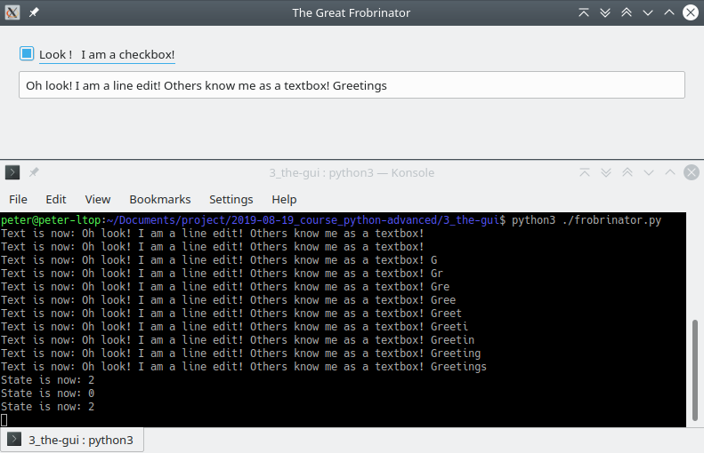fig 5: The Great Frobri-thing (Hear the sound of applause!)
- # -*- coding: utf-8 -*-

- # Form implementation generated from reading ui file './frobrinator.ui'
- #
- # Created by: PyQt4 UI code generator 4.12.1

- from PyQt4 import QtCore, QtGui

- try:
- _fromUtf8 = QtCore.QString.fromUtf8
- except AttributeError:
- def _fromUtf8(s):
- return s

- try:
- _encoding = QtGui.QApplication.UnicodeUTF8
- def _translate(context, text, disambig):
- return QtGui.QApplication.translate(context, text, disambig, _encoding)
- except AttributeError:
- def _translate(context, text, disambig):
- return QtGui.QApplication.translate(context, text, disambig)

- class Ui_MainWindow(object):

- def Handle_LineEdit_TextChanged (self):
- print ("Text is now: %s" % self.lineEdit.text ())

- def Handle_CheckBox_Toggled (self, state):
- print ("State is now: %s" % state)

- def setupUi(self, MainWindow):
- MainWindow.setObjectName(_fromUtf8("MainWindow"))
- MainWindow.resize(790, 147)
- self.centralwidget = QtGui.QWidget(MainWindow)
- self.centralwidget.setObjectName(_fromUtf8("centralwidget"))
- self.checkBox = QtGui.QCheckBox(self.centralwidget)
- self.checkBox.setGeometry(QtCore.QRect(20, 20, 181, 23))
- self.checkBox.setObjectName(_fromUtf8("checkBox"))
- self.lineEdit = QtGui.QLineEdit(self.centralwidget)
- self.lineEdit.setGeometry(QtCore.QRect(20, 50, 751, 33))
- self.lineEdit.setObjectName(_fromUtf8("lineEdit"))
- MainWindow.setCentralWidget(self.centralwidget)
- self.menubar = QtGui.QMenuBar(MainWindow)
- self.menubar.setGeometry(QtCore.QRect(0, 0, 790, 31))
- self.menubar.setObjectName(_fromUtf8("menubar"))
- MainWindow.setMenuBar(self.menubar)
- self.statusbar = QtGui.QStatusBar(MainWindow)
- self.statusbar.setObjectName(_fromUtf8("statusbar"))
- MainWindow.setStatusBar(self.statusbar)

- self.lineEdit.textChanged.connect (self.Handle_LineEdit_TextChanged)
- self.checkBox.stateChanged.connect (self.Handle_CheckBox_Toggled)

- self.retranslateUi(MainWindow)
- QtCore.QMetaObject.connectSlotsByName(MainWindow)

- def retranslateUi(self, MainWindow):
- MainWindow.setWindowTitle(
- _translate("MainWindow", "The Great Frobrinator", None))
- self.checkBox.setText(
- _translate("MainWindow", "Look ! I am a checkbox!", None))
- self.lineEdit.setText(
- _translate(
- "MainWindow",
- "Oh look! I am a line edit! Others know me as a textbox!",
- None
- )
- )

- if __name__ == "__main__":
- import sys
- app = QtGui.QApplication(sys.argv)
- MainWindow = QtGui.QMainWindow()
- ui = Ui_MainWindow()
- ui.setupUi(MainWindow)
- MainWindow.show()
- sys.exit(app.exec_())
What can you put into the event handlers? Your imagination is the limit... you could set the form's color to yellow when you click the button or minimize it when you type "hello" into the text box! Our example above is boring - all it does is to print a message onto the terminal!
So... we didn't really have an event in China (Admit you found the heading kool, otherwise I will attach an event handler to your left earlobe!), but we have plenty of events on our forms, and you are the expert when it comes to handle them! To recap -
- On your GUI you place various widgets,
- Each widget can send events, depending on what the user does with it
- To give your GUI life you have to create event handlers (each handler a function) and connect those to the form's widgets.
- You only need to create (and connect) those handlers you need

Our GUI
After all that long fluff, let's turn our attention back to the GUI we use. We presented the looks at the beginning of this chapter. Here is the source code as created by pyuic (I removed a lot of the generated code, because I want to show our parts):

- from PyQt4 import QtCore, QtGui

- ... snip ...

- class Ui_MainWindow(object):
- def setupUi(self, MainWindow):
- ... snip ...

- def retranslateUi(self, MainWindow):
- ... snip ...

- if __name__ == "__main__":
- import sys
- ... snip ...

Firstly, we need some event handlers that make the form alive. We need three event handlers (meaning: functions):
- An event handler which captures mouse (left) clicks on the Play button,
- An event handler which captures item selections on the left hand playlist,
- An event handler which captures value changes on the volume slider (i.e. user moves the slider).
We implement these functions as methods of the Ui_MainWindow class, and we mark them as private by putting an underscore in front of them:

- from PyQt4 import QtCore, QtGui

- ... snip ...

- class Ui_MainWindow(object):
- """
- The local GUI.
- """
- def _Handle_BtnPlay_Click (self):
- """
- Event handler: User clicked "Play" button.
- """
- ... to be added later ...

- def _Handle_LstPlaylist_Select (self, item):
- """
- Event handler: User selected a song on the playlist.
- """
- ... to be added later ...

- def _Handle_SldVolume_ChangeValue (self):
- """
- Event handler: User changed volume setting.
- """
- ... to be added later ...

- def setupUi(self, MainWindow):
- ... snip ...

- self.fBtnPlay.clicked.connect (self._Handle_BtnPlay_Click)
- self.fLstPlaylist.itemClicked.connect (self._Handle_LstPlaylist_Select)
- self.fSldVolume.sliderMoved.connect
- (self._Handle_SldVolume_ChangeValue)

- def retranslateUi(self, MainWindow):
- ... snip ...

- if __name__ == "__main__":
- import sys
- ... snip ...

As you see, we have three little event handlers and their evil little sisters (connection statements in setupUI()). Note that from here forthwith we do some better source commenting. This is going to be the standard. Good source commenting makes code much much more readable - even to yourself after five years!
For the full code of our GUI, see Appendix A, Listing 1.
Task: Implement some behaviour in the new GUI:
- At application startup have the program load three items into the left hand playlist and set the Play button disabled.
- When you click an item in the playlist set the Play button enabled. Then write the text of what you clicked into the terminal (via print(...)).
- When you click the (enabled) Play button, and it has "Play" written on it, change its text to "Pause".
- When you click the (enabled) Play button, and it has "Pause" written on it, change its text to "Play".
- When you move the slider, have it write its current value to the terminal (via print (...)).

The GUI reloaded
So far our GUI stands by itself. The GUI is the app! As you did your last task you will have noticed that the code grew more and more complex! You may get a hunch that this will become much more complex as you go on. For example, you could bind the vlc part into the GUI and then integrate everything, so you hear the music you select. It's a fast way of getting some results, and it's good to test something quickly or do some prototyping. But if we want to develop this further (and we will) then we should really not cram everything into the GUI code - it would become a bloated unmanageable mess! The mistake we'd make would be quite simply that we are trying to integrate the application into the GUI! What we should do instead is to integrate the GUI into our application! This little reversal means a lot for the GUI code as it will mean a much smaller and tidier code - making the thing manageable and maintainable! And it opens a world of opportunities what else we could integrate into our application! For example, as you have seen in chapter 2 there is also another, web based UI to come!
The first step to a good GUI is that we give it a voice that speaks in a large application. What was that code word again, back in chapter 2? Wasn't there something about APIs?

APIs, delegates and singleness
As you will see, our GUI is a highly specialized thing. Its main purpose is to interact with the user by capturing user actions (events: clicks, slides, ...) and changing its appearance (changing some text, coloring some element blue, ...). Because it's so specialized it needs a special set of functions to express that. Unfortunately we cannot allow this special-ness to spread to the entire application! Especially, if we also integrate another UI (that web based one) which is highly specialized as well! That's why we provide each of these special components with a delegate - that is a class which makes them both appear the same to our application. We call it a delegate because it represents the specialized UI components, so both of them present the same API to our application! The result will be an enormously more readable and maintainable code!
Enough with the preface, let's do it! Here's what I mean:
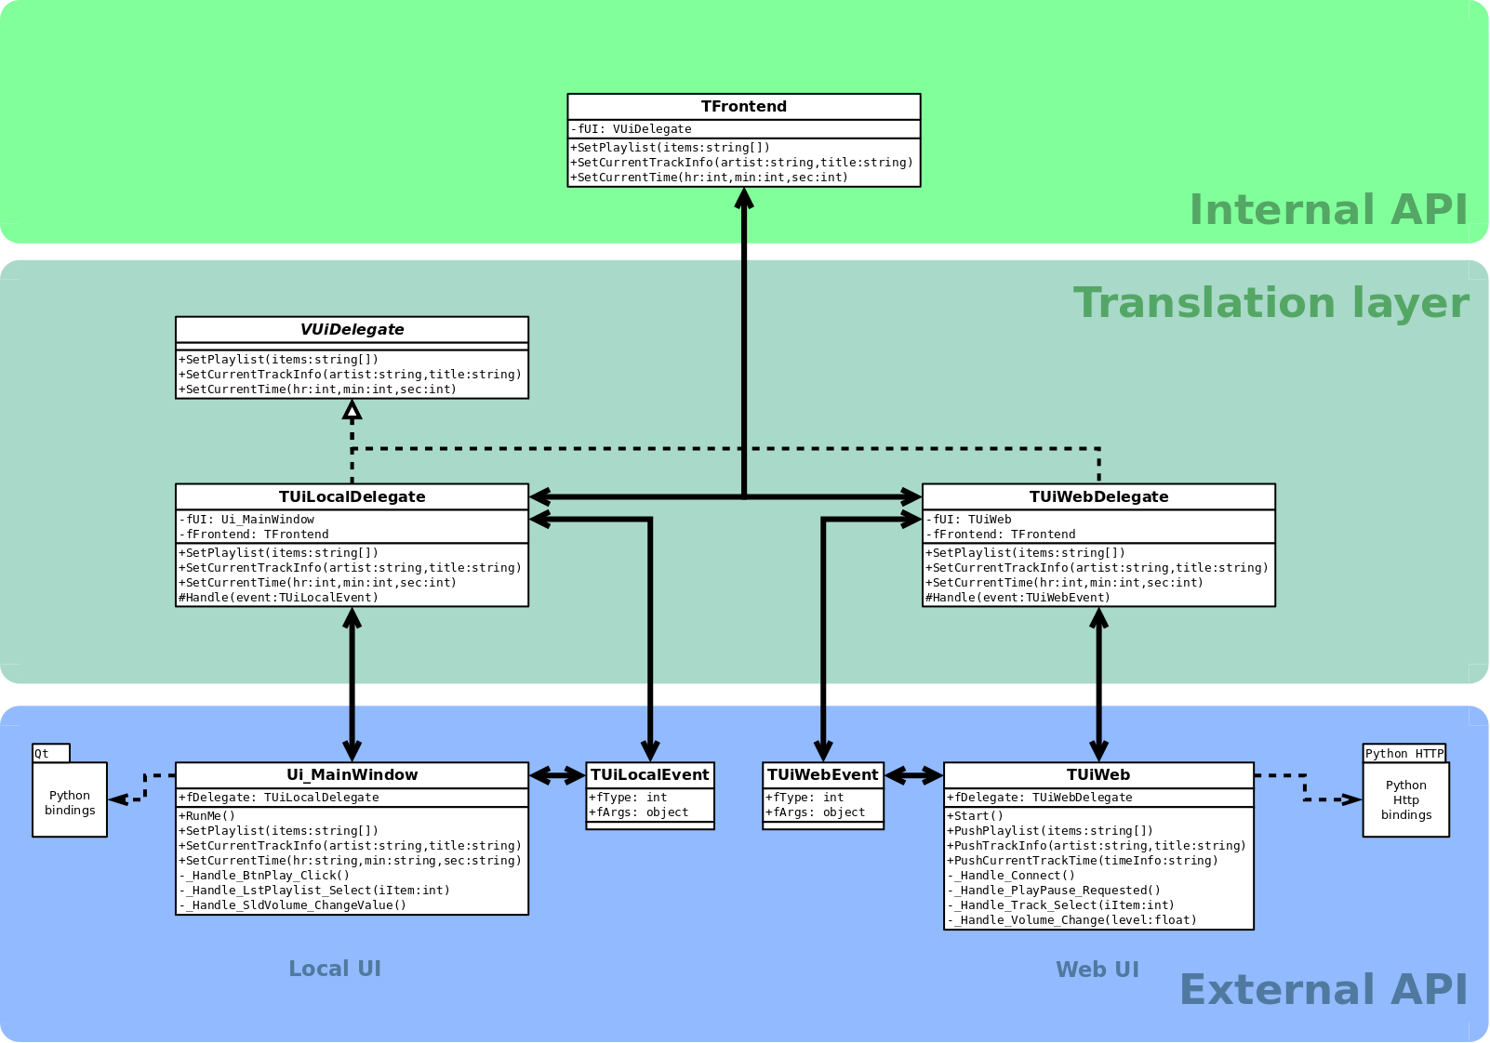
Here we put some flesh and bones on the big picture we presented back in lesson 2. Basically, we have the external API (UI components), the internal API (our program) and the delegates as the glue between the two. You can see that the components in the external API use their own specialized set of methods. For example, you would call SetPlaylist to fill the playlist in the local UI whilst you would call PushPlaylist in the web UI.
Meanwhile, the Delegates provide identical methods for filling the playlist, namely SetPlaylist. This means that whatever UI we use, from our internal API calls SetPlaylist. This concept can scale indefinitely - we can add as many different UIs as we want, and thanks to the Delegates we always call SetPlaylist to fill the playlist widget.
To enforce consistency we provide a base class - VUiDelegate - and have all delegates inherit from this class. VUiDelegate contains nothing but method stubs, and each delegate must implement the methods prescribed by the it. You will notice that VUiDelegate provides only setters (SetPlaylist, SetCurrentTrackInfo, SetCurrentTime), but none of the Handle methods. This is because the setters are called from our application whilst the handlers are called by the resp. frontends. The handlers are as specialized as the frontends which call them. The handlers can still talk to our application by calling the appropriate method in the TFrontend class.

Let's talk about TFrontend! We now have a unified view on all UIs, so why not bundle the whole access via one object? When the application runs we will provide a single, application wide, object of type TFrontend which channels all our wishes to whatever UI is running at the moment. To the application (internal API) the single TFrontend object becomes our facade of the the whole UI framework. The internal API does not need to know what kind of UI it operates, it just tells the facade what it wants done on the UI. For example, if our application wants to set the title and artist of the current track it calls frontend's method SetCurrentTrackInfo which then calls SetCurrentTrackInfo of the current delegate which then calls the appropriate method(s) in the current UI.
TFrontend is the last step to make UI access easy as we now have one object via which we talk to any UI. Note the difference - I said, "one object", not just "one class". Application wide, there is one and only one object (menaing - instance of a class) that we use for our UI work. This pattern is called singleton pattern (singleton being that one object), and it makes the whole UI access insanely easy for our application!

Lesson 4: The controller
Objective: Show the concept of a state machine and integrate the GUI into it. Demonstrate how the state machine controls the GUI.
So far we have implemented the program's logic in the GUI. This has several drawbacks, most notably that it is inflexible (as we are bound to a single GUI only) and makes the program convoluted, i.e hard to maintain. The way forward is to follow the "separation of concerns" principle by exporting the program's logic into its own part. We shall explore a viable route by introducing a controller which utilizes a state engine at its core. A state machine is usually shown as the diagram in fig 6.
fig 6: State machine
A state machine provides fine grained control of complex applications, also with asynchronous processes. Our media player uses plenty of those! Here is a hypothetical program run and how the state engine controls the player.
At program start we set the state engine to state null. | 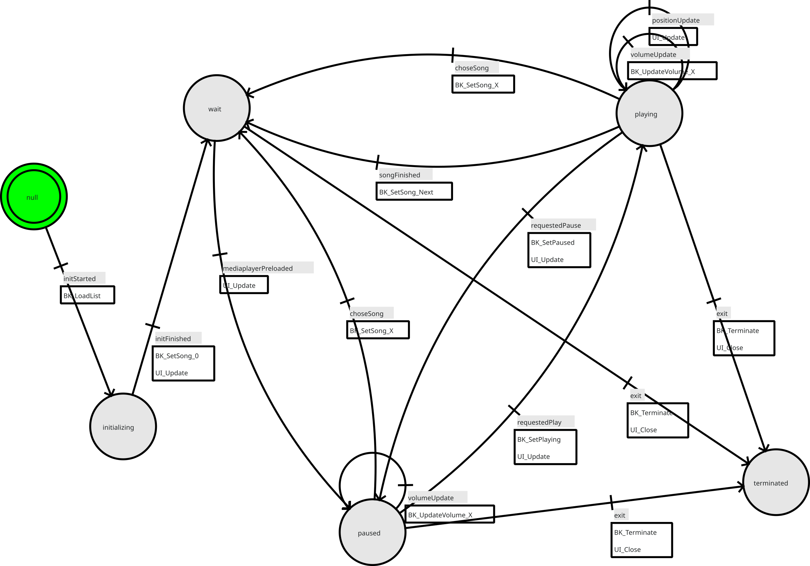
We issue event initStarted.  This sets the engine into state initializing.  State machine calls BK_LoadList () to load the songs into the playlist. | 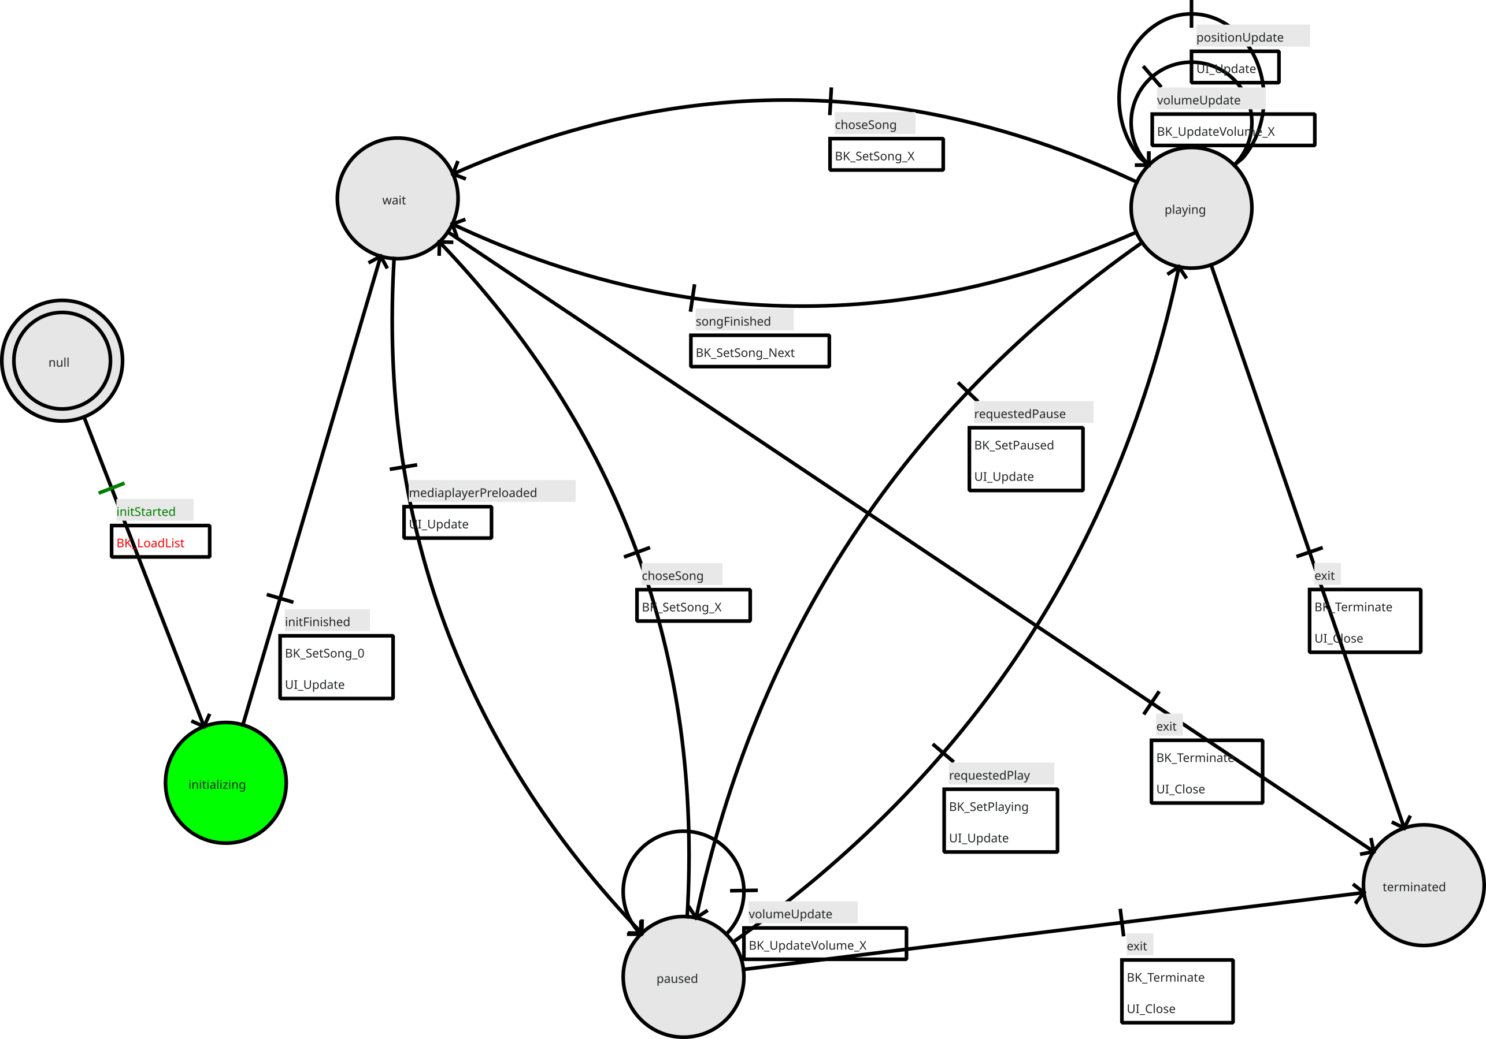
List has loaded. We issue event initFinished.  This sets the state machine into state wait.  State machine calls BK_SetSong (0) to have the backend load the first song into the media layer.  Song loading is asynchronous, i.e. we wait for another event from the backend when the media layer has actually loaded the song. | 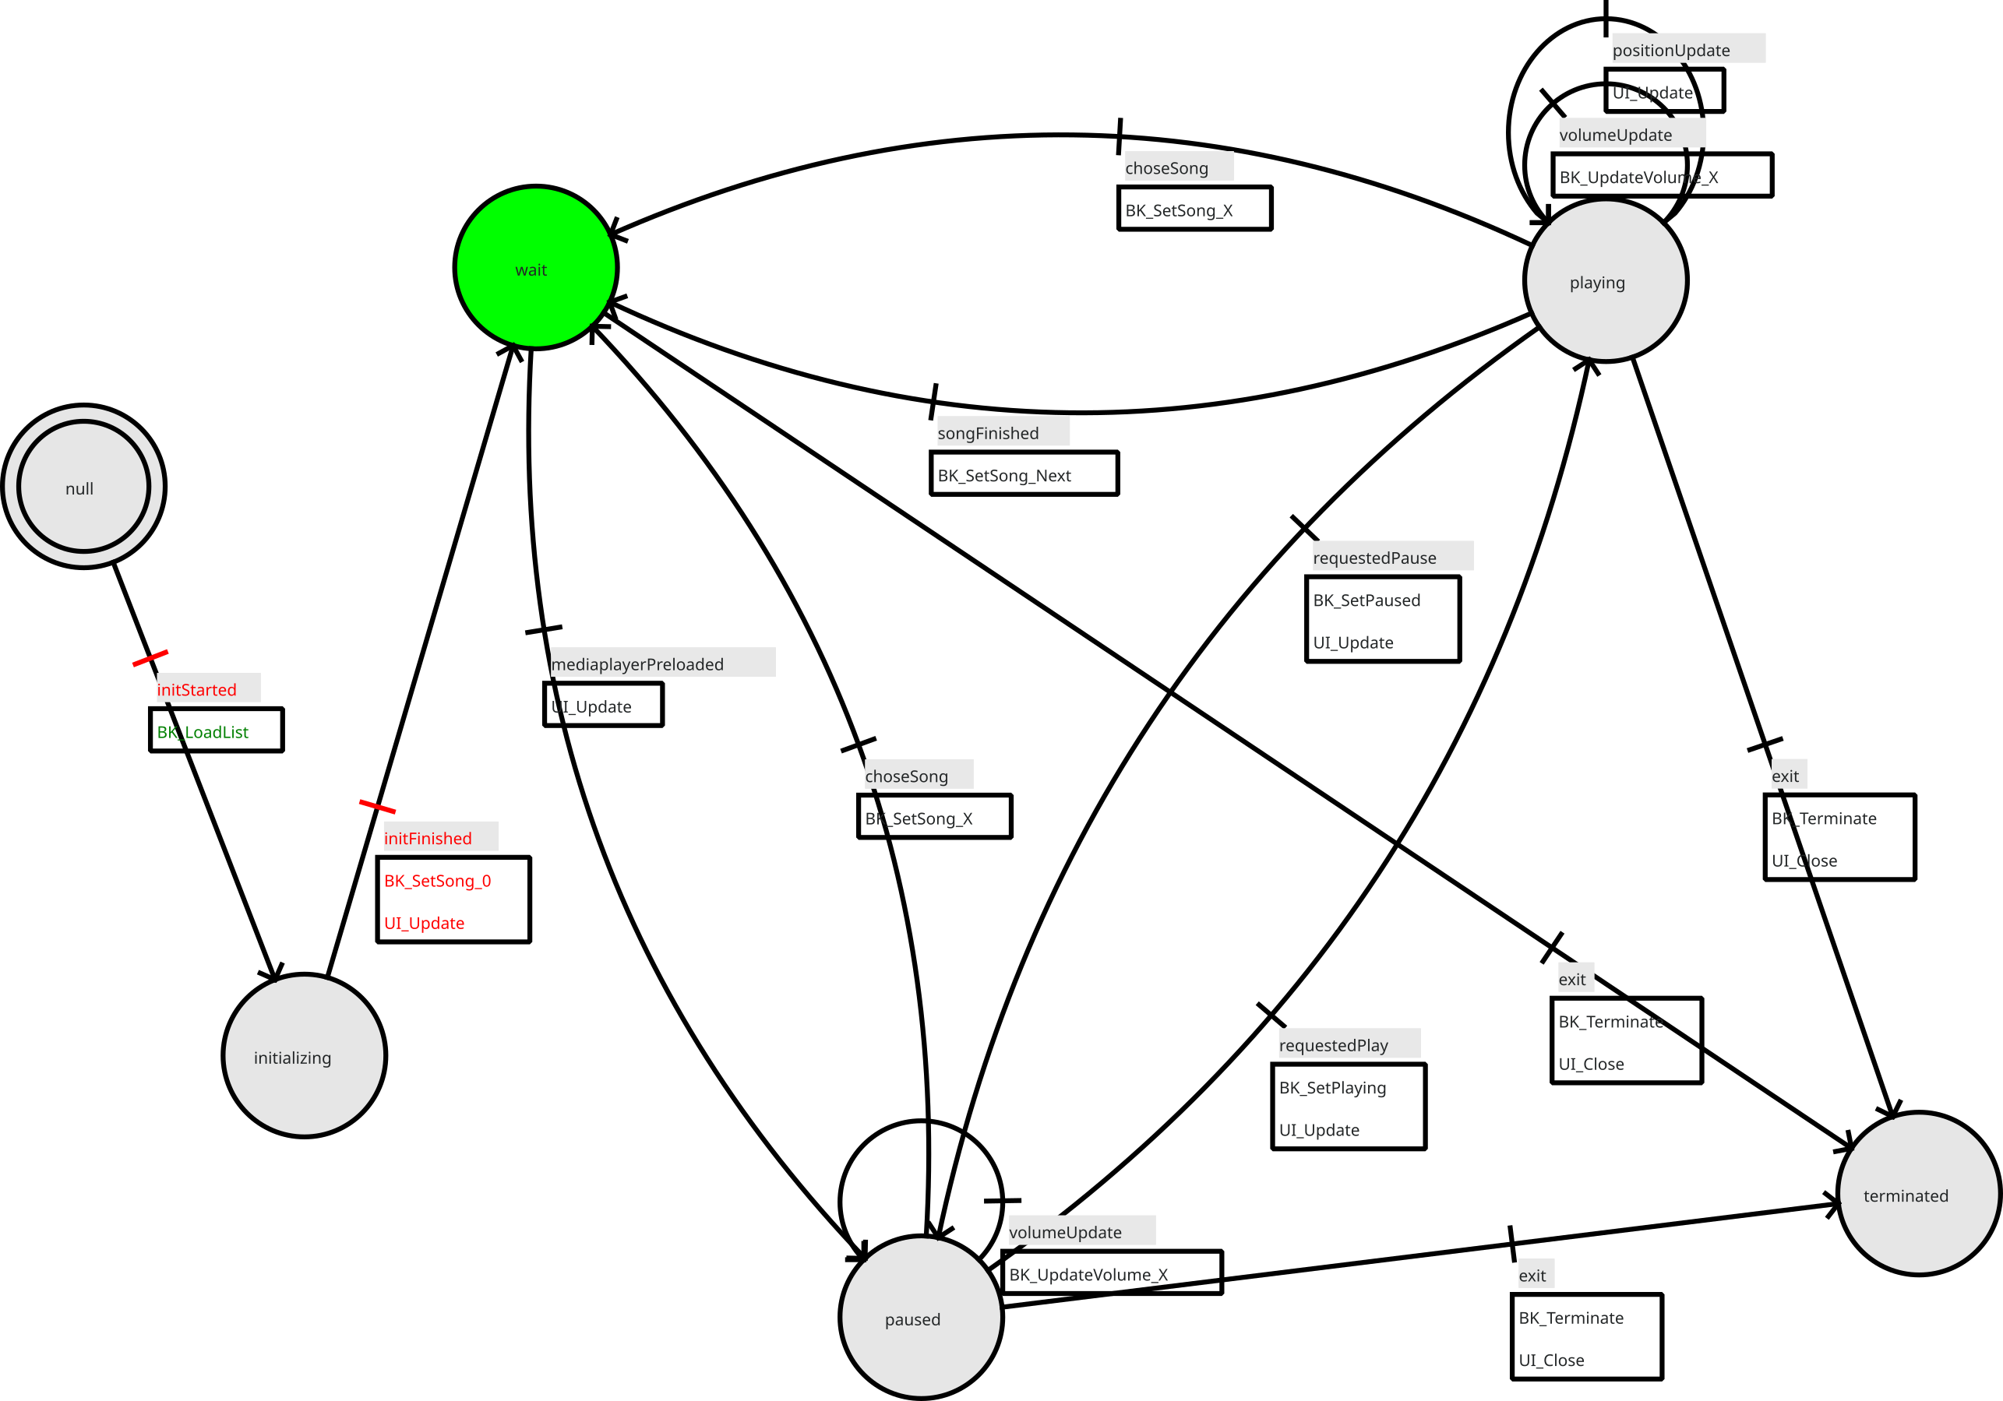
Media layer has loaded the song. Backend issues the event mediaplayerPreload.  This sets the state engine into state paused.  State machine calls UI_Update () to update the frontend (UI). | 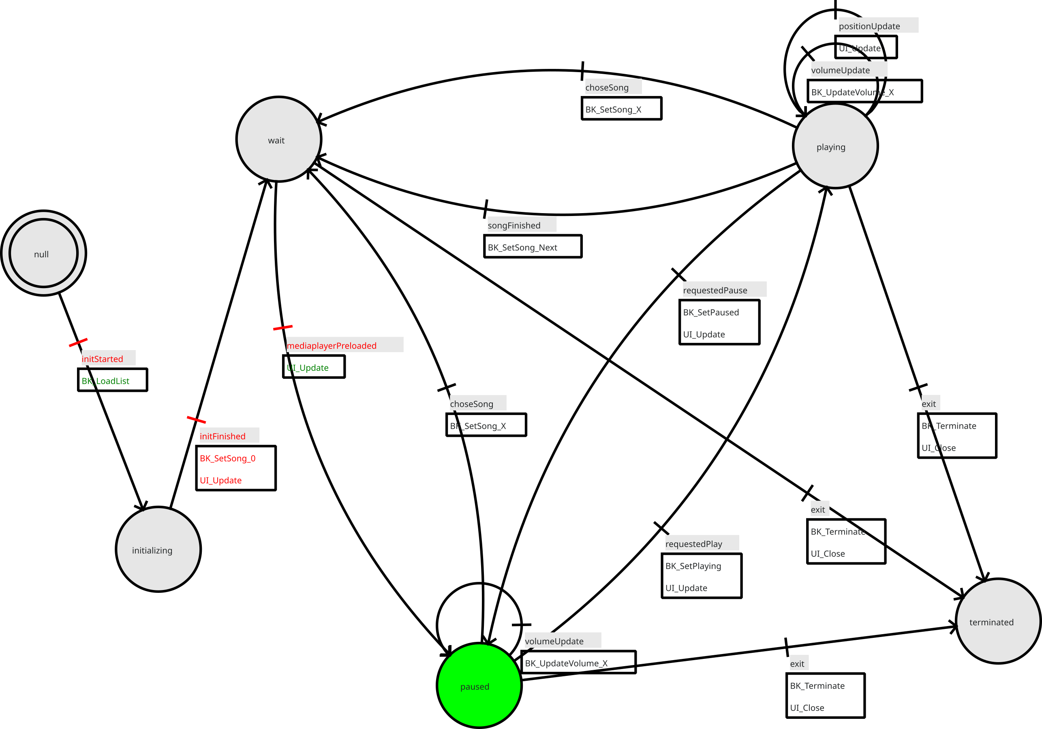
User clicked the big Play button which issues a requestPlay event.  This sets the state engine into state playing.  State machine first calls BK_SetPlaying () (media layer plays track), then UI_Update () to update the Frontend (UI). | 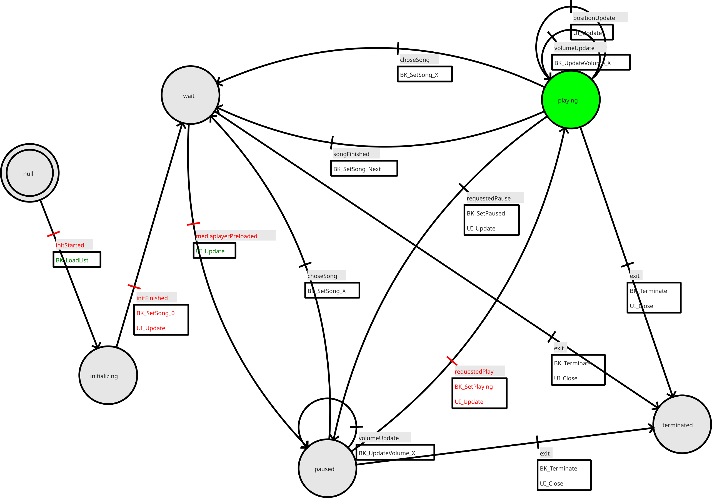
Song has finished, so the backend layer issues a songFinished event.  This sets the state machine into state wait.  State machine calls BK_SetSong_Next () to have the backend load the next song into the media layer. | 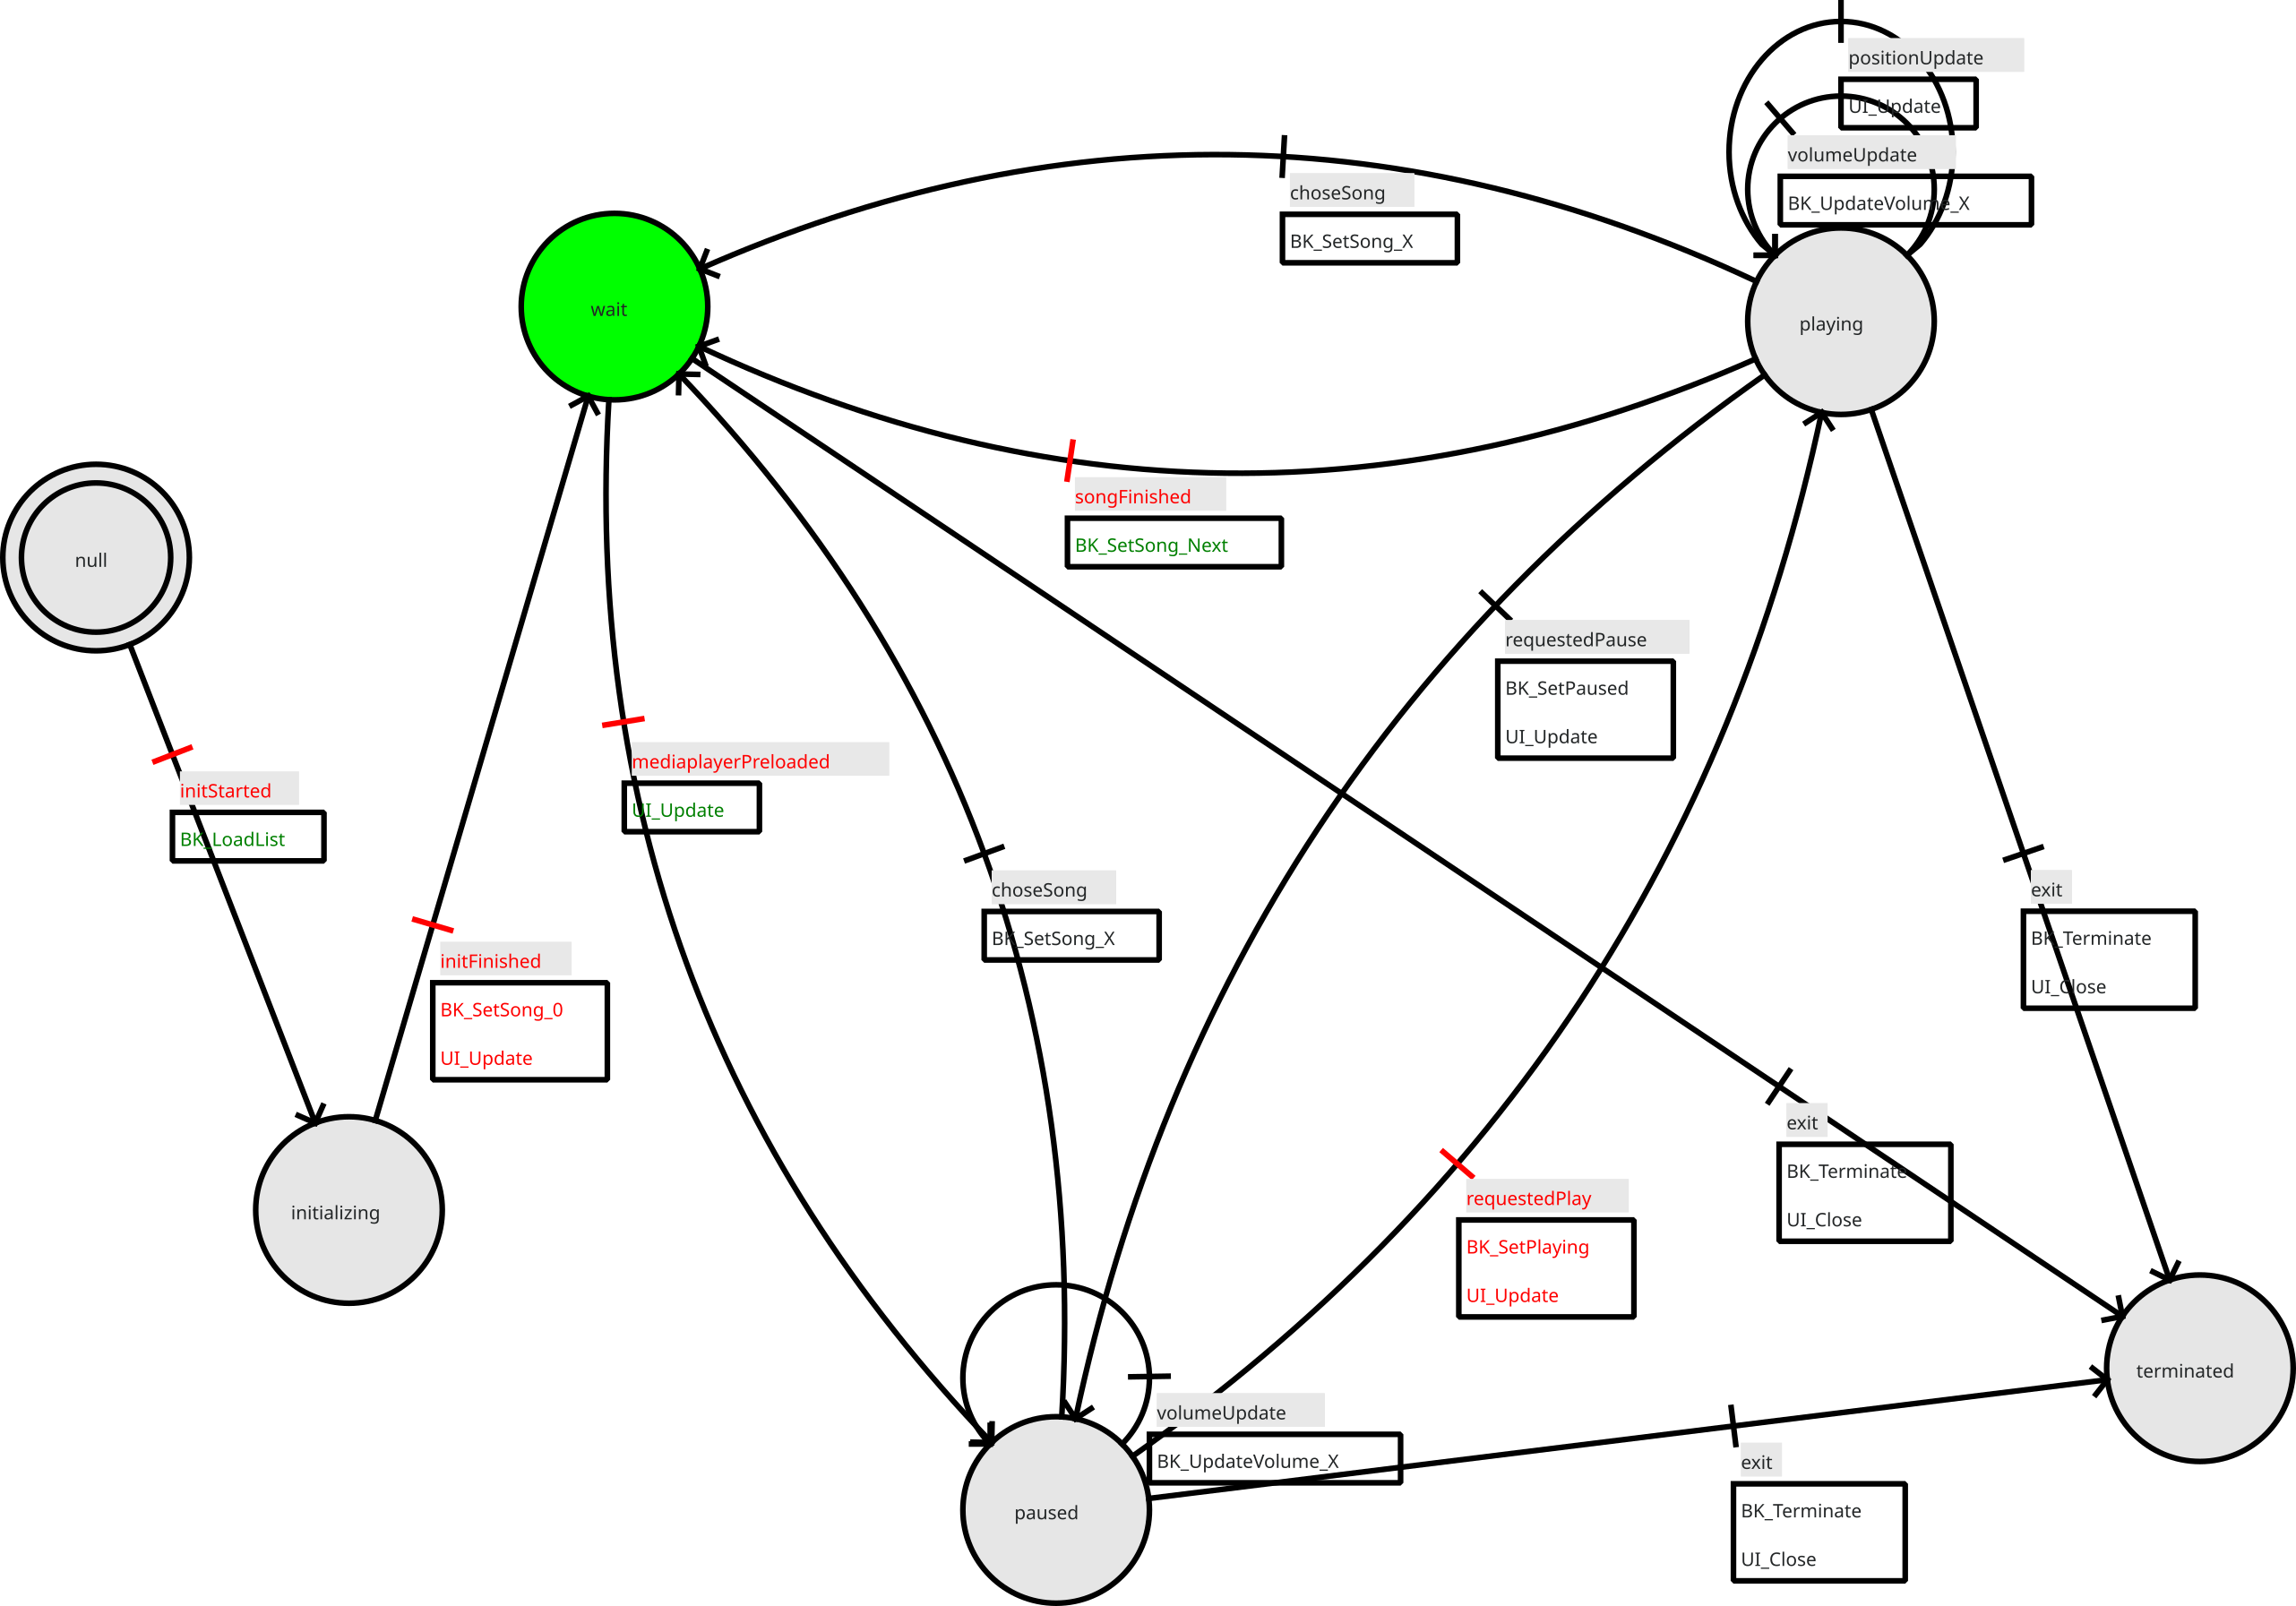
Media layer has loaded the next song. Backend issues the event mediaplayerPreload.  This sets the state engine into state paused.  State machine calls UI_Update () to update the frontend (UI). | 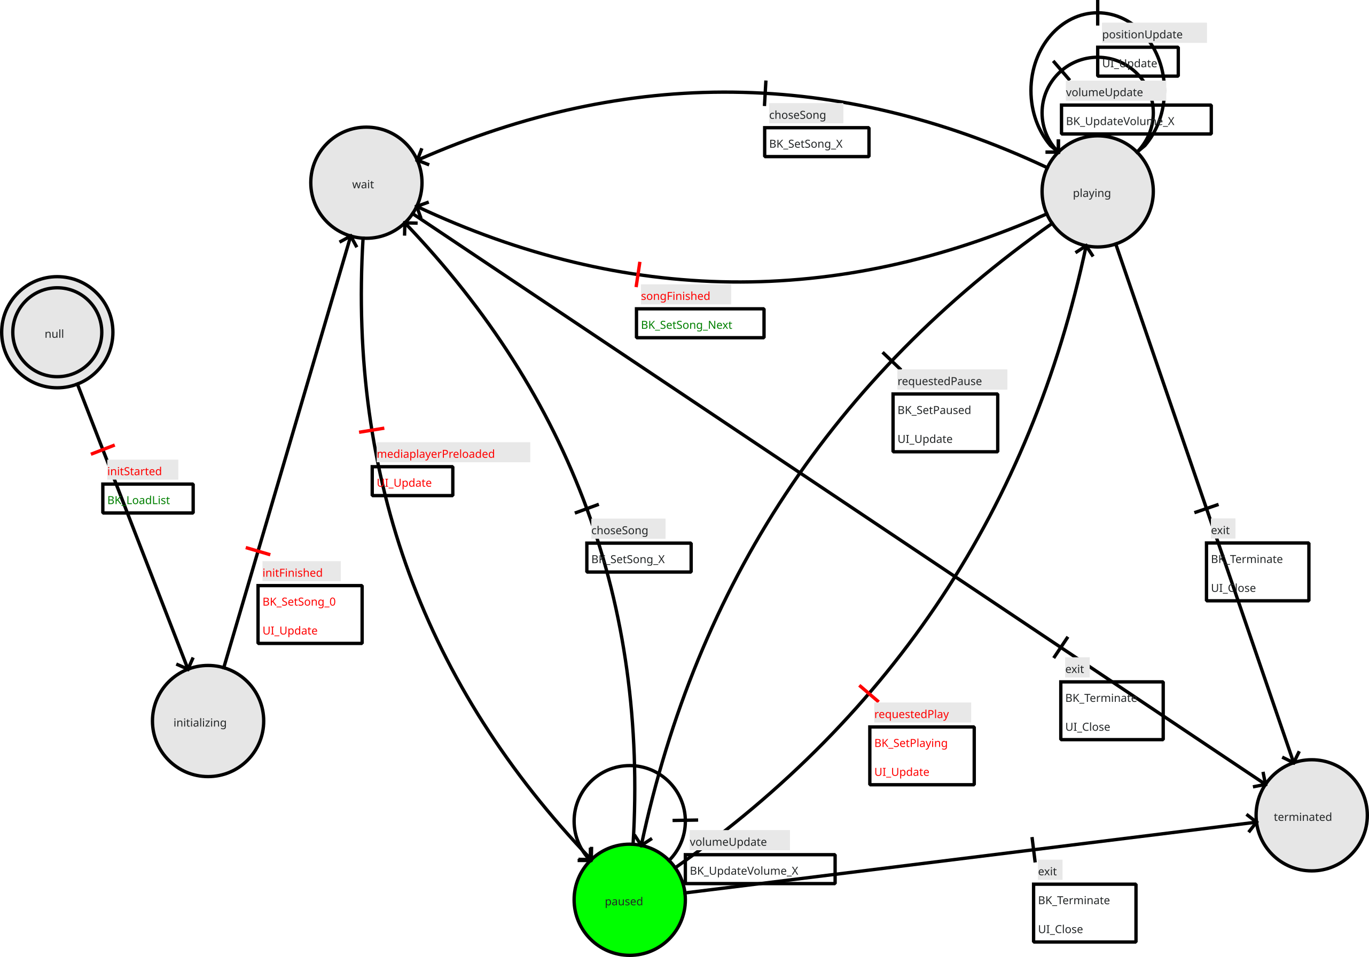
User clicked the Play button which issues a requestPlay event.  This sets the state engine into state playing.  State machine first calls BK_SetPlaying () (media layer plays track), then UI_Update () to update the Frontend (UI). | 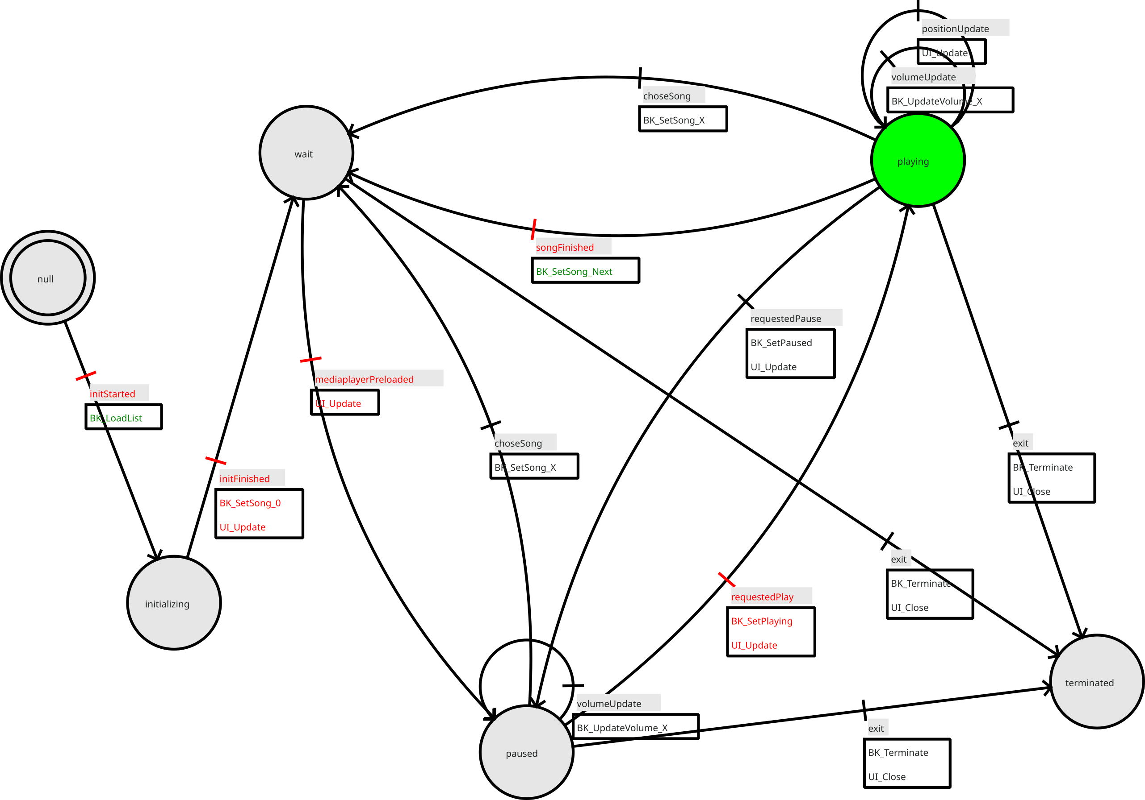
User clicked the Pause button which issues a requestPause event.  This sets the state engine into state paused.  State machine first calls BK_SetPaused () (media layer plays track), then UI_Update () to update the Frontend (UI). | 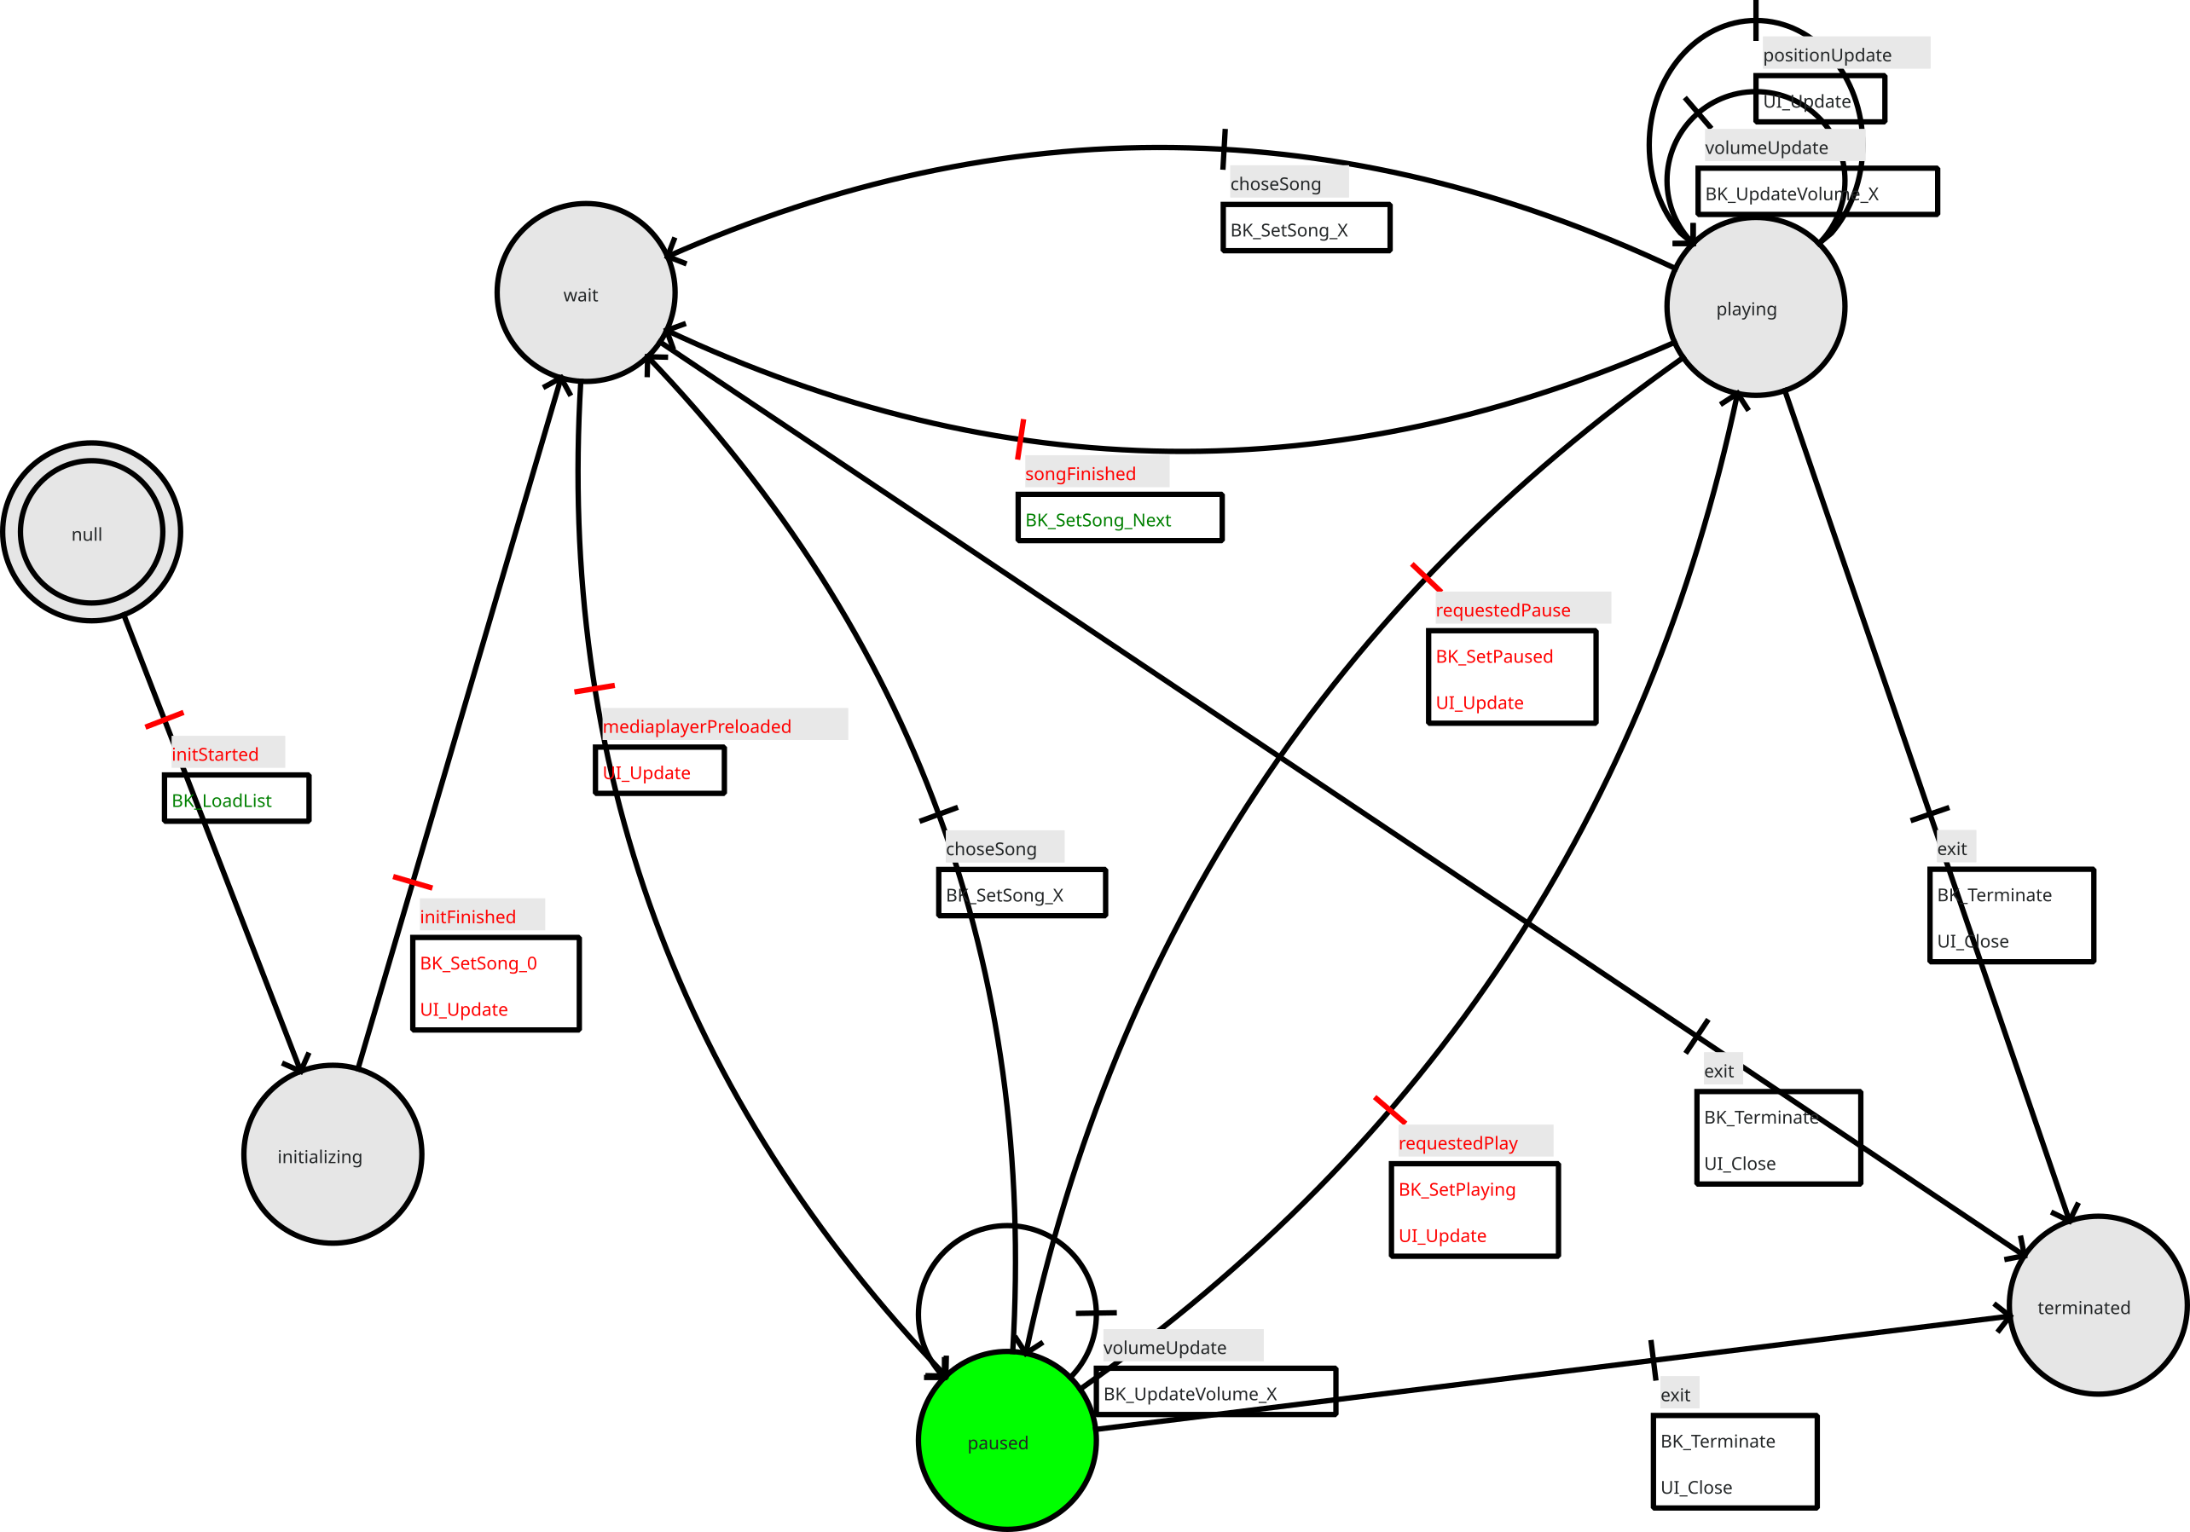
User closed the application which issues an exit event.  This sets the state engine into state terminated.  State machine first calls BK_Terminate () which cleans up any traces (close audio streams etc.) and updates the frontend (UI) so it shows that we exit. | 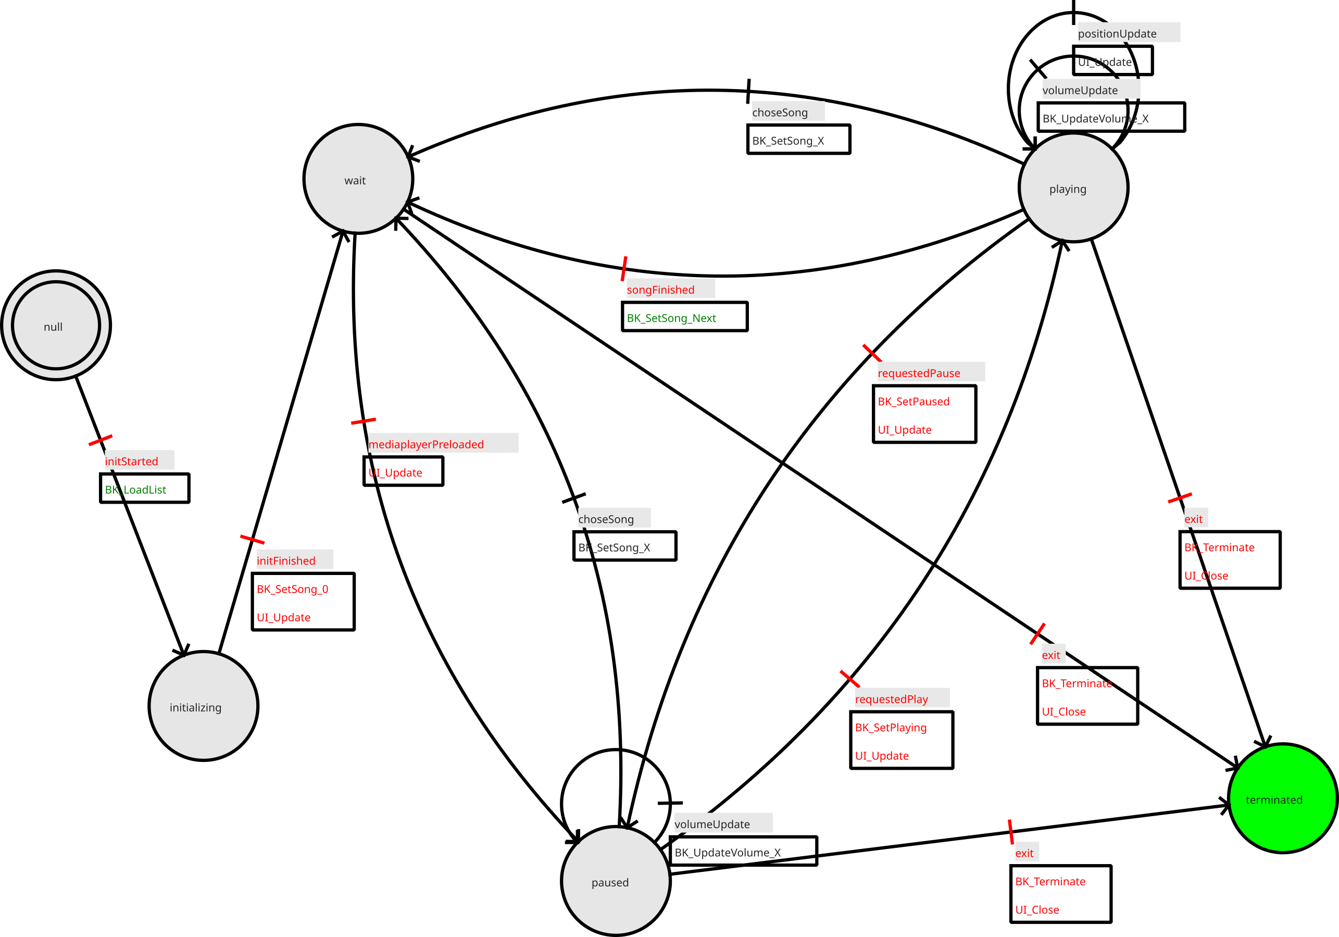

Lesson 5: The backend
Objective: We build the backend layer which controls audio system and provides a simple playlist management.

Lesson 6: The controller II
Objective: We integrate controller and audio backend and connect it with the GUI.

Lesson 7: WEB GUI, visual design
Objective: We design a simple web GUI (HTML + CSS).

Lesson 8: Player, web service
Objective: We design the player's web backend (Web + web socket server + delegate).

Lesson 9: Integrating web GUI and web service.
Objective: We design a javascript library which communicates with the player's web service to send user requests (track choice, volume updates, ...), receive server information (track infos, track position, volume, ...) and update the web GUI

Appendix A (Source code)

Listing 1:
- # -*- coding: utf-8 -*-

- # Form implementation generated from reading ui file './gui.ui'
- #
- # Created by: PyQt4 UI code generator 4.12.1

- from PyQt4 import QtCore, QtGui

- try:
- _fromUtf8 = QtCore.QString.fromUtf8
- except AttributeError:
- def _fromUtf8(s):
- return s

- try:
- _encoding = QtGui.QApplication.UnicodeUTF8
- def _translate(context, text, disambig):
- return QtGui.QApplication.translate(context, text, disambig, _encoding)
- except AttributeError:
- def _translate(context, text, disambig):
- return QtGui.QApplication.translate(context, text, disambig)

- class Ui_MainWindow(object):
- def _Handle_BtnPlay_Click (self):
- """
- Event handler: User clicked "Play" button.
- """
- ... to be added later ...

- def _Handle_LstPlaylist_Select (self, item):
- """
- Event handler: User selected a song on the playlist.
- """
- ... to be added later ...

- def _Handle_SldVolume_Move (self, currentValue):
- """
- Event handler: User changed volume setting.
- """
- ... to be added later ...

- def setupUi(self, MainWindow):
- MainWindow.setObjectName(_fromUtf8("MainWindow"))
- MainWindow.resize(965, 600)
- self.centralwidget = QtGui.QWidget(MainWindow)
- self.centralwidget.setObjectName(_fromUtf8("centralwidget"))
- self.horizontalLayout = QtGui.QHBoxLayout(self.centralwidget)
- self.horizontalLayout.setObjectName(_fromUtf8("horizontalLayout"))
- self.verticalLayout = QtGui.QVBoxLayout()
- self.verticalLayout.setSizeConstraint(QtGui.QLayout.SetDefaultConstraint)
- self.verticalLayout.setContentsMargins(0, 0, 0, -1)
- self.verticalLayout.setObjectName(_fromUtf8("verticalLayout"))
- self.label = QtGui.QLabel(self.centralwidget)
- font = QtGui.QFont()
- font.setPointSize(14)
- font.setBold(True)
- font.setWeight(75)
- self.label.setFont(font)
- self.label.setTextFormat(QtCore.Qt.PlainText)
- self.label.setObjectName(_fromUtf8("label"))
- self.verticalLayout.addWidget(self.label)
- self.fLstSongs = QtGui.QListWidget(self.centralwidget)
- font = QtGui.QFont()
- font.setPointSize(14)
- font.setBold(True)
- font.setWeight(75)
- self.fLstSongs.setFont(font)
- self.fLstSongs.setVerticalScrollBarPolicy(QtCore.Qt.ScrollBarAlwaysOn)
- self.fLstSongs.setHorizontalScrollBarPolicy(QtCore.Qt.ScrollBarAlwaysOff)
- self.fLstSongs.setUniformItemSizes(False)
- self.fLstSongs.setSelectionRectVisible(True)
- self.fLstSongs.setObjectName(_fromUtf8("fLstSongs"))
- self.verticalLayout.addWidget(self.fLstSongs)
- self.horizontalLayout.addLayout(self.verticalLayout)
- self.line = QtGui.QFrame(self.centralwidget)
- self.line.setFrameShape(QtGui.QFrame.VLine)
- self.line.setFrameShadow(QtGui.QFrame.Sunken)
- self.line.setObjectName(_fromUtf8("line"))
- self.horizontalLayout.addWidget(self.line)
- self.frame = QtGui.QFrame(self.centralwidget)
- sizePolicy = QtGui.QSizePolicy(
- QtGui.QSizePolicy.Minimum, QtGui.QSizePolicy.Preferred)
- sizePolicy.setHorizontalStretch(0)
- sizePolicy.setVerticalStretch(0)
- sizePolicy.setHeightForWidth(
- self.frame.sizePolicy().hasHeightForWidth())
- self.frame.setSizePolicy(sizePolicy)
- self.frame.setMinimumSize(QtCore.QSize(640, 0))
- self.frame.setFrameShape(QtGui.QFrame.StyledPanel)
- self.frame.setFrameShadow(QtGui.QFrame.Raised)
- self.frame.setLineWidth(0)
- self.frame.setObjectName(_fromUtf8("frame"))
- self.verticalLayout_3 = QtGui.QVBoxLayout(self.frame)
- self.verticalLayout_3.setObjectName(_fromUtf8("verticalLayout_3"))
- self.frame_2 = QtGui.QFrame(self.frame)
- self.frame_2.setFrameShape(QtGui.QFrame.NoFrame)
- self.frame_2.setFrameShadow(QtGui.QFrame.Raised)
- self.frame_2.setObjectName(_fromUtf8("frame_2"))
- self.verticalLayout_2 = QtGui.QVBoxLayout(self.frame_2)
- self.verticalLayout_2.setObjectName(_fromUtf8("verticalLayout_2"))
- spacerItem = QtGui.QSpacerItem(
- 20, 84, QtGui.QSizePolicy.Minimum, QtGui.QSizePolicy.Expanding)
- self.verticalLayout_2.addItem(spacerItem)
- self.fLblSongTitle = QtGui.QLabel(self.frame_2)
- font = QtGui.QFont()
- font.setPointSize(14)
- self.fLblSongTitle.setFont(font)
- self.fLblSongTitle.setAlignment(QtCore.Qt.AlignCenter)
- self.fLblSongTitle.setObjectName(_fromUtf8("fLblSongTitle"))
- self.verticalLayout_2.addWidget(self.fLblSongTitle)
- self.frame_3 = QtGui.QFrame(self.frame_2)
- self.frame_3.setFrameShape(QtGui.QFrame.NoFrame)
- self.frame_3.setFrameShadow(QtGui.QFrame.Raised)
- self.frame_3.setObjectName(_fromUtf8("frame_3"))
- self.horizontalLayout_2 = QtGui.QHBoxLayout(self.frame_3)
- self.horizontalLayout_2.setObjectName(_fromUtf8("horizontalLayout_2"))
- spacerItem1 = QtGui.QSpacerItem(
- 197, 20, QtGui.QSizePolicy.Expanding, QtGui.QSizePolicy.Minimum)
- self.horizontalLayout_2.addItem(spacerItem1)
- self.fBtnPlay = QtGui.QPushButton(self.frame_3)
- self.fBtnPlay.setMinimumSize(QtCore.QSize(188, 78))
- font = QtGui.QFont()
- font.setPointSize(26)
- font.setBold(True)
- font.setWeight(75)
- self.fBtnPlay.setFont(font)
- self.fBtnPlay.setCheckable(False)
- self.fBtnPlay.setObjectName(_fromUtf8("fBtnPlay"))
- self.horizontalLayout_2.addWidget(self.fBtnPlay)
- spacerItem2 = QtGui.QSpacerItem(
- 197, 20, QtGui.QSizePolicy.Expanding, QtGui.QSizePolicy.Minimum)
- self.horizontalLayout_2.addItem(spacerItem2)
- self.verticalLayout_2.addWidget(self.frame_3)
- self.fLblTime = QtGui.QLabel(self.frame_2)
- font = QtGui.QFont()
- font.setPointSize(23)
- self.fLblTime.setFont(font)
- self.fLblTime.setAlignment(QtCore.Qt.AlignCenter)
- self.fLblTime.setObjectName(_fromUtf8("fLblTime"))
- self.verticalLayout_2.addWidget(self.fLblTime)
- spacerItem3 = QtGui.QSpacerItem(
- 20, 200, QtGui.QSizePolicy.Minimum, QtGui.QSizePolicy.Expanding)
- self.verticalLayout_2.addItem(spacerItem3)
- self.verticalLayout_3.addWidget(self.frame_2)
- self.line_2 = QtGui.QFrame(self.frame)
- self.line_2.setFrameShape(QtGui.QFrame.HLine)
- self.line_2.setFrameShadow(QtGui.QFrame.Sunken)
- self.line_2.setObjectName(_fromUtf8("line_2"))
- self.verticalLayout_3.addWidget(self.line_2)
- self.frame_4 = QtGui.QFrame(self.frame)
- self.frame_4.setFrameShape(QtGui.QFrame.NoFrame)
- self.frame_4.setFrameShadow(QtGui.QFrame.Raised)
- self.frame_4.setObjectName(_fromUtf8("frame_4"))
- self.horizontalLayout_3 = QtGui.QHBoxLayout(self.frame_4)
- self.horizontalLayout_3.setObjectName(_fromUtf8("horizontalLayout_3"))
- spacerItem4 = QtGui.QSpacerItem(
- 40, 20, QtGui.QSizePolicy.Expanding, QtGui.QSizePolicy.Minimum)
- self.horizontalLayout_3.addItem(spacerItem4)
- self.label_2 = QtGui.QLabel(self.frame_4)
- self.label_2.setObjectName(_fromUtf8("label_2"))
- self.horizontalLayout_3.addWidget(self.label_2)
- self.fSldVolume = QtGui.QSlider(self.frame_4)
- sizePolicy = QtGui.QSizePolicy(
- QtGui.QSizePolicy.Fixed, QtGui.QSizePolicy.Fixed)
- sizePolicy.setHorizontalStretch(0)
- sizePolicy.setVerticalStretch(0)
- sizePolicy.setHeightForWidth(
- self.fSldVolume.sizePolicy().hasHeightForWidth())
- self.fSldVolume.setSizePolicy(sizePolicy)
- self.fSldVolume.setMinimumSize(QtCore.QSize(225, 0))
- self.fSldVolume.setBaseSize(QtCore.QSize(0, 0))
- self.fSldVolume.setAcceptDrops(False)
- self.fSldVolume.setTracking(True)
- self.fSldVolume.setOrientation(QtCore.Qt.Horizontal)
- self.fSldVolume.setInvertedAppearance(False)
- self.fSldVolume.setInvertedControls(False)
- self.fSldVolume.setObjectName(_fromUtf8("fSldVolume"))
- self.horizontalLayout_3.addWidget(self.fSldVolume)
- self.verticalLayout_3.addWidget(self.frame_4)
- self.horizontalLayout.addWidget(self.frame)
- MainWindow.setCentralWidget(self.centralwidget)
- self.menubar = QtGui.QMenuBar(MainWindow)
- self.menubar.setGeometry(QtCore.QRect(0, 0, 965, 31))
- self.menubar.setObjectName(_fromUtf8("menubar"))
- MainWindow.setMenuBar(self.menubar)
- self.statusbar = QtGui.QStatusBar(MainWindow)
- self.statusbar.setObjectName(_fromUtf8("statusbar"))
- MainWindow.setStatusBar(self.statusbar)

- self.fBtnPlay.clicked.connect (self._Handle_BtnPlay_Click)
- self.fLstPlaylist.itemClicked.connect (self._Handle_LstPlaylist_Select)
- self.fSldVolume.sliderMoved.connect (self._Handle_SldVolume_Move)

- QtCore.QMetaObject.connectSlotsByName(MainWindow)

- def retranslateUi(self, MainWindow):
- MainWindow.setWindowTitle(_translate("MainWindow", "myplayer", None))
- self.label.setText(_translate("MainWindow", "Songlist", None))
- self.fLblSongTitle.setText(
- _translate("MainWindow", "Artist - Track", None))
- self.fBtnPlay.setText(_translate("MainWindow", "Play", None))
- self.fLblTime.setText(_translate("MainWindow", "00:00", None))
- self.label_2.setText(_translate("MainWindow", "Volume", None))

- if __name__ == "__main__":
- import sys
- app = QtGui.QApplication(sys.argv)
- MainWindow = QtGui.QMainWindow()
- ui = Ui_MainWindow()
- ui.setupUi(MainWindow)
- MainWindow.show()
- sys.exit(app.exec_())

Listing 2: Lesson 3, gui.py
- # -*- coding: utf-8 -*-

- # Form implementation generated from reading ui file './gui.ui'
- #

- from PyQt4 import QtCore, QtGui

- try:
- _fromUtf8 = QtCore.QString.fromUtf8
- except AttributeError:
- def _fromUtf8(s):
- return s

- try:
- _encoding = QtGui.QApplication.UnicodeUTF8
- def _translate(context, text, disambig):
- return QtGui.QApplication.translate(context, text, disambig, _encoding)
- except AttributeError:
- def _translate(context, text, disambig):
- return QtGui.QApplication.translate(context, text, disambig)

- class Ui_MainWindow(object):
- def setupUi(self, MainWindow):
- MainWindow.setObjectName(_fromUtf8("MainWindow"))
- MainWindow.resize(965, 600)
- self.centralwidget = QtGui.QWidget(MainWindow)
- self.centralwidget.setObjectName(_fromUtf8("centralwidget"))
- self.horizontalLayout = QtGui.QHBoxLayout(self.centralwidget)
- self.horizontalLayout.setObjectName(_fromUtf8("horizontalLayout"))
- self.verticalLayout = QtGui.QVBoxLayout()
- self.verticalLayout.setSizeConstraint(QtGui.QLayout.SetDefaultConstraint)
- self.verticalLayout.setContentsMargins(0, 0, 0, -1)
- self.verticalLayout.setObjectName(_fromUtf8("verticalLayout"))
- self.label = QtGui.QLabel(self.centralwidget)
- font = QtGui.QFont()
- font.setPointSize(14)
- font.setBold(True)
- font.setWeight(75)
- self.label.setFont(font)
- self.label.setTextFormat(QtCore.Qt.PlainText)
- self.label.setObjectName(_fromUtf8("label"))
- self.verticalLayout.addWidget(self.label)
- self.fLstSongs = QtGui.QListWidget(self.centralwidget)
- font = QtGui.QFont()
- font.setPointSize(14)
- font.setBold(True)
- font.setWeight(75)
- self.fLstSongs.setFont(font)
- self.fLstSongs.setVerticalScrollBarPolicy(QtCore.Qt.ScrollBarAlwaysOn)
- self.fLstSongs.setHorizontalScrollBarPolicy(QtCore.Qt.ScrollBarAlwaysOff)
- self.fLstSongs.setUniformItemSizes(False)
- self.fLstSongs.setSelectionRectVisible(True)
- self.fLstSongs.setObjectName(_fromUtf8("fLstSongs"))
- self.verticalLayout.addWidget(self.fLstSongs)
- self.horizontalLayout.addLayout(self.verticalLayout)
- self.line = QtGui.QFrame(self.centralwidget)
- self.line.setFrameShape(QtGui.QFrame.VLine)
- self.line.setFrameShadow(QtGui.QFrame.Sunken)
- self.line.setObjectName(_fromUtf8("line"))
- self.horizontalLayout.addWidget(self.line)
- self.frame = QtGui.QFrame(self.centralwidget)
- sizePolicy = QtGui.QSizePolicy(QtGui.QSizePolicy.Minimum, QtGui.QSizePolicy.Preferred)
- sizePolicy.setHorizontalStretch(0)
- sizePolicy.setVerticalStretch(0)
- sizePolicy.setHeightForWidth(self.frame.sizePolicy().hasHeightForWidth())
- self.frame.setSizePolicy(sizePolicy)
- self.frame.setMinimumSize(QtCore.QSize(640, 0))
- self.frame.setFrameShape(QtGui.QFrame.StyledPanel)
- self.frame.setFrameShadow(QtGui.QFrame.Raised)
- self.frame.setLineWidth(0)
- self.frame.setObjectName(_fromUtf8("frame"))
- self.verticalLayout_3 = QtGui.QVBoxLayout(self.frame)
- self.verticalLayout_3.setObjectName(_fromUtf8("verticalLayout_3"))
- self.frame_2 = QtGui.QFrame(self.frame)
- self.frame_2.setFrameShape(QtGui.QFrame.NoFrame)
- self.frame_2.setFrameShadow(QtGui.QFrame.Raised)
- self.frame_2.setObjectName(_fromUtf8("frame_2"))
- self.verticalLayout_2 = QtGui.QVBoxLayout(self.frame_2)
- self.verticalLayout_2.setObjectName(_fromUtf8("verticalLayout_2"))
- spacerItem = QtGui.QSpacerItem(20, 84, QtGui.QSizePolicy.Minimum, QtGui.QSizePolicy.Expanding)
- self.verticalLayout_2.addItem(spacerItem)
- self.fLblSongTitle = QtGui.QLabel(self.frame_2)
- font = QtGui.QFont()
- font.setPointSize(14)
- self.fLblSongTitle.setFont(font)
- self.fLblSongTitle.setAlignment(QtCore.Qt.AlignCenter)
- self.fLblSongTitle.setObjectName(_fromUtf8("fLblSongTitle"))
- self.verticalLayout_2.addWidget(self.fLblSongTitle)
- self.frame_3 = QtGui.QFrame(self.frame_2)
- self.frame_3.setFrameShape(QtGui.QFrame.NoFrame)
- self.frame_3.setFrameShadow(QtGui.QFrame.Raised)
- self.frame_3.setObjectName(_fromUtf8("frame_3"))
- self.horizontalLayout_2 = QtGui.QHBoxLayout(self.frame_3)
- self.horizontalLayout_2.setObjectName(_fromUtf8("horizontalLayout_2"))
- spacerItem1 = QtGui.QSpacerItem(197, 20, QtGui.QSizePolicy.Expanding, QtGui.QSizePolicy.Minimum)
- self.horizontalLayout_2.addItem(spacerItem1)
- self.fBtnPlay = QtGui.QPushButton(self.frame_3)
- self.fBtnPlay.setMinimumSize(QtCore.QSize(188, 78))
- font = QtGui.QFont()
- font.setPointSize(26)
- font.setBold(True)
- font.setWeight(75)
- self.fBtnPlay.setFont(font)
- self.fBtnPlay.setCheckable(False)
- self.fBtnPlay.setObjectName(_fromUtf8("fBtnPlay"))
- self.horizontalLayout_2.addWidget(self.fBtnPlay)
- spacerItem2 = QtGui.QSpacerItem(197, 20, QtGui.QSizePolicy.Expanding, QtGui.QSizePolicy.Minimum)
- self.horizontalLayout_2.addItem(spacerItem2)
- self.verticalLayout_2.addWidget(self.frame_3)
- self.fLblTime = QtGui.QLabel(self.frame_2)
- font = QtGui.QFont()
- font.setPointSize(23)
- self.fLblTime.setFont(font)
- self.fLblTime.setAlignment(QtCore.Qt.AlignCenter)
- self.fLblTime.setObjectName(_fromUtf8("fLblTime"))
- self.verticalLayout_2.addWidget(self.fLblTime)
- spacerItem3 = QtGui.QSpacerItem(20, 200, QtGui.QSizePolicy.Minimum, QtGui.QSizePolicy.Expanding)
- self.verticalLayout_2.addItem(spacerItem3)
- self.verticalLayout_3.addWidget(self.frame_2)
- self.line_2 = QtGui.QFrame(self.frame)
- self.line_2.setFrameShape(QtGui.QFrame.HLine)
- self.line_2.setFrameShadow(QtGui.QFrame.Sunken)
- self.line_2.setObjectName(_fromUtf8("line_2"))
- self.verticalLayout_3.addWidget(self.line_2)
- self.frame_4 = QtGui.QFrame(self.frame)
- self.frame_4.setFrameShape(QtGui.QFrame.NoFrame)
- self.frame_4.setFrameShadow(QtGui.QFrame.Raised)
- self.frame_4.setObjectName(_fromUtf8("frame_4"))
- self.horizontalLayout_3 = QtGui.QHBoxLayout(self.frame_4)
- self.horizontalLayout_3.setObjectName(_fromUtf8("horizontalLayout_3"))
- spacerItem4 = QtGui.QSpacerItem(40, 20, QtGui.QSizePolicy.Expanding, QtGui.QSizePolicy.Minimum)
- self.horizontalLayout_3.addItem(spacerItem4)
- self.label_2 = QtGui.QLabel(self.frame_4)
- self.label_2.setObjectName(_fromUtf8("label_2"))
- self.horizontalLayout_3.addWidget(self.label_2)
- self.fSldVolume = QtGui.QSlider(self.frame_4)
- sizePolicy = QtGui.QSizePolicy(QtGui.QSizePolicy.Fixed, QtGui.QSizePolicy.Fixed)
- sizePolicy.setHorizontalStretch(0)
- sizePolicy.setVerticalStretch(0)
- sizePolicy.setHeightForWidth(self.fSldVolume.sizePolicy().hasHeightForWidth())
- self.fSldVolume.setSizePolicy(sizePolicy)
- self.fSldVolume.setMinimumSize(QtCore.QSize(225, 0))
- self.fSldVolume.setBaseSize(QtCore.QSize(0, 0))
- self.fSldVolume.setAcceptDrops(False)
- self.fSldVolume.setTracking(True)
- self.fSldVolume.setOrientation(QtCore.Qt.Horizontal)
- self.fSldVolume.setInvertedAppearance(False)
- self.fSldVolume.setInvertedControls(False)
- self.fSldVolume.setObjectName(_fromUtf8("fSldVolume"))
- self.horizontalLayout_3.addWidget(self.fSldVolume)
- self.verticalLayout_3.addWidget(self.frame_4)
- self.horizontalLayout.addWidget(self.frame)
- MainWindow.setCentralWidget(self.centralwidget)
- self.menubar = QtGui.QMenuBar(MainWindow)
- self.menubar.setGeometry(QtCore.QRect(0, 0, 965, 31))
- self.menubar.setObjectName(_fromUtf8("menubar"))
- MainWindow.setMenuBar(self.menubar)
- self.statusbar = QtGui.QStatusBar(MainWindow)
- self.statusbar.setObjectName(_fromUtf8("statusbar"))
- MainWindow.setStatusBar(self.statusbar)

- self.retranslateUi(MainWindow)
- QtCore.QMetaObject.connectSlotsByName(MainWindow)

- def retranslateUi(self, MainWindow):
- MainWindow.setWindowTitle(_translate("MainWindow", "myplayer", None))
- self.label.setText(_translate("MainWindow", "Songlist", None))
- self.fLblSongTitle.setText(_translate("MainWindow", "Artist - Track", None))
- self.fBtnPlay.setText(_translate("MainWindow", "Play", None))
- self.fLblTime.setText(_translate("MainWindow", "00:00", None))
- self.label_2.setText(_translate("MainWindow", "Volume", None))

- if __name__ == "__main__":
- import sys
- app = QtGui.QApplication(sys.argv)
- MainWindow = QtGui.QMainWindow()
- ui = Ui_MainWindow()
- ui.setupUi(MainWindow)
- MainWindow.show()
- sys.exit(app.exec_())

Listing: Lesson 3, gui.py with event handlers
- # -*- coding: utf-8 -*-

- # Form implementation generated from reading ui file './gui.ui'
- #

- import sys

- from PyQt5 import QtCore, QtGui, QtWidgets

- class TUILocal:
- def __init__ (self, delegate):
- self.fApp = None
- self.fDelegate = delegate
- self.fWndMain = None

- def Handle_List_Click (self, item):
- pass

- def Handle_Play_Click (self):
- pass

- def Handle_Volume_Moved (self, currentValue):
- pass

- def UIStart (self):
- self.fDelegate.Handle_HasInitStarted ()
- self.fApp = QtWidgets.QApplication (sys.argv)
- self.fWndMain = QtWidgets.QMainWindow ()
- self._setupUi (self.fWndMain)
- self.fWndMain.show ()
- self.fDelegate.Handle_HasInitFinished ()
- self.fApp.exec ()

- def _setupUi(self, mainWindow):
- mainWindow.setObjectName("MainWindow")
- mainWindow.resize(965, 600)
- self.centralwidget = QtWidgets.QWidget(mainWindow)
- self.centralwidget.setObjectName("centralwidget")
- self.horizontalLayout = QtWidgets.QHBoxLayout(self.centralwidget)
- self.horizontalLayout.setObjectName("horizontalLayout")
- self.verticalLayout = QtWidgets.QVBoxLayout()
- self.verticalLayout.setSizeConstraint(QtWidgets.QLayout.SetDefaultConstraint)
- self.verticalLayout.setContentsMargins(0, 0, 0, -1)
- self.verticalLayout.setObjectName("verticalLayout")
- self.label = QtWidgets.QLabel(self.centralwidget)
- font = QtGui.QFont()
- font.setPointSize(14)
- font.setBold(True)
- font.setWeight(75)
- self.label.setFont(font)
- self.label.setTextFormat(QtCore.Qt.PlainText)
- self.label.setObjectName("label")
- self.verticalLayout.addWidget(self.label)
- self.fLstSongs = QtWidgets.QListWidget(self.centralwidget)
- font = QtGui.QFont()
- font.setPointSize(14)
- font.setBold(True)
- font.setWeight(75)
- self.fLstSongs.setFont(font)
- self.fLstSongs.setVerticalScrollBarPolicy(QtCore.Qt.ScrollBarAlwaysOn)
- self.fLstSongs.setHorizontalScrollBarPolicy(QtCore.Qt.ScrollBarAlwaysOff)
- self.fLstSongs.setUniformItemSizes(False)
- self.fLstSongs.setSelectionRectVisible(True)
- self.fLstSongs.setObjectName("fLstSongs")
- self.verticalLayout.addWidget(self.fLstSongs)
- self.horizontalLayout.addLayout(self.verticalLayout)
- self.line = QtWidgets.QFrame(self.centralwidget)
- self.line.setFrameShape(QtWidgets.QFrame.VLine)
- self.line.setFrameShadow(QtWidgets.QFrame.Sunken)
- self.line.setObjectName("line")
- self.horizontalLayout.addWidget(self.line)
- self.frame = QtWidgets.QFrame(self.centralwidget)
- sizePolicy = QtWidgets.QSizePolicy(QtWidgets.QSizePolicy.Minimum, QtWidgets.QSizePolicy.Preferred)
- sizePolicy.setHorizontalStretch(0)
- sizePolicy.setVerticalStretch(0)
- sizePolicy.setHeightForWidth(self.frame.sizePolicy().hasHeightForWidth())
- self.frame.setSizePolicy(sizePolicy)
- self.frame.setMinimumSize(QtCore.QSize(640, 0))
- self.frame.setFrameShape(QtWidgets.QFrame.StyledPanel)
- self.frame.setFrameShadow(QtWidgets.QFrame.Raised)
- self.frame.setLineWidth(0)
- self.frame.setObjectName("frame")
- self.verticalLayout_3 = QtWidgets.QVBoxLayout(self.frame)
- self.verticalLayout_3.setObjectName("verticalLayout_3")
- self.frame_2 = QtWidgets.QFrame(self.frame)
- self.frame_2.setFrameShape(QtWidgets.QFrame.NoFrame)
- self.frame_2.setFrameShadow(QtWidgets.QFrame.Raised)
- self.frame_2.setObjectName("frame_2")
- self.verticalLayout_2 = QtWidgets.QVBoxLayout(self.frame_2)
- self.verticalLayout_2.setObjectName("verticalLayout_2")
- spacerItem = QtWidgets.QSpacerItem(20, 84, QtWidgets.QSizePolicy.Minimum, QtWidgets.QSizePolicy.Expanding)
- self.verticalLayout_2.addItem(spacerItem)
- self.fLblSongTitle = QtWidgets.QLabel(self.frame_2)
- font = QtGui.QFont()
- font.setPointSize(14)
- self.fLblSongTitle.setFont(font)
- self.fLblSongTitle.setAlignment(QtCore.Qt.AlignCenter)
- self.fLblSongTitle.setObjectName("fLblSongTitle")
- self.verticalLayout_2.addWidget(self.fLblSongTitle)
- self.frame_3 = QtWidgets.QFrame(self.frame_2)
- self.frame_3.setFrameShape(QtWidgets.QFrame.NoFrame)
- self.frame_3.setFrameShadow(QtWidgets.QFrame.Raised)
- self.frame_3.setObjectName("frame_3")
- self.horizontalLayout_2 = QtWidgets.QHBoxLayout(self.frame_3)
- self.horizontalLayout_2.setObjectName("horizontalLayout_2")
- spacerItem1 = QtWidgets.QSpacerItem(197, 20, QtWidgets.QSizePolicy.Expanding, QtWidgets.QSizePolicy.Minimum)
- self.horizontalLayout_2.addItem(spacerItem1)
- self.fBtnPlay = QtWidgets.QPushButton(self.frame_3)
- self.fBtnPlay.setMinimumSize(QtCore.QSize(188, 78))
- font = QtGui.QFont()
- font.setPointSize(26)
- font.setBold(True)
- font.setWeight(75)
- self.fBtnPlay.setFont(font)
- self.fBtnPlay.setFocusPolicy (QtCore.Qt.NoFocus)
- self.fBtnPlay.setCheckable(False)
- self.fBtnPlay.setObjectName("fBtnPlay")
- self.horizontalLayout_2.addWidget(self.fBtnPlay)
- spacerItem2 = QtWidgets.QSpacerItem(197, 20, QtWidgets.QSizePolicy.Expanding, QtWidgets.QSizePolicy.Minimum)
- self.horizontalLayout_2.addItem(spacerItem2)
- self.verticalLayout_2.addWidget(self.frame_3)
- self.fLblTime = QtWidgets.QLabel(self.frame_2)
- font = QtGui.QFont()
- font.setPointSize(23)
- self.fLblTime.setFont(font)
- self.fLblTime.setAlignment(QtCore.Qt.AlignCenter)
- self.fLblTime.setObjectName("fLblTime")
- self.verticalLayout_2.addWidget(self.fLblTime)
- spacerItem3 = QtWidgets.QSpacerItem(20, 200, QtWidgets.QSizePolicy.Minimum, QtWidgets.QSizePolicy.Expanding)
- self.verticalLayout_2.addItem(spacerItem3)
- self.verticalLayout_3.addWidget(self.frame_2)
- self.line_2 = QtWidgets.QFrame(self.frame)
- self.line_2.setFrameShape(QtWidgets.QFrame.HLine)
- self.line_2.setFrameShadow(QtWidgets.QFrame.Sunken)
- self.line_2.setObjectName("line_2")
- self.verticalLayout_3.addWidget(self.line_2)
- self.frame_4 = QtWidgets.QFrame(self.frame)
- self.frame_4.setFrameShape(QtWidgets.QFrame.NoFrame)
- self.frame_4.setFrameShadow(QtWidgets.QFrame.Raised)
- self.frame_4.setObjectName("frame_4")
- self.horizontalLayout_3 = QtWidgets.QHBoxLayout(self.frame_4)
- self.horizontalLayout_3.setObjectName("horizontalLayout_3")
- spacerItem4 = QtWidgets.QSpacerItem(40, 20, QtWidgets.QSizePolicy.Expanding, QtWidgets.QSizePolicy.Minimum)
- self.horizontalLayout_3.addItem(spacerItem4)
- self.label_2 = QtWidgets.QLabel(self.frame_4)
- self.label_2.setObjectName("label_2")
- self.horizontalLayout_3.addWidget(self.label_2)
- self.fSldVolume = QtWidgets.QSlider(self.frame_4)
- sizePolicy = QtWidgets.QSizePolicy(QtWidgets.QSizePolicy.Fixed, QtWidgets.QSizePolicy.Fixed)
- sizePolicy.setHorizontalStretch(0)
- sizePolicy.setVerticalStretch(0)
- sizePolicy.setHeightForWidth(self.fSldVolume.sizePolicy().hasHeightForWidth())
- self.fSldVolume.setSizePolicy(sizePolicy)
- self.fSldVolume.setMinimumSize(QtCore.QSize(225, 0))
- self.fSldVolume.setBaseSize(QtCore.QSize(0, 0))
- self.fSldVolume.setAcceptDrops(False)
- self.fSldVolume.setTracking(True)
- self.fSldVolume.setOrientation(QtCore.Qt.Horizontal)
- self.fSldVolume.setInvertedAppearance(False)
- self.fSldVolume.setInvertedControls(False)
- self.fSldVolume.setObjectName("fSldVolume")
- self.horizontalLayout_3.addWidget(self.fSldVolume)
- self.verticalLayout_3.addWidget(self.frame_4)
- self.horizontalLayout.addWidget(self.frame)
- mainWindow.setCentralWidget(self.centralwidget)
- self.menubar = QtWidgets.QMenuBar(mainWindow)
- self.menubar.setGeometry(QtCore.QRect(0, 0, 965, 30))
- self.menubar.setObjectName("menubar")
- mainWindow.setMenuBar(self.menubar)
- self.statusbar = QtWidgets.QStatusBar(mainWindow)
- self.statusbar.setObjectName("statusbar")
- mainWindow.setStatusBar(self.statusbar)

- self.fBtnPlay.clicked.connect (self.Handle_Play_Click )
- self.fSldVolume.sliderMoved.connect (self.Handle_Volume_Moved )
- self.fLstSongs.itemClicked.connect (self.Handle_List_Click )

- mainWindow.setWindowTitle ("myplayer")
- self.label.setText ("Songlist")
- self.fLblSongTitle.setText ("Ivan Torrent - Beyond love")
- self.fBtnPlay.setText ("Play")
- self.fLblTime.setText ("00:00")
- self.label_2.setText ("Volume")

- QtCore.QMetaObject.connectSlotsByName(mainWindow)

In my own software work I often found that I was actually more productive when I designed the GUI first. It sort of was the next best thing to designing my program customer focused.
For the script's source, see Appendix A, Listing: Lesson 3, gui.py.
As you don't want to handle anything else you don't need any other event handlers.
Sorry, I mislead you... in Qt the textbox isn't called a textbox... it's actually called a line edit!
It's just a convention saying to others "Please don't use". In current python every method is (really) public.

