Write selects on the tables:

1. select all fields from universities,

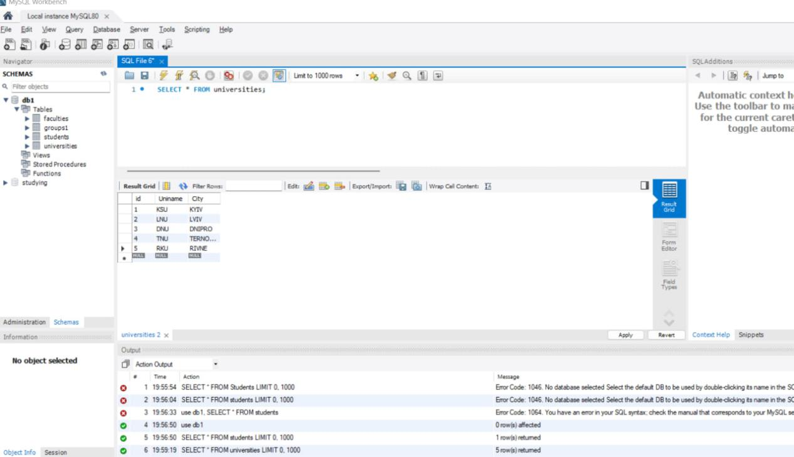

1. select only the first and last names of students,

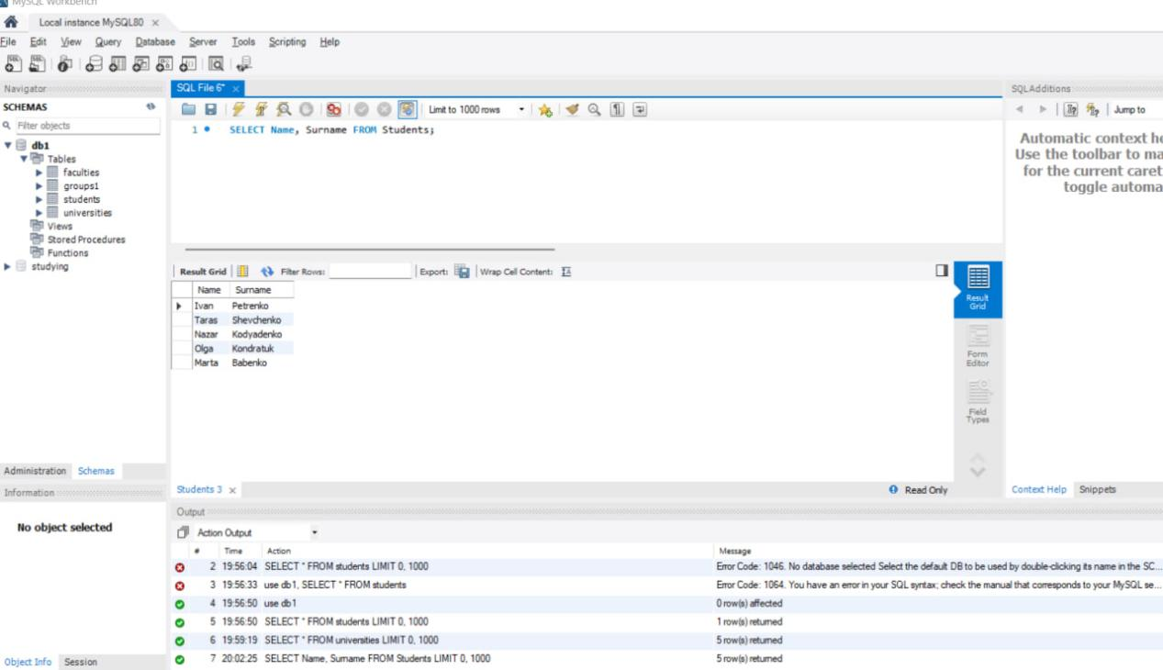

1. select only those students whose name is Ivan,

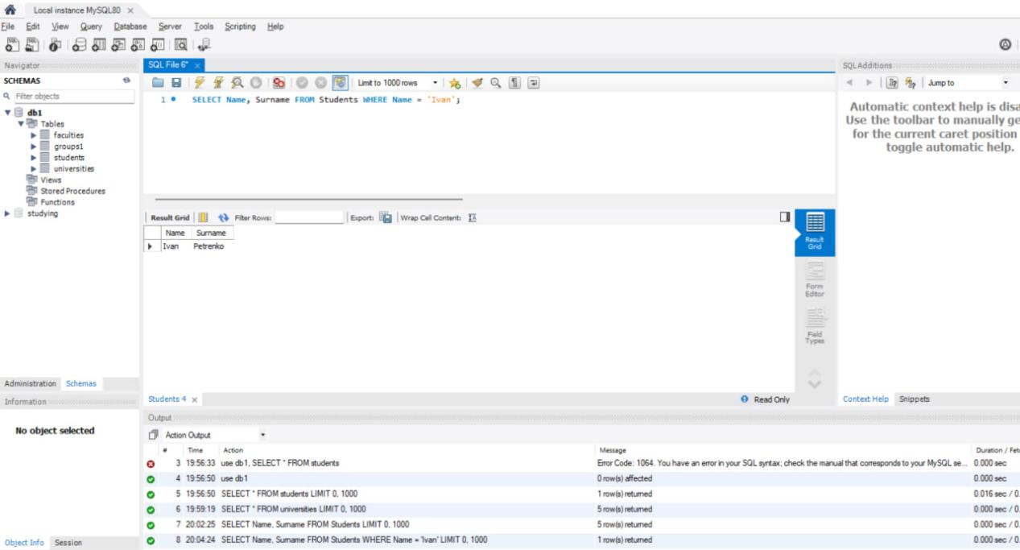

1. select only those groups whose numbers are greater than 300,

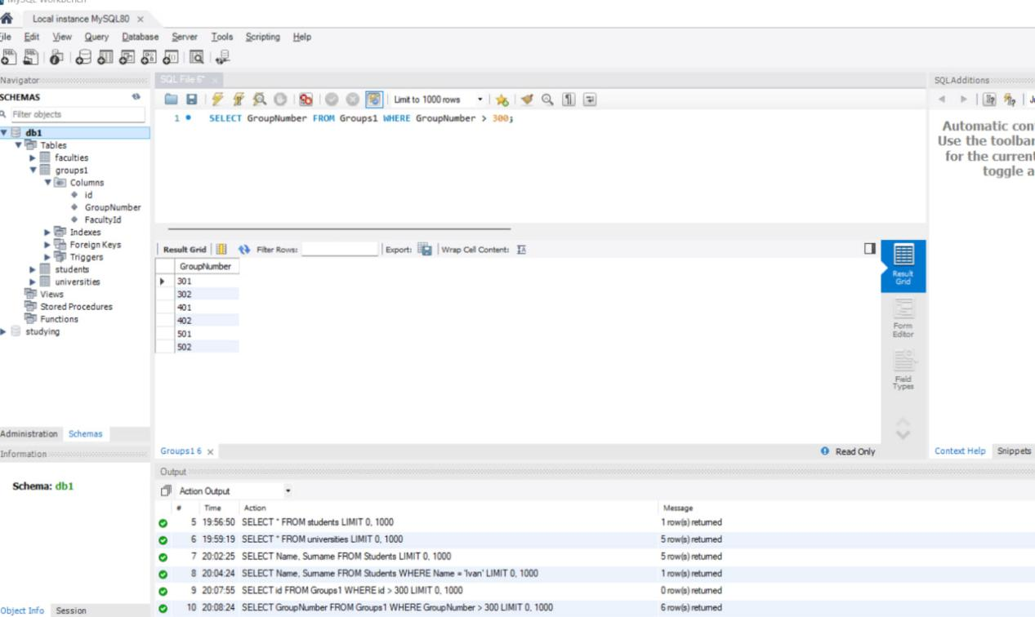

1. select only those universities that contain the letter U in their names.

