Write the following SQL commands (Do not use MySQL):

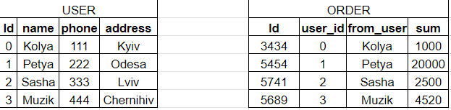

1. Retrieve the phone number and address of the user Muzik.

ELECT phone, address

FROM USER

WHERE name = 'Muzik';

1. Retrieve all users whose name ends with A

SELECT *

FROM USER

WHERE name LIKE '%a';

1. Retrieve data about users whose order amount is over 2000 UAH.

SELECT "USER".*

FROM "USER"

JOIN "ORDER" ON "USER".id = "ORDER".user_id

WHERE "ORDER".sum > 2000;

1. Count the number of orders in the table

SELECT COUNT(*) AS total_orders

FROM "ORDER";

e) Calculate the total amount of orders placed.

SELECT SUM(sum) AS total_sum

FROM "ORDER";

Write the following SQL commands (Do not use MySQL):

1. There is an imaginary table Workers (id. name, hireDate, profession). Get all Testers from the Workers table, sort by hire date

SELECT *

FROM Workers

WHERE profession = 'Тестувальник'

ORDER BY hireDate ASC;

1. Get the last 5 hired Testers from the Workers table

SELECT *

FROM Workers

WHERE profession = 'Тестувальник'

ORDER BY hireDate DESC

LIMIT 5;