In the databases, create tables, relationships between them and fill them with data. Requirements:

1. Universities table with columns Id, UniName, City. One or more universities in the name must contain the letter U (LNU, CHNU)

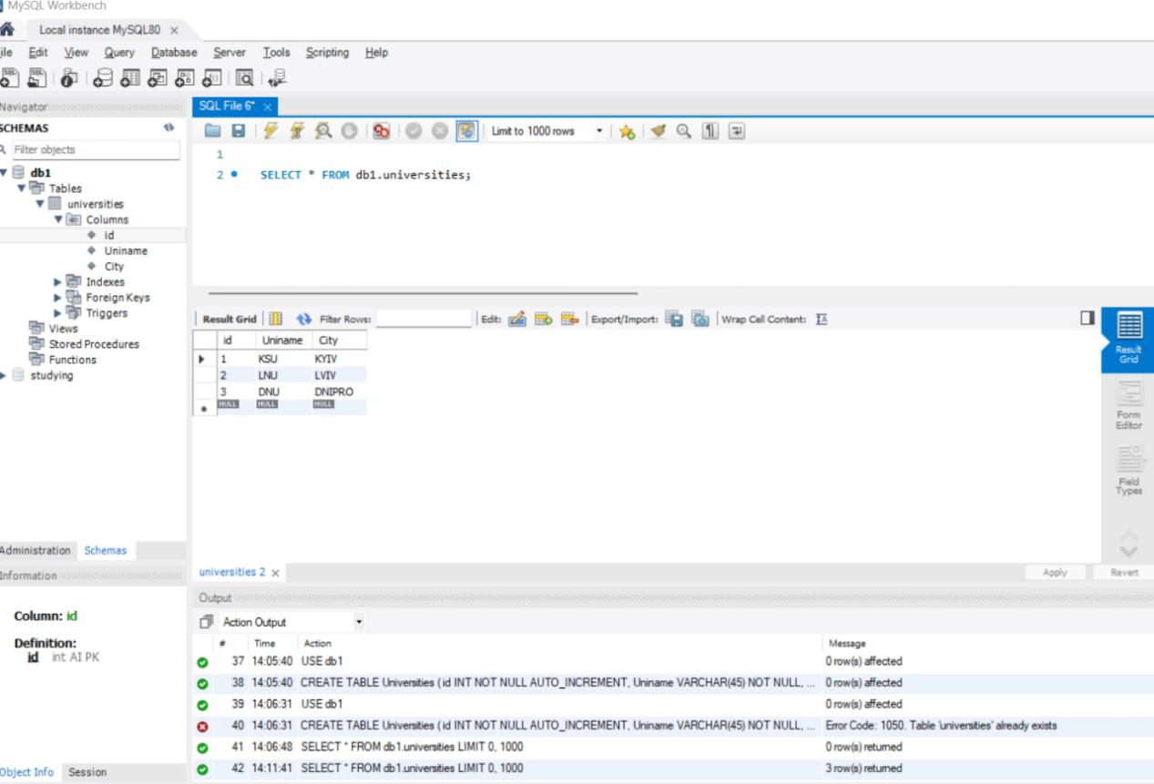

1. Faculties table with columns Id, Name, UniversityId (tied with a foreign key to the Universities table).

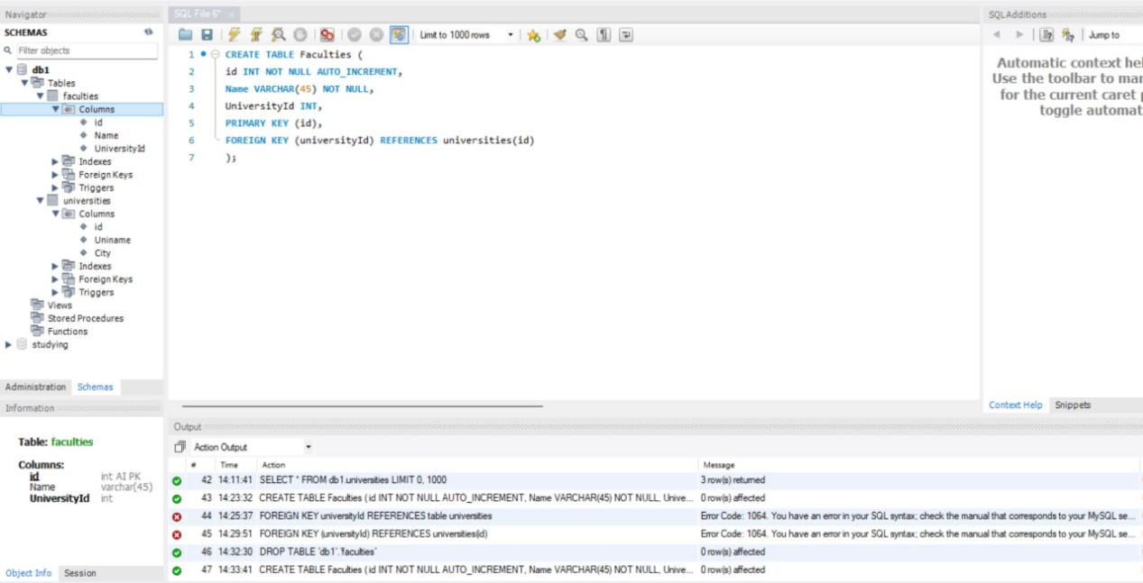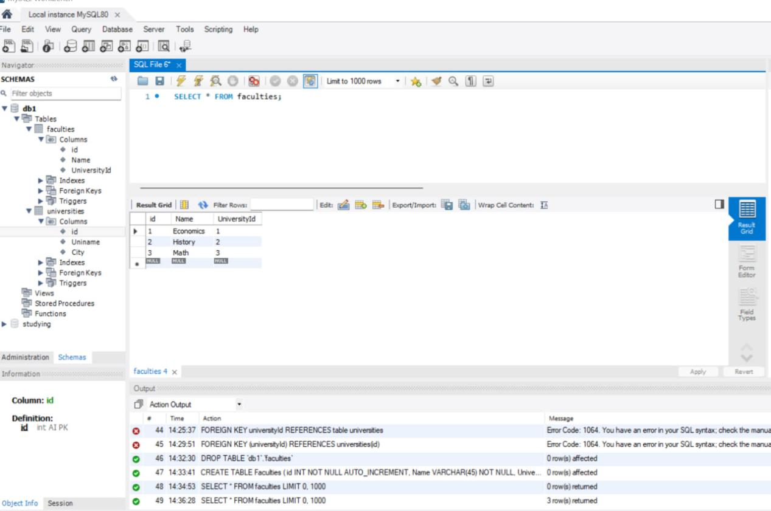

1. Groups table with branches Id, GroupNumber, FacultyId (tied with a foreign key to the Faculties table). When filling in, keep in mind that group numbers depend on the course. The first digit of the group always indicates the course (1 course = 102, 103, etc. group). Create one or two groups for each (1-5) course.

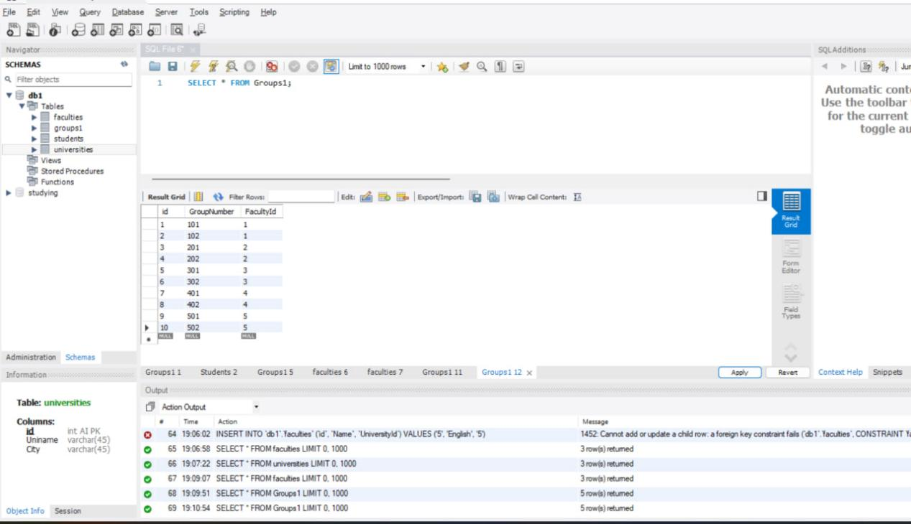

d) Students table with columns Id, Name, Surname, Age, GroupId (tied with a foreign key to the Groups table). When filling in, create one student with the name Ivan.

