Consumer

User ->

1. Name -> varchar(50), not null
2. Phone Number -> varchar(13) , not null, unique-> +91xxxxxxxxx
3. Email -> varchar(20), not null, unqiue, check(regex)
4. Username -> varchar(20) -> pk -> identity
5. Password -> varchar(20), check (for len and strength [@, &, %] )
6. Date of birth -> date
7. Address -> Text

Cards ->

1. User -> foreign key
2. Registration date -> null datetime (validity period)
3. Validity Upto -> dervied -> (registration date + 6 years) **
4. Registration number -> pk -> identity
5. Card Limit -> money (max credit limit on the card initially)
6. isActive -> Boolean default false
7. Card Type -> foreign key
   1. Type -> varchar(20) pk
   2. Charge -> money
   3. Credit limit -> money
8. Bank -> foreign key (if can be linked with ISFC)
   1. Bank -> varchar(20) pk
9. Savings account number -> varchar(20) not null unique
10. IFSC Code -> foreign key
    1. IFSC Code -> varchar(20)

Products ->

1. Product id -> int pk identity
2. Product Name -> Varchar(20) not null
3. Product Details -> text
4. Cost -> money not null
5. Image -> text not null (url)

Debit Transactions -> (check credit value > product value)

1. Transactionid -> int pk identity
2. User -> foreign key (Accounts)
3. Product -> foreign key (Products)
4. Schemes -> foreign key
   1. schemeName varchar(20) pk
5. Transaction datetime -> datetime
6. Instalment -> initial cost / scheme name
7. Last payment -> datetime
8. Balance left -> money (initial money by default)
9. isActive true by default (is balance left = 0, close transaction)

Credit Transactions -> ( isActive == true && balance left > 0)

1. debit transaction id -> foreign key (debit transaction)
2. Amount -> money
3. Datetime -> datetime

**DB**

Code First -> easy to work in a team

**Angular**

Pages ->

1. Product list (Home page) -> login not required
2. HeaderComponent
3. Courosel
4. SingularProductDetailComponent(@Input productName, productDetail, cost, imageurl)
5. Run the above in for loop to get the page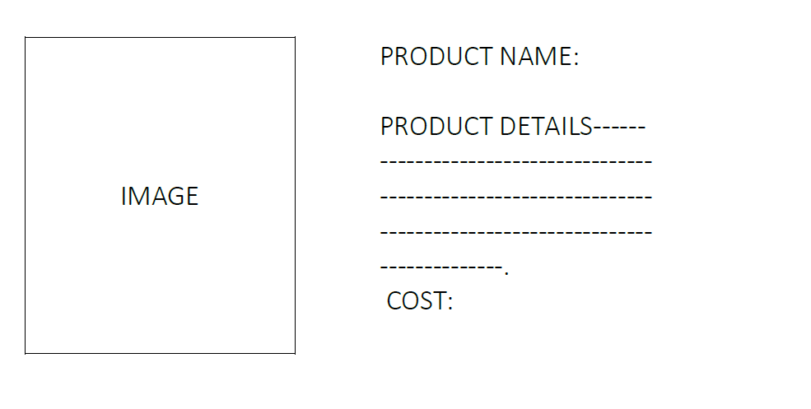
6. FooterComponent
7. Product detail (single product)

a. HeaderComponent

b.SingularProductDetailComponent(@Input productName, productDetail, cost, imageurl)



c. Emi dropdown and Emi Starts at

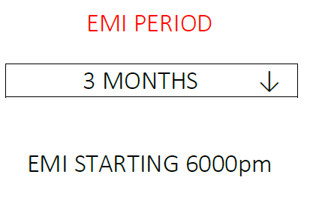

d. pay now

e. terms and conditions

f. footerComponent

1. Login
2. HeaderComponent
3. UserName & password input & links
4. FooterComponent
5. Register
6. HeaderComponent
7. Registration Form
8. Footer Component
9. Admin

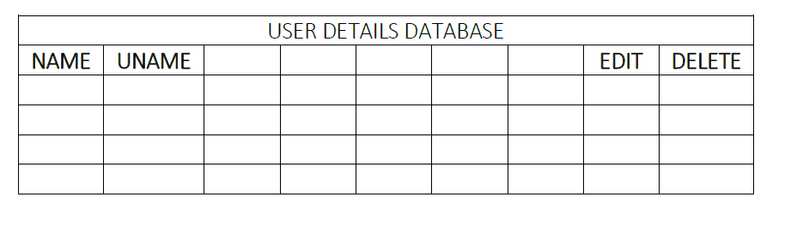

1. Table -> <td><input value=”$val”> fill in the rows dynamically post on edit button
2. Create another column for verify.. after clicking modal will come with a dialogue box
3. Think!
4. Admin Verification
5. Make another page with same content
6. Dashboard (profile)
7. HeaderComponent
8. EMICardComponent

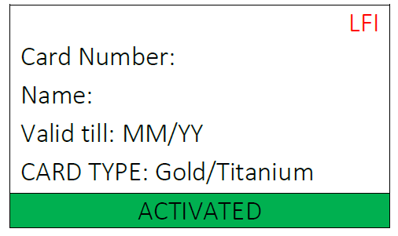

1. Show Details (fetch from backend)
2. FooterComponent
3. Forget Password
4. HeaderComponent
5. Form (UserName / Phone Number)
6. FooterComponent
7. Change Password
8. HeaderComponent
9. Form (UserName / Phone Number)
10. FooterComponent
11. Admin Login
12. HeaderComponent
13. UserName and Password fields
14. FooterComponent
15. Terms and conditions
16. list

Common Components->

1. Navbar
2. Footer

Authentication -> vraj (login/ register)

Products -> alok

Dashboard + Transactions -> shambhavi

Admin Verification -> rahul