MS.NET
Mini Project
Prometheus
Prometheus was the wisest of all.
His name means “forethought” and
He was able to foretell the future’

Document Revision History

Date | Revision No. | Author | Summary of Changes
17-07-2017 | 1.0 | Pankaj Patil | Initial Draft

Table of Contents
Introduction 4
Setup Checklist 4
Instructions 4
Problem Statement 5
Objective 5
Abstract of the project 5
Functional components of the project 5
Technology used: 8
Implementation 9
Summary of the functionality to be built: 9
Guidelines on the functionality to be built: 9

Introduction
This document outlines a mini project for the .NET Line of Technology (LOT). The project is to develop Prometheus. This document contains the requirements, work flow of the system and gives guidelines on how to build the functionality gradually in each of the course modules of the .NET LOT.

Setup Checklist
Minimum System Requirements
- Intel Pentium 4 and above Windows 2007, 2008 and 2010
- Memory 4 GB
- Internet Explorer 8.0 or higher
- SQL Server 2012 client and access to SQL Server 2012 server
- Visual Studio 2013

Instructions
- The code modules in the mini project should follow all the coding standards.
- Create a directory by your name in drive <drive>. In this directory, create a subdirectory MiniProject. Store your Project here.
- You can refer to your course material.
- You may also look up the help provided in the MSDN
- Since this project work will span over couple of months, you will need to take care of maintaining the code

Problem Statement

Objective
Development of Prometheus (means “forethought)
Abstract of the project
Prometheus is a system that can help teachers communicate homework to their students and that supports students in planning their homework. It is believed that the creation of this system is a solution to a problem that has been recognized in the education system. Students seem to have problems planning their homework, especially at the University where there are few contact hours. This system can solve this problem by providing functionalities that support planning.
The goal of this project is to develop a system that addresses the problem described in the problem description, i.e. a system that helps teachers communicate homework to students and helps students to plan those homework assignments.

Prometheus allows to store, process, retrieve and analyze information with respective to the administrative and inventory management
Users of the System will be: Student, Teacher and Administrator
Role of Student User:
- Can enroll for Courses.
- View their Homework.
- Devise a planning for their Homework
Role of Teacher User:
- Can schedule homework assignments for the courses they teach
- Can view all the homework assignments for their students
- Teacher cant view the planning of the students
Role of Admin User:
- Manage the application.
- Can add Teachers, Students and courses to the system.
- Can search Teachers, Students and courses to the system.
At this stage, only teachers can be administrators (and an administrator is always a teacher).

Requirements
This application is designed for students and teachers to help them plan their homework. The system will be an extension to Blackboard. The Prometheus application is a stand-alone application and only extends Blackboard in a way that it offers a possibility that Blackboard does not. Thus enrolling in a Blackboard course will not enroll the student in Prometheus. If Prometheus proves to be successful, the two systems can be integrated. For the time being Prometheus is designed as a stand-alone system however. The system should meet the following requirements.
- Teachers should be able to see which students are enrolled in the courses that they teach.
- Teachers should be able to add homework to the system, with the appropriate deadline and an estimate of the time required.
- The teacher should only be able to add homework for their own courses. The teacher should also be able to edit the homework. The homework deadline cannot occur the created date.
.
- Teachers should have an overview for each course, that tells them which other courses their Students have.
- Students should be able to enroll for the available courses. They should not be able to enroll in a course they are already enrolled to.
- Students should be able to see for which courses they are enrolled.
- Students should have an overview of all the homework in one course. The required time, the deadline and the content of the assignment can be read from this overview.
- Students should have an overview of all the homework that they are assigned to do.

Functional components of the project
Application Architecture:
Distributed web applications traditionally to be designed and built across three logical tiers:
- Database Access Layer (DAL)
- Business Logic Layer (BLL)
- Presentation Layer
The DAL refers to the database itself, the stored procedures, and the component that provides an interface to the database. The BLL refers to the component that encapsulates all the business logic of the application. And, the Presentation layer refers to the web application pages.
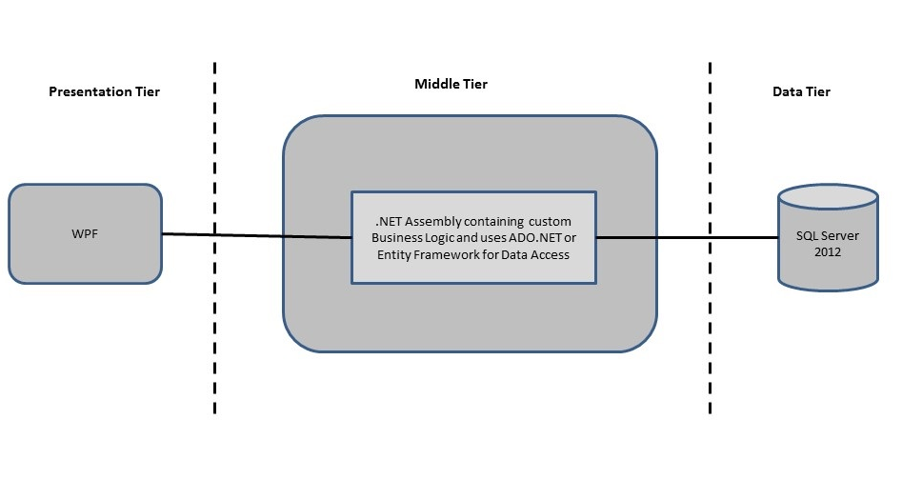
Design guidelines
- All the exceptions/errors to be captured and user friendly message to be displayed on the CommonError page.
- Data access layer of 3-tier use ADO.NET data access using SQL stored procedures - All the database interaction would be performed using Data Access Component. Most common methods in Data Access Component would be –
- Create Connection to the Database
- Create Command Object
- Set Command Type to Stored Procedure
- Create and Populate Parameters
- Execute the Command
- Close the Connection

Technology used:
    - Presentation Layer
      - WPF 4.5
    - Business Layer
      - Business Logic Components and Services :-
        - C# 5.0
    - Database Layer
      - Databases:-
        - SQL Server 2012

Implementation

Summary of the functionality to be built:
The participants need to develop the Prometheus System by building the functionality incrementally in each of the course modules of .NET LOT.
 | Sr. No |  | Course | Duration | Functionality to be built
 |  |  | Course | (in PDs) | Functionality to be built
 | 1 |  | MS SQL Server 2012 | 4 | Creating relevant database tables and stored procedures
 | 2 |  | NET Framework 4.5 + C# 5.0 | 7.5 | Developing Business components (C# classes)
 | 3 |  | ADO.NET 4.5 | 3 | Integrating the DAL ,BLL and PL
 | 4 |  | LINQ to Entity Framework | 2 | Creating data model and data context and using LINQ to entities
 | 5 |  | WPF 4.5 | 2 | Incorporating advanced UI functionality with WPF 4.5
 | 6 |  | Mini Project Presentation | 1 | The Mini Project Presentation day

Note: Saturday half day will be devoted for mini project

Guidelines on the functionality to be built:
The functionality and components to be built in each of the course modules of .NET LOT is as follows:
- Course: SQL Server 2012
This section describes some of the basic steps involved in designing and creation of the database for the application.
Create Data Model - identify the different tables and fields that we will need, which would later be used for building the rest of the application.
Database Schema - Taking these objects, we can easily identify our main tables in the database.
  - Create the following database tables with following fields: [make your assumptions in case you require few more fields]
      - Teacher :TeacherID, FName, LName Address, DOB, City, Password MobileNo, IsAdmin
      - Student : StudentID, FName,LName, Address, DOB, City, Password, MobileNo
      - Course : CourseID, CourseName, StartDate, EndDate
      - Teaches : TeacherID ,CourseID
      - Enrollment : CourseID, StudentID
      - Homework : HomeWorkID, Description, Deadline, ReqTime, LongDescription
      - Assignment : HomeWorkID, TeacherID, CourseID
- Course: WPF 4.5
  - Develop the prototypes for following functionalities:
    - Login / Sign In: Login screen would display asking user to enter ‘User Id’ & ‘Password’. If the supplied user credentials are valid the HomePage would be displayed, else appropriate Login error message would be displayed
    - Home Page: On successful user authentication (validation of userid/password provided by the user in login screen) the homepage would be displayed. The Homepage would contain below sections/contents:
Header section: The header section would be common across all the pages and would mainly have –
- Sign In Link – On click it would take to Login page
- Registration Link- On click it would take to Registration page
- Search: Search for information
Main content section: It would display generic Welcome message giving overview of the site. Should have menu for Teacher, Student and Admin

  - For Student:
        - User will get option to add, update the personal information
        - User will get option to Search
          - For available Courses.
          - For their Homework.
        - User will able to devise a planning for their Homework
  - For Teacher
    - User will option to add, update the personal information
    - View the details of all Courses
    - View the details of all Students
    - View all Homework assignments for their students

- Course: C# 5.0 and ADO.NET 4.5
  - Develop business components (C# classes) for the following functionality:
    - Student Class :- This class will Contain methods which will allow to manage all of the Student
    - Employee Class :- This class will Contain methods which will allow to manage all of the Employee
    - Course Class: - This class will contain methods which will allow to manage all of the Course.
    - Enrollment Class :- This class will Contain methods which will allow managing Enrollment
    - Homework Class :- This class will Contain methods which will allow managing Homework

You need to create Layered Architecture which comprises of Presentation Layer (winforms / WPF), Business Logic Layer (C# Classes) and DAL Layer (Using ADO.Net 4.5 / Linq and Entity Framework)
DAL Layer of ADO.NET 4.5 will include all the required code snippets for CRUD Operations.
All the CRUD operations should use SQL Server Stored Procedures (For Insert, Update, Delete and Search).
The connectionString should be stored in the configuration file only.
OR
- Course : LINQ and EF
  - Use the database first approach and create the Entity data model consist of the following entities :
    - Student Class :- This class will hold the details of the Student
    - Employee Class :- This class will hold the details of the Employee
    - Course Class: - This class will hold the details of the Course.
    - Enrollment Class :- This class will hold the details of the Enrollment
    - Homework Class :- This class will hold the details of the Homework
  - Use Data context to perform CRUD operations and Implement the required logic using LINQ (like retrieving data, sorting data, searching data etc).
- Course: ADO.NET 4.5 and WPF 4.5
  - Integrate all screens (sssWPF pages) with business components (C# classes) to complete the entire functionality Project Evaluation Guidelines
The project it is to be evaluated based on the following five parameters:
- Proper Database Structure and UI designing as per the specifications –(15 Marks)
  - Proper Database Design and Stored Procedure
  - Visual look and feel of the UI
- Project Completion – (20 Marks)
  - Timely Completion of the project
  - Integration of all component of the system
- Defect free execution – (30 Marks)
  - Error free execution of individual modules and the whole system
  - Validation
  - Functionality as per the specified requirements
- Compliance of standard and guidelines – (15 Marks)
  - Appropriate comments entries
  - Adherence to naming conventions for classes, functions, variables and files
  - Simplicity of user interface and screen layouts
  - Maintainability of codes (for example, no one function should be more than 100 lines)
- Group Presentation and Query handling – (20 Marks)
  - Participants (Group of 3 to 4) to present the project with UML Diagrams(use case diagram and one of the sequence or activity diagram) and PPT

