RDF File based Clipper Tool

The RDF File based Clipper is a tool that clips an RDF product (set of files) into another RDF product (set of files) representing a smaller geographical area or region. The RDF File Clipper requires no database and works purely on files.

The tool is developed and maintained by Nokia HERE Technical Customer Support.

# Hardware & Software Requirements

The biggest RDF region is Europe. To clip a larger country like Germany or Turkey out of Europe requires a machine with 6 GB physical RAM. To clip a larger city like Berlin out of Europe requires a machine with 2 GB physical RAM.  
The server needs sufficient disk space to store the loaderfiles of the full RDF and the loaderfiles of the clip.  
The clipper tool requires Java version 1.7 or higher. It is tested on Windows 7/8 32/64 bit and on 64 bit Ubuntu Linux.

# Starting the RDF Clipper

The RDF File can be started as a standalone command line tool, as standalone GUI tool, or from within the RDFViewer.

1. Start the RDF File Clipper as command line tool via clip_RDF.bat -h (Windows) or clip_RDF.sh -h (Linux). These scripts are in RDFViewer’s top level directory.

Clip_RDF.bat -h

RDF File based Clipper.  
Usage:

Clip_RDF.sh/.bat -rdf <PATH_TO_RDF> -countries DEU,AUT,CHE

Commad line options:

-rdf <source> RDF source directory>  
-out <target> RDF Clip target directory where the clipped files will be saved.  
-countries <countries> For example: DEU,AUT,CHE  
 OR  
-admins <admin IDs> For example: 21002623,21002891  
 OR  
-productregions <product region list> For example: NL,BB,G1,K2  
-h or --help or -? : print this message  
-gui : start with graphical user interface

1. Use the command line (see above) without command line parameters, e.g. double-click the clip_RDF.bat to launch the standalone GUI.

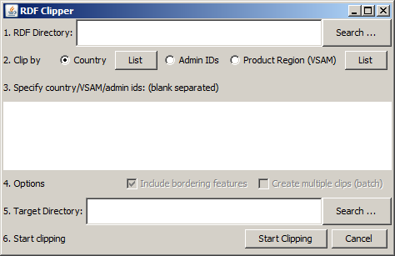

1. Start RDFViewer by executing run.bat (Windows) or run.sh (Linux) and open the RDF File clipper by clicking “Tools > Create RDF Clip”.  
   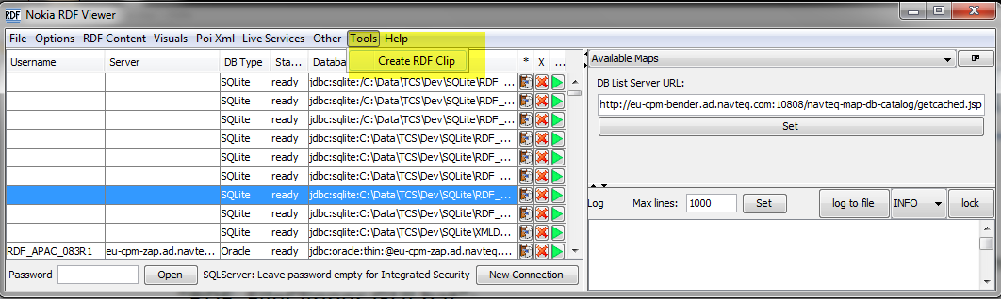

# The Graphical User Interface – Clipping Steps

There are 6 steps involved to create RDF clips – these are described below

## Specify RDF Directory

The downloaded tar files must be unpacked, but the files inside the folder can be leaved as ‘gz’ format. The installer is using the Oracle installation scripts even if it installs to a different database.

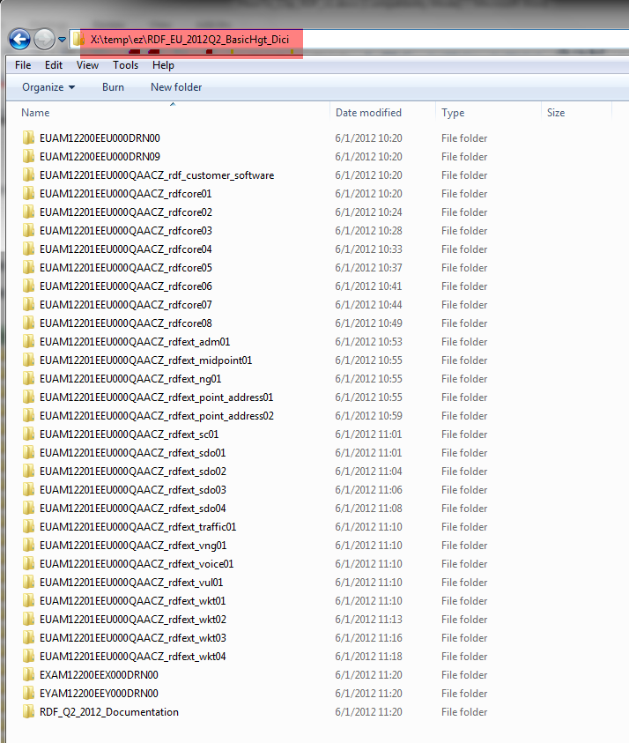 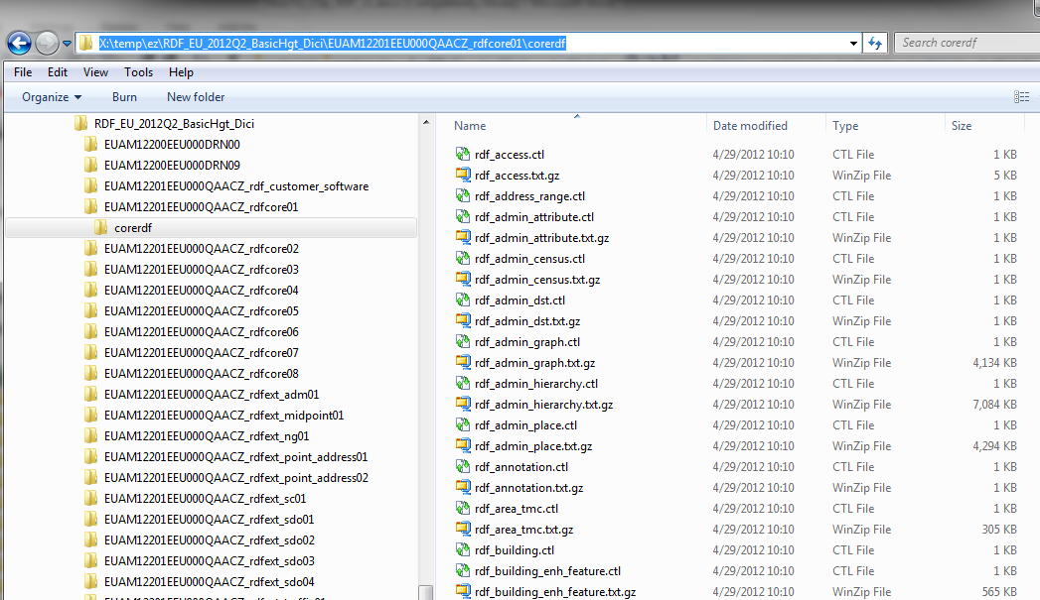

The parent folder of the unpacked files should be set as RDF Directory.

## Choose Clip Mode

There are 3 modes to select the region to be clipped:

* by ISO country code (e.g. DEU, FRA, LUX, MEX )
* by Administrative Area ID ( ID representing the administrative entity )
* by product region code ( VSAM code e.g. G1, F2, I3, … )

## Define the Content of the Clip

In *Country mode*, specify a (blank separated) list of ISO country codes. A list of all applicable country codes can be obtained by pressing the List button besides the Country radio button.

In *Admin mode*, specify a (blank separated) list of Admin Place IDs.  
Admin Places IDs can be an arbitrary mix from any level (builtup, order8, order2, order1 and country).

Admin Place IDs can be looked up in the RDF tables RDF_ADMIN_PLAC, RDF_FEATURE_NAMES and RDF_FEATURE_NAME with owner = ‘A’. The FEATURE_ID is the admin_place_id.

In *Product Region mode*, specify a (blank separated) list of region IDs (VSAMs). A list of all applicable product-region codes can be obtained by pressing the List button besides the Product Region (VSAM) radio button.

## Select options

Currently no options can be set – see also section ‘additional notes on RDF File Clipper’.

## Specify Target Directory

Enter or choose the target directory where the clipped RDF product files shall be stored.

## Start Clipping

Press the button to start clipping. The clipping process can last several hours, depending on the size of the original RDF, the size of the generated clip and the CPU and I/O performance of the server.

Once clipping completed successfully, the target directory has a structure identical to the original RDF directory.

# Some notes on the RDF File Clipper

## General

In general, only features that can be administratively associated to the clipping region identified are selected – features that can only be partially associated (so not fully covered by the area identified) are excluded from the clip.

However, there are some exceptions here:

* Area features are included, if at least one face is fully covered by the area identified – there by, only the applicable face will be included / selected
* Linear cartographic features (e.g. country boundaries) are included if at least one link is covered by the area identified – thereby, only the applicable links will be included
* Linear cartographic features representing administrative borders referencing administrative entities neighboring area identified are excluded
* If a zone is partially outside the selected area (so *spatially* only partially coved by the clip) the zone is included in the clip, however with only the applicable link-zone references.

## Clipping modes and feature selection

Both clipping modes *Country* and *Admin IDs* will trigger the same feature selection logic. In case of clipping mode *Country*, the set of ISO country-codes are mapped onto a set of underlying settlement and order-8 IDs, that are in turn used for feature selection. The same holds for clipping mode *Admin IDs*, each specified administrative area identified is mapped onto a set of underlying settlement and order-8 IDs

Clipping mode *Product Region* allows creating RDF clips with the same set of features as Nokia L&C customers would receive by other product-region based extracts such as our (legacy) extracts, for example SIF+. This feature was recently added to the RDF File Clipper to facilitate customer migrations to RDF without (significant) changes in their product-creation process.

In principle, the feature selection logic is the same as for the other clipping modes: the selected product-regions are translated into a set of (high-level) administrative areas that are mapped onto a set of underlying settlement and order-8 IDs

Additionally, the *Product Region* clipping mode additionally supports the following:

* Inclusion of selected (pre-identified) *enclaves* to prevent holes
* Exclusion of selected (pre-identified) *exclaves* to prevent non-connected road networks
* Inclusion of area features that are relevant for map-display (for the applicable area )

All product-region information utilized / processed by the RDF File Clipper is taken from the different SC_% tables that are shipped with each RDF product.

* Area definitions for each product region
* Exception links that might apply between product regions
* Pre-assigned area features

Please note that the information above is not utilized, when clipping modes *Country* or *Admin IDs* are used.

## Creating smaller clips

When smaller clips area created (e.g. a specified city), it *might* occur that some features are excluded unexpectedly, such a large rivers spanning large areas including the selected city.

The reason is that some larger area features are not necessarily *cut* by Nokia L&C along city- or *order8* borders and therefore not selected by the feature selection rules (see above)

This will not happen if RDF clips are created by *product-region*, since this is prevented by the Nokia L&C database coding rules (in other words, larger area features are always, cut along product-region borders)

Nokia L&C is considering to handle this by the RDF File Clipper in the future.