RDF Installation

# RDF Installation Prerequisites

Nokia does not provide tools for installing or configuring or managing a database server.  
Also it assumes that the (empty) database incl. schema, user, permissions, table spaces and data files are already created. Customers should use the standard database management tools to do this. On the installation machine, the required Database Clients must be installed.

# RDF Installation using the Workflow that comes with RDF

RDF comes with an installation script for Oracle. Please refer to the Installation Guide that comes with RDF.  
For SQLServer, PostgreSQL/PostGIS, SQLite, MySQL (and Oracle), customers can use RDF Installer tool that is delivered with the RDFViewer tool.  
Nokia does not recommend that customers install RDFs with manually created scripts, because the RDF schema keeps evolving and customers would have to adapt their scripts.

# RDF Installation via Command Line

This is recommended for customers that want to include the RDF installation as automated batch step into their compile process.

Start the RDF Installer via install_RDF.bat (Windows) or install_RDF.sh (Linux).

# RDF Installation via GUI

This is recommended for customers that want to manually install an RDF.

Start the RDF Viewer via run.bat (Windows) or run.sh (Linux). Connect to the (empty) database. Select “Tools” - “RDF Installer”:

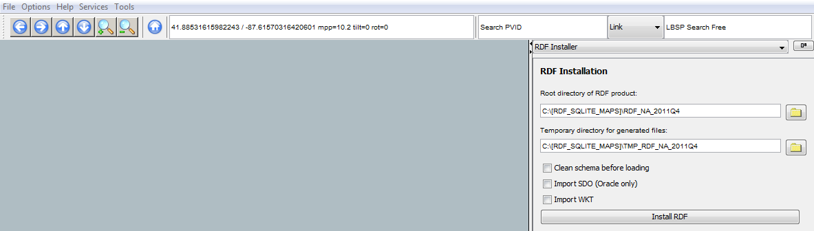

## Root Directory of Product

The tar files downloaded from NAVTEQ should be unpacked.  
The parent folder of the unpacked files should be set as RDF root directory.

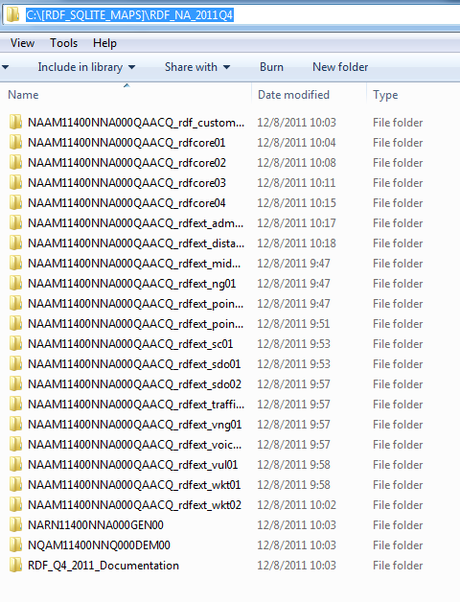

## Temporary directory

A temporary directory must be specified, big enough to store all unzipped loaderfiles.

## Start from Scratch

If installing into a previously loaded RDF this option must be selected in order to drop the existing RDF tables. Also if the install process failed and re-running it is not possible, then start from scratch.

## Import SDO (Oracle only)

Oracle Spatial Data Objects (SDO) can be imported to Oracle databases only. They are used with the Oracle Spatial Data Cartridge.

## Import WKT (SQLServer, PostGIS)

Well Known Text (WKT) are geometric objects in open source format which can be installed to a database as text. The geometry of all objects is present in a relational form (RDF_LINK_GEOMETRY). SDO and WKT are alternate representations.

## Install RDF

After the directories and options are set the RDF can be installed via the installation button.

## Next Steps after RDF Installation

Once installation completed successfully, the RDF Viewer can be used to compile aggregated Layers to visually present the RDF content. A restart of running RDF Viewer may be required before compilation. With the “Compiler Plugin” it is possible to compile all preselected layers:

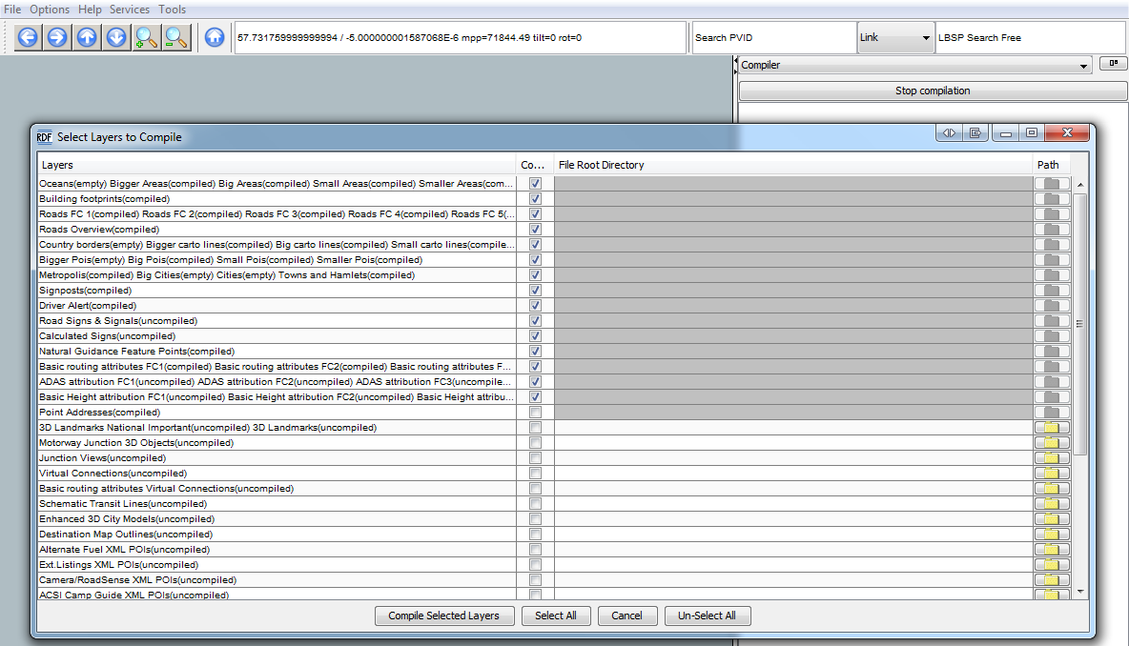

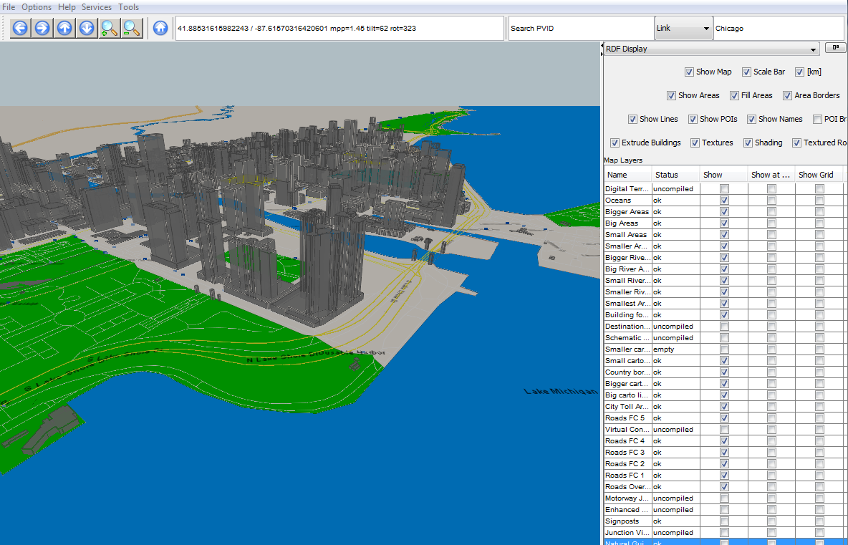

## PostgreSQL Configuration Hints

Although RDF on PostgreSQL on 32 bit systems works, 64 bit is recommended for large RDF databases.

Hardware recommendations

**Disk space**: A full Europe RDF installation requires about 200 GB, including all indexes.

**Hard Disk**: Disk performance is critical for performance.

**Memory**: A minimum of 16 GB main memory is required for acceptable SQL performance.

|  |  |  |
| --- | --- | --- |
| postgresql.conf Parameter | Recommended value for RDF | Explanation |
| effective_cache_size | 512 MB | Main memory table cache. PostgreSQL generally recommends 50 – 75% of physical main memory. |
| maintenance_work_mem | 384 MB | Index and key creation, VACUUM processes. Can be increased temporarily for such operations. |
| shared_buffers | 1024 MB | Defines a block of memory that PostgreSQL will use to hold requests that are awaiting attention from the kernel buffer and CPU. PostgreSQL generally recommends 25% of physical main memory. |
| work_mem | 300 MB | Memory for sorting, per connected client. |

## MySQL Configuration Hints

Following parameter settings are recommended in mysql.ini:

[mysqld]

innodb_data_home_dir="..../" *(200 GB disk space required to install EU + 150 GB to compile it for RDFViewer)*

tmpdir=”....”   *(50 GB temp disk space required to install EU RDF, 250 GB to compile EU for RDFViewer)*

default-storage-engine=INNODB  *(only InnoDB storage engine is supported, MyISAM is untested)*

innodb_buffer_pool_size=12000M *(80% of physical memory)*

memlock

To compile RDF for RDFViewer, following settings are required in addition:

wait_timeout=130000

net_retry_count=50

net_write_timeout=3600

## Installing RDF when the Installer is not on the Database Server

It is strongly recommended to execute the installation process directly on the database server.  
If the installer must run on a different machine, performance is worse.  
The directory path of the source directory and the temp directory must be specified with UNC \\servername\directory paths that work identical both on the installer host and on the database host (on Linux identical mount path names instead of UNC paths).