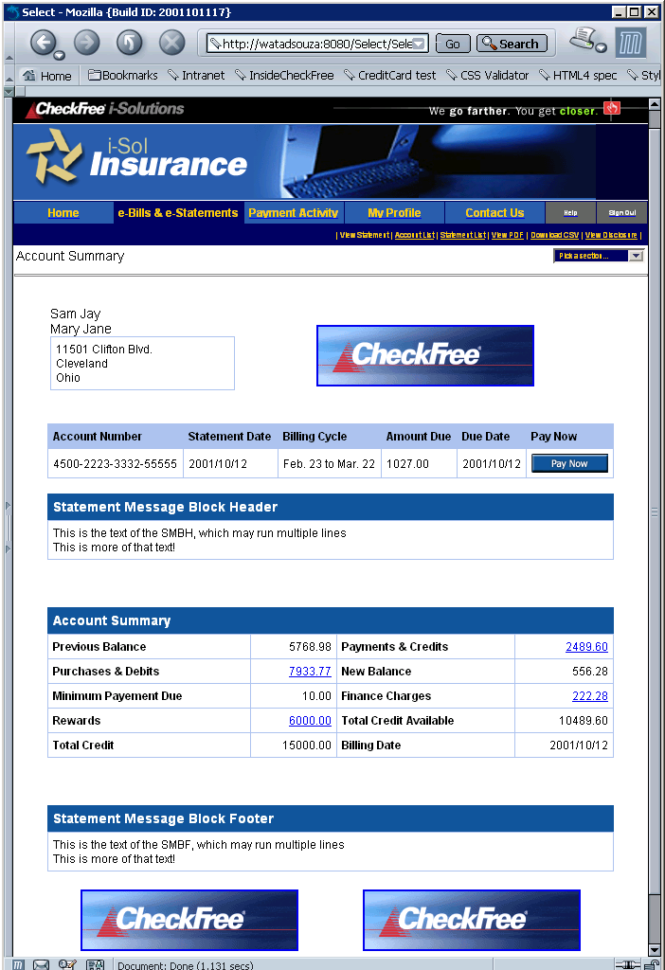 | OwnerInfo  Address & MD: TopRight  {PreauthorizedChecking, RootSection or NoPayRootSection}  Stmt msg block header  AccountActivity + AccountSummary  Stmt msg block footer  MD: BottomLeft & BottomRight
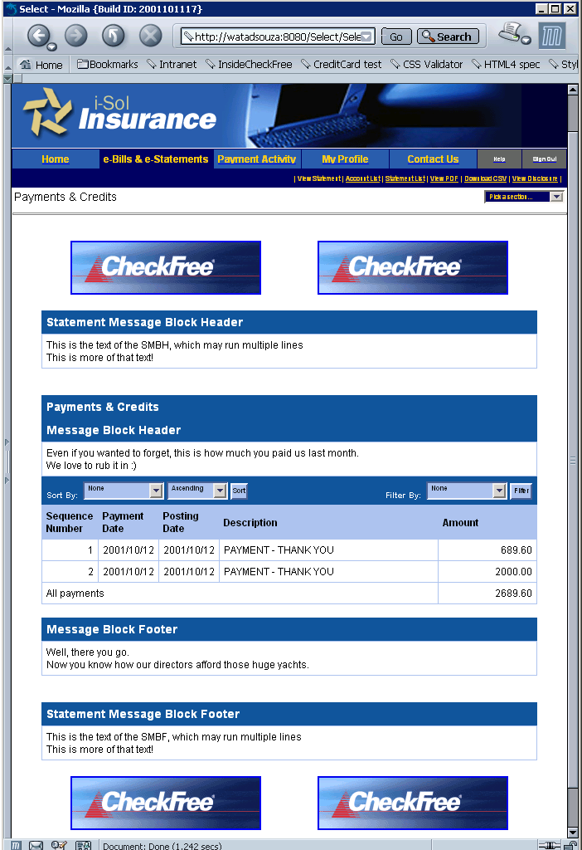 | MarketDirect:  TopLeft & TopRight  Header msg block (HMB)  HMB/Message  Payments: Title  Payments/HMB  Payments/HMB/Msg  SortFilterBar  Payments/  PaymentDetails  Paym.../PaymentTotals  Payments/FMB  Payments/FMB/Msg  Footer Message Block  FMB/Message  MD: BottomLeft & BottomRight
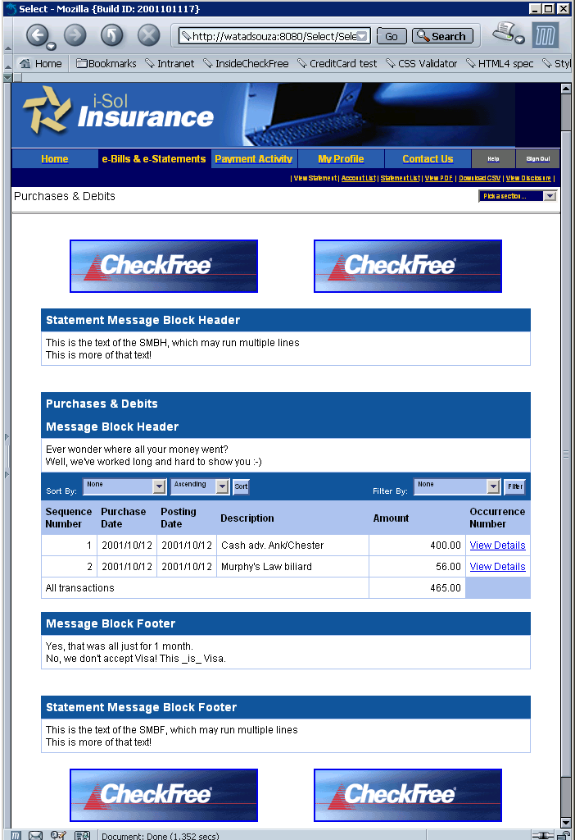 | MarketDirect:  TopLeft & TopRight  Header msg block (HMB)  HMB/Message  Transactions: Title  Transactions/HMB  Transactions/HMB/Msg  SortFilterBar  Transactions/  TransactionDetails  Tran.../TransactionTotals  Transactions/FMB  Transactions/FMB/Msg  Footer Message Block  FMB/Message  MD: BottomLeft & BottomRight
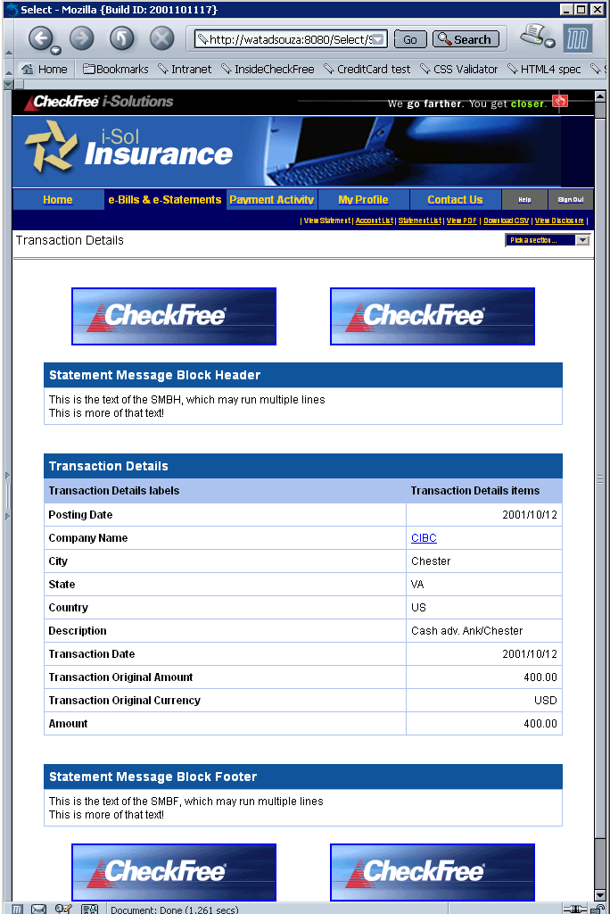 | MD: TopLeft & TopRight  HeaderMessageBlock  Transactions/  TransactionDetails  FooterMessageBlock  MD:  BottomLeft & BottomRight
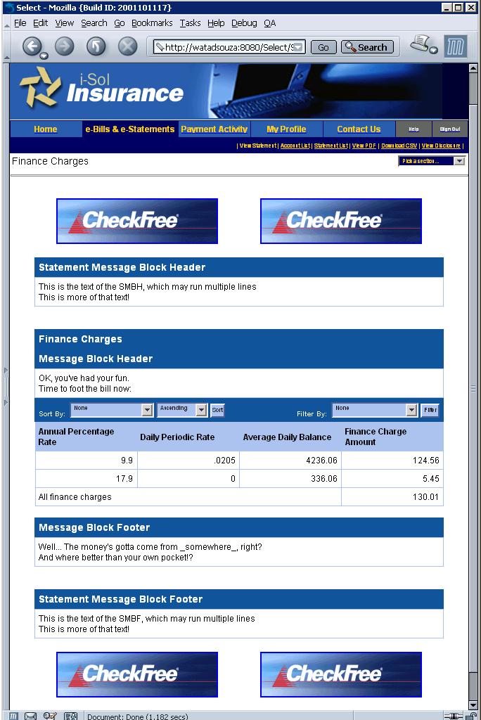 | MarketDirect:  TopLeft & TopRight  Header msg block (HMB)  HMB/Message  FinanceCharges: Title  FinanceCharges/HMB  FC/HMB/Msg  SortFilterBar  FinanceCharges/  FinanceChargeDetails  FC/FinanceChargeTotals  FinanceCharges/FMB  FC/FMB/Msg  Footer Message Block  FMB/Message  MD: BottomLeft & BottomRight
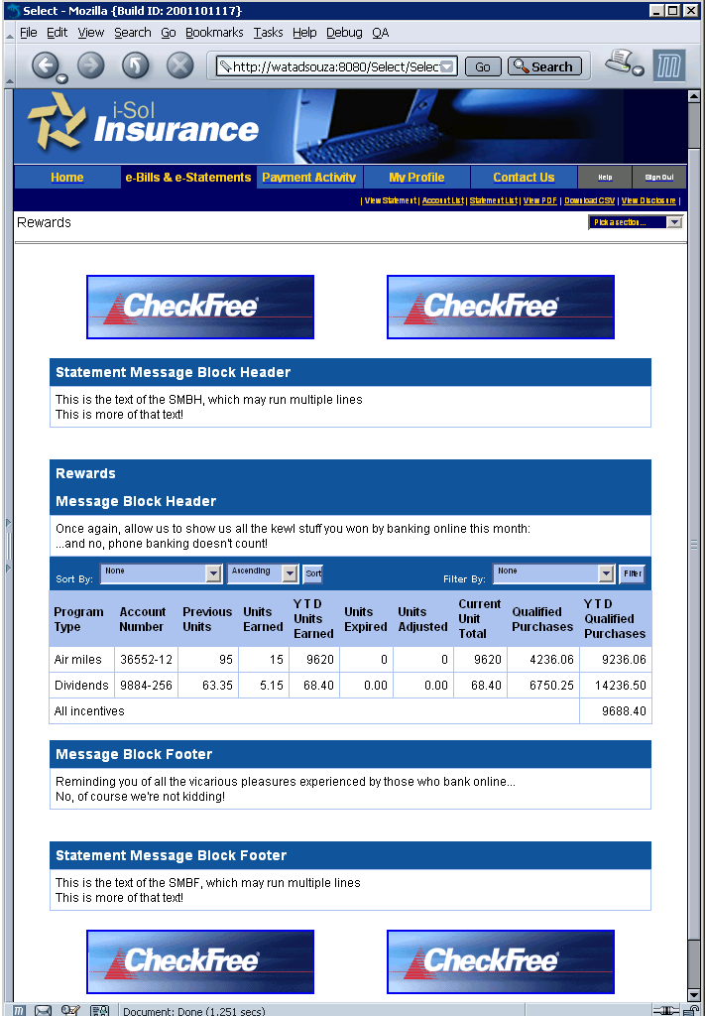 | MarketDirect:  TopLeft & TopRight  Header msg block (HMB)  HMB/Message  Incentives: Title  Incentives/HMB  Incentives/HMB/Msg  SortFilterBar  Incentives/Incentive  Incen.../IncentiveTotals  Incentives/FMB  Incentives/FMB/Msg  Footer Message Block  FMB/Message  MD: BottomLeft & BottomRight

