Sentinel Snmp-integrator Chinese code error issue

1 Original event and Correlation event before action（Screenshot as below）
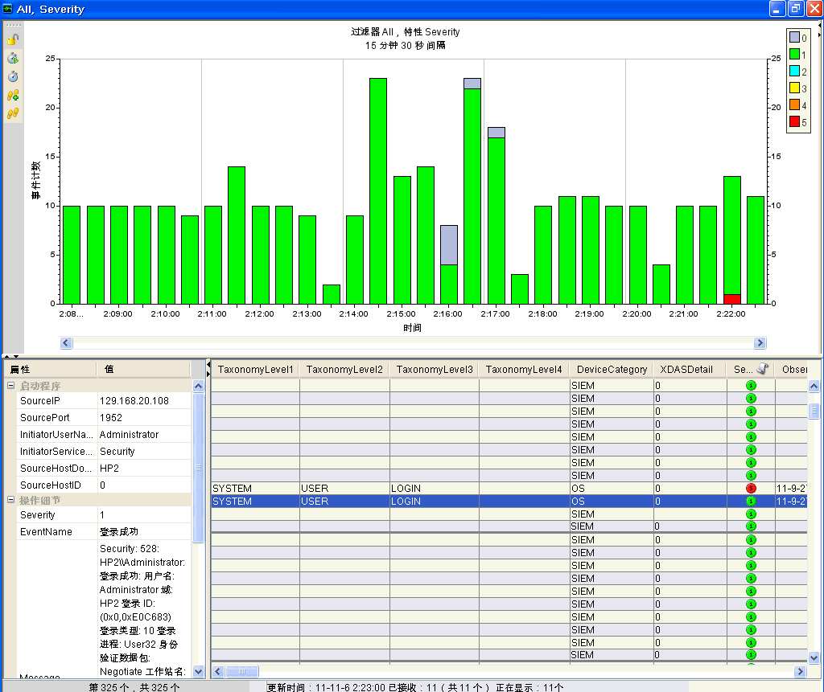

2、Use SNMP-integrator to send alert：
[{"xdasoutcomename":"XDAS_OUT_SUCCESS","evt":"????","sev":"4","repip":"129.168.20.108","sip":"129.168.20.108","rn":"Unknown_Reporter","rv21":"C76D2820-C395-1029-BB86-001321B5C0B3","xdastaxname":"XDAS_AE_CREATE_SESSION","rv22":"985A9A40-D4D4-102E-BFE5-000C299873BA","spint":"1952","rt2":"renpin_snmp_rule","msg":"Security: 528: HP2\\\\Administrator: ????: ???: Administrator ?: HP2 ?? ID: (0x0,0xE0C683) ????: 10 ????: User32 ???????: Negotiate ????: HP2 ?? GUID: - ??????: HP2$ ????: WORKGROUP ????? ID: (0x0,0x3E7) ????? ID: 1312 ????: - ?????: 129.168.20.108 ???: 1952","sn":"HP2","dt":"1320517323742"},{"xdasoutcomename":"XDAS_OUT_SUCCESS","evt":"????","sev":"1","repip":"129.168.20.108","sip":"129.168.20.108","rn":"Unknown_Reporter","rv21":"C76D2820-C395-1029-BB86-001321B5C0B3","xdastaxname":"XDAS_AE_CREATE_SESSION","rv22":"985A9A40-D4D4-102E-BFE5-000C299873BA","spint":"1952","msg":"Security: 528: HP2\\\\Administrator: ????: ???: Administrator ?: HP2 ?? ID: (0x0,0xE0C683) ????: 10 ????: User32 ???????: Negotiate ????: HP2 ?? GUID: - ??????: HP2$ ????: WORKGROUP ????? ID: (0x0,0x3E7) ????? ID: 1312 ????: - ?????: 129.168.20.108 ???: 1952","sn":"HP2","dt":"1320517323742"}]

MEMO：Correlationevent is: Event Name = 登录成功

