1. Output on web browser when request is found

https://localhost:8080/index.html





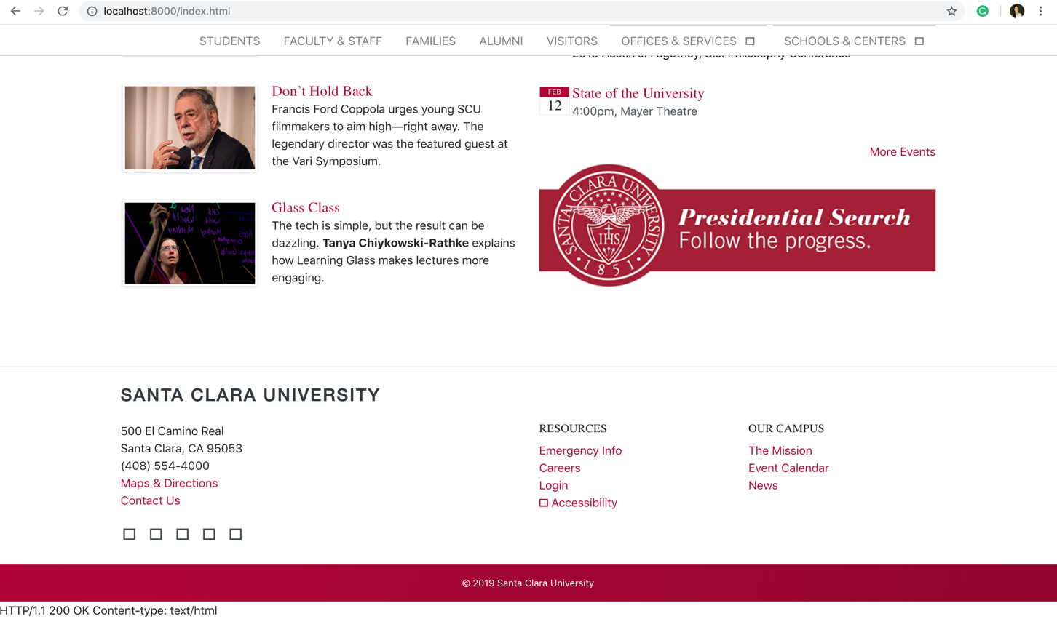

1. Output on web browser when requested resource not found

https://localhost:8080/myHome

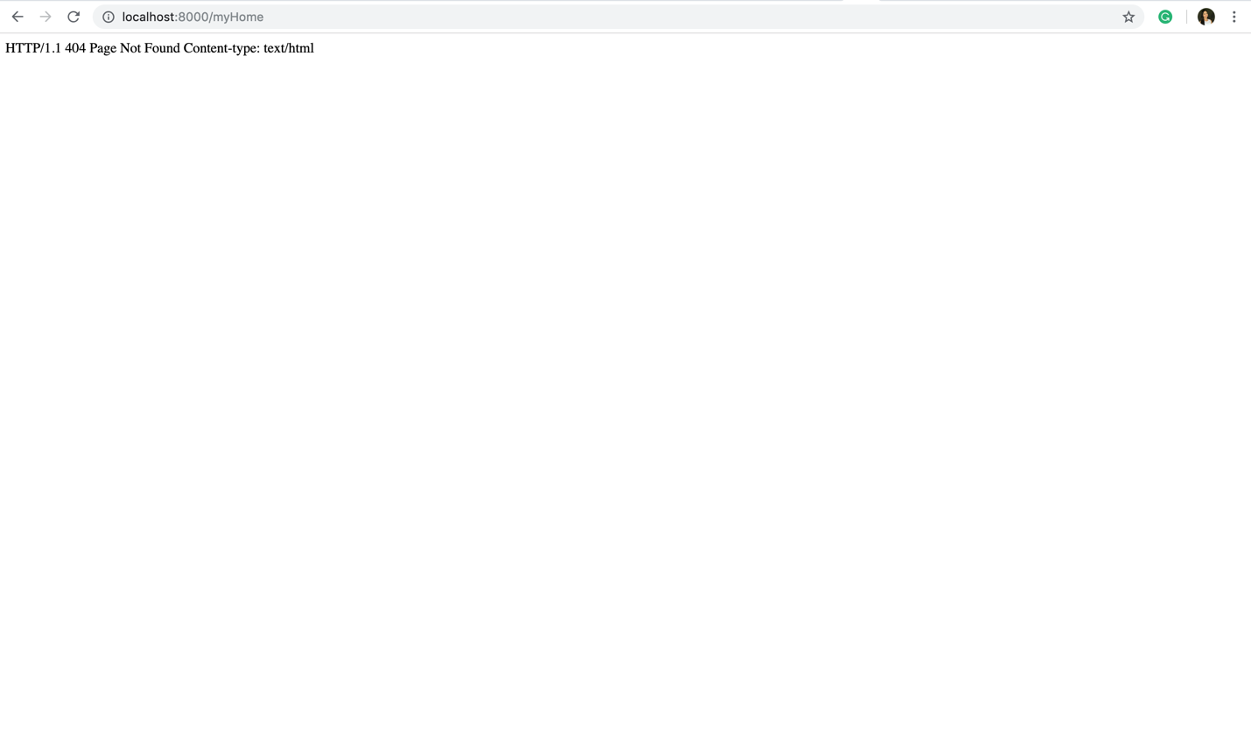

1. Out put on Terminal Using telnet when requested file found

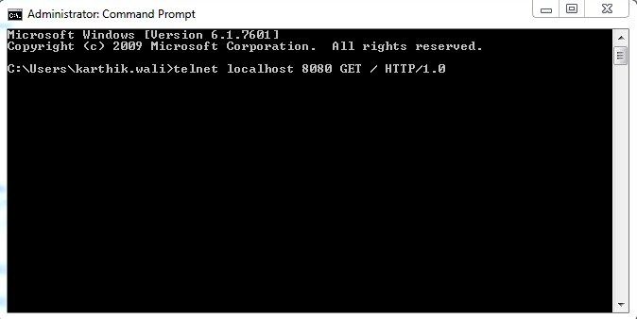

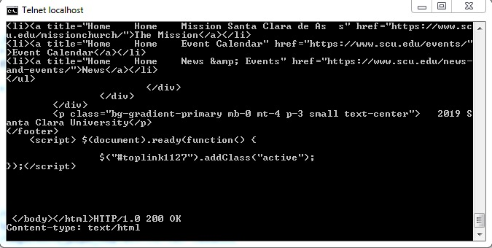

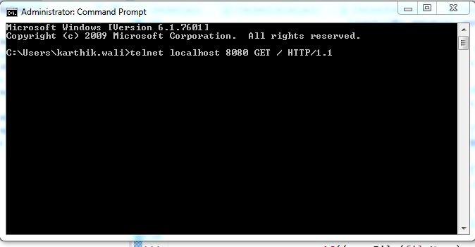

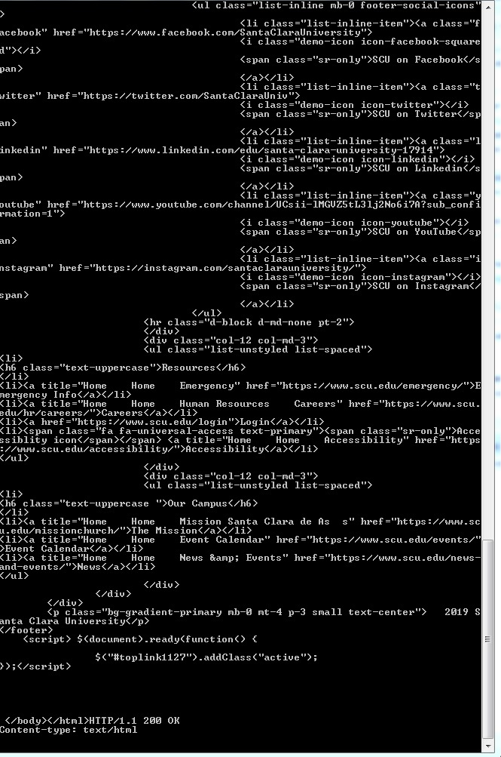

1. Wrong File Path: telnet localhost 8080 GET /user/ HTTP1.1

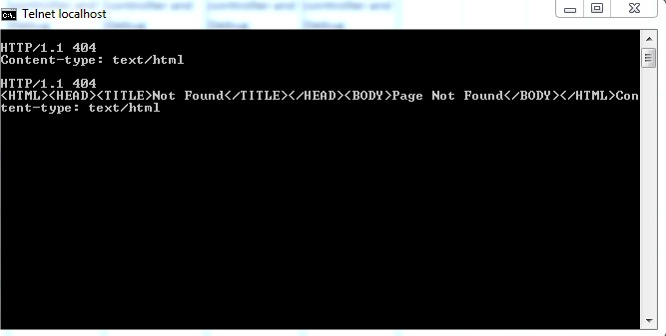

1. Wrong HTTP Request: telnet localhost 8080 GET / HTTP/2.0

