Contents
Mowing Section 1
Mower: 1
Model 4
Variables: 4
Function 4

Mowing Section

Mower:
Scripts:
-> mower.gd
Require:
-> model
Apart_of:
->Job scene
Signals:
-> collided: signal for collision
-> fuel_empty: no more fuel left. Mower won’t send collision signa
Description:
The mower scene contains the physical mower body. The mower scene consists of the mower character node and the camera that follows the player. In 0.3 redesign the mower undergoes a change from the box shape of before to a more complex shape. The wheels now also spin. The fuel used when idling is now calculated here (stored in model
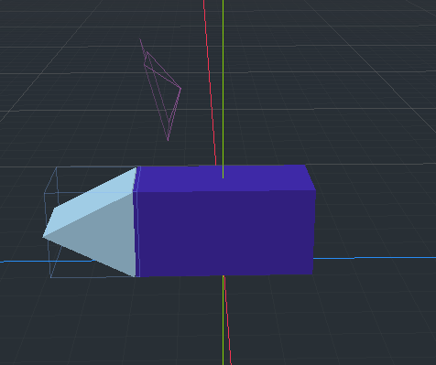Figure 1: In Version 0.2
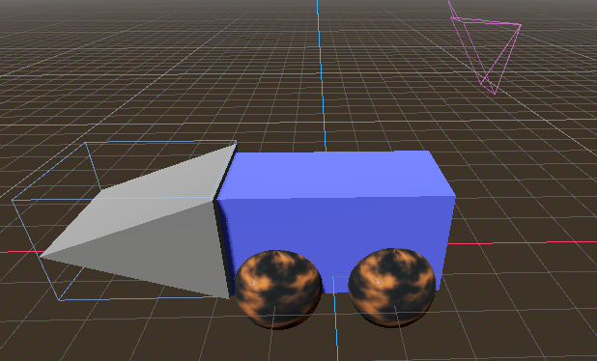Figure 2: in version 0.3
Summary of nodes:
Box: Cube mesh for the green colour main section of the mower. No collision
Cutter: Prism mesh for the blade at the front. The size of this is calculated in code based on value in model
Wheels(4 of them): sphere mesh for the wheels. Using a noise texture. TO REPLACE: find out how to draw a custom texture
Base of mower: a small collision node to keep mower on “ground” in game
Camera3D: Camera node to follow the mower around
Cutter collision: a cube collision node outlined in figure 2. The extents of this is calculated in code based on value from model
Summary of functions:
get_input: function to get user input. This handles both when using keyboard and also when using virtual input (for smartphone). Rotation of wheels is also calculated in this function. Changed from 0.2 this function also computes idle fuel use (NOT fuel used when mowing. That requires collision calculations which are not done here)
Save function: None. Relies on model saving variables.
Load function: None

Model

Variables:
(Note s/g means there is a set and get function with the similar name ex get_speed(), set_blade_length(). Additional methods are mentioned in the functions section)
var speed (s/g): The current speed of mower
var blade_length (s/g): multiplier of the blade size. Sets how much grass is cut at once.
var mower_fuel (s/g): integer value of how much fuel is left.
var mower_fuel_idle_counter (s/g): since the progress bar node shows in whole numbers this counter is used to keep track of fuel used OUTSIDE of mowing the grass. Both when moving and not moving
var idle_fuel_use (s/g): limit after which fuel use should be triggered.

Function
is_mower_fuel_idle_counter(): check if idle_fuel_use limit has been reached by idle fuel use counter.
increment_mower_fuel_idle_counter(add): since most times only will be adding to fuel idle counter (and not get()) then this function adds a given value to mower fuel idle counter.
save_game_data(file_name): function stores all variables in the model in the format of a dictionary.
file_name = save_game_ID.
Dictionary: (Key -> name of variable in model : Value-> value)

load_game_data(file_name): Function loads the saved model from a save file. Only 1 variable should be stored (read: save_game(file_name) ).
expect: dictionary (key -> variable name in model: value -> value)
error: if a variable name does not exist in current model (perhaps the feature was added after the save file), maintain a default value.

