
Name | Uswa Minael
Registration No. | FA25-BDS-050
Department | Computer Science
Program | Data science
Subject | Programming Fundamentals
Instructor | Mr. Khurram Iqbal
Assignment No. | 01
Question – 1: Define and explain the programming paradigms with the help of examples.
Answer: Programming Paradigm is an approach or style of writing and structuring a program.
Types: There are two main types of programming paradigms .
- Imperative Paradigm
- It is a type of programming paradigm in which the main focus of a programmer is how to write a program.
- Step-by-step commands are given to the computer.
- Languages like Python, Java etc are used within this paradigm.
- It contains loops and variables etc.
Example: In order to write a program that prints numbers from 1 to 10 , we provide step by step instructions to the computer, which change the state of the computer.

- Declarative Paradigm
- It is the type of programming paradigm in which the main focus is of a progarmmer is what to do.
- The Programmer describes what are the results he wants, and the steps are figured out automatically by the computer.
- Languages like SQL are used within this paradigm.
Example: Give me the sum of numbers. The only thing being told is what we want, and the computer will figure out the steps automatically.

Question – 2: This question focuses on the types of errors.

- Write JAVA statements that can produce Syntax Errors. Give three different examples and write the names of errors.

- System.out.println(“Hello World”) // missing statement terminator
- Pablic static void main (String [] args){ // misspelled keyword public
- System.out.print (“Welcome to Java”).
public class Greet { // wrong order of code

- Write JAVA statements that can produce Logical Errors. Give three different examples and briefly explain the reason (1-2 lines)

- int average = (5 – 4) / 2;
Explanation: The program will run but the logic used for finding average is wrong, instead of (+) operator (–) is used.

- double area = length / width;
Explanation: In this statement , wrong formula for the calculation of the area of a square is stated.

- marks = 90;
if (marks >= 60) {
System.out.println(“D”);}
else if (marks >= 90); {
System.out.println(“A”);}
else {
System.out.println(“F”);}
Explanation: In this program, it is logically wrong to write the condition (marks >= 60) first, as the marks are greater than 90, it will print D in the first run which will give the wrong output.

- Write JAVA statements that can produce Run Time Errors. Give three different examples and briefly explain the reason (1-2 lines)

- int result = 10 / 0; //Zero Division Error
- String name = “John”.
Int num = (int) name; // Type Casting Error
- Scanner sc = new Scanner (System.in);
Int num = sc. nextInt(); //Input Mismatch if user types “hello”

- The following programs have syntax errors. Write clearly type of error and its correction (in tabular form). After you have corrected the syntax errors, show the output of this program.
public class ErrorDemo { public static void main (String [] args) { int number; number = "ten”.
float pi = 3,1416;
double result == 0;
if (number = 5)
System.out.println("Number is 5");
}

System.out.println("Result is: " + result;
}
}
//2nd program….
public class Test{ public static void main (String [] arg) {
count = 1; sum = count + PRIME; x:= 25.67; newNum = count * ONE + 2; sum + count = sum; x = x + sum * COUNT;
System.out.println(" count = " + count + ", sum = "
+ sum + ", PRIME = " + Prime);
}
}

number = "ten"; | number = 10; | String stored in a variable with int datatype
double result == 0; | double result = 0; | Realational operator in place of assignment
if (number = 5) { | If (condition number == 5) { | Assigment operator in place of is equal to
Float pi = 3,1416; | Float pi = 3.1416f; | Comma in place of decimal and datatype is declared as float without appending f
("Result is: "+result; | ("Result is: " + result;) | Missing parenthesis
STATEMENTS WITH BUGS | DEBUGGED CODE | ERRORS

1st Program
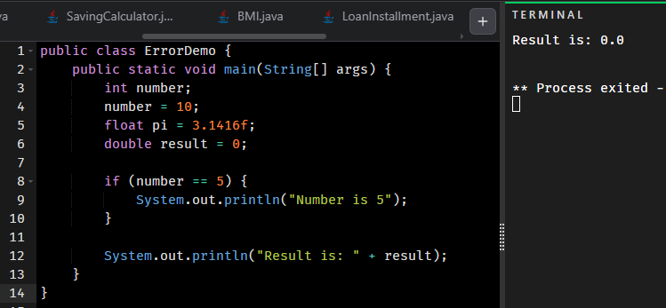

STATEMNET WITH BUGS | DEBUGGED STATEMENTS | ERRORS
count = 1; | int count = 1; | Initialisation without declaration
sum = count + PRIME; | int prime = 7;  int sum = count + prime; | Variable prime is not declared and initialised, variable sum is not declared.
x:= 25.67; | x = 25.67; | Colon used at wrong place and undeclared variable x
newNum = count*ONE* 2; | int newNum = count*1*2; | Undeclared variable newNum, ONE is not defined
x = x + sum * COUNT; | x = x + sum * count; | COUNT is not defined, however, count is
System.out.println(" count = " + count + ", sum = " + sum + ", PRIME = " + Prime); | System.out.println(" Count = " + count + ", Sum = " + sum + ", Prime = " + prime); | Prime is not defined, prime is.

2nd Program
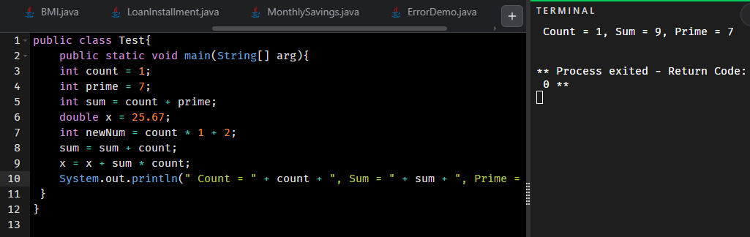

Question – 3: This question focuses on the basic elements of JAVA language (comments,
Special Symbols, Reserve Words, and Identifiers)

Consider following JAVA Code
/*This program will calculate product of three numbers */ public class Product {
public static void main (String [] args) {
int num1 = 10; // first number
int num2 = 20; // second number
int num3 = 1;// third number
int result; //product of numbers
result = num1 * num2 * num3.
System.out.println("Product of numbers: "+result);
}
}
You are required to identify following (Show your answer as tabular form)
- comments (Single Line, Multiline),
- Special symbols (three)
- Reserve words (three)
- Identifier (predefined and defined by user) (three each)
- Standard Input Stream Object
- Standard Output Stream Object

Multi-line comment | /*This program will calculate product of three numbers */
Single line comment | // first , // second number , // third number , //product of numbers
Special Symbols | ; (statement terminator)  + (addition , type conversion operator)  { } (for enclosing a block of code)
Reserved Words | int , public , main
Identifier (user-defined) | result , num1, num2
Identifier (predefined) | class , main, print
Standard Input Stream Object | Not found in this program
Standard Output Stream Object | System.out.println()

Question – 4: This question focuses on the basic elements of JAVA language (Primitive Data
Types, Expressions and Assignments, Arithmetic Operators, Order of Precedence, Augmented
Assignment Operators, Type Conversion)

  - Write Java statements that accomplish the following.
  - Declare a String variable named name and assign it the value "Java".
String name = “Java”;

  - Declare a boolean variable named isPassed and set it to true.
boolean isPassed = true;

  - Multiply two int variables a and b, and store the result in an int variable product.
int product = a * b;

  - Declare a float variable temperature and initialize it with the value 36.6.
float temperature = 36.6f ;

  - Assign the remainder when dividing num1 by num2 to an int variable remainder.
int remainder = num1 % num2 ;

  - Suppose p and q are double variables. Output the contents of p, q, and the expression (p * q) / 2.
System.out.println ( p );
System.out.println ( q);
System.out.println ( (p * q) / 2);

  - Declare a char variable symbol and assign it the value '#'.
char symbol = ‘#’;

  - Declare three int variables to store the marks of three subjects.
int subject1 = 75 ;
int subject2 = 50 ;
int subject3 = 46 ;

  - Copy the value of an int variable score into a double variable resultScore.
Suppose int score = 100 ;
double resultScore = (double) score ;

  - radius is a double. Write a statement to compute the area of a circle and store it in a double variable area.
double area = 3.14 * radius * radius ;

  - Suppose a, b and c ,d are int variables and a = 5, b = 6, c=7, d = 2. What value is assigned to each variable after each statement executes? If a variable is undefined at a particular statement, report UND (undefined)
Statements | a | B | c | d
a = (++b) * 2 + (c--); | 21 | 7 | 6 | 2
c = (a++) - (--d) + b; | 22 | 7 | 27 | 1
b = (d--) + (c++) * ++a; | 23 | 644 | 28 | 0
d = (--a) + (b++) - (c--); | 22 | 645 | 27 | 638

  - Suppose a, b, and sum are int variables and c is a double variable. What value is assigned to each variable after each statement executes? Suppose a = 3, b = 5 , and c = 14.1
Statements | a | b | c | sum
sum = a + b + (int) c; | 3 | 5 | 14 | 22
c /= a; | 3 |  | 4.6
b += (int) c - a; | 3 | 6 | 4
a *= 2 * b + (int) c; | 40 | 6 | 4

JAVA PROGRAMMING QUESTIONS
Question 5.
Ali lives in a village where he uses both solar energy and electricity from the company. During the day, he consumes electricity generated from his solar system, which costs him only Rs. 7 per unit. After 5 PM, he uses electricity from the company, which charges Rs. 60 per unit. Ali wants to calculate how much money he is saving by using solar energy. Create a program that asks for the number of units consumed from the solar system and the number of units consumed from the electricity company. The program should then calculate the total bill if all units were taken from the company, the actual bill using both solar and company electricity, and the total savings Ali makes by using solar power.
Code:
public class SavingCalculator {
static Scanner sc = new Scanner (System.in);
public static void main(String [] args){

System.out.print("Enter number of units used from solar system: ");
int units1 = sc.nextInt();
System.out.print("Enter number of units used from electricity company: ");
int units2 = sc.nextInt();

int billFromSolar = units1 * 7;
int billFromCompany = units2 * 60;
int actualBill = billFromCompany + billFromSolar;

int totalBillFromCompany = (units1 + units2) * 60;

int saving = totalBillFromCompany - actualBill;

System.out.println("By using Solar System you are saving Rs." + saving);
}
}

Question 6.
Sara visits her doctor for a regular health check-up, and the doctor asks her to calculate her Body Mass Index (BMI) to monitor her fitness. Sara’s weight is 62 kilograms, and her height is 1.68 meters. The formula for BMI is the weight divided by the square of the height. Create a program that calculates Sara’s BMI and displays the result.
Code:
public class BMI{
public static void main (String... args){

double height = 1.68;
double weight = 62;

int BMI = (int) (weight / (height * height));

System.out.println("Your Body Mass Index (BMI) is " + BMI);
}
}

Question 7.
Ahmed works in a private company and earns Rs. 50,000 each month. His monthly expenses, however, are Rs. 37,500. Ahmed plans to purchase a new laptop that costs Rs. 100,000. He wants to calculate how long it will take to save enough money. Create a program that calculates Ahmed’s monthly savings and determines how many months are required for him to save enough money to buy the laptop.
Code:
public class MonthlySavings {
public static void main(String [] args){
double income = 50000;
double expenses = 37500;
double saving = 50000 - 37500;

double monthsRequired = 1000000 / saving;
System.out.println((int) monthsRequired + " months are required to save enough money to buy your desired laptop." );
}
}

Question 8.
The weather station in Lahore has reported today’s temperature as 32 degrees Celsius. For preparing an international weather report, the same temperature also needs to be expressed in Fahrenheit and Kelvin. The formulas to use are Fahrenheit = (9/5 × Celsius) + 32 and Kelvin = Celsius + 273.15. Create a program that converts 32 degrees Celsius into Fahrenheit and Kelvin and displays the converted values.
Code:
public class TemperatureConverter{
public static void main (String [] args){
double Celsius = 32;

double Kelvin = Celsius + 273.15;

double Farenheit = (9/ (5 * Celsius)) + 32;

System.out.println("Temperature in Celsius: " + Celsius);
System.out.println("Temperature in Kelvin: " + Kelvin);
System.out.println("Temperature in Farenheit: " + Farenheit);

}
}

Question 9.
Hassan has purchased a car by taking a loan of Rs. 1,200,000 from the bank. The loan is to be repaid in 5 years with an annual interest rate of 12%. Hassan wants to know his monthly installment amount so he can plan his expenses. The formula for calculating the monthly installment is Payment = (P × r) / (1 – (1 + r)^(-n)), where P is the loan amount, r is the monthly interest rate (annual rate divided by 12), and n is the total number of months. Create a program that calculates Hassan’s monthly car loan installment.

Code:
public class LoanInstallment{
public static void main(String... args){
double loan = 1200000;
double annualRate = 0.12;
double monthlyRate = 0.12 / 12;
int totalMonths = 60;

double monthlyInstallment = (loan * monthlyRate) / (1 - Math.pow(1 + monthlyRate, -totalMonths));

System.out.printf("Your monthly car loan installment is: Rs. %.2f%n", monthlyInstallment);
}
}

Question – 10:

Research several car-pooling websites. Create an application that calculates your daily driving cost, so that you can estimate how much money could be saved by carpooling, which also has other advantages such as reducing carbon emissions and reducing traffic congestion. The application should input the following information and display the user’s cost per day of driving to work:
- Total miles driven per day.
- Cost per gallon of gasoline.
- Average miles per gallon.
- Parking fees per day.
- Tolls per day.
Code:
import java.util.*;
public class CarPooling{
static Scanner sc = new Scanner (System.in);
public static void main(String... arg){

System.out.print("Enter total miles driven per day: " );
double totalMiles = sc.nextDouble();

System.out.print("Enter cost per gallon of gasoline: " );
double costPerGallon = sc.nextDouble();

System.out.print("Enter average miles per gallon: " );
double averageMiles = sc.nextDouble();

System.out.print("Enter parking fees per day: " );
double dailyParkingFees = sc.nextDouble();

System.out.print("Enter tolls per day: " );
double dailyTolls = sc.nextDouble();

double dailyFuel = (totalMiles / averageMiles) * costPerGallon;

float dailyCost = (float) (dailyFuel + dailyParkingFees + dailyTolls) ;

System.out.println("Your cost per day of driving to work is $" + dailyCost );
}
}

Question – 11:

Write an application that inputs one number consisting of five digits from the user and show the number in reverse order. Note the reverse order must also be a number. E.g. 93324

Code:
import java.util.*;
public class ReverseOrder {
static Scanner sc = new Scanner (System.in);
public static void main(String [] args){

System.out.print("Enter a five digit number: ");
int number = sc.nextInt();

int num1 = number % 10;
number = number / 10;

int num2 = number % 10;
number = number / 10;

int num3 = number % 10;
number = number / 10;

int num4 = number % 10;
number = number / 10;

System.out.print(num1);
System.out.print(num2);
System.out.print(num3);
System.out.print(num4);
System.out.print(number);

}
}
The reverse order number: 4 2 3 3 9

