***MINI PROJECT REPORT***

***On***

“**Web Development***”*

*Submitted in partial fulfillment of the requirement for the award of the degree*

*of*

***BACHELOR OF TECHNOLOGY***

*in*

***“Computer Science and Engineering”***

*by*

**UJJAWAL SINGH**



DEPARTMENT OF COMPUTER SCIENCE AND ENGINEERING **INSTITUTE OF TECHNOLOGY & MANAGEMENT, GIDA,**

**GORAKHPUR**

SESSION: 2021-22

**i**



**INSTITUTE OF TECHNOLOGY & MANAGEMENT** GIDA, GORAKHPUR

**CANDIDATE’S DECLARATION / CERTIFICATE**

This is certified that the work which is being presented in the mini project entitled “**Web Development”** in partial fulfillment of the requirement for the award of the degree of **Bachelor of Technology** and submitted in the Department of Computer Science and Engineering of **Institute of Technology & Management, GIDA, Gorakhpur** is an authentic record of my own work carried out during the semester under the supervision of **“UDMEY”**

The matter presented in this mini project has not been submitted by me for the award of any other degree of this or any other Institute/University.

(Ujjawal Singh)

This is to certify that the above statement made by the candidate is correct to the best of my knowledge.

Date: 03/12/2021 (Candidate Signature)

MR CHHITEESH RAI MR ASHUTOSH KUMAR RAO

Mini Project Coordinator H.O.D (CSE/IT)

**ii**

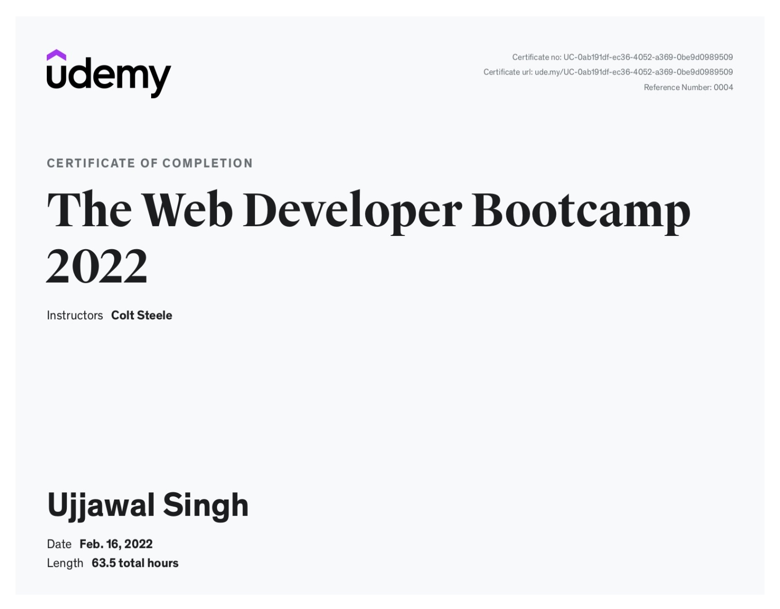

**iii**

**ABSTRACT**

In this project report, I have presented an overview of C language. The whole report is divided into five main chapters and a chapter dedicated to my project as mentioned in the Content section. Each chapter is further divided in several subtopics. There are six chapters in total stated as **Introduction to C, Structure of C, compilation, execution, character set, identifiers, keywords, constants, variable, expression, Operators**, **loops & types and Project: digital clock.**

Every subtopic contains detailed explanation about the topic. From At the end of 6th chapter i.e., Project: digital clock with its source code. My project is based on C language. This program are just for an example purpose. It is developed using C coding.

**iv**

**ACKNOWLEDGEMENT**

Whenever a module of work is completed, there is always a source of inspiration. I always find my parents as my torch bearers. While completing this task, I realized from my inner core that Rome was not built in day. I found a stack of mini project reports in the library of ITM Gorakhpur library. Those reports are the landmarks for me on the way of this task. The presented report is an effort of day and night works. Selection is always tough; undoubtedly I am accepting this fact.

I am sincerely thankful to **ASHUTOSH KUMAR RAO** (CSE/IT) &MINI PROJECT **CHHITEESH RAI** for his support. I express my gratitude and thanks to all the faculties and staff members of Computer Science & Engineering department for their sincere cooperation in furnishing relevant information to complete this mini project report well in time successfully.

Finally, my greatest debt is to my parents, my family for their enduring love, support and forbearance during my project work.

**UJJAWAL SINGH**

**B.Tech. (CSE)**

**IIIRD Sem.**

**v**

**TABLE OF CONTENTS**

|  |  |  |
| --- | --- | --- |
| **CHAPTER NO.** | **TITLE** | **PAGE NO.** |
|  | Certificate | **ii** |
|  | Internship Certificate | **iii** |
|  | Abstract | **iv** |
|  | Acknowledgement | **v** |
|  | Table of Contents | **vi** |
|  | List of Figure | **vii** |
| **CHAPTER-1:** | **INTRODUCTION TO C**  1.1 Introduction to C  1.2 Compilation  1.3 Execution | **01 - 07** |
| **CHAPTER-2:** | **CHARACTER SET**  2.1 Character set  2.2 Identifiers  2.3 Keywords | **08 - 10** |
| **CHAPTER-3**  **CHAPTER-4**  **CHAPTER-5** | **CONSTANTS & VARIABLE**  3.1 Constants  3.2 Variables  **EXPRESSION & OPERATORS**  4.1 Expressions  4.2 Operators  **LOOPS**  5.1 Do While  5.2 While | **11 - 14**      **15 - 20**    **21 - 25** |

**vi**

|  |  |  |
| --- | --- | --- |
| **CHAPTER 6**  **CONCLUSION**  **REFERENCE** | **PROJECT: DIGITAL CLOCK** | **26 - 27**    **28**    **29** |

**LIST OF FIGURES**

**1. FIG 1 02 2. FIG 2 07 3. FIG 3 08 4. FIG 4 12 5. FIG 5 27 5. OUTPUT 04 6. OUTPUT 05 7. OUTPUT 07 8. OUTPUT 17 9. OUTPUT 22 10. OUTPUT 23**

**11. OUTPUT 25 12. OUTPUT 27 vii**