## Scoring Metrics

### Product Data

Learning rate .0005

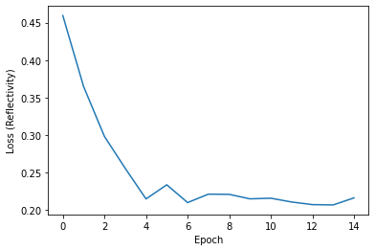

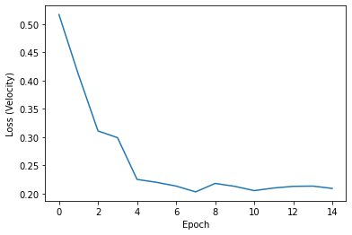

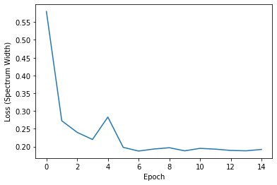

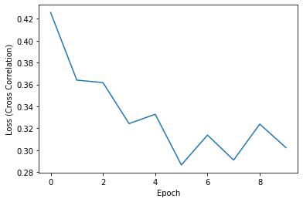

Lots of epochs, doesn’t seem to overfit.. 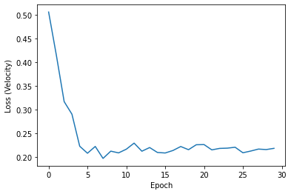

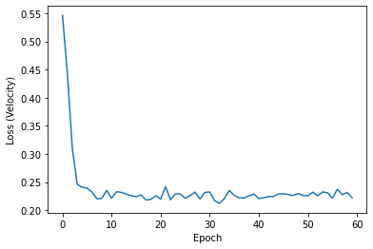

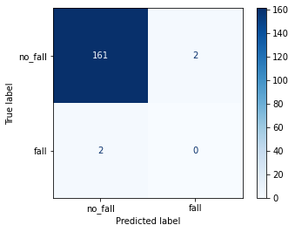

Reflectivity (conf = .6)

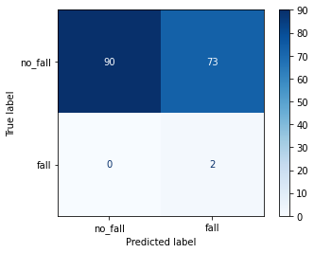

Velocity (conf = .6)

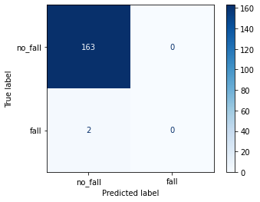

SW (conf = .6)



CC (conf = .6)

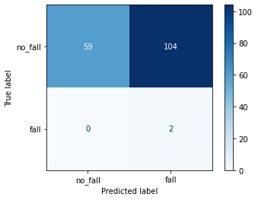

All data (conf = .5)

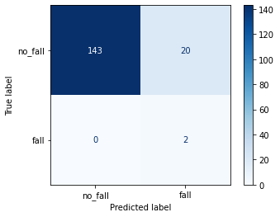

All data (conf = .79)

reflectivity

[1, 1, 0, 0, 0, 0, 0, 0, 0, 0, 0, 0, 0, 0, 0, 0, 0, 0, 0, 0, 0, 0, 0, 0, 0, 0, 0, 0, 0, 0, 0, 0, 0, 0, 0, 0, 0, 0, 0, 0, 0, 0, 0, 0, 0, 0, 0, 0, 0, 0, 0, 0, 0, 0, 0, 0, 0, 0, 0, 0, 0, 0, 0, 0, 0, 0, 0, 0, 0, 0, 0, 0, 0, 0, 0, 0, 0, 0, 0, 0, 0, 0, 0, 0, 0, 0, 0, 0, 0, 0, 0, 0, 0, 0, 0, 0, 0, 0, 0, 0, 0, 0, 0, 0, 0, 0, 0, 0, 0, 0, 0, 0, 0, 0, 0, 0, 0, 0, 0, 0, 0, 0, 0, 0, 0, 0, 0, 0, 0, 0, 0, 0, 0, 0, 0, 0, 0, 0, 0, 0, 0, 0, 0, 0, 0, 0, 0, 0, 0, 0, 0, 0, 0, 0, 0, 0, 0, 0, 0, 0, 0, 0, 0, 0, 0]

0.09545454545454546

[0.56304872 0.56710839 0.57393545 0.57404357 0.57540095 0.58204162

0.58546305 0.59029186 0.599415 0.60900521 0.61292475]

no skill 0.012121212121212121

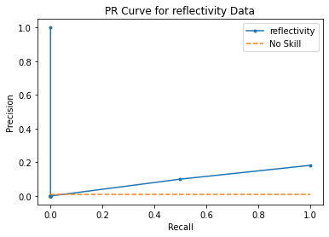

0.9447852760736196

[1.61292475 0.61292475 0.57393545 0.56304872 0.07526729 0. ]

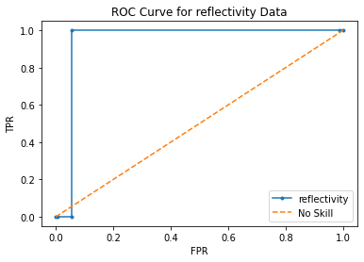

velocity

[1, 1, 0, 0, 0, 0, 0, 0, 0, 0, 0, 0, 0, 0, 0, 0, 0, 0, 0, 0, 0, 0, 0, 0, 0, 0, 0, 0, 0, 0, 0, 0, 0, 0, 0, 0, 0, 0, 0, 0, 0, 0, 0, 0, 0, 0, 0, 0, 0, 0, 0, 0, 0, 0, 0, 0, 0, 0, 0, 0, 0, 0, 0, 0, 0, 0, 0, 0, 0, 0, 0, 0, 0, 0, 0, 0, 0, 0, 0, 0, 0, 0, 0, 0, 0, 0, 0, 0, 0, 0, 0, 0, 0, 0, 0, 0, 0, 0, 0, 0, 0, 0, 0, 0, 0, 0, 0, 0, 0, 0, 0, 0, 0, 0, 0, 0, 0, 0, 0, 0, 0, 0, 0, 0, 0, 0, 0, 0, 0, 0, 0, 0, 0, 0, 0, 0, 0, 0, 0, 0, 0, 0, 0, 0, 0, 0, 0, 0, 0, 0, 0, 0, 0, 0, 0, 0, 0, 0, 0, 0, 0, 0, 0, 0, 0]

0.016806891025641025

[0.62009847 0.62148786 0.62186211 0.62344688 0.62505752 0.62611586

0.6275171 0.63127667 0.63269019 0.63391608 0.6370523 0.63824672

0.64310861 0.6461972 0.64647871 0.64698964 0.64811468 0.65054095

0.65374768 0.65518993 0.65606463 0.65809351 0.66838795 0.66926795

0.67040431 0.67122734 0.67430609 0.68082798 0.68554032 0.68801087

0.68844616 0.69056767 0.69320351 0.69368273 0.69382936 0.69391388

0.69396496 0.69604826 0.69887698 0.69890797 0.6999141 0.70442778

0.70560765 0.70650184 0.71783745 0.71936631 0.72841555 0.7305544

0.73100454 0.73179585 0.73257118 0.73770255 0.74030471 0.7438435

0.74447572 0.749111 0.75019884 0.75028181 0.75452018 0.75664979

0.76670277 0.77045596 0.77131808 0.78169948 0.80121905]

no skill 0.012121212121212121

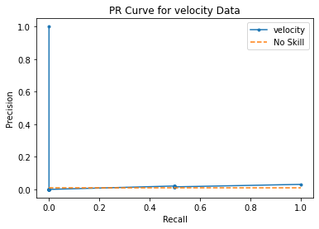

0.6625766871165645

[1.80121905 0.80121905 0.65374768 0.65054095 0.62148786 0.62009847

0.08253847 0. ]

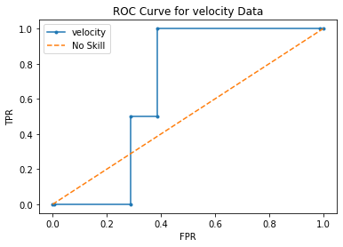

spectrum_width

[1, 1, 0, 0, 0, 0, 0, 0, 0, 0, 0, 0, 0, 0, 0, 0, 0, 0, 0, 0, 0, 0, 0, 0, 0, 0, 0, 0, 0, 0, 0, 0, 0, 0, 0, 0, 0, 0, 0, 0, 0, 0, 0, 0, 0, 0, 0, 0, 0, 0, 0, 0, 0, 0, 0, 0, 0, 0, 0, 0, 0, 0, 0, 0, 0, 0, 0, 0, 0, 0, 0, 0, 0, 0, 0, 0, 0, 0, 0, 0, 0, 0, 0, 0, 0, 0, 0, 0, 0, 0, 0, 0, 0, 0, 0, 0, 0, 0, 0, 0, 0, 0, 0, 0, 0, 0, 0, 0, 0, 0, 0, 0, 0, 0, 0, 0, 0, 0, 0, 0, 0, 0, 0, 0, 0, 0, 0, 0, 0, 0, 0, 0, 0, 0, 0, 0, 0, 0, 0, 0, 0, 0, 0, 0, 0, 0, 0, 0, 0, 0, 0, 0, 0, 0, 0, 0, 0, 0, 0, 0, 0, 0, 0, 0, 0]

0.03753119429590018

[0.41167492 0.41245204 0.41337278 0.41366011 0.41478768 0.41582179

0.41587174 0.41662967 0.41682938 0.41779557 0.41802582 0.41837218

0.41871354 0.42002693 0.42068341 0.4218196 0.42406622 0.42487615

0.42610773 0.42644447 0.42668548 0.42729095 0.4276813 0.43009081

0.43191817 0.43319938 0.43676132 0.43717694 0.43785614 0.44531518

0.45034322 0.45036668 0.45780867 0.45882091 0.46533486 0.47414565

0.47515523 0.47694305 0.47698349 0.48570499 0.48654053 0.48684344

0.48695421 0.50029427 0.50662148 0.50848079 0.51166356 0.51785004

0.51863796 0.53134656 0.53547138]

no skill 0.012121212121212121

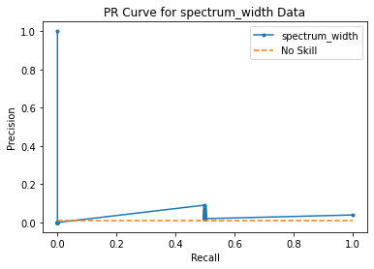

0.8190184049079755

[1.53547138 0.53547138 0.48684344 0.48654053 0.41245204 0.41167492

0.10640049 0. ]

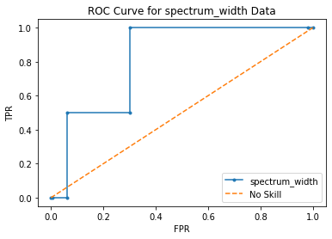

cross_correlation_ratio

[1, 0, 0, 0, 0, 0, 0, 0, 0, 0, 0, 0, 0, 0, 0, 0, 0, 0, 0, 0, 0, 0, 0, 0, 0, 0, 0, 0, 0, 0, 0, 0, 0, 0, 0, 0, 0, 0, 0, 0, 0, 0, 0, 0, 0, 0, 0, 0, 0, 0, 0, 0, 0, 0, 0, 0, 0, 0, 0, 0, 0, 0, 0, 0, 0, 0, 0, 0, 0, 0, 0, 0, 0, 0, 0, 0, 0, 0, 0, 0, 0, 0, 0, 0, 0, 0, 0, 0, 0, 0, 0, 0, 0, 0, 0, 0, 0, 0, 0, 0, 0, 0, 0, 0, 0, 0, 0, 0, 0, 0, 0, 0, 0, 0, 0, 0, 0, 0, 0, 0, 0, 0, 0, 0, 0, 0, 0, 0, 0, 0, 0, 0, 0, 0, 0, 0, 0, 0, 0, 0, 0, 0, 0, 0, 0, 0, 0, 0, 0, 0, 0, 0, 0, 0, 0, 0, 0, 0, 0, 0, 0, 0, 0, 0, 1]

0.022468122909698997

[0.24113169 0.24193524 0.24549612 0.24611634 0.24645349 0.24697599

0.24828681 0.2497324 0.2504133 0.25099733 0.25194624 0.25331235

0.25416708 0.25652096 0.25701478 0.2571024 0.26025388 0.26207915

0.26495966 0.26598731 0.26667276 0.26830363 0.27430204 0.27730796

0.28956753 0.29237333 0.29841432 0.2984257 0.30430856 0.31320581

0.31413764 0.31831139 0.31937805 0.3298308 0.33153278 0.33539608

0.33549881 0.34640405 0.34647441 0.34865004 0.35426006 0.35522494

0.35903338 0.35968384 0.36472332 0.36699146 0.37187561 0.37361637

0.37433657 0.37499711 0.38096812 0.39589405 0.3991389 0.40400407

0.40638861 0.43803215 0.44189671 0.44227189 0.44283244 0.45302722

0.46555582 0.48101348 0.53274137 0.54208785 0.54927045]

no skill 0.012121212121212121

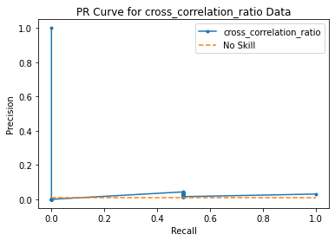

0.7392638036809815

[1.54927045 0.54927045 0.35968384 0.35903338 0.24193524 0.24113169

0.05688747 0. ]

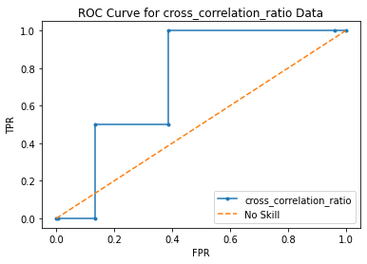

All_fields

[1, 1, 0, 0, 0, 0, 0, 0, 0, 0, 0, 0, 0, 0, 0, 0, 0, 0, 0, 0, 0, 0, 0, 0, 0, 0, 0, 0, 0, 0, 0, 0, 0, 0, 0, 0, 0, 0, 0, 0, 0, 0, 0, 0, 0, 0, 0, 0, 0, 0, 0, 0, 0, 0, 0, 0, 0, 0, 0, 0, 0, 0, 0, 0, 0, 0, 0, 0, 0, 0, 0, 0, 0, 0, 0, 0, 0, 0, 0, 0, 0, 0, 0, 0, 0, 0, 0, 0, 0, 0, 0, 0, 0, 0, 0, 0, 0, 0, 0, 0, 0, 0, 0, 0, 0, 0, 0, 0, 0, 0, 0, 0, 0, 0, 0, 0, 0, 0, 0, 0, 0, 0, 0, 0, 0, 0, 0, 0, 0, 0, 0, 0, 0, 0, 0, 0, 0, 0, 0, 0, 0, 0, 0, 0, 0, 0, 0, 0, 0, 0, 0, 0, 0, 0, 0, 0, 0, 0, 0, 0, 0, 0, 0, 0, 0]

0.07982456140350877

[0.7968549 0.79739857 0.8050855 0.8075525 0.8095093 0.8095803

0.81122524 0.81372696 0.81715447 0.82407564 0.8261735 0.8277226

0.8306269 0.833754 0.8515037 0.8528359 0.85410935 0.86315566

0.8699064 0.93052197]

no skill 0.012121212121212121

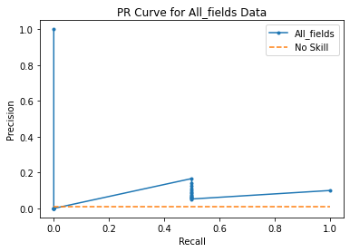

0.9294478527607362

[1.930522 0.93052197 0.8528359 0.8515037 0.79739857 0.7968549

0.04677616]

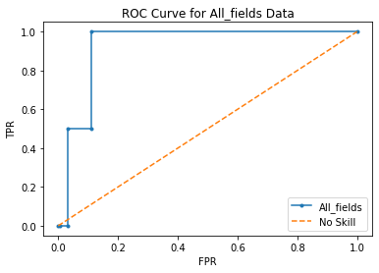

If I 3x weight reflectivity:

All_fields

[1, 1, 0, 0, 0, 0, 0, 0, 0, 0, 0, 0, 0, 0, 0, 0, 0, 0, 0, 0, 0, 0, 0, 0, 0, 0, 0, 0, 0, 0, 0, 0, 0, 0, 0, 0, 0, 0, 0, 0, 0, 0, 0, 0, 0, 0, 0, 0, 0, 0, 0, 0, 0, 0, 0, 0, 0, 0, 0, 0, 0, 0, 0, 0, 0, 0, 0, 0, 0, 0, 0, 0, 0, 0, 0, 0, 0, 0, 0, 0, 0, 0, 0, 0, 0, 0, 0, 0, 0, 0, 0, 0, 0, 0, 0, 0, 0, 0, 0, 0, 0, 0, 0, 0, 0, 0, 0, 0, 0, 0, 0, 0, 0, 0, 0, 0, 0, 0, 0, 0, 0, 0, 0, 0, 0, 0, 0, 0, 0, 0, 0, 0, 0, 0, 0, 0, 0, 0, 0, 0, 0, 0, 0, 0, 0, 0, 0, 0, 0, 0, 0, 0, 0, 0, 0, 0, 0, 0, 0, 0, 0, 0, 0, 0, 0]

0.12045454545454547

[0.68256795 0.684972 0.6856164 0.6942264 0.6944457 0.70122355

0.7124456 0.72570765 0.7355751 0.7423635 0.75683296]

no skill 0.012121212121212121

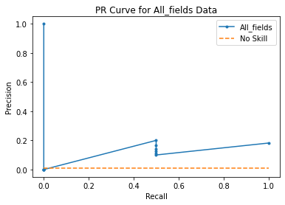

0.9601226993865031

[1.756833 0.75683296 0.72570765 0.7124456 0.684972 0.68256795

0.05400828]

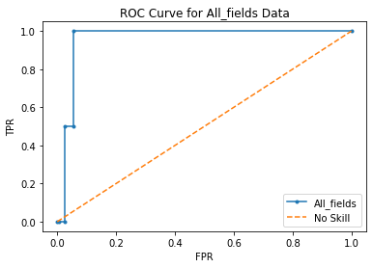

Linear combination at 70% confidence:

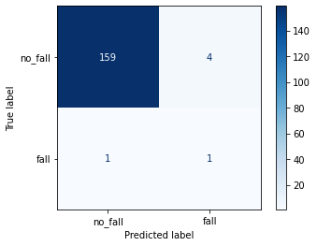

### Null Data

Null loss

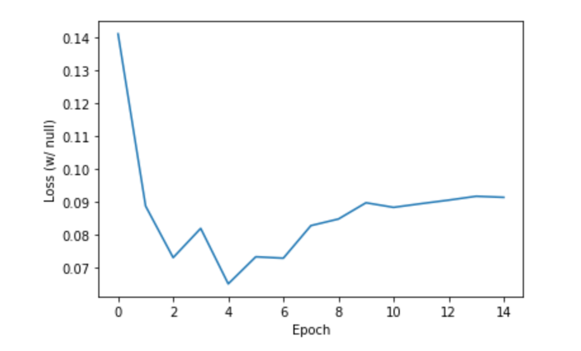

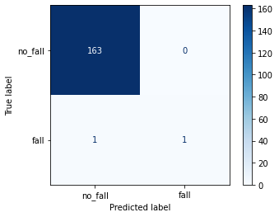

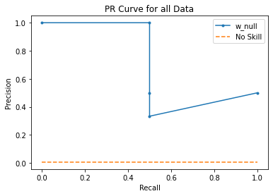

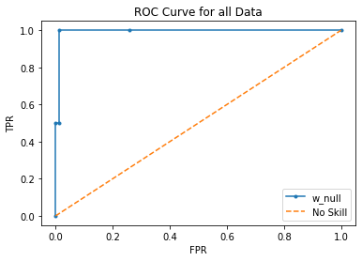

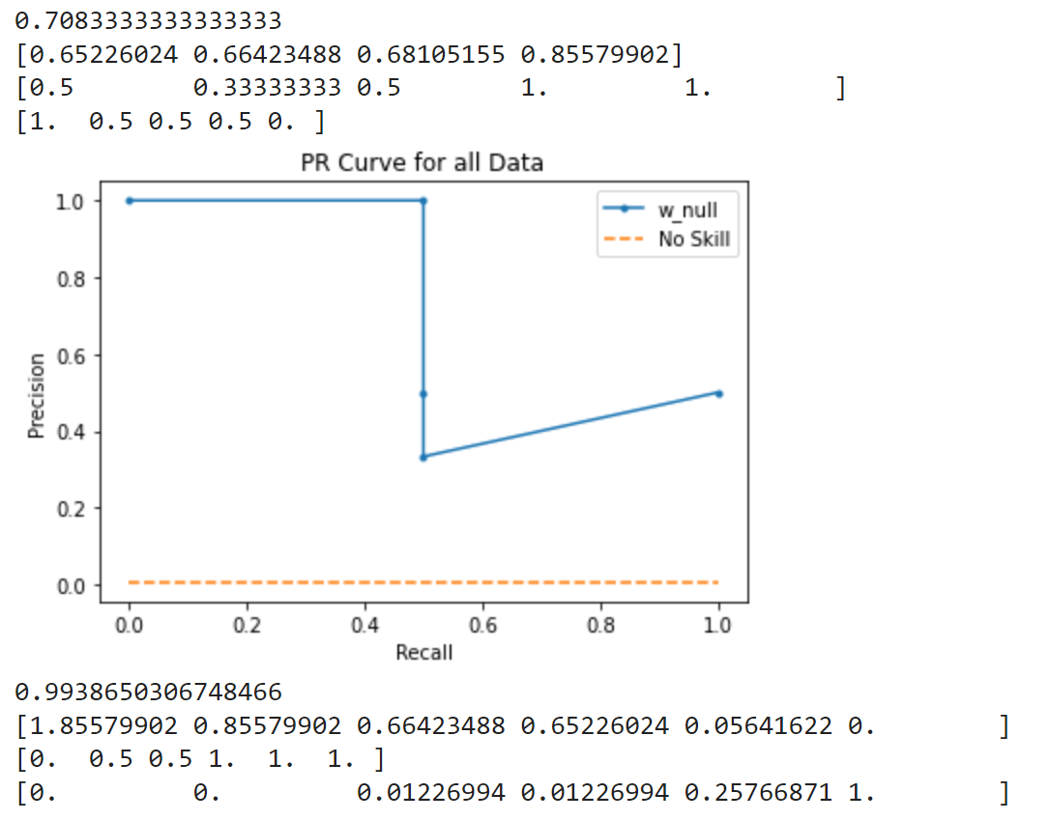

No Null loss

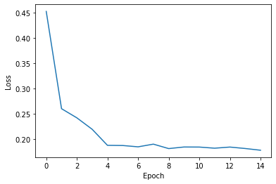

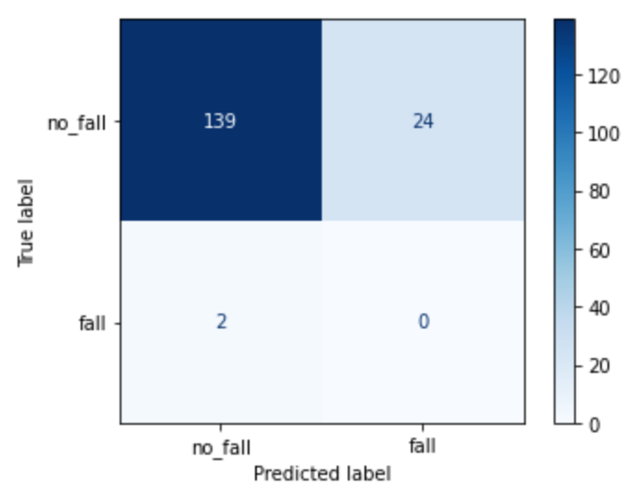

Conf int = .70

All falls at .62 conf int

