Final Release README

Application Name: Minigram

Group Number: 11

Team Members: Keegan Black, Diego Maceda, Joseph Manahan, Matthew Ewing

Dependencies: Xcode 11.4, Swift 5, Firebase Auth, Firebase Firestore, Firebase Storage, Firebase Functions, Apple Push Notification Service

**Testing Instructions:**

* The project can be accessed by opening the MiniGram.xcworkspace file.
* The project requires an Apple Developers License to work correctly because of notifications integration with the Apple Push Notification Service.
  + If you would like to build the app without an Apple Developers License, please click on the “x” circled below and uncheck “Remote Notifications”.

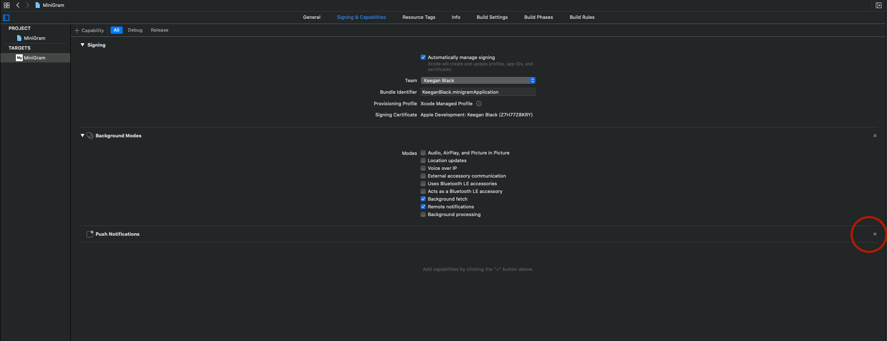

* The app works best in portrait mode on any iPhone of your choice!
* You can test the app with the following credentials, and/or create your own account!
  + Joseph’s Account
    - Email: admirilred@gmail.com
    - Password: password
  + Keegan’s Account:
    - Email: keeganblack@utexas.edu
    - Password: password
  + Matthew’s Account:
    - Email: matthew.ewing@utexas.edu
    - Password: password
  + Diego’s Account:
    - Email: dmaceda22@gmail.com
    - Password: password

|  |  |  |  |  |  |
| --- | --- | --- | --- | --- | --- |
| Feature | Description | Release Planned | Release Actual | Deviations | Who/Percentage Worked On |
| Launch Screen | Display our app logo while app is loading | Alpha | Alpha | None | Diego (100%) |
| Login Page | Allow login by email, account creation, and auto-login if they have previously logged into the app | Alpha | Alpha | None | Keegan (70%)  Matthew (30%) |
| Home Tab UI | Well designed display of local test posts including post picture, caption, user, user photo, like button, and segue to comments | Alpha | Alpha | None | Matthew (100%) |
| Discover Tab UI | Well designed display of local test posts in a gallery view as well as a search bar to search all users | Alpha | Alpha | None | Keegan (100%) |
| Add Tab UI | Well designed layout and all basic camera functionality for adding posts and miniatures to the user’s collection | Alpha | Alpha | None | Joseph (100%) |
| Profile Tab UI | Well designed display of local test posts and test miniatures as well as the UI required for settings without functionality | Alpha | Alpha | None | Diego (100%) |
| Add Tab Database Functionality | Builds upon clean UI and implements functionality required to upload post photo and caption or miniature photo and miniature attributes to Firebase Firestore and Firebase Storage | Beta | Beta | None | Joseph (60%)  Keegan (30%)  Matthew (10%) |
| Profile Tab Database Functionality | Builds upon clean UI and implements functionality required to download your personal post photos and captions as well as miniature photos and miniature attributes, and finally the number of followers you have from Firebase Firestore and Firebase Storage. Additionally, the settings view controllers are fully functional for updating account information, changing password, deleting account, and switching between light and dark mode. | Beta | Beta | Delete account functionali-ty was not completed in time for the Beta release but is fully functional in the Final release | Keegan (37.5%)  Diego (37.5%)  Matthew (25%) |
| Post View | Displays a single post, including a working like button, the caption, and a segue to the comments for the given post. Accessible from the profile and explore tabs. | Beta | Beta | None | Keegan (70%)  Diego (30%) |
| Miniature View | Displays a single miniature including all the fields and information associated with the given miniature. | Beta | Beta | None | Diego (100%) |
| Dark Mode Add and Profile Tabs | Implemented required background colors, font colors, and logo assets for dark mode on these two tabs | Beta | Beta | None | Keegan (25%)  Diego (25%)  Matthew (25%)  Joseph (25%) |
| Home Tab Database Functionality | Builds upon clean UI and implements functionality required to download post photos and captions of users that you are following from Firebase Firestore and Firebase Storage. Additionally, displays the username and user photo of the post’s author and has a fully functioning like button. Each post has a view all comments button that correctly segues to the comment view with the post’s comments. | Final | Final | None | Matthew (70%)  Diego (30%) |
| Comment View | Displays all comments for a given post as well as the user that left the comment and that user’s photo. Allows for adding comments to posts. | Final | Final | None | Keegan (60%)  Matthew (40%) |
| Discover Tab Database Functionality | Builds upon clean UI and implements functionality required to download post photos and captions of users that you are not following from Firebase Firestore and Firebase Storage. When clicked, a view of the post will appear allowing the user to see the caption, access the like button, and segue to the comment view. The search bar is fully functional using data from Firebase Firestore and allows users to be located via their name and username. When a user is clicked on, their profile page appears and you can view their posts and miniatures as well as access the follow button. | Final | Final | None | Keegan (100%) |
| Dark Mode Home and Discover Tabs | Implemented required background colors, font colors, and logo assets for dark mode on these two tabs | Final | Final | None | Keegan (25%)  Diego (25%)  Matthew (25%)  Joseph (25%) |
| Notifications | Will notify users when another user leaves a new comment on one of their posts via Apple Push Notifications and Firebase functions. | Final | Final | None | Keegan (90%)  Matthew (5%)  Diego (5%) |
| Tapping on username in home tab linking to profile | When searching for users on the Explore tab, you can click on the search results to view the user’s profile and follow them. We have extended this functionality to the home tab allowing our users to view the profile of those they are following without having to search for them once again. | Extra Feature | Final | None | Keegan (50%)  Matthew (50%) |