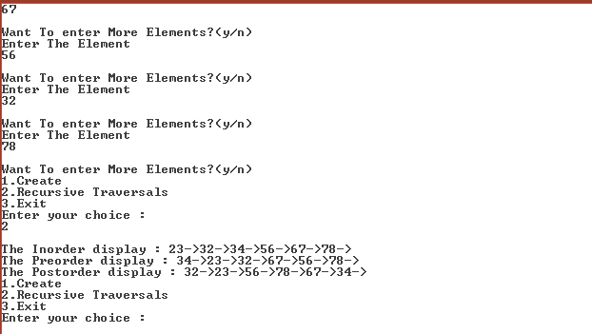

# include <stdio.h>

# include <stdlib.h>

typedef struct BST {

int data;

struct BST *lchild, *rchild;

} node;

void insert(node *, node *);

void inorder(node *);

void preorder(node *);

void postorder(node *);

int main()

{

int choice;

char ans = 'N';

int key;

node *new_node, *root, *tmp, *parent;

node *get_node();

root = NULL;

printf("\nProgram For Binary Search Tree ");

do {

printf("\n1.Create");

printf("\n2.Recursive Traversals");

printf("\n3.Exit");

printf("\nEnter your choice :");

scanf("%d", &choice);

switch (choice) {

case 1:

do {

new_node = get_node();

printf("\nEnter The Element ");

scanf("%d", &new_node->data);

if (root == NULL)

root = new_node;

else

insert(root, new_node);

printf("\nWant To enter More Elements?(y/n)");

ans = getch();

} while (ans == 'y');

break;

case 2:

if (root == NULL)

printf("Tree Is Not Created");

else {

printf("\nThe Inorder display : ");

inorder(root);

printf("\nThe Preorder display : ");

preorder(root);

printf("\nThe Postorder display : ");

postorder(root);

}

break;

}

} while (choice != 3);

return 0;

}

node *get_node() {

node *temp;

temp = (node *) malloc(sizeof(node));

temp->lchild = NULL;

temp->rchild = NULL;

return temp;

}

void insert(node *root, node *new_node) {

if (new_node->data < root->data) {

if (root->lchild == NULL)

root->lchild = new_node;

else

insert(root->lchild, new_node);

}

if (new_node->data > root->data) {

if (root->rchild == NULL)

root->rchild = new_node;

else

insert(root->rchild, new_node);

}

}

void inorder(node *temp) {

if (temp != NULL) {

inorder(temp->lchild);

printf("%d->", temp->data);

inorder(temp->rchild);

}

}

void preorder(node *temp) {

if (temp != NULL) {

printf("%d->", temp->data);

preorder(temp->lchild);

preorder(temp->rchild);

}

}

void postorder(node *temp) {

if (temp != NULL) {

postorder(temp->lchild);

postorder(temp->rchild);

printf("%d->", temp->data);

}

}