|  |
| --- |
| Fake news detection using machine learning    Minor Project Submitted in Partial Fulfillment of the Requirements for the Degree of  Bachelor of Technology in the field of Electronics and communication Engineering.    BY  Utsav Kashyap (123221102068)  Rahul Kumar (123221102034)  Saurabh Kumar (123231102207)  Aryan Kumar (123221102016)    Under the supervision of  Dr. Indranath Sarkar      Department of ---------------------------------  JIS College of Engineering  Block-A, Phase-III, Kalyani, Nadia, Pin-741235  West Bengal, India Jun, 2025 |

1

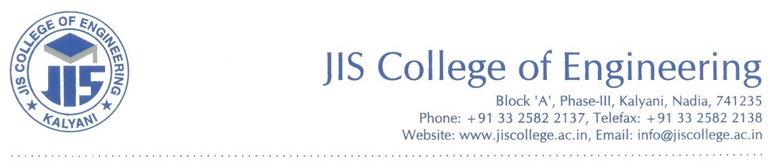

CERTIFICATE

This is to certify that Utsav Kashyap (123221102068), Rahul Kumar (123221102034) Saurabh Kumar (123231102207) & Aryan Kumar (123221102016). Has completed his project entitled Fake news detection using machine learning, under the guidance of Dr .. Indranath Sarkar in partial fulfilment of the requirements for the award of the Bachelor of Technology in Electronics and Communication Engineering from JIS college of Engineering (An Autonomous Institute) is an authentic record of their own work carried out during the academic year 2024-25 and to the best of our knowledge, this work has not been submitted elsewhere as part of the process of obtaining a degree, diploma, fellowship or any other similar title.

---------------------------------

Signature of the Supervisor

---------------------------------

Signature of the Co-Supervisor

Place:

Date:

ACKNOWLEDGEMENT

The analysis of the project work wishes to express our gratitude to Dr. Indranath Sarkar for allowing the degree attitude and providing effective guidance in development of this project work. Her conscription of the topic and all the helpful hints, she provided, contributed greatly to successful development of this work, without being pedagogic and overbearing influence.

We also express our sincere gratitude to Dr. Moumita pal Head of the Department of Electronics and Communication Engineering of JIS College of Engineering and all the respected faculty members of Department of ECE for giving the scope of successfully carrying out the project work.

Finally, we take this opportunity to thank to Dr. Partha Sarkar, Principal of JIS College of Engineering for giving us the scope of carrying out the project work.

Date:

3

…………………………………….………………………………….

Utsav Kashyap

B.TECH in Electronics and Communication Engineering

3rdYear/6thSemester

Univ Roll—123221102068

…………………………………….………………………………….

Rahul Kumar

B.TECH Electronics and Communication Engineering

3rdYear/6thSemester

Univ Roll—123221102034

…………………………………….………………………………….

Saurabh Kumar

B.TECH Electronics and Communication Engineering

3rdYear/6thSemester

Univ Roll— 123231102207