Satellite Pollution Super-Resolution
Project walkthrough: every step, why it was done, and how the models differ

Sprint 2 (one-patch test) · Sprint 3 (first RQ1 numbers)
Sprint 4 & 5 started early (EPA PM2.5, RQ4) · RQ3 confidence-map check
Branch: ryan-dev · October 2026

How to use this document: Read it top to bottom once. Each sprint section has the same pattern: what we did, pseudo code for the steps, a blue Why? box explaining the reasoning, and a green Result box. Real file names are in code font so you can open the actual code next to it.

Contents
1. The big picture 4
The four research questions 4
The pipeline in one picture 4
Key words 5
2. Setup: getting the computer ready 6
3. The shared pieces every sprint uses 7
3.1 Loading the data (src/dataset.py) 7
3.2 The shared model shell (src/models/sr_net.py) 7
3.3 The scores (src/metrics.py) 8
4. The three models: what each one does and how they differ 9
4.1 EDSR: work small, enlarge at the end 9
4.2 U-Net: enlarge first, then zoom out and back in 9
4.3 SwinIR-light: a transformer that compares pixels 10
4.4 Side-by-side comparison 11
5. Sprint 2: can the model copy ONE patch? 12
Step by step 12
The learning-rate bug we found 13
Results 13
6. Sprint 3: train on real patches, compare with bicubic (RQ1) 15
Step 1: split the data fairly 15
Step 2: the training loop 15
Results (validation patches, never trained on) 16
7. Sprint 4 (started early): EPA PM2.5 and the first RQ4 look 17
Step 1: download EPA PM2.5 (src/epa_pm25.py) 17
Step 2: match AOD to each monitor (src/rq4_first_look.py) 17
Step 3: two ways to score, and why 18
Results (June 2023) 18
8. Sprint 5 preview: sharpened AOD vs EPA (code check) 20
Step 1: find the fair days 20
Step 2: sharpen around each monitor 20
Results 20
9. RQ3: is the confidence map honest? (teacher's feedback) 22
What was measured 22
What we found 22
10. What's left, and every command 24
Still to do 24
Every command, in order 24
Where to read more 25

1. The big picture
The project takes a blurry satellite pollution map and makes it sharper. The satellite (NASA MODIS, product MAIAC) measures AOD: how much haze or particle pollution is in the air column. We have AOD at 1 km pixels. We pretend we only have the blurry 4 km version, and train a neural network to rebuild the sharp 1 km map from it. If the network can do that better than a simple stretch (bicubic), it's useful.

The four research questions
RQ | Question | Where we are
RQ1 | Can deep SR sharpen AOD 4 km → 1 km better than bicubic? | First numbers: yes, slightly (Sprint 3)
RQ2 | Does forcing the sharp map to average back to the blurry one reduce made-up detail? | Not started (Sprint 4, Rency)
RQ3 | Is the confidence map reliable (90% sure = right 90% of the time)? | Early check done; teacher says be careful
RQ4 | Does sharpened AOD match ground PM2.5 (EPA monitors) better than blurry AOD? | Pipeline built; not enough data yet

The pipeline in one picture
NASA MAIAC AOD (1 km) <- Rency, Track A (Google Earth Engine)
|
v
daily DFW maps data/raw_tifs/dfw_aod_2023-06-*.tif (135 x 168 pixels each)
|
v cut into 64x64 patches, make the blurry 16x16 version (4x4 averages)
data/sprint2_patches.npz (144 patches: lr 16x16, hr 64x64, mask)
|
v train a model: blurry 16x16 -> sharp 64x64 (+ confidence map)
checkpoints/edsr_real.pt, unet_real.pt, swinir_real.pt
|
+--> RQ1: compare with bicubic (RMSE, PSNR, SSIM)
+--> RQ3: is the confidence map honest? (coverage)
+--> RQ4: does it match EPA ground PM2.5 better? (R^2)

Key words
Word | Meaning
AOD | Aerosol Optical Depth. How hazy the air is. Around 0.15 in DFW in June. No units.
LR / lr | Low-resolution (blurry) map: 16x16 pixels of 4 km. Careful: args.lr means learning rate, a different thing.
HR / hr | High-resolution (sharp) map: 64x64 pixels of 1 km. The answer we want.
Patch | A small square cut from the big map (64x64 at 1 km = 64 km x 64 km).
Mask | 1 = real pixel, 0 = missing (cloud or bad reading). Every loss and score skips mask = 0.
Bicubic | The standard 'smooth stretch' for enlarging an image. The baseline we must beat.
Epoch / step | A step = one weight update. An epoch = one pass through all training patches.
Learning rate | How big each weight update is. Too big = training blows up; too small = slow.
RMSE | Average error size in AOD units. Lower is better.
PSNR | Image quality in decibels (dB). Higher is better. +3 dB ≈ half the squared error.
SSIM | How similar the shapes/structure look, 0 to 1. Higher is better.
Detail ratio | How much pixel-to-pixel variation vs the real map. 1.0 = right, <1 = too blurry, >1 = invented noise.
Coverage90 | How often the true value falls inside the model's '90% sure' range. Should be 0.90.
R² | How much of the up-and-down in one thing another explains. 0 = nothing, 1 = everything.

2. Setup: getting the computer ready
Before anything could run, the right Python packages had to be installed. This took more care than expected because of one hidden problem.
Commands (simplified)
pip install torch --index-url .../cu130 # PyTorch, GPU version (for the RTX 3080)
pip install numpy matplotlib scikit-image timm
pip install rasterio pandas python-docx # later: reading map files, tables
Watch out: Installing timm (needed by SwinIR) also installs torchvision, and that quietly replaced the GPU version of PyTorch with a CPU-only one. Everything still ran, just ~10x slower. Fix: reinstall torch and torchvision together from the CUDA index after installing timm.
Why? A GPU does thousands of multiplications at once. Training SwinIR on the CPU would take many minutes per run instead of about one. Every script prints device: cuda (GPU) or device: cpu at the start so you can always check.

3. The shared pieces every sprint uses
Three building blocks are used by everything later: loading the data, the shared model shell, and the scores. Understanding these makes every sprint easy to follow.

3.1 Loading the data (src/dataset.py)
Rency's file data/sprint2_patches.npz holds 144 patches from 29 days of June 2023:
Name | Shape | Meaning
lr | 144 x 1 x 16 x 16 | blurry inputs (4x4 block averages)
hr | 144 x 1 x 64 x 64 | sharp 1 km answers, already real AOD
mask | 144 x 1 x 64 x 64 | 1 = real pixel, 0 = missing (hr is stored as 0 there)
scale | 4 | each low-res pixel = a 4x4 block of high-res pixels

Pseudo code: loading
def read_real_patches(path):
data = load(path)
hr_mask = data.mask > 0
# a low-res pixel is real if ANY of its 16 high-res pixels is real
lr_mask = hr_mask grouped into 4x4 blocks -> any()
hr = where(hr_mask, data.hr, NaN) # missing 0s -> NaN ("not a number")
lr = where(lr_mask, data.lr, NaN)
return lr, hr, scale

class AODDataset:
def __init__(lr, hr, mean, std):
masks = isfinite(lr), isfinite(hr) # 1 = real, 0 = NaN
lr, hr = (lr - mean) / std, (hr - mean) / std # normalize
replace NaN with 0 # the mask says they're fake
def to_aod(x):
return x * std + mean # undo normalize for scoring
Why? Missing = 0 is dangerous. A real AOD can be close to 0, so the code turns Rency's zeros back into NaN and keeps a separate mask. Normalizing (making values sit around 0 with spread 1) helps neural networks learn, because their starting weights expect numbers of that size. to_aod() undoes it so every score is in real AOD units. The values are already real AOD, so we never multiply by MAIAC's 0.001 scale factor again.

3.2 The shared model shell (src/models/sr_net.py)
All three models (EDSR, U-Net, SwinIR) are wrapped in the same shell. The model body only has to predict the missing detail; the shell adds it on top of a bicubic stretch.
Pseudo code: the shell
class SRModel:
def forward(lr, lr_mask):
detail, log_var = body(lr, lr_mask) # EDSR, U-Net or SwinIR
bicubic = bicubic_stretch(lr, x4) # 16x16 -> 64x64, smooth
sharp = bicubic + detail # model adds the fine detail
if use_consistency: # RQ2 rule, OFF for now
sharp = make_consistent(sharp, lr)
return sharp, clamp(log_var, -10, 10) # sharp map + confidence
Why? Learning only the detail is easier than learning the whole map: at the start, detail = 0 and the output is already as good as bicubic. This is called residual learning. Putting every model in the same shell makes the comparison fair: the only thing that changes is the body.
The confidence map is log_var: the log of the variance (spread) the model expects at each pixel. Log is used so it can never be negative, and it's clamped so exp() can't blow up.

The uncertainty loss (used by train.py)
def uncertainty_loss(sharp, log_var, target, mask):
# per pixel: 0.5 * ( error^2 / variance + log(variance) )
loss = 0.5 * (exp(-log_var) * (target - sharp)^2 + log_var)
return average of loss over real pixels only (mask = 1)
Why? The first term punishes errors, divided by the variance: if the model says 'I'm unsure here' (big variance), being wrong costs less. The second term (log_var) charges a fee for saying 'unsure', so the model can't just claim to be unsure everywhere. The balance makes it predict a variance that matches its real error. This is the Gaussian negative log-likelihood (Kendall & Gal, 2017). It can go negative, which is normal.

3.3 The scores (src/metrics.py)
Pseudo code: scores
rmse(pred, target, mask) = sqrt( mean over real pixels of (pred - target)^2 )
psnr = 10 * log10( AOD_RANGE^2 / mean squared error )
ssim = structure similarity (cloudy pixels filled with the truth)
detail_ratio = sqrt( pixel-to-pixel change in pred / same in target )
coverage(level) = fraction of pixels where |pred - target| <= z * std
z = 1.645 for 90%, 1.282 for 80%, ...
Why? Every score takes the mask, so missing pixels never count. Coverage uses the normal distribution: if the model's spread is honest, 90% of true values fall within 1.645 standard deviations of the prediction.

4. The three models: what each one does and how they differ
All three take the same input (the 16x16 blurry map plus its 16x16 cloud mask, glued together as 2 channels) and give the same output (64x64 detail + 64x64 confidence). They differ in how they look at the map.

4.1 EDSR: work small, enlarge at the end
Paper: Lim et al., 'Enhanced Deep Residual Networks for Single Image Super-Resolution', 2017. File: src/models/edsr.py. Size: 1,516,418 weights.
Pseudo code: EDSR body
input: AOD (16x16) + mask (16x16) -> 2 channels
x = conv3x3(input) # 2 -> 64 feature channels
y = x
repeat 16 times: # residual blocks
y = y + conv3x3( relu( conv3x3(y) ) ) # small correction each time
x = x + conv3x3(y) # long skip connection
repeat 2 times: # 16 -> 32 -> 64
x = conv3x3(x) ; x = PixelShuffle(x, 2)
detail = conv3x3(x) # 64x64
confidence = conv3x3(x) # 64x64
- All the thinking happens at 16x16. Only at the very end is the result enlarged. That makes it fast and light on memory.
- Residual blocks: each block adds a small correction to what it got (y + change). Stacking 16 of them lets the network build up complex patterns without getting lost.
- PixelShuffle: instead of stretching, it turns extra channels into extra pixels: 4 channels at one pixel become a 2x2 block. Done twice gives 4x.
- No batch normalization (unlike many networks), because it rescales values, and for AOD the actual values matter.
- What it sees: each 3x3 conv looks at neighbours; after ~35 convs it can see the whole 16x16 patch, but mostly focuses on local texture.

4.2 U-Net: enlarge first, then zoom out and back in
Paper: Ronneberger et al., 'U-Net', 2015. File: src/models/unet.py. Size: 1,925,346 weights.
Pseudo code: U-Net body
big = bicubic_stretch(AOD, x4) # 16x16 -> 64x64 first
x = glue(big, nearest_stretch(mask)) # 2 channels at 64x64
e1 = DoubleConv(x) # 32 ch, 64x64 <- fine detail
e2 = DoubleConv(pool(e1)) # 64 ch, 32x32
e3 = DoubleConv(pool(e2)) # 128 ch, 16x16
b = DoubleConv(pool(e3)) # 256 ch, 8x8 <- sees the whole patch
d3 = DoubleConv(glue(up(b), e3)) # back to 16x16, + skip from e3
d2 = DoubleConv(glue(up(d3), e2)) # back to 32x32, + skip from e2
d1 = DoubleConv(glue(up(d2), e1)) # back to 64x64, + skip from e1
detail, confidence = conv1x1(d1), conv1x1(d1)
- Enlarge first: it starts from a 64x64 bicubic version and then corrects it.
- Shaped like a U: the left side shrinks the map (64 → 32 → 16 → 8) so the network sees the big picture (regional haze, plumes). The right side grows it back.
- Skip connections carry the fine detail from each left level straight across to the matching right level, so nothing sharp is lost in the shrinking.
- Multi-scale: it naturally mixes 'what's happening across the whole patch' with 'what's at this pixel'.
- Works at full 64x64 resolution most of the time, so it uses more memory than EDSR.

4.3 SwinIR-light: a transformer that compares pixels
Paper: Liang et al., 'SwinIR', 2021 (built on the Swin Transformer). Files: src/models/swinir.py (our wrapper) and swinir_official.py (the authors' code, unchanged). Size: 920,432 weights.
Pseudo code: SwinIR body
x = conv3x3(AOD + mask) # 2 -> 60 channels, 16x16
repeat 4 groups:
repeat 6 layers:
split the 16x16 map into 8x8 windows
every pixel ATTENDS to every other pixel in its window:
weight = similarity(pixel_a, pixel_b)
new_a = weighted average of all pixels in the window
every other layer: SHIFT the windows by 4 pixels
(so information can cross window borders)
small MLP on each pixel
group output = group input + conv(...) # residual, like EDSR
x = conv3x3(x) ; PixelShuffle(x, 4) # 16x16 -> 64x64 in one go
detail, confidence = channel 0, channel 1
- Attention instead of fixed filters: a conv always looks at neighbours with the same fixed weights. Attention decides, for each pixel, which other pixels matter based on how similar they are. A pixel on a smoke streak can 'look along' the streak.
- Windows: comparing every pixel with every other is expensive, so it compares inside 8x8 windows, and shifts the windows every other layer so information spreads across the patch.
- Light version: the official 'lightweight SR' settings (60 channels, 4 groups of 6 layers), so it has the fewest weights of the three.
- Slowest: attention is more work per pixel than a conv. About 10x slower per step than EDSR here.

4.4 Side-by-side comparison
 | EDSR | U-Net | SwinIR-light
Type | CNN (convolutions) | CNN, encoder-decoder | Transformer (attention)
Works at | 16x16, enlarges at end | 64x64, enlarges at start | 16x16, enlarges at end
How it sees context | Local filters, stacked deep | Shrinks to 8x8 to see the whole patch | Pixels compare with each other in shifting windows
Weights | 1.52M | 1.93M | 0.92M (fewest)
Speed (1-patch test, GPU) | ~10 s | ~12 s | ~106 s (slowest)
Sprint 2: copy one patch | 0.7% of bicubic error, steady | 1.4%, bounces around | 1.7%, slow but steady
Sprint 3: unseen patches, RMSE | 0.0142 | 0.0142 | 0.0140 (best)
Sprint 3: detail ratio | 0.53 | 0.40 (smoothest) | 0.54
RQ3: coverage90 (target 0.90) | 0.89 (closest) | 0.87 | 0.83 (most overconfident)

Why? Comparing three very different designs answers 'does the kind of model matter for AOD?'. If all three end up similar (as so far), the bottleneck is the data, not the architecture. That's useful to know before spending time tuning one model.

5. Sprint 2: can the model copy ONE patch?
Rency's request: 'Train a small model on one patch until it can copy that patch. Compare it to plain bicubic. Skip the confidence map and the average-back check for now.' File: src/overfit_one_patch.py.
Why? This is a classic sanity check. A model that can't even memorize one example has a bug (wrong loss, shapes don't line up, data broken, learning rate too high). If it can, the whole training pipeline works, and we can move on to real training. It doesn't show the model works on new data; that's Sprint 3.

Step by step
Pseudo code: overfit_one_patch.py
# 1. pick one patch
dataset = load_real_patches("data/sprint2_patches.npz")
patch = the most varied patch among those >= 95% cloud-free # -> patch 40
lr, lr_mask, hr, hr_mask = dataset[patch] (with a batch size of 1)

# 2. build the model (average-back rule OFF)
model = build_model("edsr") # or unet, swinir
optimizer = Adam(model.weights, learning_rate = 2e-4)

# 3. train on the same patch 2000 times
repeat 2000 times:
sharp, _ = model(lr, lr_mask) # _ = ignore the confidence map
loss = mean over real pixels of (sharp - hr)^2 # masked MSE
optimizer.zero_grad() # clear last step's gradients
loss.backward() # how does each weight affect the loss?
optimizer.step() # nudge every weight to lower the loss
every 100 steps: print RMSE / PSNR / SSIM / detail, model vs bicubic

# 4. verdict
ratio = model RMSE / bicubic RMSE
PASS if ratio < 0.10 # model error under 10% of bicubic's
save the figure

Why each choice
- Most varied patch: a flat patch would be too easy; bicubic would already look perfect. Patch 40 has streaks and edges.
- 95% cloud-free: so almost every pixel counts in the score.
- Masked MSE, not the uncertainty loss: Rency asked to skip the confidence map, so the simplest loss is used.
- PASS threshold 10%: after 2000 looks at the same patch, a working model should be far better than bicubic.
- Fixed random seed (0): the same starting weights every run, so results are (nearly) repeatable.

The learning-rate bug we found
The first rerun on this computer failed. With learning rate 1e-3, EDSR reached an error of about 3e-5 by step 900, then blew up at step 1200 (RMSE jumped to ~350, worse than random).
step 900 | RMSE 0.00003 <- almost perfect
step 1100 | RMSE 0.00010
step 1200 | RMSE 12.7 <- one huge step overshot
step 2000 | RMSE 353.6 -> FAIL
Why? The Adam optimizer takes steps of roughly the same size even when the error is tiny. Near a perfect fit, a 1e-3 step overshoots, the next step is worse, and it spirals. EDSR is normally trained at about 1e-4, so 1e-3 was 5-10x too high. Changed the default to 2e-4 (same as train.py). It then stayed stable for all 2000 steps.

Results
 | Bicubic | EDSR | U-Net | SwinIR-light
RMSE | 0.0235 | 0.00017 | 0.00033 | 0.00040
Error vs bicubic | - | 0.7% | 1.4% | 1.7%
PSNR gain | - | +42.7 dB | +37.2 dB | +35.3 dB
SSIM | 0.798 | 1.000 | 1.000 | 1.000
Detail | 0.24 (blurry) | 1.00 | 1.00 | 1.00
Verdict | - | PASS | PASS | PASS

Result: All three models can learn real AOD through the shared shell. U-Net's error bounces during training, so its final number changes most between runs (0.6% to 1.4%), but it always passes. Patch 43 (100% cloud-free) also passed with EDSR: 0.4% of bicubic's error.
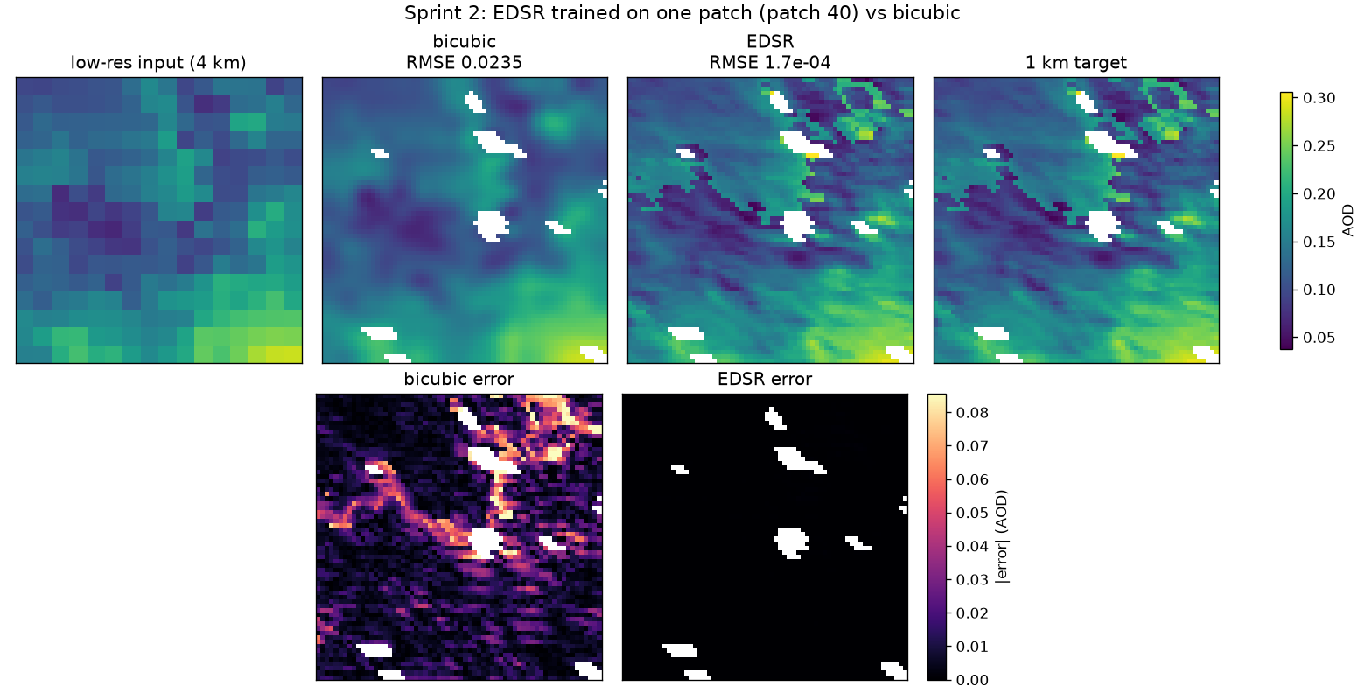
EDSR copying patch 40. Top: input, bicubic, model, target. Bottom: error maps (black = no error).
How to read the figure: top row uses one shared colour scale for AOD; the model panel looks just like the target, while bicubic is smooth. Bottom row: bicubic's error is brightest along sharp edges; the model's is black everywhere. White spots are missing pixels. The U-Net and SwinIR versions are sprint2_overfit_unet.png and sprint2_overfit_swinir.png and look the same.
Watch out: GPU results can change in the last digits between runs even with the same seed (e.g. RMSE 0.00016 vs 0.00018), because GPUs add numbers in slightly different orders.

6. Sprint 3: train on real patches, compare with bicubic (RQ1)
Task (Track B): 'Train on real s=4 patches; first PSNR/SSIM/RMSE vs bicubic.' Files: src/train.py, src/dataset.py (make_real_datasets). These are preliminary numbers on June 2023 only; the final ones need Rency's year split (2018-21 train / 2022 validation / 2023 test).

Step 1: split the data fairly
Pseudo code: the split
def make_real_datasets(path, val_fraction = 0.2):
lr, hr = read_real_patches(path) # 144 patches, in DATE order
cut = 80% of 144 = 115
# neighbouring patches from the same day OVERLAP by half a patch
while any patch just before the cut overlaps any patch just after it:
cut = cut - 1 # move the cut earlier
mean, std = mean and spread of hr[:cut] # TRAINING patches only
train = AODDataset(lr[:cut], hr[:cut], mean, std) # 112 patches
val = AODDataset(lr[cut:], hr[cut:], mean, std) # 32 patches (June 28-30)
Why? Not a random split: Rency cuts a 64x64 patch every 32 pixels, so neighbours share half their pixels. A random split would put nearly identical pixels in both sets and make the scores look too good. Splitting by date and moving the cut until nothing overlaps prevents that. Normalization uses training patches only so no information leaks from the validation set.

Step 2: the training loop
Pseudo code: train.py
model = build_model(name) # edsr / unet / swinir
optimizer = Adam(model.weights, learning_rate = 2e-4)
for epoch in 1 .. 300:
for batch of 32 training patches (shuffled):
sharp, log_var = model(lr, lr_mask)
loss = uncertainty_loss(sharp, log_var, hr, hr_mask)
optimizer.zero_grad(); loss.backward(); optimizer.step()
every 25 epochs:
scores = evaluate(model, validation set) # never trains on these
print RMSE / PSNR / SSIM vs bicubic, detail, coverage90 ...
save weights to checkpoints/<model>_real.pt
- Batches of 32: the model updates after every 32 patches; averaging over a batch makes each step steadier.
- Shuffle: a new order every epoch so the model doesn't learn anything from the order.
- 300 epochs: 112 patches is small, so many passes are needed; scores level off around epoch 150-200.
- Evaluate every 25 epochs: scoring is slower than training, and every epoch isn't needed to see the trend.
def evaluate(model, val_loader):
collect predictions for ALL validation batches first,
then score the whole set at once
# averaging per-batch RMSEs would NOT equal the overall RMSE

Results (validation patches, never trained on)
 | RMSE ↓ | PSNR ↑ | SSIM ↑ | Detail (1.0 = right)
Bicubic | 0.0147 | 36.68 | 0.891 | 0.32
EDSR | 0.0142 | 36.92 | 0.902 | 0.53
U-Net | 0.0142 | 36.93 | 0.900 | 0.40
SwinIR-light | 0.0140 | 37.10 | 0.905 | 0.54

Result: All three beat bicubic on every score: about 4-5% lower RMSE, +0.25 to +0.42 dB PSNR. They add real detail (0.32 → ~0.5) while error goes down, so the detail isn't made up. They're still too smooth (real maps have ~2x more detail).
Why? Why the gain is small: 112 patches from one month is very little data. Sprint 2 proved the models can learn fine detail; doing it on new patches needs many more examples. Why no winner: 32 validation patches from 3 days can't separate 0.0140 from 0.0142.
Sentence for the midterm: 'On a preliminary June 2023 split, all three SR models beat bicubic (best: RMSE 0.0140 vs 0.0147, +0.4 dB PSNR, SSIM 0.905 vs 0.891). Final numbers will use the 2018-21 / 2022 / 2023 year split.'

7. Sprint 4 (started early): EPA PM2.5 and the first RQ4 look
After the midterm, Ryan leads Track A, which includes pulling EPA ground PM2.5 data. It doesn't depend on Rency's year split, so it was started early. EPA data is for evaluation only, never training.

Step 1: download EPA PM2.5 (src/epa_pm25.py)
Pseudo code: epa_pm25.py
DFW_BOX = lon -97.8 to -96.3, lat 32.3 to 33.5 # same box as the AOD maps

for kind in [hourly, daily]:
file = download aqs.epa.gov/.../{kind}_88101_2023.zip # 88101 = PM2.5
keep rows inside DFW_BOX and between start and end dates
site_id = state-county-site-POC # one id per instrument

# satellite passes: Terra ~10:30, Aqua ~13:30 local time
midday = hourly readings at 10:00, 11:00, 12:00, 13:00, 14:00
-> average per instrument per day (need at least 3 of the 5 hours)
save hourly, daily, midday and the monitor list to data/epa/
Why? Prebuilt EPA files need no login. Midday average: the satellite sees DFW around 10:30 and 13:30, so PM2.5 at that time is the fair comparison, not the 24-hour average. We don't yet know which pass each daily map came from, so the window covers both. POC: some sites have more than one instrument; later they're averaged so each site counts once.
Result: 10 instruments at 7 sites (Dallas x2, Fort Worth/Tarrant x3, Denton, Kaufman). June 2023: 5,608 hourly readings, 236 midday averages; midday PM2.5 median 13.9 µg/m³ (range 3.6-40.4).

Step 2: match AOD to each monitor (src/rq4_first_look.py)
Pseudo code: matching
for each day's AOD map (data/raw_tifs/dfw_aod_2023-06-DD.tif):
hr_map = read 1 km AOD (NaN = cloud)
lr_map = 4x4 block averages, copied back to all 16 pixels # blurry version
for each monitor with PM2.5 that day:
row, col = map position of the monitor's lat/lon
aod_4km = lr_map[row, col]
aod_1km = hr_map[row, col]
aod_1km_3x3 = average of the 3x3 pixels around it (clouds skipped)
keep monitor-days where all three exist # same points for every version
Why? 4 km vs 1 km at the same spot is the heart of RQ4: if the sharp version tracks PM2.5 better, sharpening is worth it. The 4 km value uses the same block averaging as the training patches. Scoring all versions on the same monitor-days keeps it fair.

Step 3: two ways to score, and why
Pseudo code: scoring
# A. all days: plain R^2 between AOD and PM2.5
r2 = correlation(aod, pm25)^2

# B. within-day: remove each day's DFW-wide level first
keep days with >= 3 monitors
aod_anomaly = aod - (that day's average aod over all monitors)
pm25_anomaly = pm25 - (that day's average pm25 over all monitors)
r2_within = correlation(aod_anomaly, pm25_anomaly)^2
Why? All days mostly measures 'hazier day = more PM2.5', which even 4 km sees. Within-day removes that and asks 'is THIS spot dirtier than the rest of DFW today?', exactly what extra resolution should help with. 3x3 average: a single 1 km pixel is noisy; averaging 9 reduces noise but keeps it local.

Results (June 2023)
R² with EPA PM2.5 | All days (88 monitor-days) | Within-day (81, on 14 days)
4 km AOD (blurry) | 0.31 | 0.04
1 km AOD (one pixel) | 0.30 | 0.01
1 km AOD (3x3 average) | 0.31 | 0.02

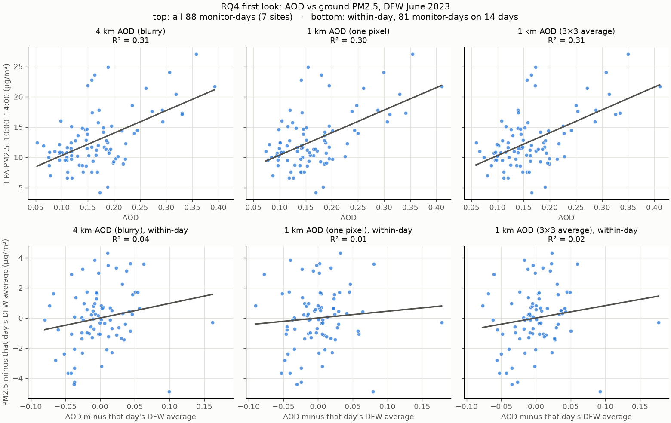
Top: all days. Bottom: within-day. Each dot is one monitor on one day.
Result: AOD tracks PM2.5 (R² ≈ 0.3, normal for raw AOD). But 1 km is no better than 4 km, and within a day AOD explains almost nothing at either resolution. At the monitors, 1 km and 4 km differ by only 0.016 AOD on average, while AOD varies 0.068 across days; within a day monitors differ by only ±4 µg/m³.
Watch out: With one month and 7 sites, the data can't show that sharper AOD tracks PM2.5 better. Options: more years (2018-2023), framing RQ4 as an open question, or focusing on highway/monitor slices. Discuss with Rency before the RQ wording is locked.

8. Sprint 5 preview: sharpened AOD vs EPA (code check)
Task (Track A, Sprint 5): 'Run the correlation: sharpened AOD vs EPA monitors, R².' File: src/rq4_sr_correlation.py. The code works end to end; the numbers are not a result yet.

Step 1: find the fair days
Pseudo code: fair days
# the models trained on the 1 km maps of early June -> they've seen those answers
rebuild Rency's patch list with HER rules:
for each day's map, for each 64x64 window every 32 pixels:
keep if >= 60% of pixels are valid
check: rebuilt patches == sprint2_patches.npz -> identical (all 144)
training days = days of the first 112 patches (13 days)
fair days = all other days (8 days)
Why? If a model already saw the true 1 km map for a day, its 'sharpened' output would look better than it really is (it partly memorized it). The .npz file has no dates, so the patch list was rebuilt with the notebook's exact rules; matching all 144 patches proves the day list is right.

Step 2: sharpen around each monitor
Pseudo code: rq4_sr_correlation.py
for each fair day:
lr = 4x4 block average of the day's map (same rule as the notebook)
for each monitor that isn't under cloud:
tile = the 16x16 low-res tile containing the monitor # training size
x = (tile - train_mean) / train_std # same normalizing
for each model: sharp = model(x) -> 64x64; read the monitor's pixel
also: bicubic, 4 km, real 1 km, 1 km 3x3
compute R^2 vs PM2.5 for every version (all days and within-day)
Why? 16x16 tiles are exactly the input size the models trained on, so they behave as they did in training. Same normalization as training is essential; otherwise the model sees numbers on the wrong scale.

Results
R² with EPA PM2.5 | All days | Within-day
4 km AOD | 0.74 | 0.43
Bicubic | 0.69 | 0.32
EDSR | 0.70 | 0.29
U-Net | 0.69 | 0.32
SwinIR-light | 0.69 | 0.31
Real 1 km | 0.69 | 0.30
Real 1 km, 3x3 | 0.71 | 0.37

Watch out: Only 21 monitor-days (8 days) and 14 within-day points. One or two points can move R² by 0.1 or more, so all versions are within noise. R² is higher than in Sprint 4 only because these 8 days happen to span a wide range of haze. This proves the code works; the real answer needs 2018-2023 data, the year split, retraining, and scoring on the 2023 test year.

9. RQ3: is the confidence map honest? (teacher's feedback)
Teacher's feedback: 'The uncertainty may be hard to quantify. Be careful with that.' We measured the confidence map of all three models to see whether he's right. Files: src/rq3_uncertainty_check.py, docs/rq3_uncertainty_note.md (the note for the teacher).

What was measured
Pseudo code: rq3_uncertainty_check.py
for each model (EDSR, U-Net, SwinIR) on the 32 validation patches:
sharp, log_var = model(lr)
std = exp(0.5 * log_var) * train_std # confidence in AOD units

1. calibration curve:
for level in 10%, 20%, ... 90%, 95%:
actual = coverage(pred, std, target, level) # should equal level
2. bootstrap: resample the 32 patches 2000 times -> range of coverage90
3. split pixels into thirds by std (most sure / middle / least sure)
-> coverage90 in each third; rank correlation(std, |error|)
4. coverage90 next to cloud gaps vs in open sky
Why? One coverage number can look fine while hiding problems. The curve checks every level; the bootstrap checks how sure we are of the number; the thirds check whether the map points at the right pixels; cloud edges check where users need it most.

What we found
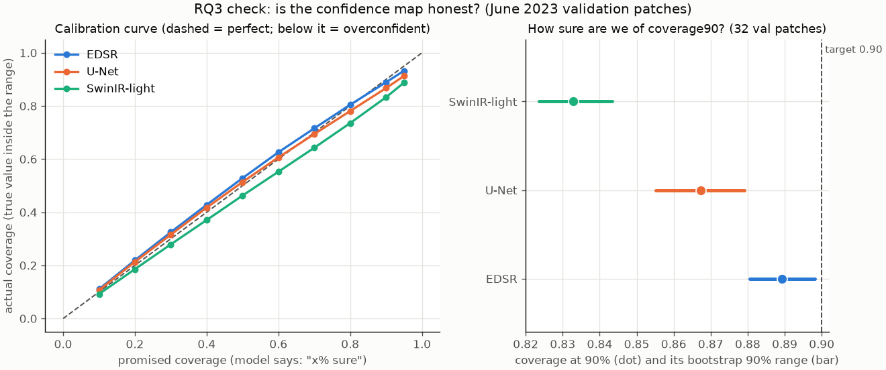
Left: calibration curves (below the dashed line = overconfident). Right: coverage90 with its bootstrap range.
Evidence | Numbers | What it means
1. On average it looks fine | coverage90 0.83-0.89; calibration error 0.02-0.04 | One number would say RQ3 is solved. It isn't.
2. Unstable | EDSR coverage90 swings 0.85-0.95 between epochs; RMSE only 0.0140-0.0143 | The answer depends on when training stops and which model
3a. Cloud edges | coverage90 0.81-0.84 near gaps vs 0.84-0.89 open sky | Overconfident exactly where users need honesty
3b. Most-sure pixels | SwinIR: 0.77 actual vs 0.90 promised; rank corr 0.37-0.40 | The map points the right way, but only roughly
4. Narrow validation | All 32 patches from 3 days (June 28-30) | Bootstrap range looks tight but it's really ~3 samples
5. Limited meaning | std ≈ 0.011-0.013, about the RMSE | Only covers 4 km → 1 km; not satellite error, not smoke days

Result: The teacher is right. The plan narrows RQ3 to a calibration check with clear limits: report the curve and coverage on the 2023 test year with ranges by day, show where it fails, choose and rescale on 2022, and state what the confidence map does not measure.
Watch out: RQ3 is Track B, which Rency leads after the swap. Share the note with Rency before office hours.

10. What's left, and every command

Still to do
Item | Who | Why it matters
Download AOD maps for 2018-2023 | Rency (Track A), maybe split with Ryan | Teacher said ASAP; RQ1, RQ3, RQ4 all need it
Year split + rerun training, RQ3, RQ4 | Rency, then Ryan | Turns preliminary numbers into real ones
Midterm text (due Oct 20) | Both | Four RQs, average-back plan, out of scope
Ask which satellite pass the TIFs came from | Ryan → Rency | Narrows the PM2.5 time window
Save patch coordinates in future patch files | Rency | Lets SR output be matched to monitors directly
Add rasterio, pandas to requirements.txt | Either | So setup works on every computer
Fix the two different timeline files | Both | timeline.md.md vs docs/proposal/timeline.md

Every command, in order
# Sprint 2: one-patch test (all three models)
# (each model also needs --figure docs/diagrams/sprint2_overfit_<model>.png
# so it doesn't overwrite the EDSR picture)
python -W ignore -m src.overfit_one_patch
python -W ignore -m src.overfit_one_patch --model unet --figure <path>
python -W ignore -m src.overfit_one_patch --model swinir --figure <path>

# Sprint 3: train on real patches (makes checkpoints/<model>_real.pt)
python -W ignore -m src.train --data real --model edsr --epochs 300 --eval_every 25
python -W ignore -m src.train --data real --model unet --epochs 300 --eval_every 25
python -W ignore -m src.train --data real --model swinir --epochs 300 --eval_every 25

# Sprint 4: EPA PM2.5 + first RQ4 look
python -m src.epa_pm25
python -m src.rq4_first_look

# Sprint 5 preview: sharpened AOD vs EPA (needs the checkpoints)
python -W ignore -m src.rq4_sr_correlation

# RQ3: confidence-map check (needs the checkpoints)
python -W ignore -m src.rq3_uncertainty_check
Always use python -m src.<name> (not python src/<name>.py), otherwise Python can't find the other project files. -W ignore hides harmless library warnings.

Where to read more
File | What's in it
docs/sprint2_overfit_README.md | Sprint 2 guide in plain language
docs/sprint3_rq1_README.md | Setup, all commands, Sprint 3 results, Sprint 4 and 5 sections
docs/rq3_uncertainty_note.md | The note for the teacher about uncertainty
src/models/architectures.md | Why these three architectures were chosen

