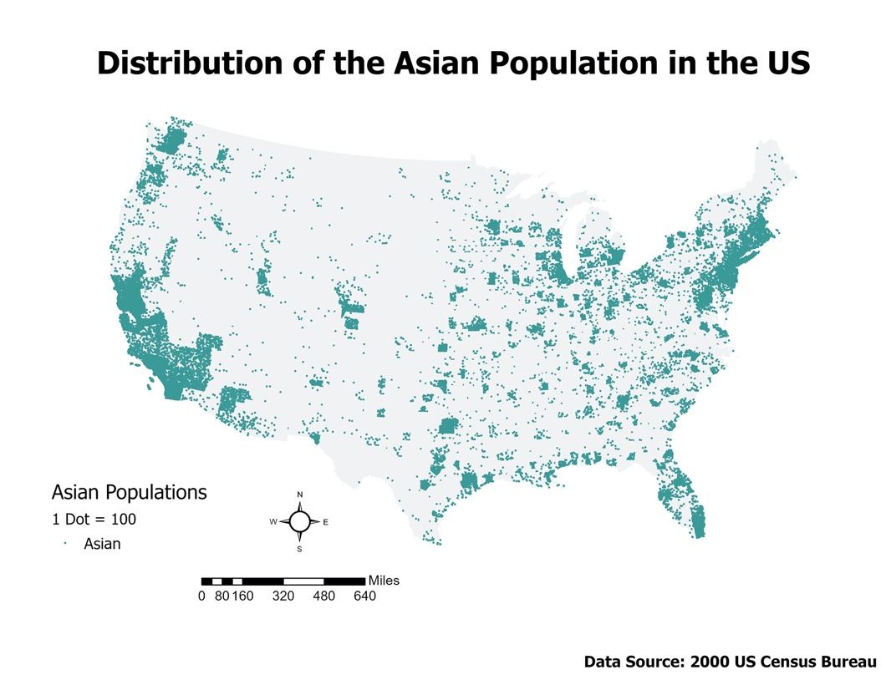

1. The map illustrates the distribution of Asian populations throughout the 48 states, each dot representing 100 people. Clustered populations appear in the Southwest (California) and the Northeast (New York). Some difficulties encountered in this section include selecting appropriate dot values that would properly depict distribution.

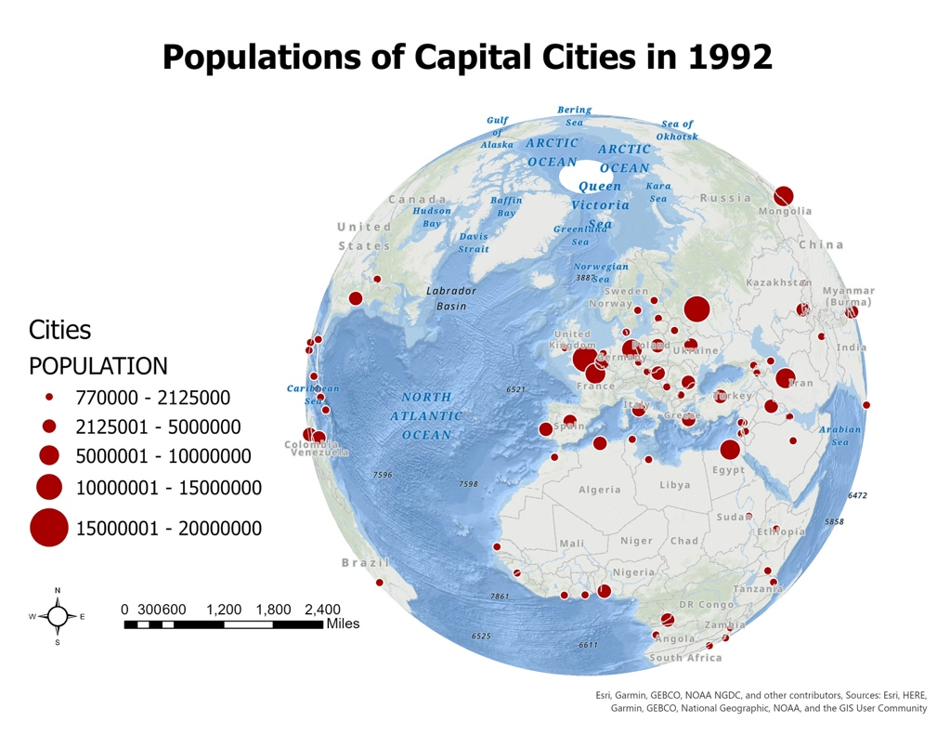

1. The map depicts populations within capital cities in 1992 – the bigger the circle, the higher the population. Majority of such populations can be seen in Europe. Again, the choice of classes was the most difficult.

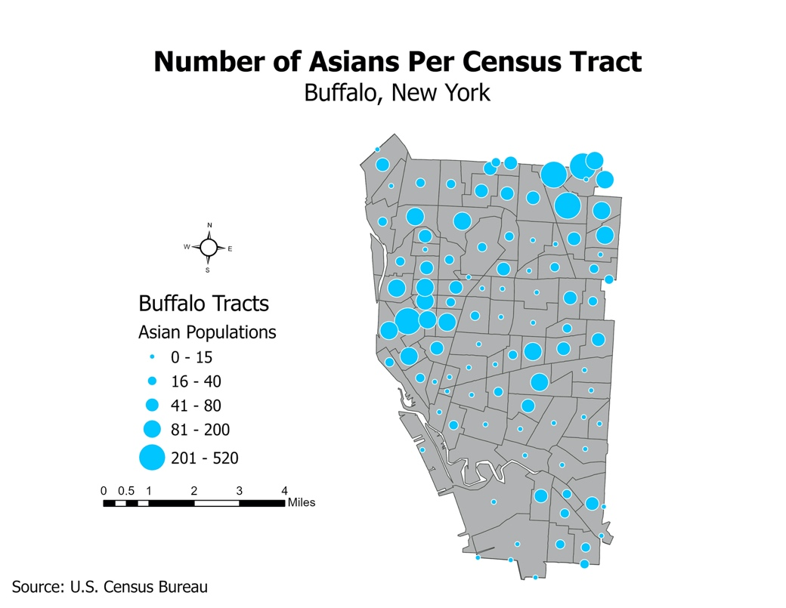

1. This map portrays Asian populations in Buffalo, New York. Similarly, the bigger circles, which can be seen in the Northeast and Western tracts, contain the highest number of Asian populations. Because this data contain smaller numbers compared to the previous data, it was much easier in terms of class distinction.

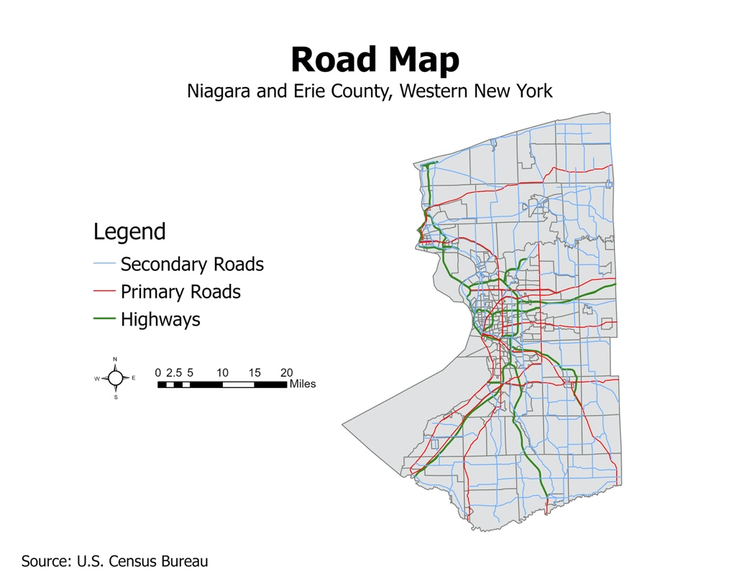

1. The map illustrates the system of different road types within Niagara and Erie County in Western New York. While secondary roads can be seen throughout the map, primary roads (in red) and highways (green) are fewer yet longer. Although not difficult, the most tedious task was creating the different road type layers based on CFCC code classification.

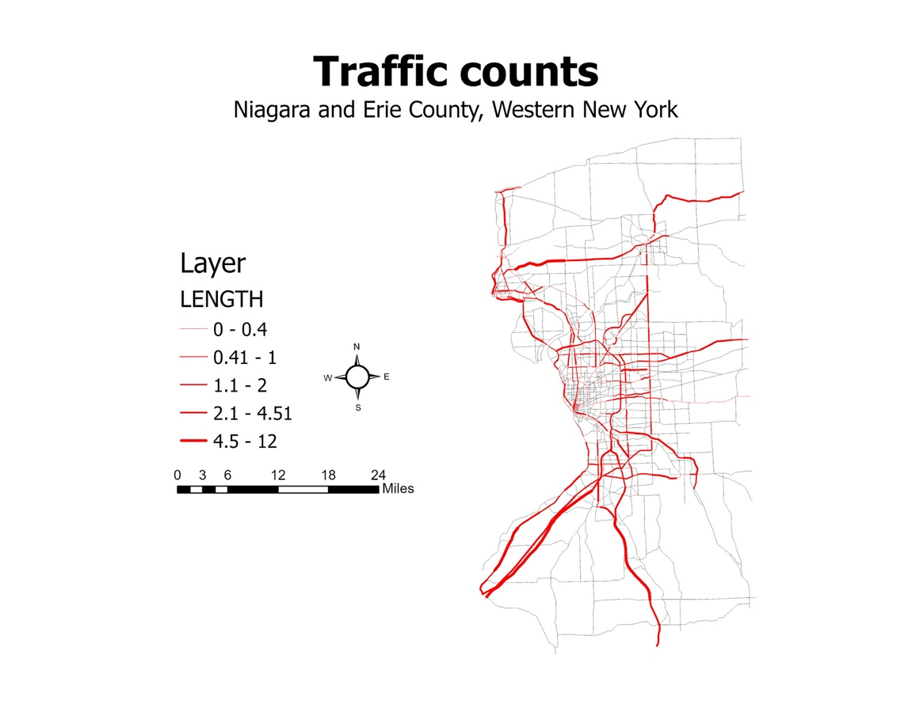

1. Lastly, this map illustrates the traffic counts within the same county. Here, the thicker the line, the higher the length value. This map corresponds to the previous one where greater traffic can be seen within highways (first) and primary roads (second). Again, the most difficult task was distinguishing between different classes, especially when the data are similar to each other.