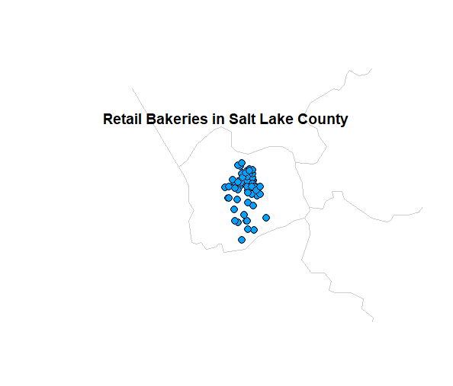

The blue circles represent the location of retail bakeries in Salt Lake County, Utah. I attempted to zoom in by using “county” instead of “state” in the maps packages in R. The most difficult part of this task was adjusting the x and y axis (i.e., xlim and ylim) functions to centralize the Salt Lake County. Data obtained from <https://koordinates.com/layer/101537-salt-lake-county-utah-grocery-stores/>.

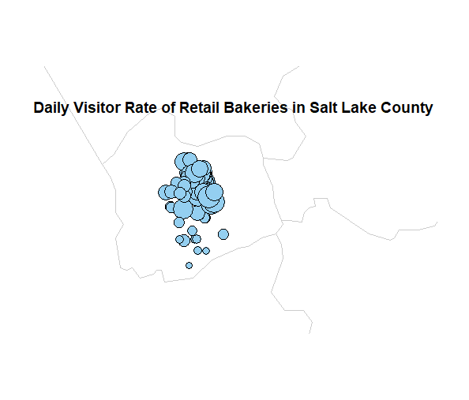

Here, the graduated blue circles represent daily visitor rates of retail bakeries in SLC. This is based on a fixed rate of 100 customers per day. Smaller circles indicate a small rate (i.e. 0.3, meaning 30 customers a day) and bigger circles indicate a high rate (i.e., 0.98, or 98 customers a day). Majority of the smaller rates are found within the southern part of the county (South Jordan, Sandy, Draper) and the higher rates are found within Salt Lake City (downtown). County and location data obtained from <https://koordinates.com/layer/101537-salt-lake-county-utah-grocery-stores/>; visitor data was made up.