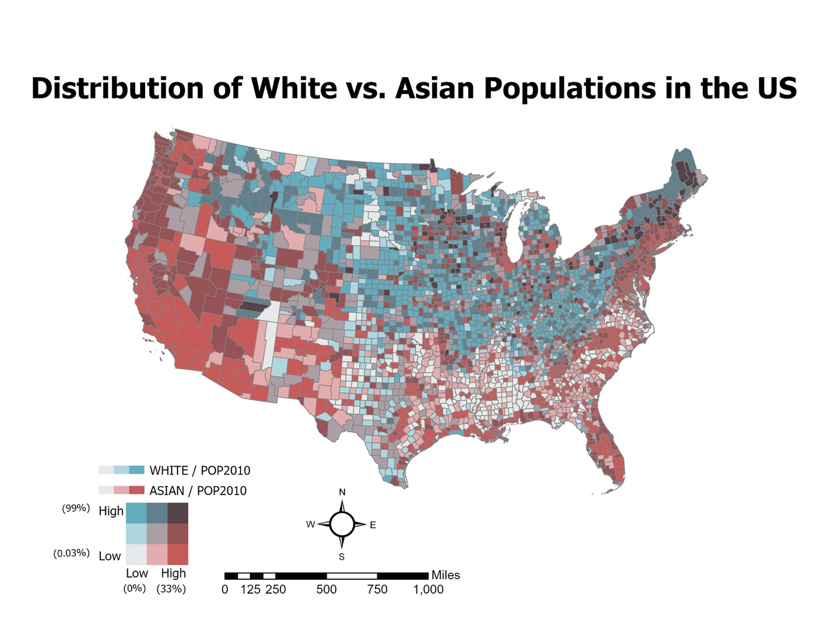

The map illustrates the distribution of two variables – the White and the Asian populations in the US. Both normalized by the 2010 population, the White population is shown in blue and the Asian in red. Here we see the major separation of the two. Majority of the White population can be seen in the Midwest to the Northeastern states. Although there are patches of Asian population within these regions, most of the latter can be seen within the Southeastern and Western states. The highest percentage is within the western coasts of Washington, Oregon, and Northern California. Not only does this bivariate map depict the combination of the distribution of the populations, it also illustrates what areas are low and high in population.