Link to dashboard: <https://www.arcgis.com/apps/dashboards/ac3d3b8f3c6945f8bd1d495dee13cc85>

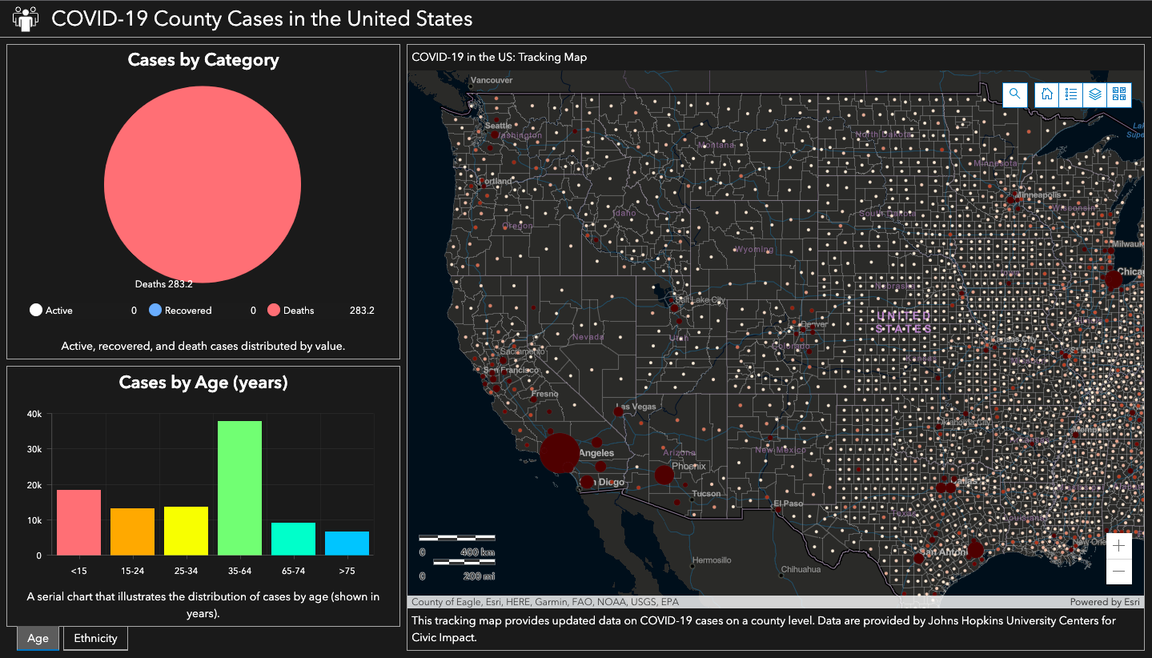

This dashboard portrays COVID-19 cases in the US by the county level. Here, the user can explore active, recovered, and death cases due to COVID-19. They can also investigate overall cases by age and ethnicity. The strengths of this dashboard include easy accessibility to varying types of information. One can simply click on a dot in the map and data will be given about that specific county. Another advantage is the ability to explore collective information illustrated by the graphs. However, a limitation is its lack of ability to compare between two or more counties. The graphs on the left only depict overall data. If one were to compare two places and analyze specified information (e.g., age), there would be no visualization. They would just have to look at the tables and the data numbers. The ability to compare data through visual aids like graphs could be a potential improvement in the future.

*Data were obtained from the Johns Hopkins University Centers for Civic Impact daily update URL.*