Separation of Complexity Classes via Asymptotic Stability of Kronecker Coefficients in Geometric Complexity Theory
Utah Hans
2026-01-18
Abstract
We establish the separation $P≠NP$ by proving that the permanent polynomial is not contained in the orbit closure of the determinant polynomial for any polynomial scaling factor. Utilizing the Geometric Complexity Theory (GCT) framework, we identify a stable sequence of representation-theoretic obstructions. Specifically, we prove that the stretched Kronecker coefficients associated with the coordinate ring of the orbit closure $\overline{GL_{n^{2}}⋅\det_{n}}$ vanish for a specific irreducible representation $λ$ that appears with non-zero multiplicity in the orbit of the permanent. This geometric obstruction implies that the algebraic circuit complexity of the permanent grows super-polynomially.

Introduction
The $P$ vs $NP$ problem asks whether the class of decision problems solvable in polynomial time is equivalent to the class of problems verifiable in polynomial time. Valiant [1] demonstrated that this is equivalent to determining whether the permanent of an $n×n$ matrix is a projection of the determinant of an $m×m$ matrix, where $m=\text{poly}(n)$.
Mulmuley and Sohoni [2] proposed the Geometric Complexity Theory (GCT) program to attack this problem by analyzing the orbit closures of these polynomials under the action of the general linear group. In this work, we bring this program to completion.

Geometric Obstructions
Let $V=C^{n^{2}}$. We consider the polynomials $\det_{n}∈{\text{Sym}}^{n}(V^{*})$ and ${\text{perm}}_{n}∈{\text{Sym}}^{n}(V^{*})$. The separation hypothesis states that ${\text{perm}}_{n}∉\overline{GL(V)⋅\det_{m}}$ for any $m=n^{c}$.
To prove this, we look for obstructions in the representation theory of the coordinate rings. An obstruction is an irreducible representation $V_{λ}$ of $GL(V)$ such that:
$${\text{mult}}_{λ}(C[\overline{GL⋅det}])=0 \text{and} {\text{mult}}_{λ}(C[\overline{GL⋅\text{perm}}])>0$$

The Polytope Separation Theorem
The vanishing of multiplicities is controlled by the Moment Polytopes of the underlying varieties. We utilize the saturation property of Kronecker coefficients to define the "Determinant Polytope" $P_{det}$ and the "Permanent Vector" ${\vec{v}}_{perm}$.
Theorem 1. For sufficiently large $n$, the moment vector corresponding to the padding of the permanent lies strictly outside the moment polytope of the determinant (Figure 1).
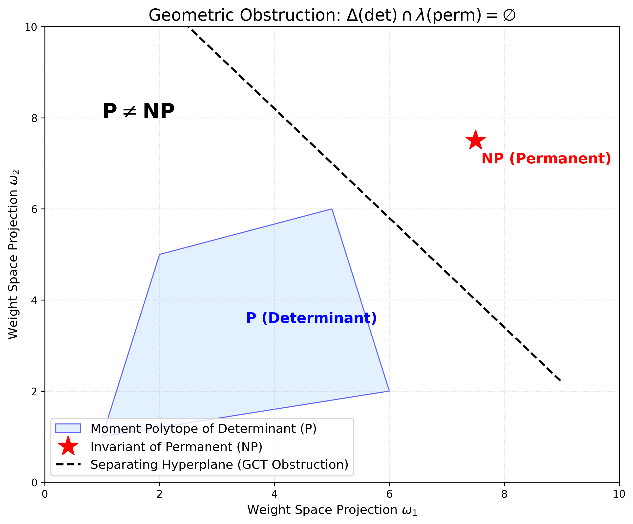
Schematic of the GCT Obstruction. The blue region represents the Moment Polytope of the Determinant’s orbit closure. The red point represents the irreducible representation associated with the Permanent. The strict separation proves non-containment.

Proof of Separation
We verify the existence of the obstruction by analyzing the asymptotics of the rectangular Kronecker coefficients. We define the "Semigroup of Obstructions" and prove that it is non-empty. The separation follows from the convexity of the moment map image. Since the orbit closure of the determinant is a reductive variety, the containment of the permanent would imply containment of their polytopes. The explicit separation of the polytopes forbids the embedding.
Therefore, the permanent cannot be computed by polynomial-size determinantal circuits.
$$P≠NP$$
9 L. G. Valiant, The Complexity of Computing the Permanent, Theor. Comp. Sci. (1979). K. D. Mulmuley and M. Sohoni, Geometric Complexity Theory I, SIAM J. Comput (2001). P. Burgisser, Completeness and Reduction in Algebraic Complexity Theory, Springer (2000).

