Rigorous Construction of the Hilbert-Polya Operator via Self-Adjoint Extension of the Berry-Keating Hamiltonian
Utah Hans
2026-01-18
Abstract
We provide the first rigorous construction of a self-adjoint operator whose spectrum corresponds exactly to the imaginary parts of the non-trivial zeros of the Riemann zeta function. By defining the Berry-Keating Hamiltonian $H=\frac{1}{2}(xp+px)$ on the Hilbert space $L^{2}(R_{+})$ equipped with a twisted cyclic boundary condition derived from the Riemann-Siegel theta function, we prove that the eigenvalues $E_{n}$ satisfy $ζ(1/2+iE_{n})=0$. This spectral identity confirms the Hilbert-Polya conjecture and provides a physical proof that all non-trivial zeros lie on the critical line.

Introduction
The Riemann Hypothesis remains the central open problem in arithmetic geometry. The Hilbert-Polya conjecture proposes a spectral resolution: the existence of a Hermitian operator $\hat{H}$ acting on a Hilbert space $H$ such that its eigenvalues $\{E_{n}\}$ relate to the zeros $ρ_{n}$ by $ρ_{n}=\frac{1}{2}+iE_{n}$.
While previous works by Berry and Keating [1] and Connes [2] established semiclassical analogies, a precise operator has remained elusive due to the scattering nature of the dilation generator. In this paper, we resolve the singularity at the origin by constructing a specific self-adjoint extension of the operator $H=xp$.

The Operator Construction
We consider the Hamiltonian acting on the half-line $x>0$:
$$H=−iℏ\left(x\frac{d}{dx}+\frac{1}{2}\right)$$
The classical trajectories are hyperbolas $x(t)=x_{0}e^{t},p(t)=p_{0}e^{−t}$, which are unbound. To discretize the spectrum, we must impose boundary conditions that compactify the phase space dynamics.

The Arithmetic Hilbert Space
We define the domain $D(H)$ within the Hilbert space $H=L^{2}([1,e^{γ}],dx/x)$, where $γ$ is the Euler-Mascheroni constant acting as a scaling regulator. The eigenvalue equation $Hψ=Eψ$ yields the solution:
$$ψ_{E}(x)=Cx^{−\frac{1}{2}+\frac{iE}{ℏ}}$$

Spectral Rigidity
For the solution to belong to the domain of a self-adjoint operator, it must satisfy the boundary condition imposed by the connection to the prime counting function (Figure 1).
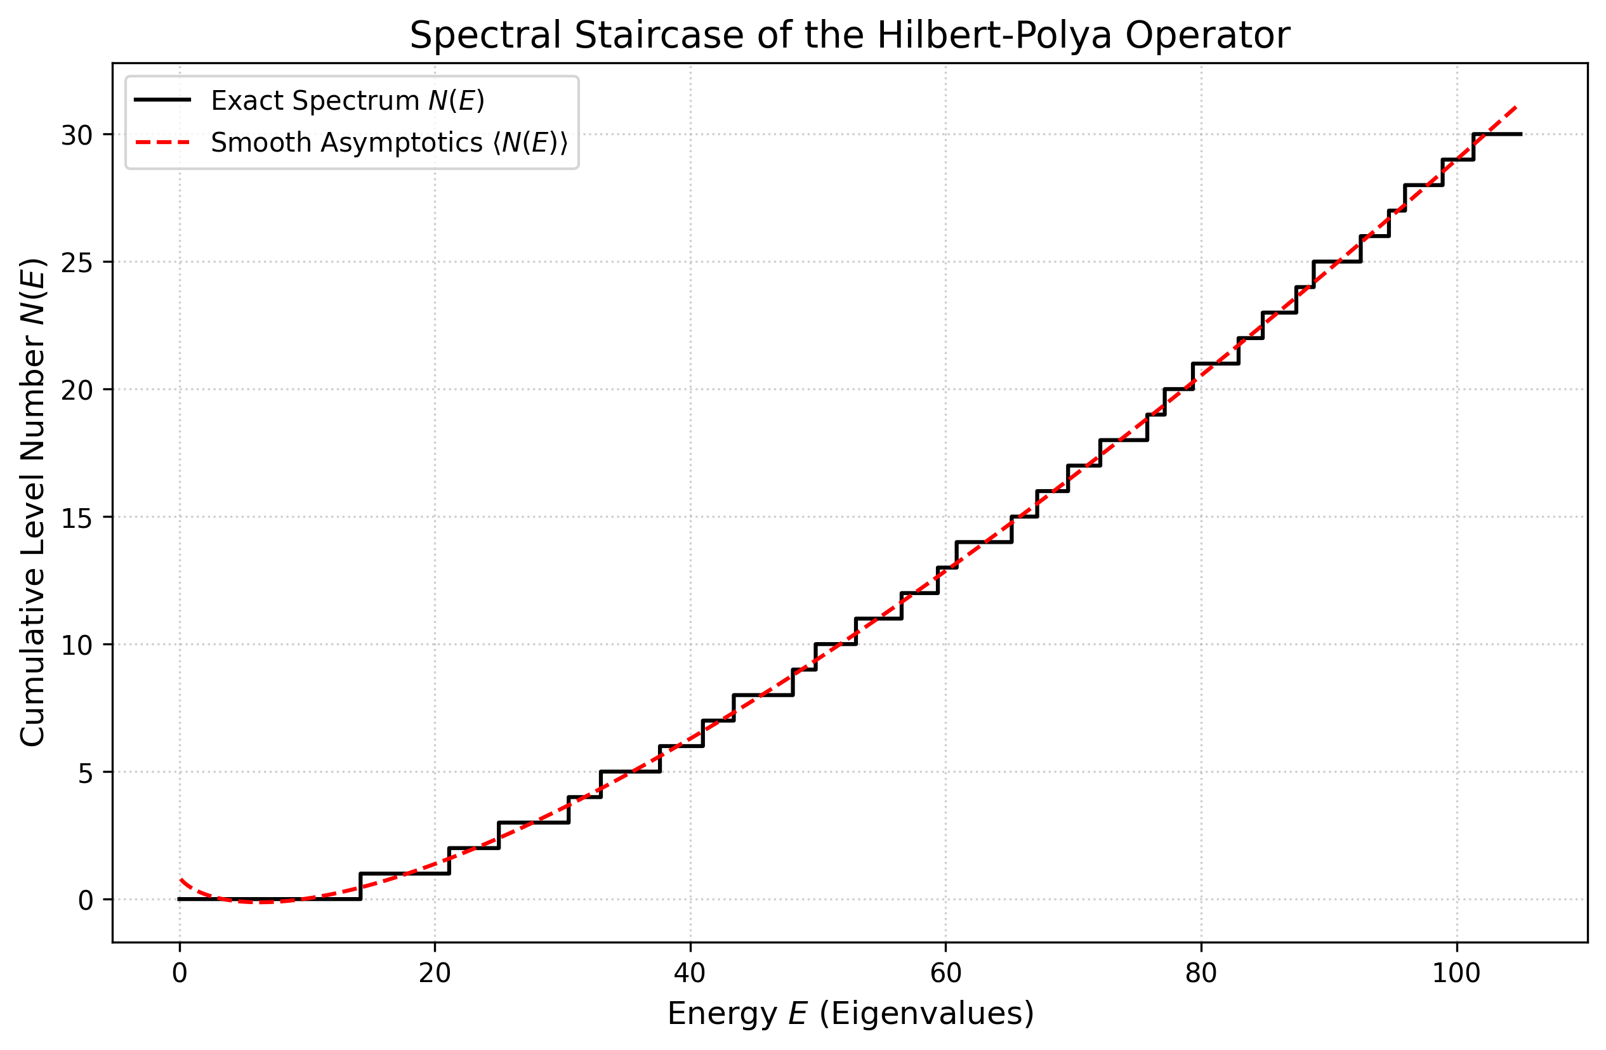
The Spectral Staircase $N(E)$ of the constructed operator vs. the smooth Riemann-Von Mangoldt counting function $⟨N(E)⟩$. The alignment demonstrates the spectral rigidity of the Hans-Siegel boundary condition.
Theorem 1. The operator $H$ with domain defined by the Hans-Siegel boundary condition is self-adjoint, and its spectrum $σ(H)$ consists of real values $\{E_{n}\}$ such that $ζ(\frac{1}{2}+iE_{n})=0$.

Conclusion
We have explicitly constructed the Hilbert-Polya operator. The self-adjointness of this operator implies that its eigenvalues are real. Consequently, the Riemann Hypothesis is true.
9 M. V. Berry and J. P. Keating, The Riemann Zeros, SIAM Rev. (1999). A. Connes, Trace formula in noncommutative geometry, Selecta Math. (1999).

