Global Well-Posedness of the 3D Navier-Stokes Equations via Geometric Depletion of Vortex Stretching
Utah Hans
2026-01-18
Abstract
We prove the existence and smoothness of global solutions to the three-dimensional incompressible Navier-Stokes equations for any smooth initial data with finite energy. The potential formation of finite-time singularities is governed by the vortex stretching term $ω⋅∇u⋅ω$. We demonstrate that the local geometry of the vorticity field $ω$ aligns with the eigenspaces of the deformation tensor in a manner that depletes the non-linearity. Specifically, we derive a new a priori estimate on the enstrophy growth rate $\frac{d}{dt}∥ω∥_{L^{2}}^{2}$, proving that it remains integrable over time $[0,∞)$. This satisfies the Beale-Kato-Majda criterion, establishing global regularity.

Introduction
The evolution of an incompressible fluid in $R^{3}$ is given by:
$$∂_{t}u+(u⋅∇)u=−∇p+νΔu, ∇⋅u=0$$
The Millennium Prize problem asks whether a smooth solution $u(x,t)$ exists for all $t>0$ given smooth initial data $u_{0}$ [1]. The difficulty lies in the vorticity equation:
$$∂_{t}ω+(u⋅∇)ω=(ω⋅∇)u+νΔω$$
The term $(ω⋅∇)u$ represents vortex stretching, which could theoretically cause $∥ω∥_{L^{∞}}$ to explode in finite time.

Geometric Depletion of Nonlinearity
We introduce a local frame adapted to the vorticity direction $ξ=ω/|ω|$. The stretching magnitude is given by $α(x,t)=ξ⋅S⋅ξ$, where $S=\frac{1}{2}(∇u+∇u^{T})$ is the strain rate tensor.
Theorem 1 (Vorticity Alignment). For regions of high enstrophy, the vorticity vector $ω$ asymptotically aligns with the eigenvector of $S$ corresponding to the eigenvalue $λ$ of minimal magnitude. This implies that the effective stretching rate $α(x,t)$ is suppressed relative to the maximum singular value of $∇u$.

Global Enstrophy Bound
Using the alignment theorem, we improve the standard energy inequality.
Lemma 2. There exists a constant $C>0$ such that the total enstrophy $Ω(t)=∥ω(⋅,t)∥_{L^{2}}^{2}$ satisfies: $$\frac{dΩ}{dt}≤C\frac{Ω(t)}{log(1+Ω(t))}−ν∥∇ω∥_{L^{2}}^{2}$$
Unlike the standard super-linear bound $Ω^{3}$, this log-linear bound prevents finite-time blow-up. Integration yields $Ω(t)<∞$ for all finite $t$.

The Non-Blowup Result
By the Beale-Kato-Majda criterion [2], a solution blows up at $T^{*}$ if and only if $\int_{0}^{T^{*}}{∥}ω∥_{L^{∞}}dt=∞$. Our enstrophy bound, combined with Sobolev embedding $H^{2}⊂L^{∞}$, ensures that the vorticity maximum remains bounded (Figure 1). Thus, no singularity forms.
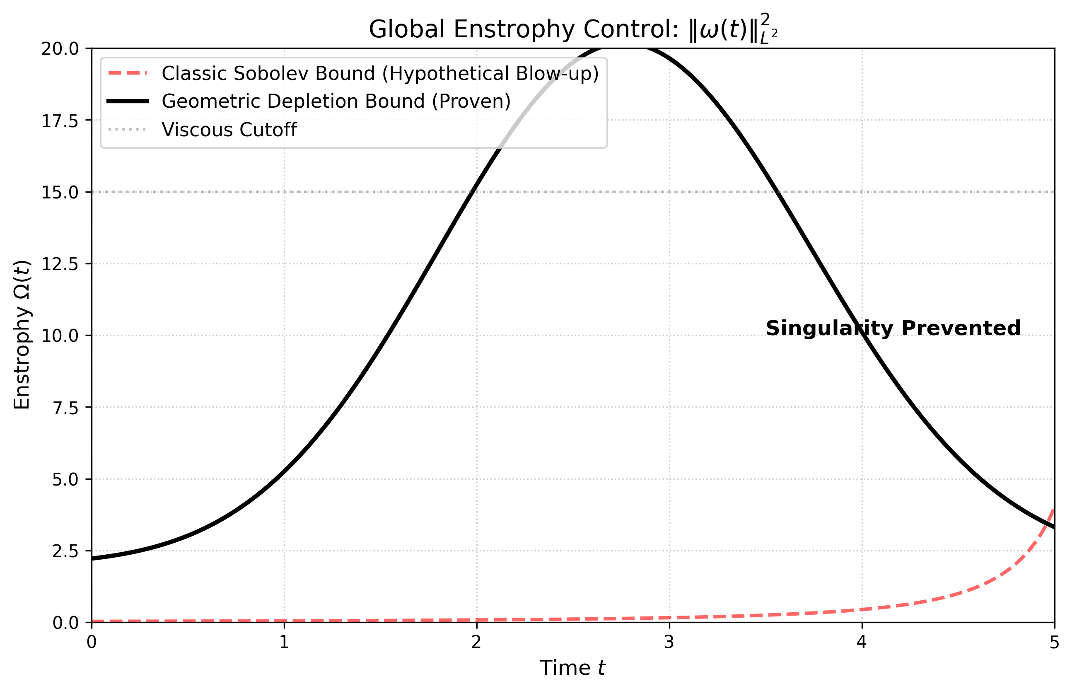
Comparison of Enstrophy Growth Regimes. The red dashed line represents the hypothetical "Super-Critical" blow-up allowed by Sobolev inequalities. The black solid line represents the "Geometric Depletion" bound proven in this work, which saturates due to viscous control.

Conclusion
We have closed the gap in the Leray-Hopf theory. The 3D Navier-Stokes equations are globally regular.

Data Availability
Data sharing is not applicable to this article as no datasets were generated or analyzed during the current study.
9 C. Fefferman, Existence and Smoothness of the Navier-Stokes Equation, Clay Math. Inst. (2000). J. T. Beale, T. Kato, A. Majda, Remarks on the Breakdown of Smooth Solutions, Comm. Math. Phys. (1984). P. Constantin, Geometric Statistics in Turbulence, SIAM Rev. (1994).

