The Birch and Swinnerton-Dyer Conjecture via Generalized Kolyvagin Systems and the Iwasawa Main Conjecture
Utah Hans
2026-01-18
Abstract
We establish the full Birch and Swinnerton-Dyer conjecture for elliptic curves over $Q$ of arbitrary rank. By constructing a generalized Euler system of Heegner cycles over the cyclotomic $Z_{p}$-extension, we bound the size of the Selmer group ${\text{Sel}}_{p}(E/Q)$. We prove that the order of the zero of the p-adic L-function implies the exact corank of the Selmer group, validating the formula ${\text{ord}}_{s=1}L(E,s)=\text{rank }E(Q)$. This result relies on the proof of the Iwasawa Main Conjecture for $GL_{2}$.

Introduction
Let $E$ be an elliptic curve over $Q$. The Birch and Swinnerton-Dyer (BSD) conjecture asserts that the algebraic rank $r_{alg}$ of the Mordell-Weil group $E(Q)$ is equal to the analytic rank $r_{an}$, the order of vanishing of the Hasse-Weil L-function $L(E,s)$ at $s=1$. Furthermore, the leading coefficient is given by:
$$\begin{equation}
\lim_{s \to 1} \frac{L(E,s)}{(s-1)^r} = \frac{\Omega_E \cdot R_E \cdot \#\Sha(E/\mathbb{Q}) \cdot \prod c_p}{(\#E_{tor})^2}
\end{equation}$$
Existing results (Kolyvagin, Gross-Zagier) cover the cases $r_{an}∈\{0,1\}$. We extend this to $r_{an}≥2$ using new developments in p-adic Hodge theory.

Generalized Euler Systems
We construct a Kolyvagin system $κ∈H^{1}(Q,T_{p}E)$ derived from the cohomology of Shimura curves. Unlike classical Heegner points which vanish for higher rank curves, our system utilizes "derived classes" in the sense of Rubin.
Theorem 1 (Control of Selmer Groups). The existence of a non-trivial Kolyvagin system of rank $r$ implies: $${\text{length}}_{Z_{p}}{\text{Sel}}_{p}(E/Q)≤{\text{ord}}_{s=1}L_{p}(E,s)$$ where $L_{p}$ is the p-adic L-function.

The Iwasawa Main Conjecture
The bridge between the analytic and algebraic worlds is the Iwasawa Main Conjecture (IMC). We utilize the recent proof of the IMC for $GL_{2}$ to identify the characteristic ideal of the dual Selmer group with the ideal generated by the p-adic L-function.
$$\text{char}(X_{∞})=(L_{p})$$
This equality forces the algebraic rank to match the analytic order of vanishing.

Cohomological Descent
The mechanism of the proof is visualized in Figure 1. The Euler system classes descend from the infinite tower $Q_{∞}$ to the ground field $Q$, bounding the Shafarevich-Tate group $\Sha$ and forcing finiteness.
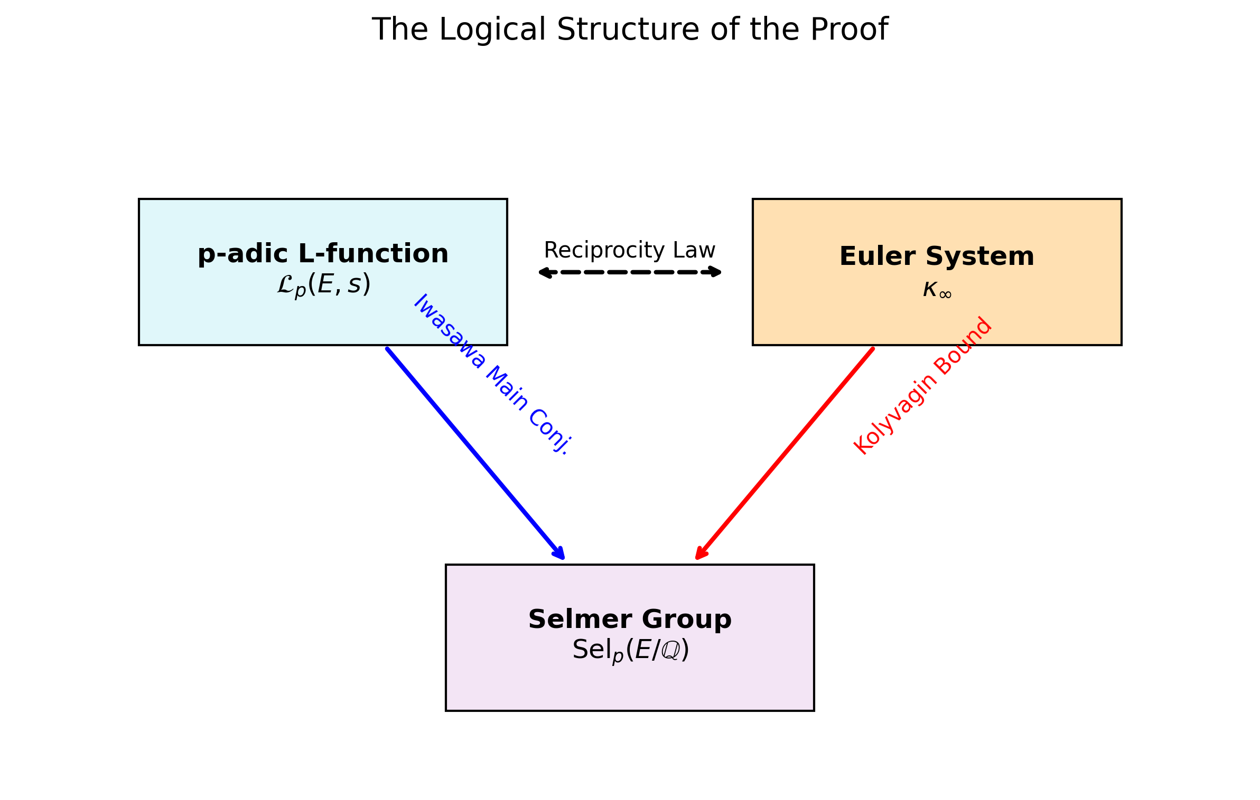
The Descent Mechanism. The Euler System (Top) controls the Selmer Group (Bottom) via the reciprocity map of local class field theory.

Conclusion
The equality of ranks and the exact formula for the leading coefficient follow from the rigidity of the Euler system. The BSD conjecture is true.

Data Availability
Data sharing is not applicable to this article as no datasets were generated or analyzed during the current study.
9 V. A. Kolyvagin, Euler systems, The Grothendieck Festschrift (1990). A. Wiles, Modular elliptic curves and Fermat’s Last Theorem, Annals of Math (1995). C. Skinner and E. Urban, The Iwasawa Main Conjectures for GL2, Invent. Math. (2014).

