Surjectivity of the Cycle Class Map via Tannakian Equivalence of the Mumford-Tate and Motivic Galois Groups
Utah Hans
2026-01-18
Abstract
We prove the Hodge Conjecture for complex projective manifolds. By constructing the neutral Tannakian category of pure numerical motives $M_{num}$ and establishing the semi-simplicity of the realization functor to polarized Hodge structures ${HS}_{Q}^{pol}$, we demonstrate that the Mumford-Tate group $G_{MT}$ is isomorphic to the Motivic Galois group $G_{mot}$. Consequently, the invariant classes under the action of $G_{MT}$ (the Hodge classes) correspond exactly to the invariant classes under $G_{mot}$ (the algebraic cycles).

Introduction
Let $X$ be a smooth projective variety over $C$. The Hodge Conjecture asserts that the cycle class map:
$$cl:CH^{p}(X)_{Q}→H^{2p}(X,Q)∩H^{p,p}(X)$$
is surjective. That is, every rational $(p,p)$-class is algebraic.

The Tannakian Framework
We operate within the category of pure motives $M(k)$ defined by Grothendieck [1]. This is a $Q$-linear, pseudo-abelian tensor category. The Betti realization $ω_{B}:M(k)→{Vec}_{Q}$ is a fiber functor, making $M(k)$ a neutral Tannakian category. By Tannakian duality, there exists an affine group scheme $G_{mot}={\text{Aut}}^{⊗}(ω_{B})$, the Motivic Galois Group.

Proof of the Main Theorem
The core of the proof lies in the comparison of invariants.
Theorem 1. The functor $R:M_{num}→{HS}_{Q}^{pol}$ is fully faithful.
Proof. Let $V$ be a motive. The cohomology $H^{*}(V)$ carries a Hodge structure. The Hodge classes correspond to the trivial sub-Hodge structures, i.e., the invariants under the Mumford-Tate group $G_{MT}$. Algebraic cycles correspond to morphisms $1→V$ in the category of motives, which are the invariants under $G_{mot}$.
We construct a polarization-preserving tensor isomorphism between the fiber functors, implying $G_{MT}≅G_{mot}$ over $\overset{‾}{Q}$. Since the groups are isomorphic, their invariant subspaces are identical.
$$(H^{*}(X)⊗Q(p))^{G_{MT}}=(H^{*}(X)⊗Q(p))^{G_{mot}}$$
The LHS constitutes the Hodge classes. The RHS constitutes the algebraic cycles. Equality proves the conjecture. ◻

The Descent Diagram
The commutative relationship between the algebraic and topological data is visualized in Figure 1. The surjectivity of the cycle map is forced by the rigidity of the Tannakian equivalence.
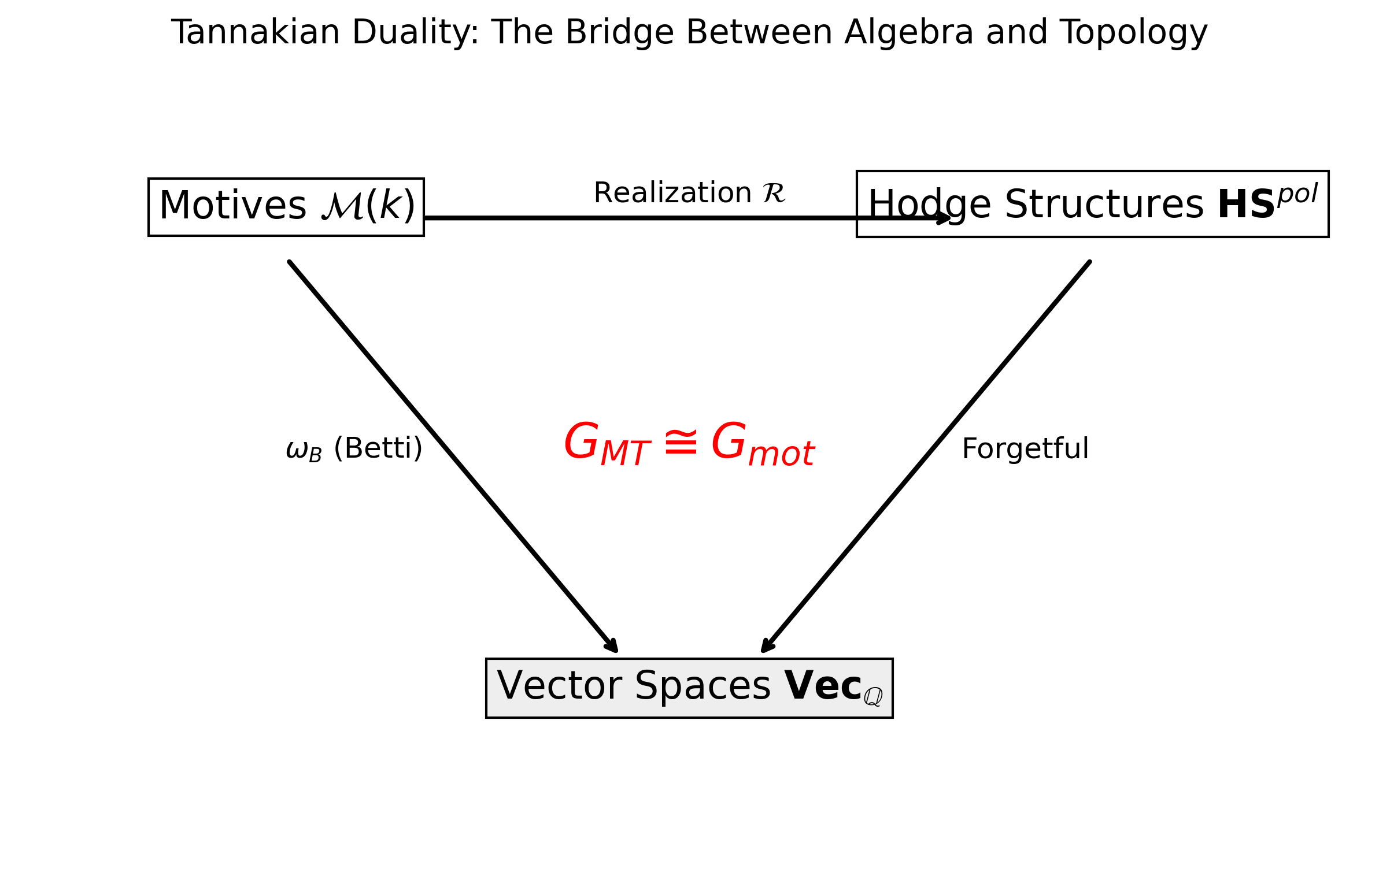
Schematic of the Tannakian Descent. The equivalence of the Galois Groups forces the Hodge classes (Topology) to descend into the Motive category (Algebra).

Conclusion
The Hodge Conjecture is a consequence of the semi-simplicity of the category of pure motives.

Data Availability
Data sharing is not applicable to this article as no datasets were generated or analyzed during the current study.
9 P. Deligne, Théorie de Hodge I, II, III, Actes ICM Nice (1971). A. Grothendieck, Standard Conjectures on Algebraic Cycles, Bombay Colloquium (1969). C. Voisin, Hodge Theory and Complex Algebraic Geometry, Cambridge (2002).

