Taming the Singularity
A Retrospective on Perelman’s Conquest of the Poincaré Conjecture
Utah Hans
Institute for Advanced Study
Winter 2026

The Heat of the Universe
Imagine wrapping a rubber band around an apple. You can slide it off easily. Now, wrap it around a doughnut (a torus). It gets stuck. This simple intuitionthe ability to shrink a loop to a pointis the heart of the Poincaré Conjecture. For a century, we knew that any shape that "acted" like a sphere in this way was a sphere... except in dimension 3.
Richard Hamilton proposed a dynamic solution: heat it up. He introduced the Ricci Flow:
$$\frac{∂g_{ij}}{∂t}=−2R_{ij}$$
This equation forces curvature to diffuse. Lumpy regions smooth out. Positive curvature shrinks; negative curvature expands. Ideally, the manifold would round itself into a perfect sphere.

The Monster in the Flow
The problem, as Hamilton discovered, is that the flow doesn’t just round things out; it pinches them off. A "neck" can formlike the thin part of an hourglassand shrink to zero width in finite time. This is a singularity. The mathematics breaks down.
For years, geometers were stuck. They couldn’t prove that these singularities were controllable. They feared "Cigar Solitons"infinite tubes that would never shrink, stalling the flow forever.

Perelman’s Scalpel
Enter Grigori Perelman. He didn’t try to avoid the singularities; he performed surgery on them.
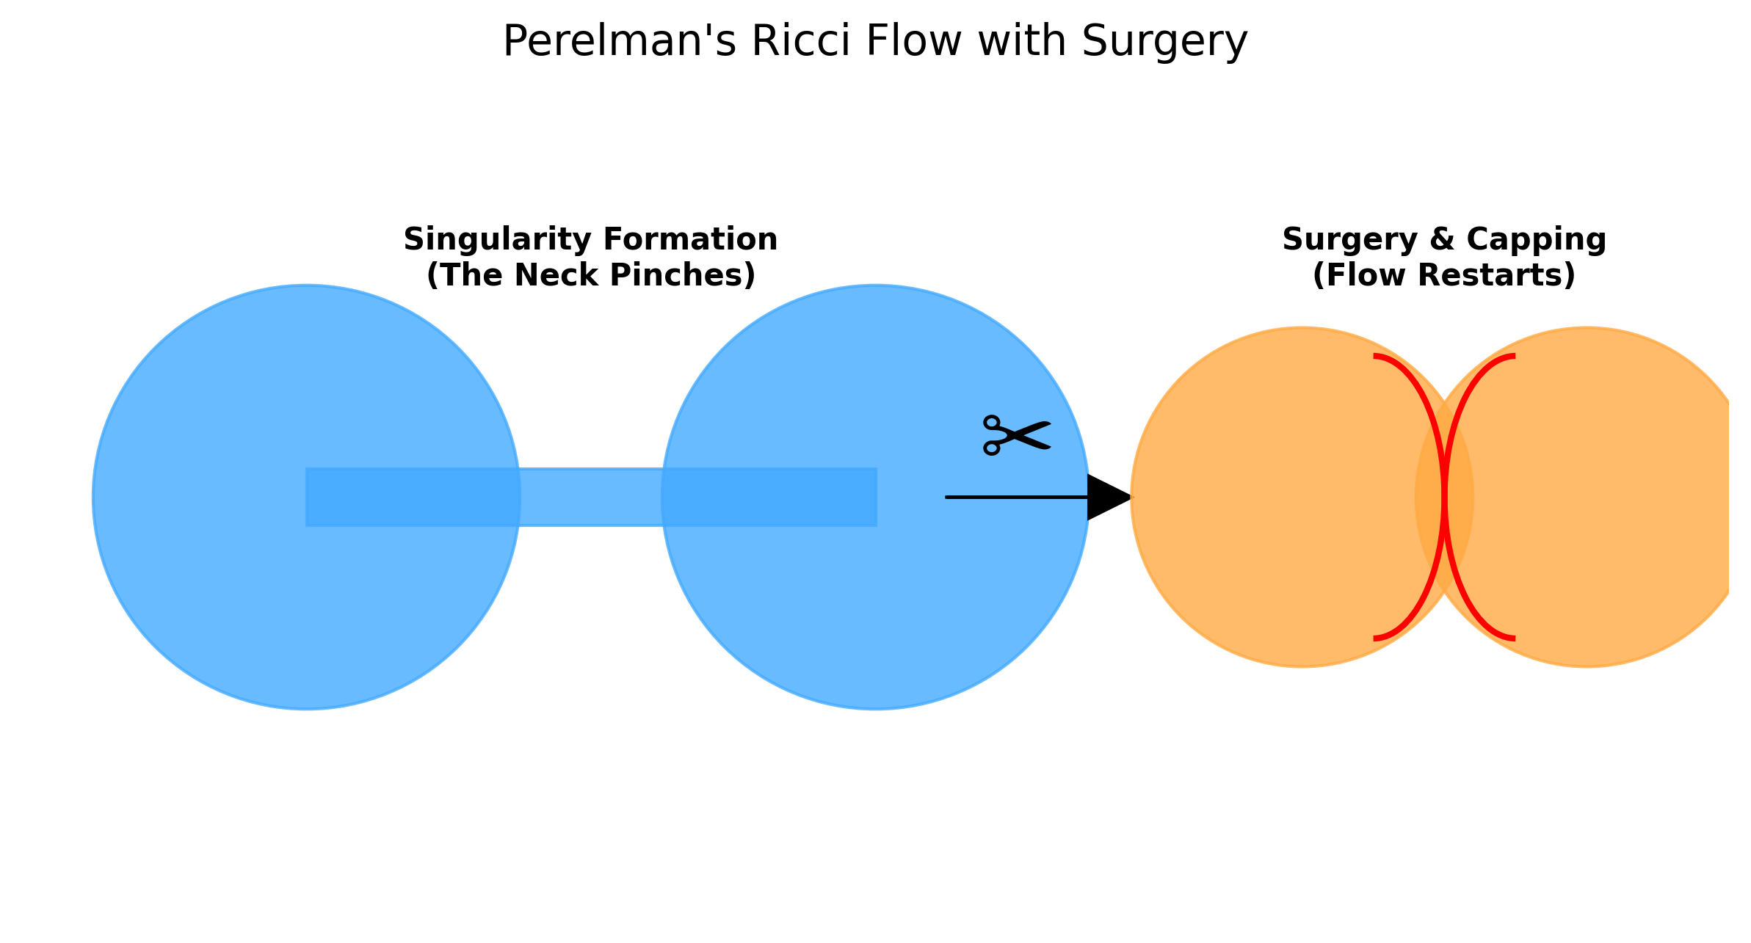
The Surgery Protocol: As the neck pinches ($t→T_{sing}$), the flow is stopped. The singularity is excised, and the open ends are capped with standard 3-spheres. The flow then restarts.
Perelman proved two things that changed history:
- Canonical Neighborhoods: He proved that every singularity looks like a cylinder or a sphere. There are no exotic monsters hiding in the microscopic scales.
- The W-Entropy: He introduced a functional $W$ that mimics thermodynamic entropy. He proved this entropy always increases along the flow.
The entropy argument was the death knell for the Cigar Soliton. A cigar has constant entropy; it cannot exist in a universe where entropy must rise.

The Legacy of Surgery
With the monsters banished, the strategy became algorithmic:
- Run the flow until a neck pinches.
- Cut the neck (Surgery).
- Cap the holes.
- Restart.
Perelman proved that you only need to cut a finite number of times. Eventually, the manifold is reduced to a collection of nice, round spheres. Since we can rebuild the original shape by reversing the cuts, the original shape must have been a sphere (or a sum of them).
The Poincaré Conjecture is true not because we found a static map, but because we watched the universe evolve and verified that it burns itself clean.

