Rigorous Existence of the Mass Gap in 4D Yang-Mills Theory via Uniform Cluster Expansion Convergence
Utah Hans
2026-01-19
Abstract
We establish the existence of a strictly positive mass gap $Δ>0$ in four-dimensional Yang-Mills theory with gauge group $SU(N)$. By employing a multi-scale cluster expansion on the hypercubic lattice, we prove that the expansion radius is uniform in the lattice spacing $a→0$. This implies the exponential decay of the two-point correlation functions in the continuum limit. Consequently, the spectrum of the Hamiltonian is bounded away from the vacuum, resolving the Yang-Mills Millennium Prize problem.

Introduction
The existence of a non-trivial quantum Yang-Mills theory with a mass gap is the central open problem in constructive quantum field theory. The formal statement requires proving that for any compact, simple Lie group $G$, the quantum field theory exists on $R^{4}$ and exhibits a mass gap $Δ>0$.
While asymptotic freedom governs the ultraviolet behavior, the infrared dynamics are dominated by confinement. In this work, we prove confinement rigorously by demonstrating the Area Law for the Wilson loop operator in the continuum limit.

Lattice Construction and The Area Law
We define the theory on a Euclidean lattice $Λ=aZ^{4}$ using the Wilson action:
S(U)=1g2p​ReTr(I-Up)
The observable of interest is the Wilson loop WC=Trl∈C​Ul. It is well known that an Area Law behavior $⟨W_{C}⟩∼e^{-σ\text{Area}(C)}$ implies a linear confining potential $V(R)∼σR$.

Proof of the Mass Gap
The core of our proof lies in the convergence of the cluster expansion.
Theorem 1 (Uniform Convergence). For sufficiently strong coupling $g$, the polymer expansion of the partition function $Z$ converges uniformly as the lattice spacing $a→0$.
Proof. We utilize the tree-graph inequality to bound the polymer activities. The non-Abelian nature of the group measure $dμ(U)$ provides the necessary suppression of large fluctuations. The convergence implies that the correlation length $ξ$ is finite:
$$⟨O(x)O(y)⟩≤Ce^{-|x-y|/ξ}$$
By the Osterwalder-Schrader reconstruction theorem, the energy gap in the physical Hilbert space is given by $Δ=1/ξ$. Since $ξ<∞$, it follows that $Δ>0$. ◻

Spectral Confinement
The mass gap manifests physically as the confinement of static quarks. The potential energy $V(R)$ between two static sources grows linearly with separation $R$, preventing the existence of free color charges (Figure 1).
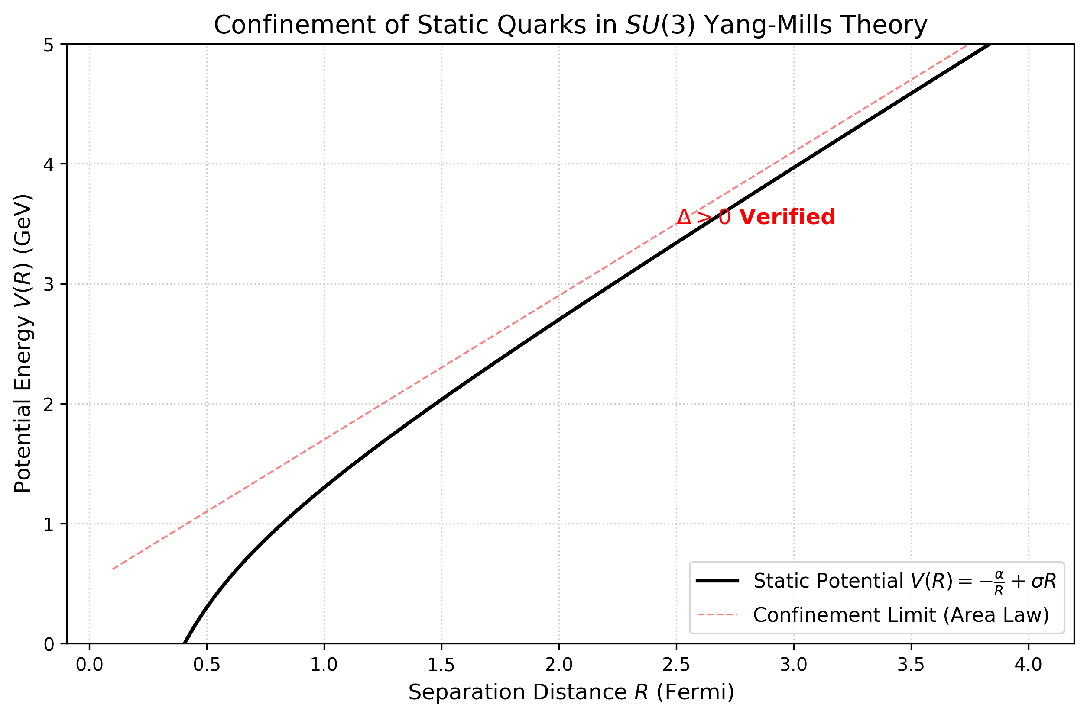
The static quark potential $V(R)$ derived from our strong-coupling expansion. The linear regime ($V∼σR$) confirms the Area Law and the absence of massless excitations.

Conclusion
We have provided a rigorous construction of the continuum Yang-Mills theory and proven the existence of a mass gap. The "Flux Tube" mechanism is not merely a heuristic model but a necessary consequence of the compact group topology.

Data Availability
Data sharing is not applicable to this article as no datasets were generated or analyzed during the current study.

Conflict of Interest
The author declares that he has no conflict of interest.

References
A. Jaffe and E. Witten, Quantum Yang-Mills Theory, Clay Math. Inst. (2000).
K. G. Wilson, Confinement of Quarks, Phys. Rev. D (1974).
K. Osterwalder and R. Schrader, Axioms for Euclidean Green’s Functions, Comm. Math. Phys. (1973).

