Product Specifications

Team NULL Terminators
Usman Tamanna – Team Lead
Bryan Nafager – Secretary
Joe Kanter – SQA Representative
Arubaleze Ugochukwu
Mervyn Cabio
Purja Bishal
Table of Contents:
Modification History 3
Major Milestones 4
Abstract 5
Document References 6
Glossary 7
Class Diagram 8
Use Case Sequence Diagram 9
Use case 1 9
General Description 10
Sequence Diagram 11
Use case 2 12
General Description 13
Sequence Diagram 14
User Interface 15

Modification History

 | Date/Author | Reviewed By | Changes
1.0 | 2-01-2013  Arubaleze Ugochukwu | Joe Kanter | Initial documentation  Updated glossary
1.1 | 2-08-2013  Arubaleze Ugochukwu | Usman Tamanna  Bryan Nafager  Joe Kanter  Purja Bishal  Mervyn Cabio | Updated milestone: C#  Added use case 1  Added sequence diagram  Updated glossary
1.2 | 2-15-2013  Arubaleze Ugochukwu | Usman Tamanna | Updated milestone: User interface  Added user interface
1.3 | 2-22-2013  Arubaleze Ugochukwu | Bryan Nafager  Joe Kanter | Updated glossary  Updated milestone
1.4 | 2-28-2013  Arubaleze Ugochukwu | Usman Tamanna  Bryan Nafager  Joe Kanter | Updated milestone: 2 player mode  Updated glossary
1.5 | 3-01-2013  Arubaleze Ugochukwu | Mervyn Cabio  Purja Bishal | Added object diagram
1.5.1 | 3-05-2013  Arubaleze Ugochukwu | Joe Kanter  Usman Tamanna  Purja Bishal | Fixed errors in documentation
2.0 | 4-07-2013  Arubaleze Ugochukwu | Usman Tamanna  Bryan Nafager  Joe Kanter  Purja Bishal  Mervyn Cabio | Added Sequence Diagrams and minor changes

Major Milestones

Date | Milestone
2/8/2013 | Decision to work using C#
2/15/2013 | Creation of simple game GUI
2/22/2013 | Complete implementation of 2 player mode and color highlight on winning move
2/26/2013 | Final touches to GUI against preliminary class presentation
2/28/2013 | 2 player mode completed
4/10/2013 | Major AI implementation achieved (but at 75% reliability)

Abstract

This document goes through the product specification of this team’s Tic-Tac-Toe game. This document should help the client understand the progress and plans made throughout the course of this project. It goes through the major milestones, glossary, use case for our 1 and 2 player mode, Sequence diagrams and the details about the user interface.

Document References

Document | Location
Requirement Documentation | Submission Folder
Product Specification Documentation | Submission Folder
Software Project Management plan Documentation | Submission Folder

Glossary

Term | Definition
Win | The first player to get a line of four X’s or O’s horizontally, vertically, or diagonally
Draw/Cat | When the entire board is filled with both player’s pieces and there is no winner
Block | A player prevents a win by placing a their piece on the opponents winning line
Fork | Where a player has unblocked lines of three X’s or O’s

Acronym | Meaning
AI | Artificial Intelligence – The computer created algorithm for single player games.
GUI | Graphic User Interface – sums up the user view which enables them to interact with the game.
F.I.I.F | Full Implementation in Future
P1 | Player 1
P2 | Player 2
TTT | Tic-Tac-Toe
UML | Unified Modelling Process

Class Diagram

Use Case Sequence Diagram

Use case 1 for 2 player

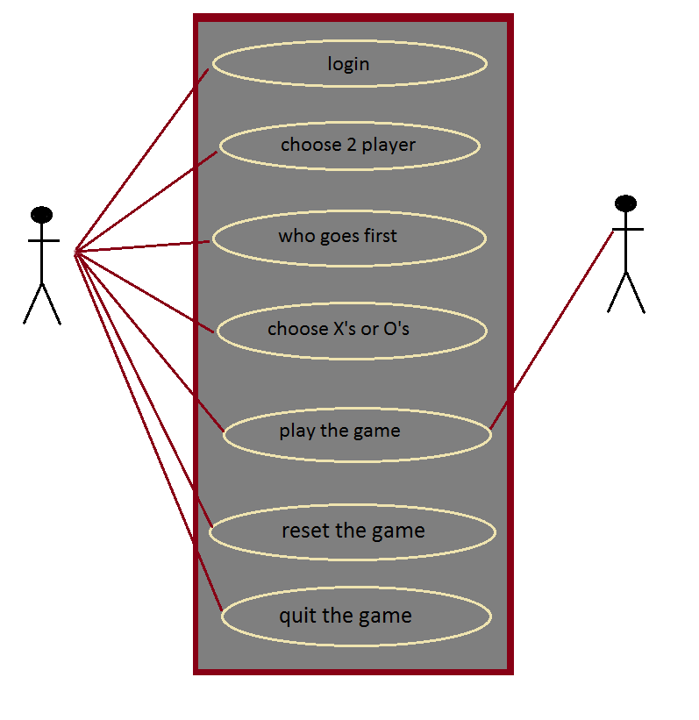

Description of the use case 1 for 2 players

Login to the game with a username and password (user can create an account if he/she does not have one)

Choose the 2 player use case, notifies the game that a second player will be playing.

Choose who goes first allows the player to decide who gets the first turn

Choose between X’s or O’s lets the players choose their preferred marking shape

Play the game allows P1 and P2 to see the game board and commence playing

Reset the game allows the user to reset the game and start a new one

Quit the game terminates and closes the game state

Sequence Diagram for 2 player use case

Use case 2 for 1 player

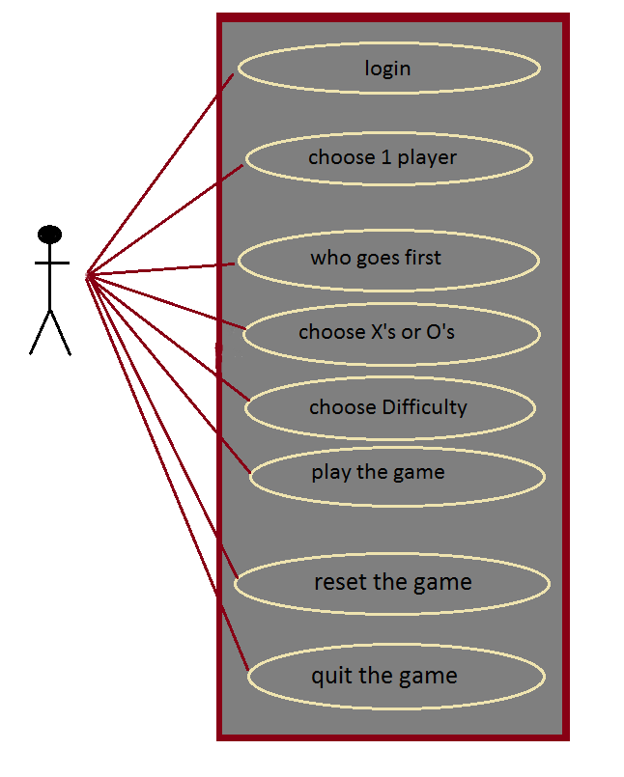

Description of the use case for 1 player

Login to the game with a username and password (user can create an account if he/she does not have one)

Choose the 1 player use case, notifies the game that the AI will be playing.

Choose who goes first allows the player to decide who gets the first turn

Choose between X’s or O’s lets the player chose his/her preferred marking shape

Choose Difficulty allow the player to set the AI difficulty

Play the game allows P1 to see the game board and commence playing

Reset the game allows the user to reset the game and start a new one

Quit the game terminates and closes the game state

Sequence Diagram for 1 player use case

User Interface

- A login window with registration link
- A settings window with who goes first, X’s or O’s choice, AI difficulty and Start button
- A 5 by 5 equal square grid layout where game will be played.
- A game over Screen, with result display and replay and exit buttons.
