# Deployment

## Introduction of SST

SST is the temporary name of this project. It aims to provide some service for both students and staff of AIBTGlobal, which includes ‘Leave of Absence’, ‘Change of Campus’, and so on. The original requirements can be found in the document of ‘Team 3.docx’.

## Framework of source code

Currently, spring-boot is used to construct this project. It is a simple version of JAVA Spring framework, which could be viewed as an MVC framework.

On the backend, there are JAVA for **model** and **control** modules. On the frontend, there are HTML/CSS/JS code for **view** module. However, technically, the frontend is a template of Java, called ‘thymeleaf’, which is a part of Java Spring framework. It is similar to JSP, and totally support HTML syntax, just some special tags for special use.

The modules diagram of spring boot is based on Spring as below.

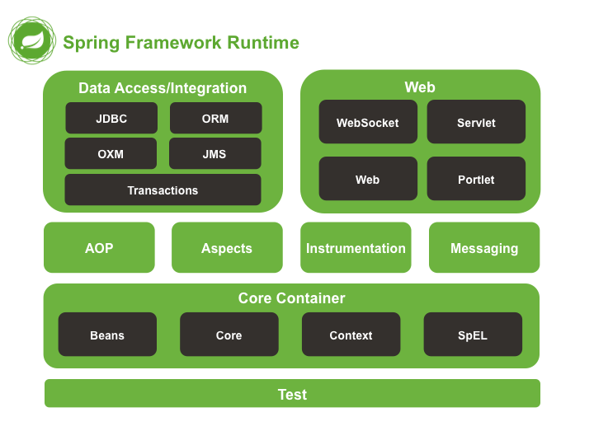

<https://docs.spring.io/spring/docs/5.0.0.M5/spring-framework-reference/html/overview.html>

But, in a nutshell, in our project, we just use a few of them. The modules we used can be found in ‘pom.xml’ in the root folder.

For example, JDBC is used for connection to MySQL database. Thymeleaf is used for web page in the frontend. Tomcat is used for deploying a web server.

This is official website of spring boot framework. You can find some tutorials from here to understand its mechanics.

<https://spring.io/projects/spring-boot>

<https://spring.io/guides/gs/spring-boot/>

## How to deployment

### Deploy in your local computer

This project can be run both on Windows 10 and Linux. Before running this project, there are some applications to be installed beforehand:

* MySQL
* JDK (I used JDK8, but I think newer version is also OK)

### Run it in you local computer

1. Edit config file

You should edit config file which is “/aibt/src/main/resources/application.properties”.

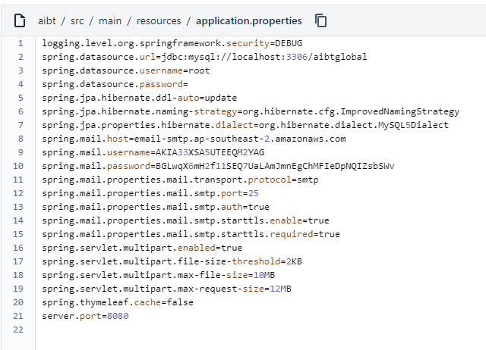

spring.datasource.url=jdbc:mysql://localhost:3306/aibtglobal

spring.datasource.username=root

spring.datasource.password=

you can use your local database.

* If you use local database, create a database called ‘aibtglobal’, and make sure the username can have the access to this database.
* Do not need to create any tables in the database, because Spring-boot will automatically create all tables in the database each time you run it. This is the function of ‘model’ in spring-boot, which means tables in database is manipulated by Spring-boot.

1. Run: “./mvnw.cmd spring-boot:run” in window system.
2. You have done if you can see ‘…started application…’ from the console output.

### Check if it is running(on Linux):

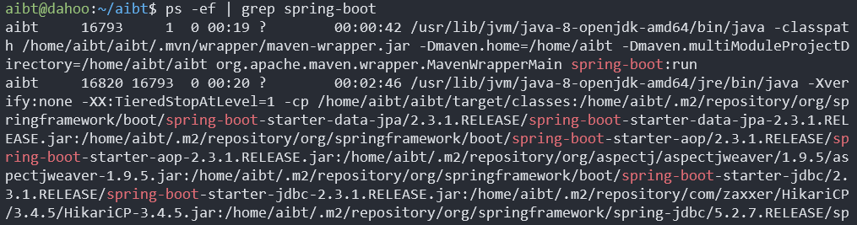

Processid_1

Processid_2

ps -ef | grep spring-boot

It is running if there are two processes being found just as the screenshot above.

### How to stop it(on Linux)?

Kill -9 processid_1 processid_2

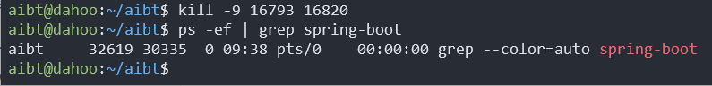

### How to access it from browser?

It can be accessed from ‘*hostname*:8080/student’.

## The structure of current code

The entry webpage is /student, from here, either student or staff can log in. Then it will redirect to /student/home for students, and to /staff for staff.

Functions are shown in ‘Section 5’ in this document. Next section.

## Main functions

The main functions are as below:

|  |
| --- |
| 1. Change of Campus |
| 1. Change of Qualification |
| 1. Leave of Absence |
| 1. Release and withdrawal |
| 1. ~~Credit transfer~~ |
| 1. Deferment |

Students can apply for each function above. And staff can process them.