Management of students from UTCN

Student: Olar Paul Dan

**Group: 30233**

Table of Contents

1. Requirements Analysis 3

1.1 Assignment Specification 3

1.2 Functional Requirements 3

1.3 Non-functional Requirements 3

2. Use-Case Model 3

3. System Architectural Design 4

4. UML Sequence Diagrams 7

5. Class Design 7

6. Data Model 8

7. System Testing 10

8. Bibliography 10

1. Requirements Analysis

# Assignment Specification

Design and implement a Java application for the management of students in the CS Department at UTCN. The application should have two types of users (student and teacher/administrator user) which have to provide a username and a password in order to use the application.

The regular user can perform the following operations:

- Add/update/view client information (name, identity card number, personal numerical code, address, etc.).

- Create/update/delete/view student profile (account information: identification number, group, enrolments, grades).

- Process class enrolment (enroll, exams, grades).

The administrator user can perform the following operations:

- CRUD on students information.

- Generate reports for a particular period containing the activities performed by a student.

# Functional Requirements

The application should perform the following operations:

* + Add/update/view client information (name, identity card number, personal numerical code, address, etc.).
  + Create/update/delete/view student profile (account information: identification number, group, enrolments, grades).
  + Generate reports for a particular period containing the activities performed by a student

# Non-functional Requirements

The system will be secured using https encrypted connections. Also we will demand user authentication and will not keep passwords in plain text. Other user data will not be encrypted as we do not find it as being sensible information.

The data will be stored in a relational database. The non-functional requirements of the Java application are:

* Availability
* Performance
* Usability

2. Use-Case Model

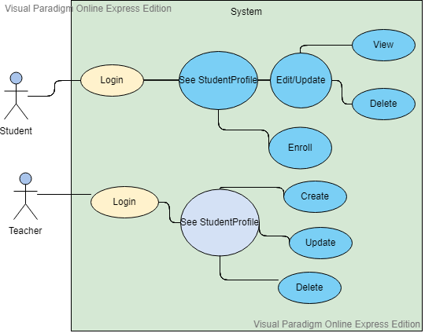

Use case: Selection of the operations an user can do

Level: User-goal

Primary actor: Student or Admin/Teacher

Main success scenario: The student register successfully after he choose the type of user and he login into his account. He choose one of the operations he can do. The system receive the information and analyse it and display or do the user’s request.

Extensions: Another scenario could be user can’t login into his account or the login fails and he can’t access the operations he want to do.

3. System Architectural Design

**3.1 Architectural Pattern Description**

The application design is based on layered architecture pattern. This pattern is a client-server architecture in which presentation, application processing, and data management functions are physically separated.

Components within the layered architecture pattern are formed into horizontal layers, each layer performing a different act within the application (e.g., presentation logic or business logic). Although the layered architecture pattern does not define the number and types of layers that must exist in the pattern, most layered architectures consist of four basic layers: presentation, business, persistence, and database.

**3.2 Diagrams**

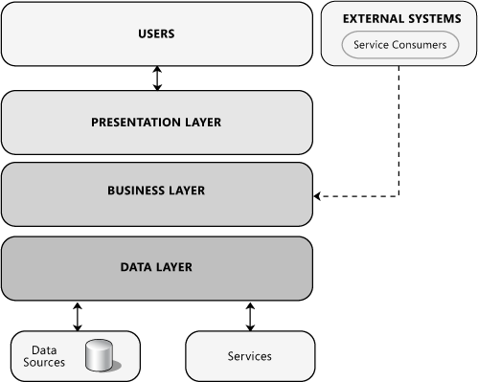

Figure The logical architecture view of a layered system

* **Presentation layer**. This layer contains the user oriented functionality responsible for managing user interaction with the system, and generally consists of components that provide a common bridge into the core business logic encapsulated in the business layer.
* **Business layer**. This layer implements the core functionality of the system, and encapsulates the relevant business logic. It generally consists of components, some of which may expose service interfaces that other callers can use.
* **Data layer**. This layer provides access to data hosted within the boundaries of the system, and data exposed by other networked systems; perhaps accessed through services. The data layer exposes generic interfaces that the components in the business layer can consume.

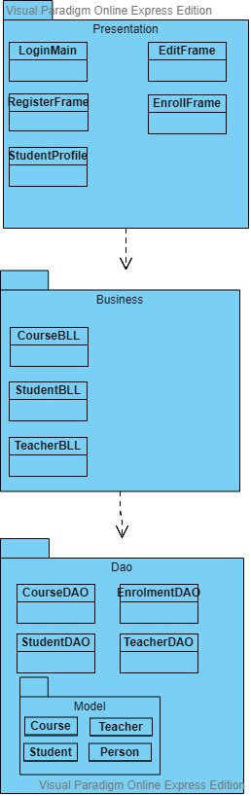

Figure Package diagram

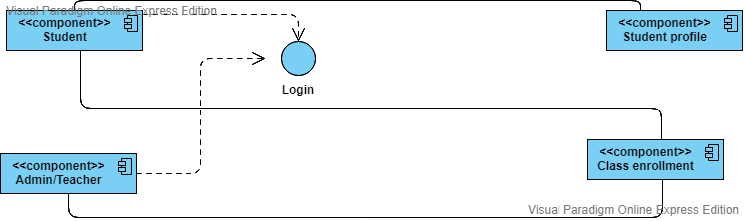

Figure Component Diagram

4. UML Sequence Diagrams

A sequence diagram simply depicts interaction between objects in a sequential order, the order in which these interactions take place.

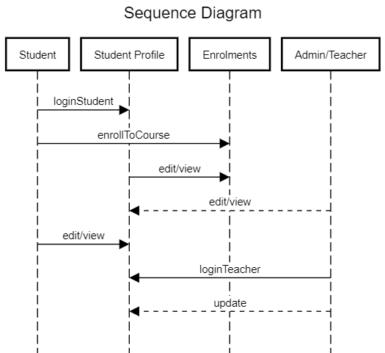

5. Class Design

**5.1 Design Patterns Description**

In the implementation of this application will use some design patterns. For example we will use the design patterns such as: SINGLETON, FACTORY METHOD.

* **SINGLETON:**  the singleton pattern is a software design pattern that restricts the instantiation of a class to one "single" instance. This is useful when exactly one object is needed to coordinate actions across the system. The term comes from the mathematical concept of a singleton.
* **FACTORY METHOD:** the factory method pattern is a creational pattern that uses factory methods to deal with the problem of creating objects without having to specify the exact class of the object that will be created. This is done by creating objects by calling a factory method—either specified in an interface and implemented by child classes, or implemented in a base class and optionally overridden by derived classes—rather than by calling a constructor**.**

Also, in the implementation of this application I used some data structures. For example:

LIST or MAP.

* **LIST:** The Java List interface, java.util.List, represents an ordered sequence of objects. The elements contained in a Java List can be inserted, accessed, iterated and removed according to the order in which they appear internally in the Java List. The ordering of the elements is why this data structure is called a List.
* **MAP:** Maps are defined by the java.util.Map interface in Java. Maps are simple data structures that associate a key with an element. This lets the map be very flexible. If the key is the hash code of the element, the map is essentially a set. If it's just an increasing number, it becomes a list. Maps are implemented by java.util.HashMap, java.util.LinkedHashMap, and java.util.TreeMap. HashMap uses a hash table. The hashes of the keys are used to find the elements in various buckets. LinkedHashMap extends this by creating a doubly linked list between the elements, allowing them to be accessed in the order in which they were inserted into the map. TreeMap, in contrast to HashMap and LinkedHashMap, uses a red-black tree. The keys are used as the values for the nodes in the tree, and the nodes point to the elements in the map.

**5.2 UML Class Diagram**

In software engineering, a **class diagram** in the Unified Modeling Language (UML) is a type of static structure diagram that describes the structure of a system by showing the system's classes, their attributes, operations (or methods), and the relationships among objects.

The class diagram is the main building block of object-oriented modeling. It is used for general conceptual modeling of the structure of the application, and for detailed modeling translating the models into programming code. Class diagrams can also be used for data modeling. The classes in a class diagram represent both the main elements, interactions in the application, and the classes to be programmed

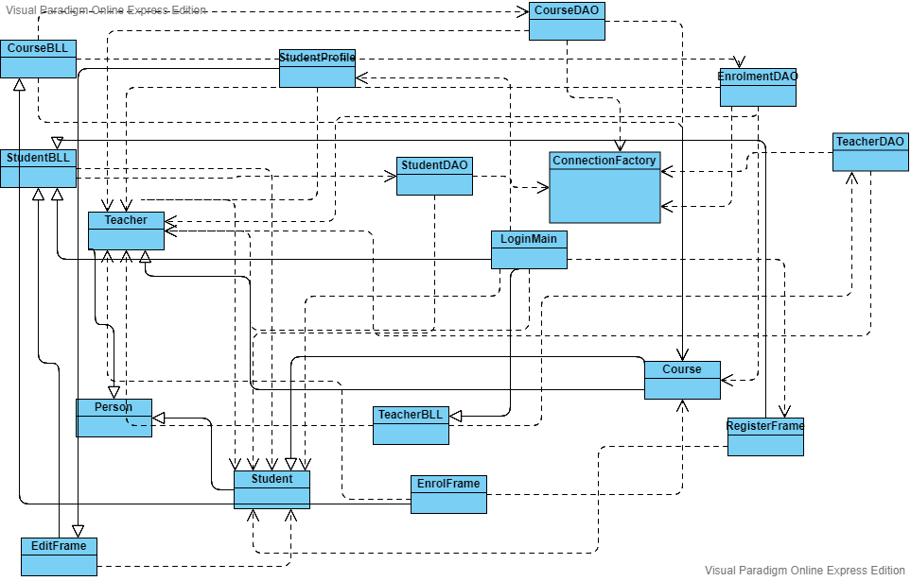

6. Data Model

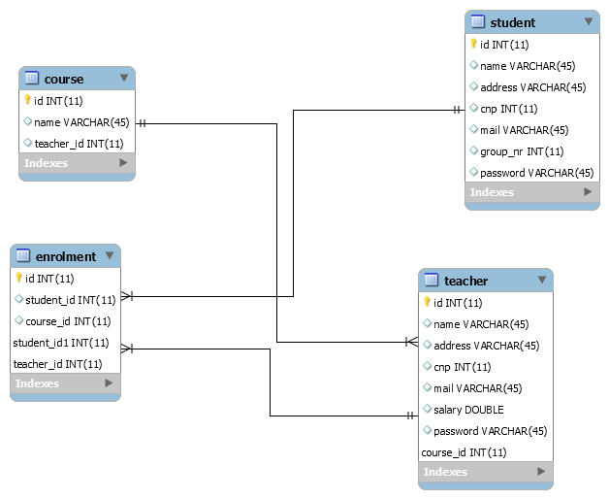

7. System Testing

A good test case design technique is crucial to improving the quality of the software testing process. This helps to improve the overall quality and effectiveness of the released software. Following are the test case design techniques to ensure high-quality of the released software.

In the application I am about to develop I will use:

* Boundary Value Analysis (BVA): this technique is applied to explore errors at the boundary of the input domain
* Equivalence Partitioning (EP): - the test input data is partitioned into a number of classes having an equivalent number of data. This helps to reduce the number of test cases.

8. Bibliography

* <https://github.com/utcn-cs-software-design-tudorv-2019/LabInfo/blob/master/assignments/Assignment1_2019_TudorV.pdf>
* <https://en.wikipedia.org/wiki/Non-functional_requirement>
* <https://en.wikipedia.org/wiki/Observer_pattern>
* <https://en.wikipedia.org/wiki/Software_design_pattern>
* <https://en.wikipedia.org/wiki/Singleton_pattern>
* <https://www.geeksforgeeks.org/unified-modeling-language-uml-sequence-diagrams/>
* <https://docs.microsoft.com/en-us/previous-versions/msp-n-p/ee658109%28v%3dpandp.10%29>
* <https://online.visual-paradigm.com/tutorials/package-diagram-tutorial/>
* <https://reqtest.com/testing-blog/test-case-design-techniques/>
* <https://en.wikipedia.org/wiki/Class_diagram>
* <http://tutorials.jenkov.com/java-collections/list.html>