Management of students from UTCN

Analysis and Design Document

Student: Olar Paul Dan

**Group: 30233**

Table of Contents

1. Requirements Analysis 3

1.1 Assignment Specification 3

1.2 Functional Requirements 3

1.3 Non-functional Requirements 3

2. Use-Case Model 3

3. System Architectural Design 4

4. UML Sequence Diagrams 6

5. Class Design 7

6. Data Model 7

7. System Testing 9

8. Bibliography 9

1. Requirements Analysis

# Assignment Specification

Design and implement a Java application for the management of students in the CS Department at UTCN. The application should have two types of users (student and teacher/administrator user) which have to provide a username and a password in order to use the application.

The regular user can perform the following operations:

- Add/update/view client information (name, identity card number, personal numerical code, address, etc.).

- Create/update/delete/view student profile (account information: identification number, group, enrolments, grades).

- Process class enrolment (enroll, exams, grades).

The administrator user can perform the following operations:

- CRUD on students information.

- Generate reports for a particular period containing the activities performed by a student.

# Functional Requirements

The application should perform the following operations:

* + Add/update/view client information (name, identity card number, personal numerical code, address, etc.).
  + Create/update/delete/view student profile (account information: identification number, group, enrolments, grades).
  + Generate reports for a particular period containing the activities performed by a student

# Non-functional Requirements

The system will be secured using https encrypted connections. Also we will demand user authentication and will not keep passwords in plain text. Other user data will not be encrypted as we do not find it as being sensible information.

The data will be stored in a relational database. The non-functional requirements of the Java application are:

* Availability
* Performance
* Usability

2. Use-Case Model

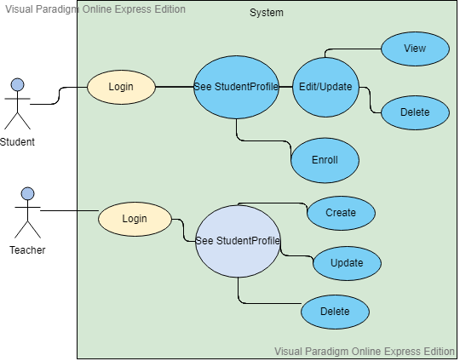

Use case: Selection of the operations an user can do

Level: User-goal

Primary actor: Student or Admin/Teacher

Main success scenario: The student register successfully after he choose the type of user and he login into his account. He choose one of the operations he can do. The system receive the information and analyse it and display or do the user’s request.

Extensions: Another scenario could be user can’t login into his account or the login fails and he can’t access the operations he want to do.

3. System Architectural Design

**3.1 Architectural Pattern Description**

This application is based on the Model-View-Controller (MVC) which is an architectural pattern that separates an application into three main logical components: the model, the view, and the controller. Each of these components are built to handle specific development aspects of an application. MVC is one of the most frequently used industry-standard web development framework to create scalable and extensible projects.

.

**3.2 Diagrams**

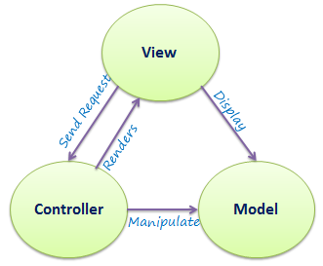

Figure 1 The logical architecture view of a layered system

* **MODEL:** The Model component corresponds to all the data-related logic that the user works with. This can represent either the data that is being transferred between the View and Controller components or any other business logic-related data.
* **VIEW:** The View component is used for all the UI logic of the application.
* **CONTROLLER:** Controllers act as an interface between Model and View components to process all the business logic and incoming requests, manipulate data using the Model component and interact with the Views to render the final output.

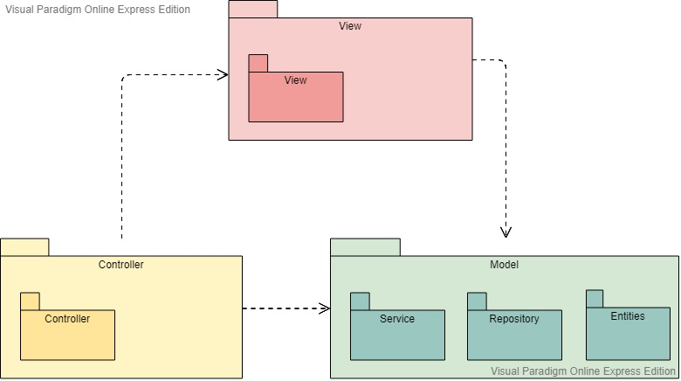

Figure 2 Package diagram

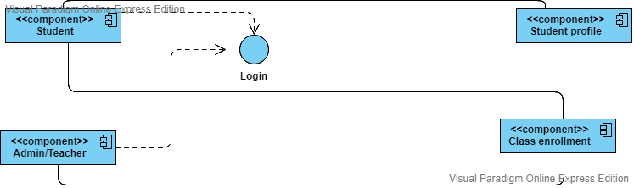

Figure 3 Component Diagram

4. UML Sequence Diagrams

A sequence diagram simply depicts interaction between objects in a sequential order, the order in which these interactions take place.

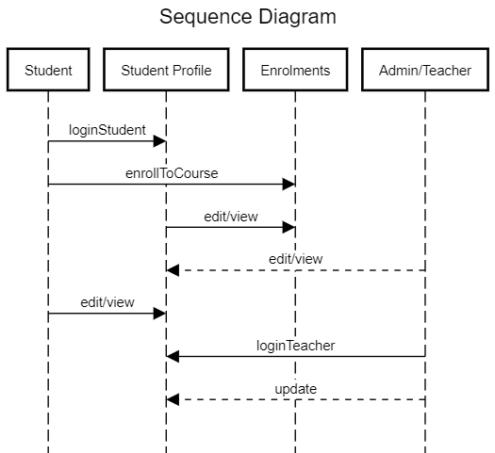

5. Class Design

**5.1 Design Patterns Description**

In the implementation of this application will use some design patterns. For example we will use the design patterns such as: SINGLETON, FACTORY METHOD.

* **SINGLETON:**  the singleton pattern is a software design pattern that restricts the instantiation of a class to one "single" instance. This is useful when exactly one object is needed to coordinate actions across the system. The term comes from the mathematical concept of a singleton.
* **FACTORY METHOD:** the factory method pattern is a creational pattern that uses factory methods to deal with the problem of creating objects without having to specify the exact class of the object that will be created. This is done by creating objects by calling a factory method—either specified in an interface and implemented by child classes, or implemented in a base class and optionally overridden by derived classes—rather than by calling a constructor**.**

Also, in the implementation of this application I used some data structures. For example:

LIST or MAP.

* **LIST:** The Java List interface, java.util.List, represents an ordered sequence of objects. The elements contained in a Java List can be inserted, accessed, iterated and removed according to the order in which they appear internally in the Java List. The ordering of the elements is why this data structure is called a List.
* **MAP:** Maps are defined by the java.util.Map interface in Java. Maps are simple data structures that associate a key with an element. This lets the map be very flexible. If the key is the hash code of the element, the map is essentially a set. If it's just an increasing number, it becomes a list. Maps are implemented by java.util.HashMap, java.util.LinkedHashMap, and java.util.TreeMap. HashMap uses a hash table. The hashes of the keys are used to find the elements in various buckets. LinkedHashMap extends this by creating a doubly linked list between the elements, allowing them to be accessed in the order in which they were inserted into the map. TreeMap, in contrast to HashMap and LinkedHashMap, uses a red-black tree. The keys are used as the values for the nodes in the tree, and the nodes point to the elements in the map.

**5.2 UML Class Diagram**

In software engineering, a **class diagram** in the Unified Modeling Language (UML) is a type of static structure diagram that describes the structure of a system by showing the system's classes, their attributes, operations (or methods), and the relationships among objects.

The class diagram is the main building block of object-oriented modeling. It is used for general conceptual modeling of the structure of the application, and for detailed modeling translating the models into programming code. Class diagrams can also be used for data modeling. The classes in a class diagram represent both the main elements, interactions in the application, and the classes to be programmed.

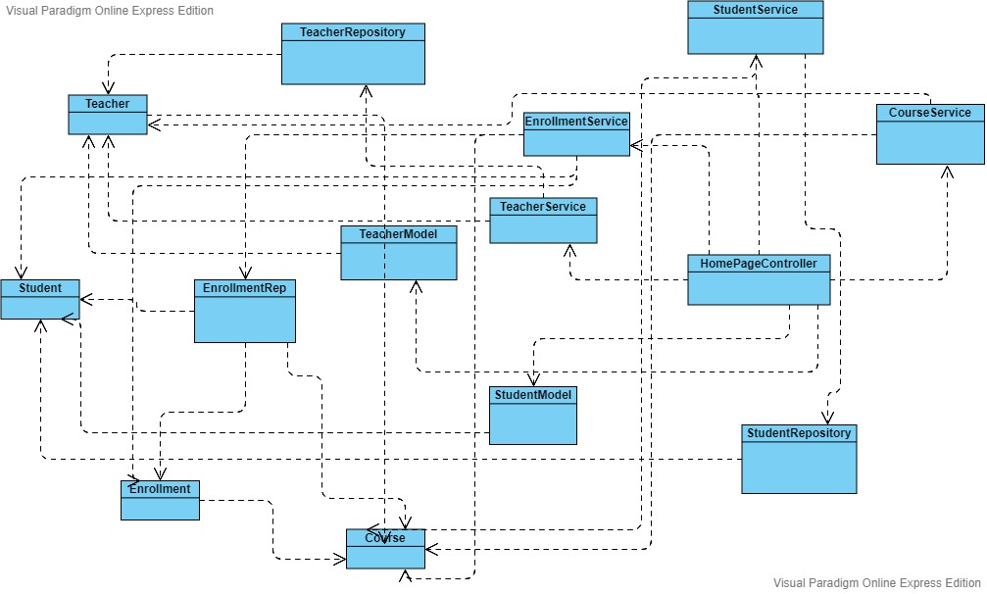

6. Data Model

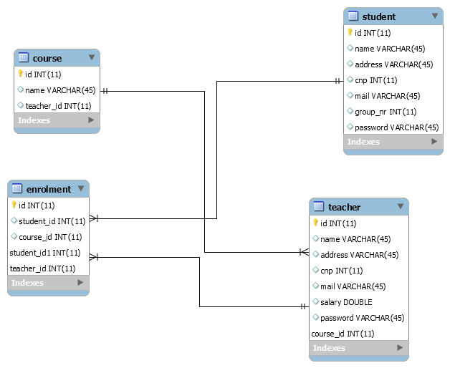

7. System Testing

A good test case design technique is crucial to improving the quality of the software testing process. This helps to improve the overall quality and effectiveness of the released software. Following are the test case design techniques to ensure high-quality of the released software.

In the application I am about to develop I will use:

* JUNIT Tests

8. Bibliography

* <https://github.com/utcn-cs-software-design-tudorv-2019/LabInfo/blob/master/assignments/Assignment1_2019_TudorV.pdf>
* <https://en.wikipedia.org/wiki/Non-functional_requirement>
* <https://en.wikipedia.org/wiki/Observer_pattern>
* <https://en.wikipedia.org/wiki/Software_design_pattern>
* <https://en.wikipedia.org/wiki/Singleton_pattern>
* <https://www.geeksforgeeks.org/unified-modeling-language-uml-sequence-diagrams/>
* <https://docs.microsoft.com/en-us/previous-versions/msp-n-p/ee658109%28v%3dpandp.10%29>
* <https://online.visual-paradigm.com/tutorials/package-diagram-tutorial/>
* <https://reqtest.com/testing-blog/test-case-design-techniques/>
* <https://en.wikipedia.org/wiki/Class_diagram>
* <http://tutorials.jenkov.com/java-collections/list.html>