Student: Berenghia Alexandra-Stefana

**Group:30641**

Table of Contents

1. Requirements Analysis 3

1.1 Assignment Specification 3

1.2 Functional Requirements 3

1.3 Non-functional Requirements 3

2. Use-Case Model 3

3. System Architectural Design 3

4. UML Sequence Diagrams 3

5. Class Design 3

6. Data Model 3

7. System Testing 3

8. Bibliography 3

1. Requirements Analysis

# Assignment Specification

The application is designed and implemented to be used for management for students at the university.

# Functional Requirements

*Design and implement a Java application for the management of students in the CS Department at TUCN. The application should have two types of users (student and teacher/administrator user) which have to provide a username and a password in order to use the application. The regular user can perform the following operations: - Add/update/view client information (name, identity card number, personal numerical code, address, etc.). - Create/update/delete/view student profile (account information: identification number, group, enrolments, grades). - Process class enrolment (enroll, exams, grades). The administrator user can perform the following operations: - CRUD on students information. - Generate reports for a particular period containing the activities performed by a student.*

# Non-functional Requirements

*[Discuss the non-functional requirements for the system]*

2. Use-Case Model

*Use case: student enroll to a course*

*Level: user-goal level*

*Primary actor: a student user*

*Main success scenario: the student opens the site, enter the username and password, and then create the*

*Extensions: if the user enter the wrong credentials, he/she will be prompted*

*]*

3. System Architectural Design

**3.1 Architectural Pattern Description**

*[Describe briefly the used architectural patterns.]*

**3.2 Diagrams**

*[Create the system’s conceptual architecture; use architectural patterns and describe how they are applied. Create package, component and deployment diagrams]*

4. UML Sequence Diagrams

*[Create a sequence diagram for a relevant scenario.]*

5. Class Design

**5.1 Design Patterns Description**

*[Describe briefly the used design patterns.]*

**5.2 UML Class Diagram**

*[Create the UML Class Diagram and highlight and motivate how the design patterns are used.]*

6. Data Model

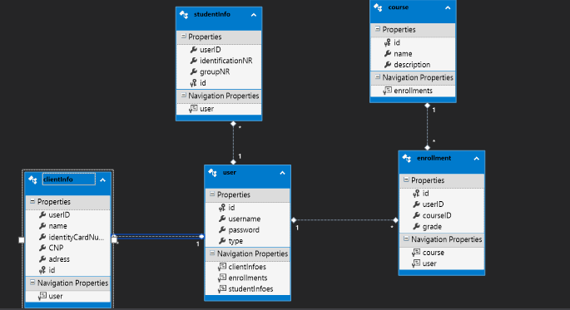

7. System Testing

*[Present the used testing strategies (unit testing, integration testing, validation testing) and testing methods (data-flow, partitioning, boundary analysis, etc.).]*

8. Bibliography