<Chat >

Use-Case Model

Version <1.0>

Revision History

|  |  |  |  |
| --- | --- | --- | --- |
| **Date** | **Version** | **Description** | **Author** |
| <3/Apr/19> | <1.0> | General Use-Cases. | Ciontu Mihail & Pantea Paul |
|  |  |  |  |
|  |  |  |  |
|  |  |  |  |

Table of Contents

1. Use-Cases Identification 4

2. UML Use-Case Diagrams 4

Use-Case Model

# Use-Cases Identification

The actors for this application are the Users, who will chat with each other, create a group of more users, and the Admins, who will be the responsible for the proper functioning of the application, he can create/update/delete/view user accounts and manages storing messages between users and any files/photos.

**Use case: Login**

**Primary actor: User (& Admin)**

**Main success scenario: User create an account on Chat Application and he will have a profile on this application. Admin stores in a database all the account and information about user accounts.**

**Use case: Adding**

**Primary actor: User**

**Main success scenario: User has a list of other users and if he wants to talk with one of them, awaits the confirmation of acceptance of the other person after which he can start the discussion**

**Use case: Chatting**

**Primary actor: User**

**Main success scenario: The user chooses from a list of contacts with whom to talk, select and start the conversation**

**Use case: Sending File**

**Primary actor: User & Admin**

**Main success scenario: When the user sends files or pictures to another user, they must take care of the file format sent , and the admin stores the files sent to a separate location from the user information**

**Use case: Maintanancing**

**Primary actor: Admin**

**Main success scenario: Admin checks that all customer information is correct and that the same user does not have multiple accounts**

# 

# UML Use-Case Diagrams

Authentification:

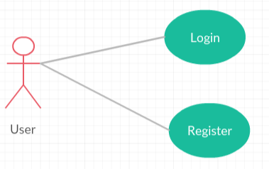

Admin Dash:

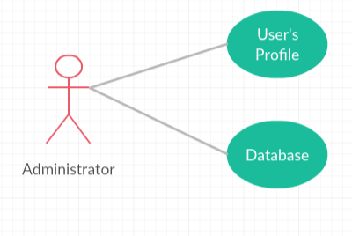

User Dash:

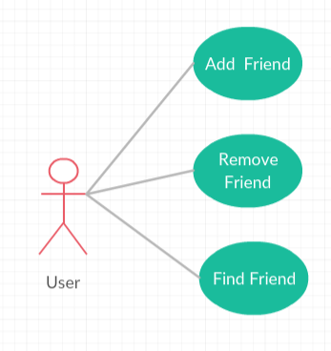

User Message Form:

