Application - National Theatre of Cluj-Napoca

Analysis and Design Document

Student: Costea Ana-Maria

**Group: 30233**

Revision History

|  |  |  |  |
| --- | --- | --- | --- |
| **Date** | **Version** | **Description** | **Author** |
| 25/04/2019 | 1.0 | Iteration 1.1 | Costea Ana-Maria |
| 02/05/2019 | 2.0 | Iteration 1.2 | Costea Ana-Maria |
| 29/05/2019 | 3.0 | Iteration 2 | Costea Ana-Maria |
|  |  |  |  |

Table of Contents

I. Project Specification 4

II. Elaboration – Iteration 1.1 4

1. Domain Model 4

2. Architectural Design 4

2.1 Conceptual Architecture 4

2.2 Package Design 4

2.3 Component and Deployment Diagrams 4

III. Elaboration – Iteration 1.2 4

1. Design Model 4

1.1 Dynamic Behavior 4

1.2 Class Design 4

2. Data Model 4

3. Unit Testing 4

IV. Elaboration – Iteration 2 4

1. Architectural Design Refinement 4

2. Design Model Refinement 4

V. Construction and Transition 5

1. System Testing 5

2. Future improvements 5

VI. Bibliography 5

# Project Specification

Application for National Theatre of Cluj-Napoca

The clients will access the application only if they have an user account, they will see the weekly program, they will get information about the favorite theater play. They will be able to set a reminder for a theater play or buy a ticket online. Other features will be added ulterior.

There will be 2 types of users : regular user (client) and admin.

Regular user will have access to the operations :

* Login or create new account
* Access the program of the theatre
* Buy a ticket for a theater play
* Add a review for their favorite play
* See the theatre’s team, with all their roles

Admin user will have access to the operations :

* Add, update or delete a theater play
* Add, update or delete a member of the theatre team
* Generate raport of all users who bought a ticket

# Elaboration – Iteration 1.1

# Domain Model

In software engineering, a domain model is a conceptual model of the domain which incorporates both behavior and data. A domain model generally uses the vocabulary of the domain, but allows a representation of the model to be communicated to non-technical users. A domain model is generally implemented as an object model within a layer that uses a lower-level layer for persistence and “publishes” an API to a higher-level layer in order to gain access to the data and behavior of the model. In UML, a class diagram is used to represent the domain model.

For my application, the domain model is represented by the environment created by users and admins, by theater plays and information about them. A class diagram will be added later, after the implementation.

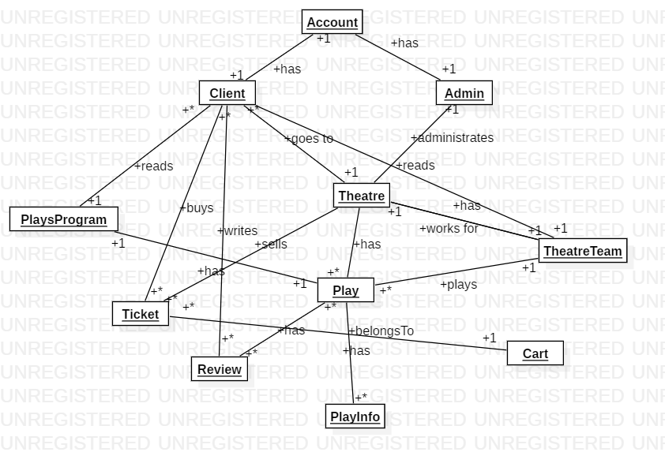

# Architectural Design

## Conceptual Architecture

The ideal architectural pattern for my application will be **layered pattern**. This will be used in order to structure the programs which can be composed in groups of subtasks, each one of these being at a particular level of abstraction. Each layer provides services to the next bigger layer. Most common layers which are used :

* Presentation Layer (UI layer)
* Application Layer (Service layer)
* Business Logic Layer (Domain layer)
* Data Access Layer (Persistence layer)

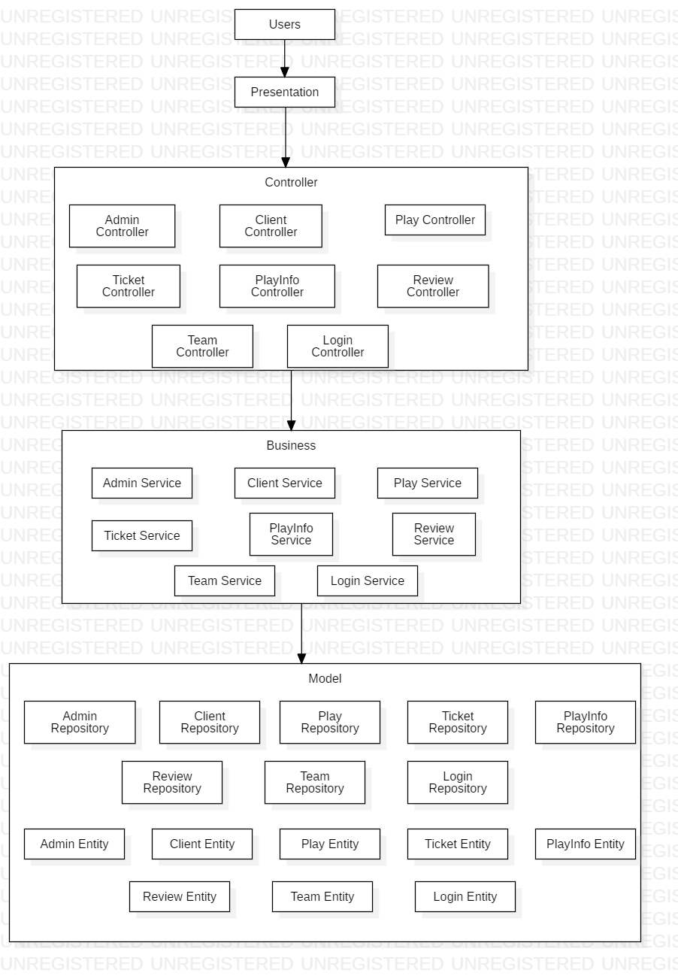

## Package Design

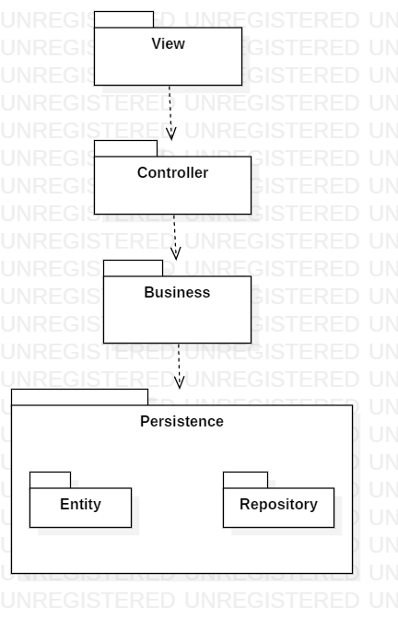

## Component and Deployment Diagrams

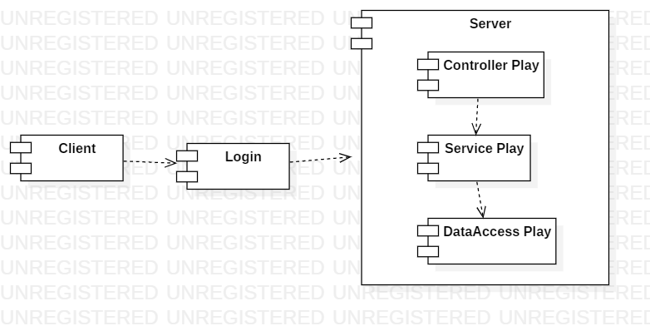

# Elaboration – Iteration 1.2

# Design Model

## Dynamic Behavior

Diagrams for the operation of buying a ticket at a theatre play. This is the final sequence diagram, added after I made the modifications and introduced the Cart classes.

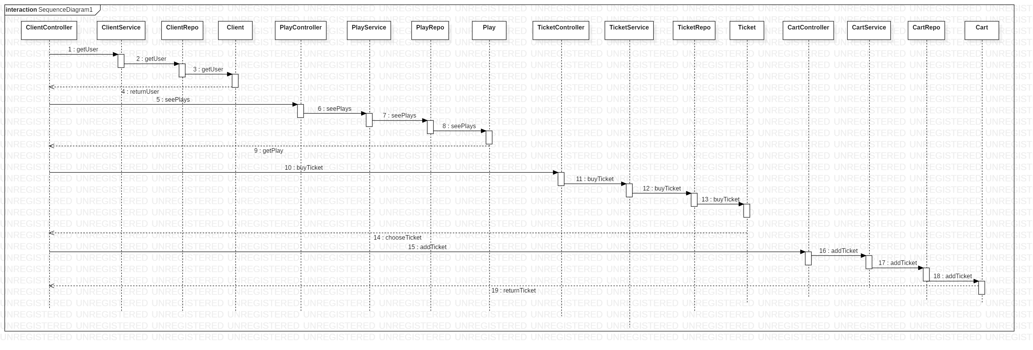

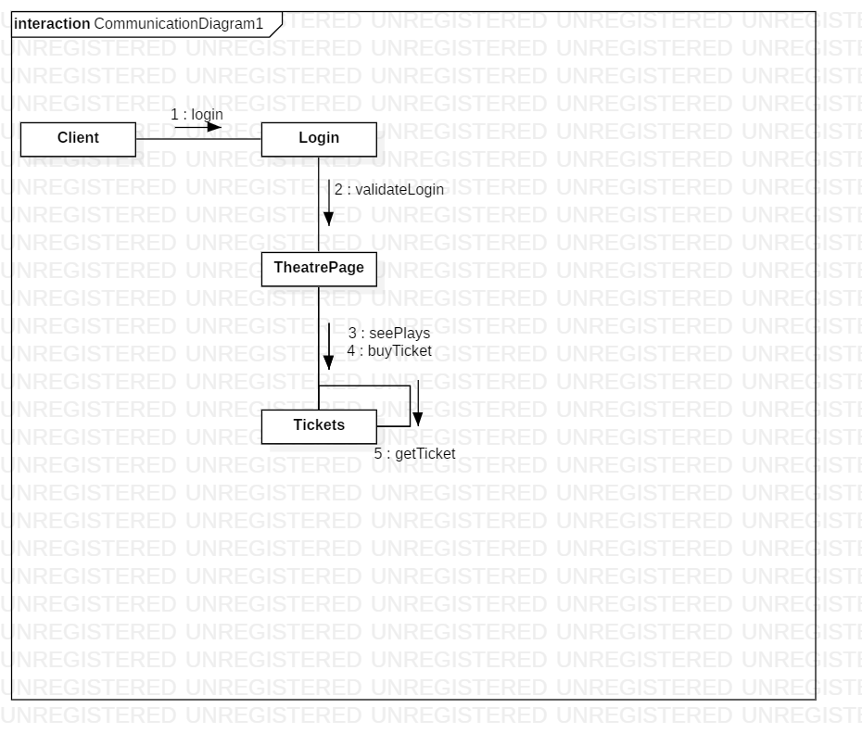

Diagrams for the operation of viewing the theatre’s team.

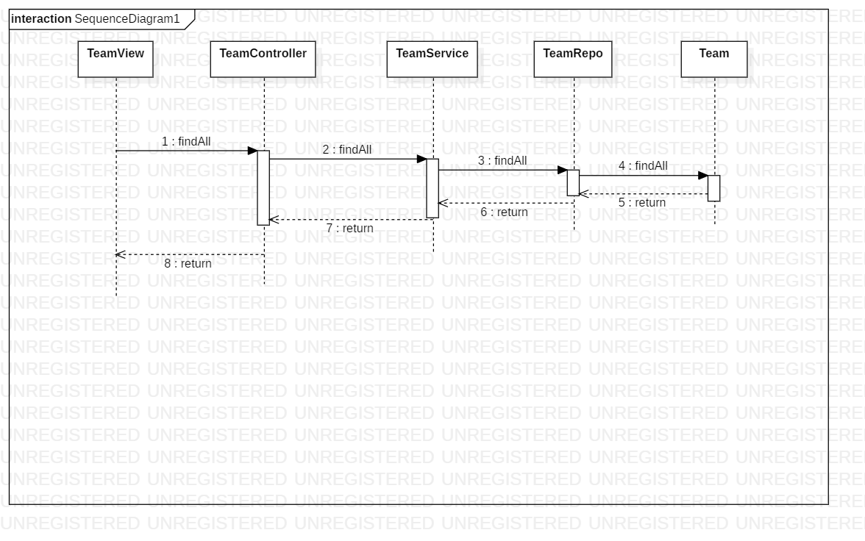

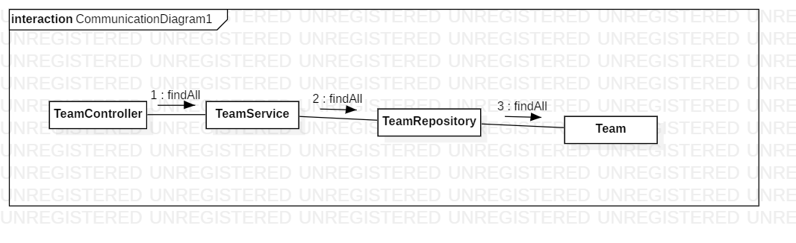

## Class Design

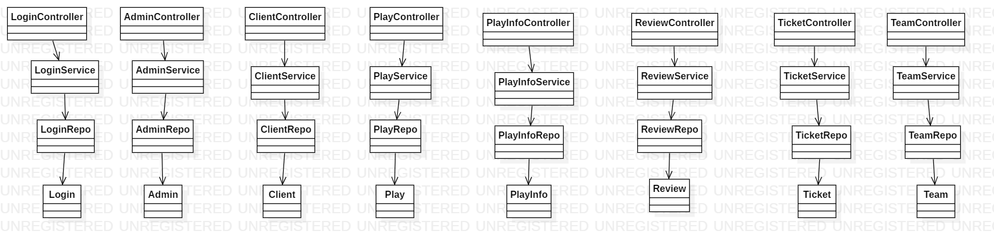

# Data Model

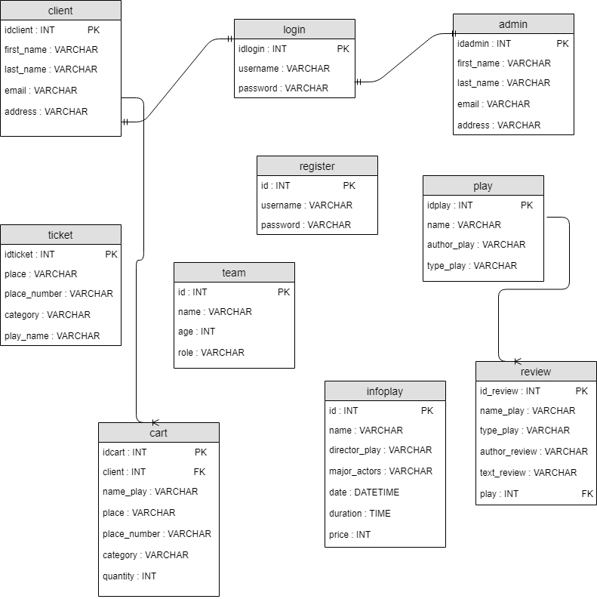

# Unit Testing

For testing, I used Junit in order to take different test cases, such as : create a new client account, buy tickets at different plays, create/read/update/delete theatre plays as admin.

# Elaboration – Iteration 2

# Architectural Design Refinement

I added in my project classes for the Cart of a client, where he can add as many tickets as he wants. I made the necessary modifications in the Architectural Design, as you can see down below.

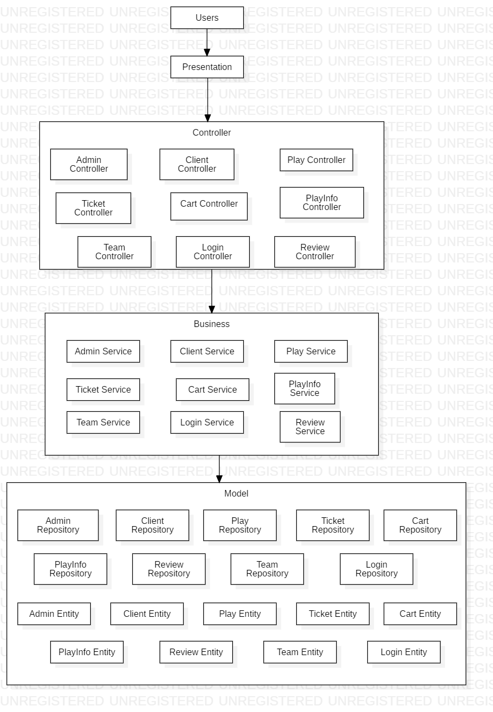

# Design Model Refinement

As I said, I added the necessary classes for Cart. I remade the class diagram for my project.

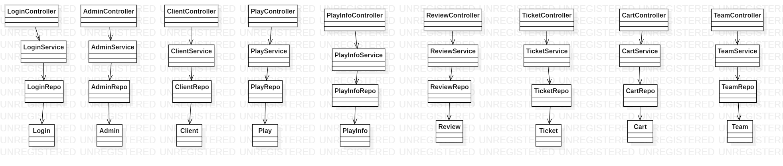

# Construction and Transition

# System Testing

As I said, my application has tests for different case scenarios, as creating new accounts, updating, adding or deleting theatre plays, updating, adding or deleting members from the theatre’s team.

# Future improvements

As future improvements, I could add some extra operations for the users, both clients and admin. Also, the view can be improved, in order to be more friendly with the user.

# Bibliography

# [1] <https://towardsdatascience.com/10-common-software-architectural-patterns-in-a-nutshell-a0b47a1e9013>

[2] <https://www.journaldev.com/1827/java-design-patterns-example-tutorial>

[3] <https://spring.io/guides/gs/accessing-data-mysql/>