Application for National Theatre of Cluj-Napoca

Use-Case Model

Version 1.0

Revision History

|  |  |  |  |
| --- | --- | --- | --- |
| **Date** | **Version** | **Description** | **Author** |
| 03/04/2019 | 1.0 | 1.0 | Costea Ana-Maria |
| 29/05/2019 | 2.0 | 2.0 | Costea Ana-Maria |
|  |  |  |  |
|  |  |  |  |

Table of Contents

1. Use-Cases Identification 4

2. UML Use-Case Diagrams 4

# Use-Cases Identification

I will represent a use-case for the scenario of buying a ticket.

**Use case** : buy a ticket

**Level** : user-goal level

**Primary actor** : regular user (client)

**Main success scenario** : client log in with his username and password, he choose a play and select the operation “Buy”

**Extensions** : if the client follows correctly the described steps, he will buy successfully a ticket at the favorite play; in other case, an error message will be generated

# UML Use-Case Diagrams

Use-Case diagram for a regular user (client) :

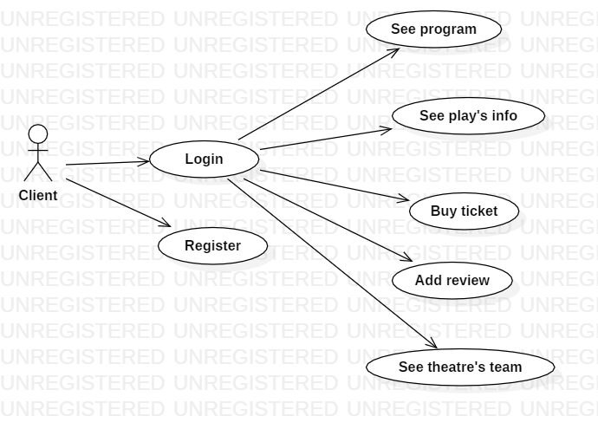

Use-Case diagram for an admin user :

