An online database for information on movies, tv series and celebrities.

Analysis and Design Document

Student:Giurgiu Diana-Ioana

**Group:30233**

Revision History

|  |  |  |  |
| --- | --- | --- | --- |
| **Date** | **Version** | **Description** | **Author** |
| <dd/mmm/yy> | <x.x> | <details> | <name> |
|  |  |  |  |
|  |  |  |  |
|  |  |  |  |

Table of Contents

I. Project Specification 4

II. Elaboration – Iteration 1.1 4

1. Domain Model 4

2. Architectural Design 4

2.1 Conceptual Architecture 4

2.2 Package Design 4

2.3 Component and Deployment Diagrams 4

III. Elaboration – Iteration 1.2 4

1. Design Model 4

1.1 Dynamic Behavior 4

1.2 Class Design 4

2. Data Model 4

3. Unit Testing 4

IV. Elaboration – Iteration 2 4

1. Architectural Design Refinement 4

2. Design Model Refinement 4

V. Construction and Transition 5

1. System Testing 5

2. Future improvements 5

VI. Bibliography 5

# Project Specification

This application is intended to be a database for Movies, Tv Shows, Celebrities(Actors) where a User can post comments in the movies/tvShows they have watched or give a rating to movies/TvShow. The comments are checked afterwards by the moderators and if they identify any illegal words(ex: swearing) the comment will be removed and depending on the rules they have crossed their penalties can vary from being mute for a period of time to their account being removed.

# Elaboration – Iteration 1.1

# Domain Model

# Architectural Design

## Conceptual Architecture

Chosen architecture pattern is layered pattern. Each pattern goes to the next layer.

## Package Design

The packages incorporated in my application are mapped by the layers they are part of:

* Presentation Layer
* Service layer
* Business Logic Layer
* Data Access Layer

## Component and Deployment Diagrams

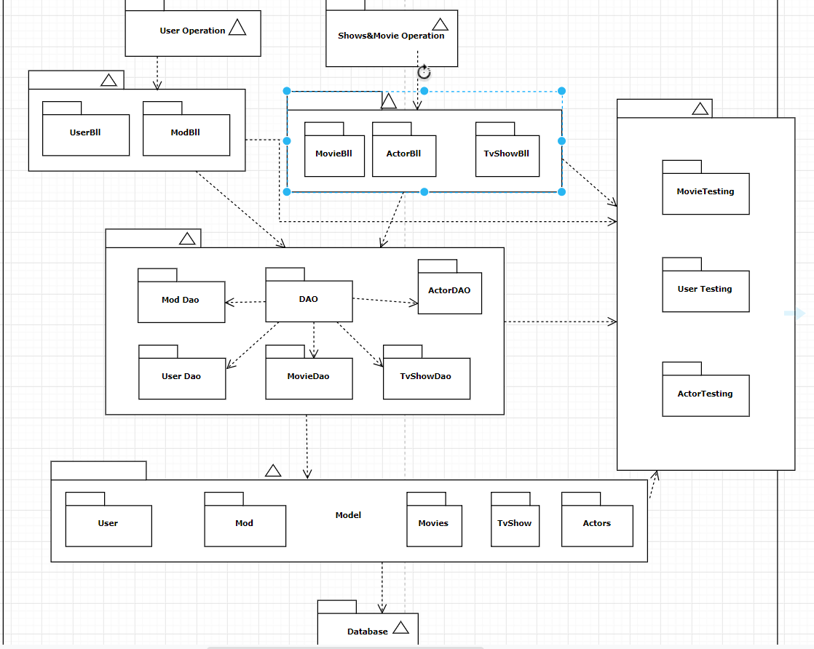

# Elaboration – Iteration 1.2

# Design Model

## Dynamic Behavior

*[Create the interaction diagrams (1 sequence, 1 communication diagrams) for 2 relevant scenarios]*

## Class Design

# Data Model

# Unit Testing

*[Present the used testing methods and the associated test case scenarios.]*

# Elaboration – Iteration 2

# Architectural Design Refinement

*[Refine the architectural design: conceptual architecture, package design (consider package design principles), component and deployment diagrams. Motivate the changes that have been made.]*

# Design Model Refinement

## *[Refine the UML class diagram by applying class design principles and GRASP; motivate your choices. Deliver the updated class diagrams.]*

# Construction and Transition

# System Testing

*[Describe how you applied integration testing and present the associated test case scenarios.]*

# Future improvements

*[Present future improvements for the system]*

# Bibliography