Movie Story

Use-Case Model

Version <1.0>

Revision History

|  |  |  |  |
| --- | --- | --- | --- |
| **Date** | **Version** | **Description** | **Author** |
| <dd/mmm/yy> | <x.x> | <details> | <name> |
| 03-04-2019 | V1 | First lines of documentation | Giurgiu Diana Ioana |
|  |  |  |  |
|  |  |  |  |
|  |  |  |  |

Table of Contents

1. Use-Cases Identification 4

2. UML Use-Case Diagrams 4

Use-Case Model

# Use-Cases Identification

**Use case: Anon requesting creation of a new account**

**Level: user**

**Primary actor: anonimous**

**Main success scenario: individual inputs correct arguments for the creation of a user account gets validated and the account is created**

**Extensions:failure to validate, requests new input from user**

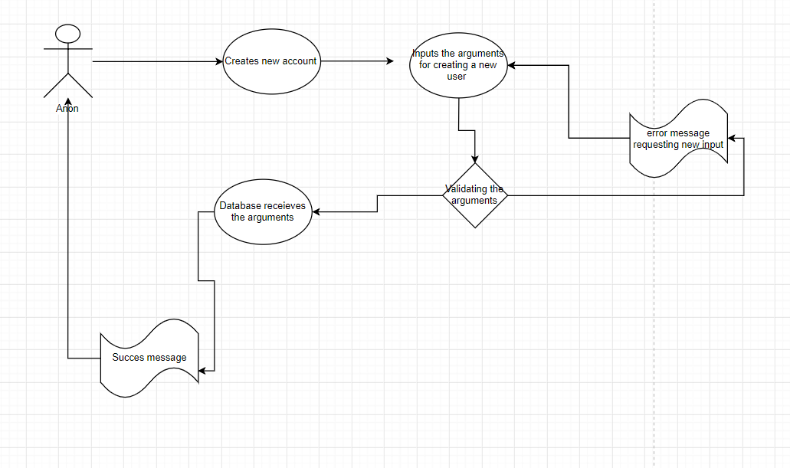

**Use case: User adding a move**

**Level: user**

**Primary actor: user**

**Main success scenario: person can update the movie they have watched and they can rate and comment in it**

**Extensions:the movie does not exist in DB, the mvie will be created**

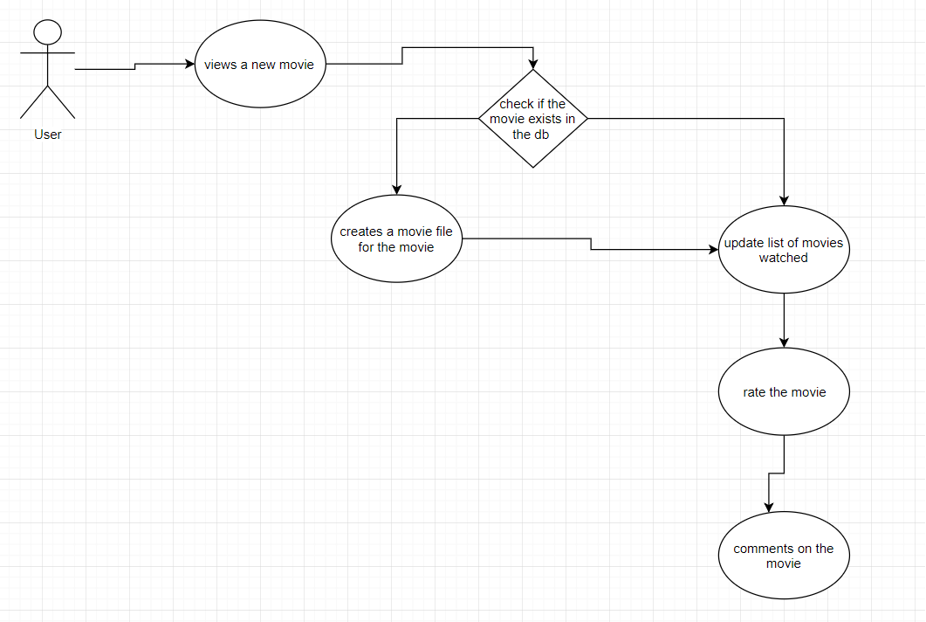

# UML Use-Case Diagrams

