Tell your friends

Use-Case Model

Version 1.0

Revision History

|  |  |  |  |
| --- | --- | --- | --- |
| **Date** | **Version** | **Description** | **Author** |
| 03/Apr/19 | 1.0 | Add first version of use-case | Grigor Sonia |
|  |  |  |  |
|  |  |  |  |
|  |  |  |  |

Table of Contents

1. Use-Cases Identification 3

2. UML Use-Case Diagrams 4

# Use-Cases Identification

This application support two types of user. The first one is a regular or general user and can do the following operations: register in the application, login, add a new book or movie in order to be reviewed, update his contact information and change his password. The second one is an administrator who can perform the next activities: add another category of book, movie, delete some types of books, movies.

*Use case: Login*

*Level: < user-goal level >*

*Primary actor: <User >*

*Main success scenario: The application opens, the user provides his email and a password, the system responds to it with opening the homepage.*

*Extensions: if a user does not have an account, the application provides possibility to create a new account.*

*Use case: Create account*

*Level: < user-goal level >*

*Primary actor: <User>*

*Main success scenario: The user inserts the personal information into the fields on the register page and click the Register button in order to insert a new user in the database associated table*

*Extensions:*

*Use case: Update personal information*

*Level: < user-goal level >*

*Primary actor: <User>*

*Main success scenario: The user edit the data in fields, which will be processed by the system and further communicated to the database for update of the current informational state*

*Extensions:*

*Use case: View Book/Movie information*

*Level: < user-goal level >*

*Primary actor: <User>*

*Main success scenario: The user can view in two different tabs all the books and movie that have been added to database*

*Extensions:*

# UML Use-Case Diagrams

Use-Case Diagram for Administrator

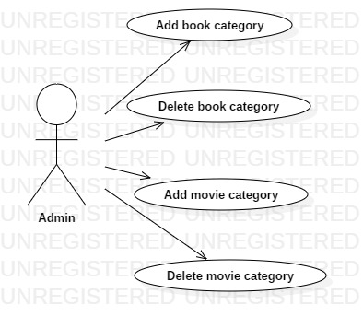

Use-Case Diagram for Regular User

