Analysis and Design Document

Student:Lăzăreanu Sabina

**Group:30233**

Revision History

|  |  |  |  |
| --- | --- | --- | --- |
| **Date** | **Version** | **Description** | **Author** |
| 23/04/2019 | 1.0 | First Version | Lăzăreanu Sabina |
|  |  |  |  |
|  |  |  |  |
|  |  |  |  |

Table of Contents

I. Project Specification 4

II. Elaboration – Iteration 1.1 4

1. Domain Model 4

2. Architectural Design 4

2.1 Conceptual Architecture 4

2.2 Package Design 4

2.3 Component and Deployment Diagrams 4

III. Elaboration – Iteration 1.2 4

1. Design Model 4

1.1 Dynamic Behavior 4

1.2 Class Design 4

2. Data Model 4

3. Unit Testing 4

IV. Elaboration – Iteration 2 4

1. Architectural Design Refinement 4

2. Design Model Refinement 4

V. Construction and Transition 5

1. System Testing 5

2. Future improvements 5

VI. Bibliography 5

# Project Specification

This is a web project than is helpful for those persons how want to make an easy and clean CV just by filling some fields and asking some questions.

This system has two types of users:

* Regular User that can create one type of CV or update an existing one
* Premium user that can choose witch type of CV want to create and can also to edit an existing CV

The generated CV will be sent on email and can be downloaded.

# Elaboration – Iteration 1.1

# Domain Model

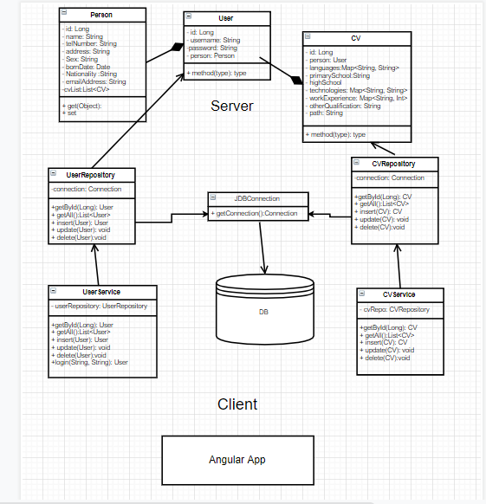

# Architectural Design

## Conceptual Architecture

This app design is based on *Layered Architecture Design Pattern*. It is the most common architecture pattern, otherwise known as the n-tier architecture pattern. This pattern is the de facto standard for most Java EE applications and therefore is widely known by most architects, designers, and developers. The layered architecture pattern closely matches the traditional IT communication and organizational structures found in most companies, making it a natural choice for most business application development efforts.

Components within the layered architecture pattern are organized into horizontal layers, each layer performing a specific role within the application (e.g., presentation logic or business logic). Although the layered architecture pattern does not specify the number and types of layers that must exist in the pattern, most layered architectures consist of four standard layers: presentation, business, persistence, and database.

Each layer of the layered architecture pattern has a specific role and responsibility within the application. For example, a presentation layer would be responsible for handling all user interface and browser communication logic, whereas a business layer would be responsible for executing specific business rules associated with the request.

This three layers are arranged on 2 tiers.

In the same time this project have a Server-Client structure, Java project being the Server component and the Angular is the Client Component.

## Package Design

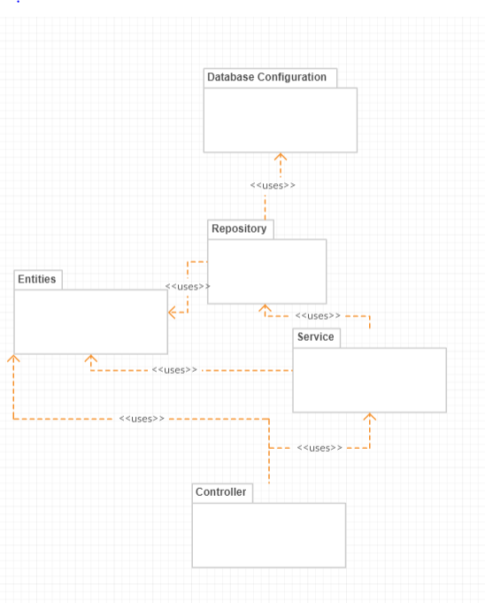

## Component and Deployment Diagrams

# 

# Elaboration – Iteration 1.2

# Design Model

## Dynamic Behavior

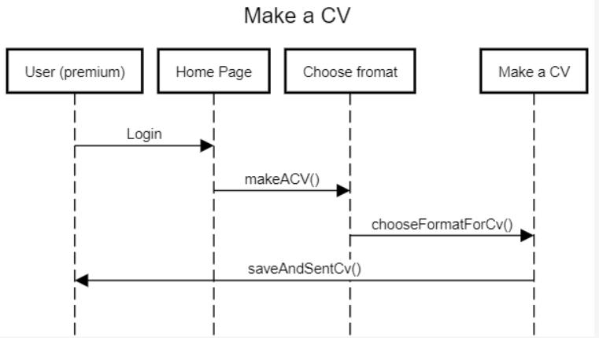

## Class Design

*[Create the UML class diagram; apply GoF patterns and motivate your choice]*

# Data Model

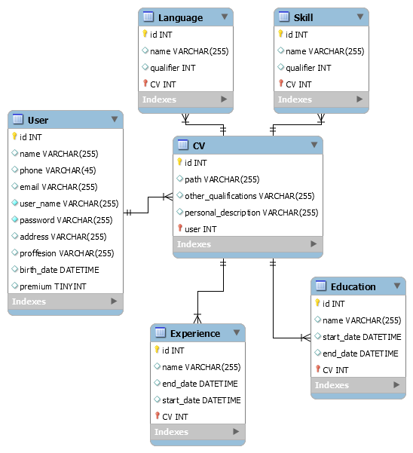

# Unit Testing

*[Present the used testing methods and the associated test case scenarios.]*

A unit test should test functionality in isolation. Side effects from other classes or the system should be eliminated for a unit test, if possible.

This can be done via using test replacements (*test doubles*) for the real dependencies. Test doubles can be classified like the following:

* A *dummy object* is passed around but never used, i.e., its methods are never called. Such an object can for example be used to fill the parameter list of a method.
* *Fake* objects have working implementations, but are usually simplified. For example, they use an in memory database and not a real database.
* A *stub* class is an partial implementation for an interface or class with the purpose of using an instance of this stub class during testing. Stubs usually don’t respond to anything outside what’s programmed in for the test. Stubs may also record information about calls.
* A *mock object* is a dummy implementation for an interface or a class in which you define the output of certain method calls. Mock objects are configured to perform a certain behavior during a test. They typically record the interaction with the system and tests can validate that.

Test doubles can be passed to other objects which are tested. Your tests can validate that the class reacts correctly during tests. For example, you can validate if certain methods on the mock object were called. This helps to ensure that you only test the class while running tests and that your tests are not affected by any side effects.

Test Case Scenarios:

# Elaboration – Iteration 2

# Architectural Design Refinement

*[Refine the architectural design: conceptual architecture, package design (consider package design principles), component and deployment diagrams. Motivate the changes that have been made.]*

# Design Model Refinement

## *[Refine the UML class diagram by applying class design principles and GRASP; motivate your choices. Deliver the updated class diagrams.]*

# Construction and Transition

# System Testing

*[Describe how you applied integration testing and present the associated test case scenarios.]*

# Future improvements

*[Present future improvements for the system]*

# Bibliography

1. <https://www.vogella.com/tutorials/Mockito/article.html>