Analysis and Design Document

Student:

**Group:**

Revision History

|  |  |  |  |
| --- | --- | --- | --- |
| **Date** | **Version** | **Description** | **Author** |
| <dd/mmm/yy> | <x.x> | <details> | <name> |
|  |  |  |  |
|  |  |  |  |
|  |  |  |  |

Table of Contents

I. Project Specification 4

II. Elaboration – Iteration 1.1 4

1. Domain Model 4

2. Architectural Design 4

2.1 Conceptual Architecture 4

2.2 Package Design 4

2.3 Component and Deployment Diagrams 4

III. Elaboration – Iteration 1.2 4

1. Design Model 4

1.1 Dynamic Behavior 4

1.2 Class Design 4

2. Data Model 4

3. Unit Testing 4

IV. Elaboration – Iteration 2 4

1. Architectural Design Refinement 4

2. Design Model Refinement 4

V. Construction and Transition 5

1. System Testing 5

2. Future improvements 5

VI. Bibliography 5

# Project Specification

The project is implemented to facilitate the communication between a clinic and its patiens. When it opens the application, the patient can see previous appointments, and can create a new appointment request, based on the illness.

# Elaboration – Iteration 1.1

# Domain Model

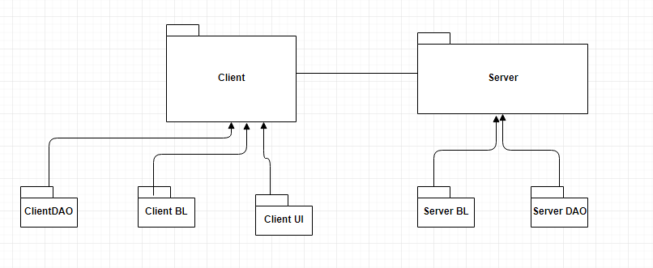

# Architectural Design

## Conceptual Architecture

The project's code will follow client-server and layers patterns.

Client/server architecture is a computing model in which the server hosts, delivers and manages most of the resources and services to be consumed by the client. This type of architecture has one or more client computers connected to a central server over a network or internet connection. This system shares computing resources.

Client/server architecture is also known as a networking computing model or client/server network because all the requests and services are delivered over a network.

Layered architecture pattern is also known as the n-tier architecture pattern. This pattern is the de facto standard for most Java EE applications and therefore is widely known by most architects, designers, and developers. The layered architecture pattern closely matches the traditional IT communication and organizational structures found in most companies, making it a natural choice for most business application development efforts.

## Package Design



## Component and Deployment Diagrams

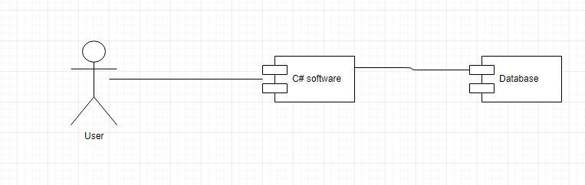

# Elaboration – Iteration 1.2

# Design Model

## Dynamic Behavior

*[Create the interaction diagrams (1 sequence, 1 communication diagrams) for 2 relevant scenarios]*

## Class Design

*[Create the UML class diagram; apply GoF patterns and motivate your choice]*

# Data Model

*[Create the data model for the system.]*

# Unit Testing

*[Present the used testing methods and the associated test case scenarios.]*

# Elaboration – Iteration 2

# Architectural Design Refinement

*[Refine the architectural design: conceptual architecture, package design (consider package design principles), component and deployment diagrams. Motivate the changes that have been made.]*

# Design Model Refinement

## *[Refine the UML class diagram by applying class design principles and GRASP; motivate your choices. Deliver the updated class diagrams.]*

# Construction and Transition

# System Testing

*[Describe how you applied integration testing and present the associated test case scenarios.]*

# Future improvements

*[Present future improvements for the system]*

# Bibliography